**EXPERIMENT NO:- 8**

**AIM:-** Write a matlab program to

a) Separate voiced and unvoiced portion of signal

b)Perform STFT on voiced and unvoiced signal

**Apparatus used:-**  MATLAB software

**Program Code:-**

clc;

close all;

clear all;

%**************************************************************************

[d fs nb]=wavread('C:\Documents and Settings\user\Desktop\pkm1');

wavplay(d)

d=d(1:50000);

d=d./max(abs(d));

figure;

plot(d);

xlabel('time')

ylabel('amp')

title('original signal')

grid on;

wavwrite(d,fs,nb,'new.wav')

%exportfig(gcf,'speech.eps','bounds','tight');

%**************************************************************************

NW=160; OLN=80; NFFT=256;

NFFT1=(NFFT/2)+1;

Time=(0:NW-1)*(1/fs);

Freq=(0:NFFT1-1)*(fs/NFFT);

%**************************************************************************

SVI=33500;

SUVI=23000;

vs=d(SVI:SVI+NW-1);

uvs=d(SUVI:SUVI+NW-1);

vs=vs./max(abs(vs));

uvs=uvs./max(abs(uvs));

figure;

subplot(211);

plot(Time,vs);

grid on;

title('A Segment of Voiced Portion of Speech');

text(0.0202,0,'(a)')

subplot(212);

plot(Time,uvs);

grid on;

title('A Segment of Unvoiced Portion of Speech');

text(0.0202,0,'(b)')

%exportfig(gcf,'vuvs.eps','bounds','tight');

%figure

%subplot(551);plot(Time,vs,'k');axis([-0.01 0.025 -1.2 1.2])

%subplot(552);plot(1:200,rand(1,200)-mean(rand(1,200)),'k');axis([-25 220 -1.2 1.2])

%subplot(553);stem([2,42,82,126,166],[1,1,1,1,1],'k');axis([-25 200 -.5 1.5])

%********************************** STFT **********************************

vs1=vs.*hamming(NW);

uvs1=uvs.*hamming(NW);

XK1=fft(vs1,NFFT);

XK1M=abs(XK1);

XK1P=angle(XK1);

XK2=fft(uvs1,NFFT);

XK2M=abs(XK2);

XK2P=angle(XK2);

XK11M=XK1M(1:NFFT1);

LXK11M=log(XK11M);

XK22M=XK2M(1:NFFT1);

LXK22M=log(XK22M);

figure;

subplot(321);

plot(Time,vs); grid on;

title('A 20 ms Segment of Voiced Portion of Speech');

text(0.0202,max(abs(vs))-range(vs)/2,'(a)')

subplot(323);

plot(Freq,XK11M);

grid on;

title('Magnitude Spectrum');

text(4030,max(abs(XK11M))-range(XK11M)/2,'(b)')

subplot(325);

plot(Freq,LXK11M);

grid on;

title('Log Magnitude Spectrum');

text(4030,-(max(abs(LXK11M))-range(LXK11M)/2),'(c)')

subplot(322);

plot(Time,uvs);

grid on;

title('A 20 ms Segment of Unvoiced Portion of Speech');

text(0.0202,max(abs(uvs))-range(uvs)/2,'(d)')

subplot(324);

plot(Freq,XK22M);

grid on;

title('Magnitude Spectrum');

text(4030,max(abs(XK22M))-range(XK22M)/2,'(e)')

subplot(326);

plot(Freq,LXK22M);

grid on;

title('Log Magnitude Spectrum');

text(4030,-(max(abs(LXK22M))-range(LXK22M)/2),'(f)')

%exportfig(gcf,'stft.eps','bounds','tight');

**Steps Followed:-**

1. Read and plot the original signal

2. Plot a segment of voiced portion of the speech using few parameters.

3. Plot a segment of unvoiced portion of speech.

4. Plot a 20 ms Segment of Voiced Portion of Speech.

5. Plot a 20 ms Segment of Unvoiced Portion of Speech.

**Figures:-**

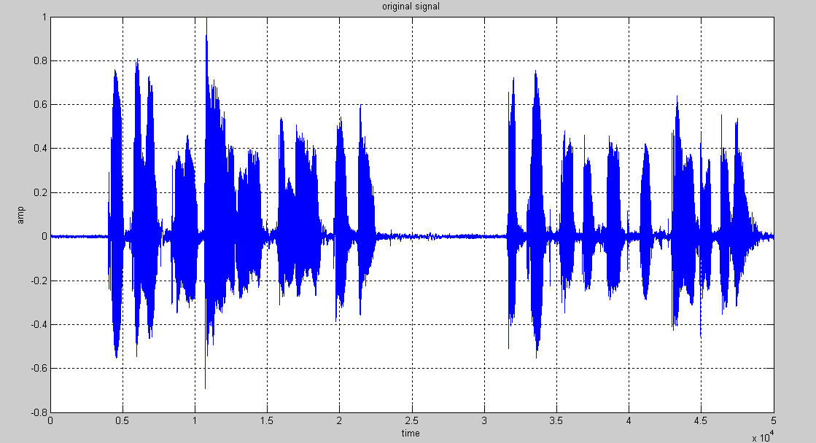

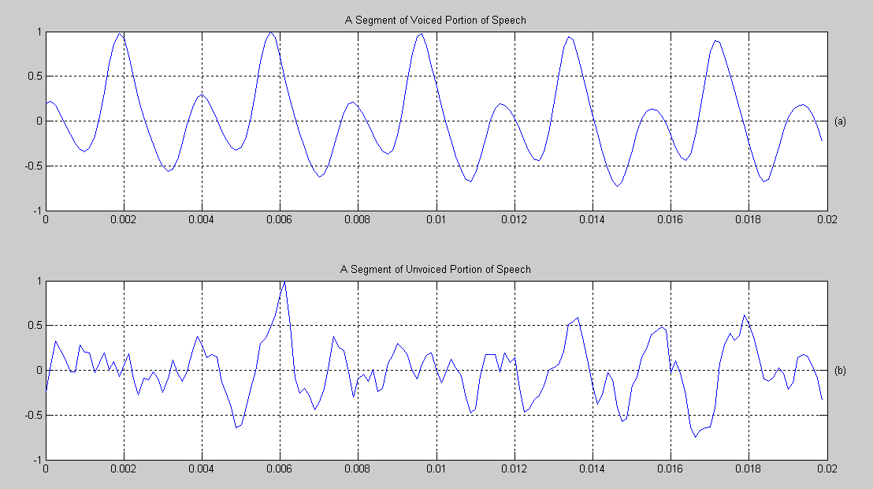

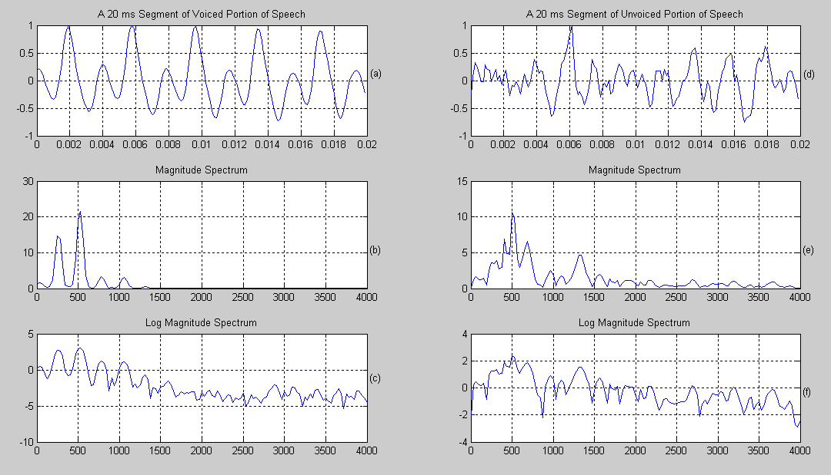

**Result:-**

The voiced and unvoiced signals separated and STFT plotted successfully.