**Experiment No. - 7**

**AIM: -** To perform Short term fourier transform using window techniques.

**APPARATUS USED: -** MATLAB 7.0, MATLAB R2011b

**MATLAB CODE:-**

[y,Fs,nbits]=wavread('C:\MATLAB7\work\sample.wav') %return the value of audio signal in Y, sampling frequency in Fs and bit resolution in nbits

wavplay(y,8000) % play backs the audio file at 11025 hz

%wavplay(y,6000) %plays the audio at sampling rate of 6000

plot(y) % it plots the signal y

axis('tight');

grid on

xlabel('TIME')

ylabel('amplitude')

title('spectrum of Y')

[x,fs,nbits]=wavread('C:\MATLAB7\work\sample.wav',[12800 13100]);

figure(2)

plot(x)

axis('tight');

grid on

xlabel('TIME')

ylabel('amplitude')

title('spectrum of x')

yfft=fftshift(x); % calculates fft of Y

figure(3)

plot(yfft)

axis('tight');

grid on

xlabel('TIME')

ylabel('frequency')

title('fft of x')

t = linspace(-10,10,2048);

eta = 1e-5;

vmin = -2;

h = double( abs(t)<1 );

hf = fftshift(abs(fft(h)));

hf = log10(eta+hf);

hf = hf/max(hf);

figure(4)

subplot(2,1,1);

plot(t, h);

title('Block window');

axis([-2 2, -.1, 1.1]);

subplot(2,1,2);

plot(t, hf);

axis([-2 2, vmin, 1.1]);

title('Fourier transform');

h = cos(t*pi()/2) .* double(abs(t)<1);

hf = fftshift(abs(fft(h)));

hf = log10(eta+hf); hf = hf/max(hf);

figure(5)

subplot(2,1,1);

plot(t, h);

title('Hamming window');

axis([-2 2, -.1, 1.1]);

subplot(2,1,2);

plot(t, hf); axis([-2 2, vmin, 1.1]);

title('Fourier transform');

h = (cos(t*pi())+1)/2 .* double(abs(t)<1);

hf = fftshift(abs(fft(h)));

hf = log10(eta+hf); hf = hf/max(hf);

figure(6)

subplot(2,1,1);

plot(t, h);

title('Haning window');

axis([-2 2, -.1, 1.1]);

subplot(2,1,2);

plot(t, hf); axis([-2 2, vmin, 1.1]);

title('Fourier transform');% size of the window

w = 64*2;% overlap of the window

q = w/2;

t = 0:3*w-1;

t1 = t-2*w;

f = w/8;% Position 0, frequency 0.

g1 = sin( pi*t/w ).^2 .* double(t<w);% Position 2*w, frequency 0.

g2 = sin( pi*t1/w ).^2 .* double( t1<w & t1>=0 );% Position 0, frequency w/8

g3 = g1 .* sin( t * 2*pi/w * f);% Position 2*w, frequency w/8

g4 = g2 .* sin( t * 2*pi/w * f);% display

figure(7)

subplot(2,2,1);

plot(g1);

axis('tight');

title('Position 0, frequency 0');

subplot(2,2,2);

plot(g2);

axis('tight');

title('Position 2*w, frequency 0');

subplot(2,2,3);

plot(g3);

axis('tight');

title('Position 0, frequency w/8');

subplot(2,2,4);

plot(g4);

axis('tight');

title('Position 2*w, frequency w/8');

figure(8)

specgram(y)

title('spectogram of y'); % display the spectrogram

**STEPS FOLLOWED:-**

1. Open the editor window in MATLAB R2011b.

2. Write the MATLAB code.

3. Read the audio signal.

4. Play the audio signal at 11025 Hz.

5. Plot the original audio signal.

6. Perform FFT on the signal.

7. Perform the window techniques( Block window, Hamming window, Haning window) on the signal.

8. Plot the resulting signals.

**RESULT:-** The experiment was performed successfully and the figures are shown below:-

**Figure:-1**

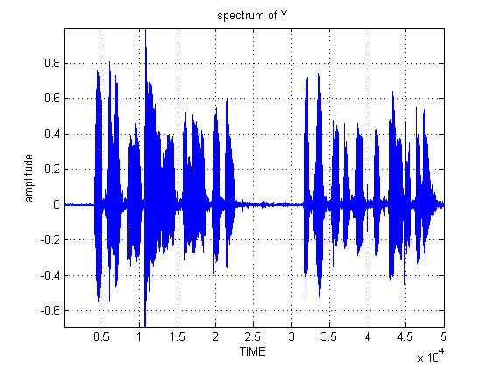

**Figure:-2**

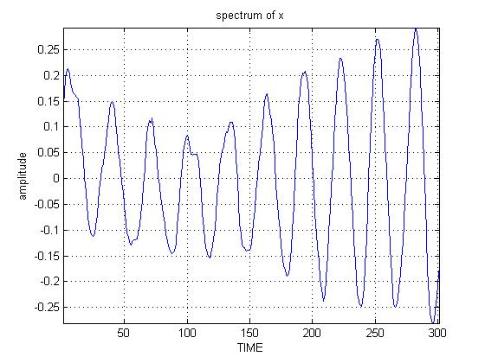

**Figure:-3**

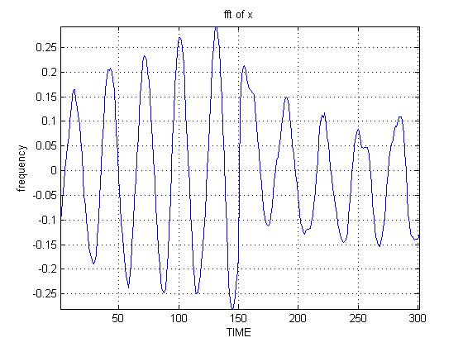

**Figure:-4**

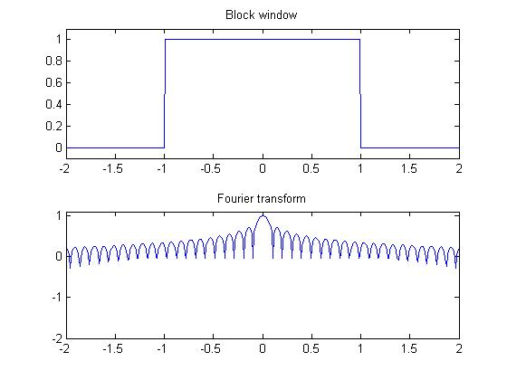

**Figure:-5**

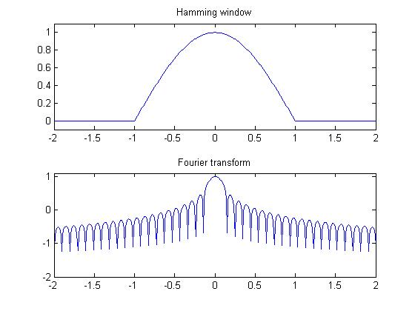

**Figure:-6**

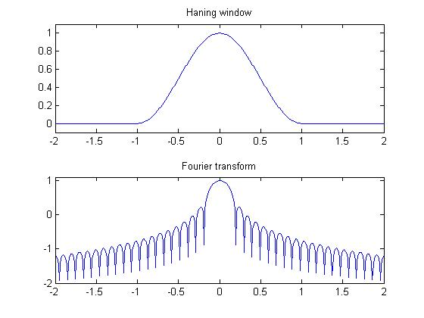

**Figure:-7**

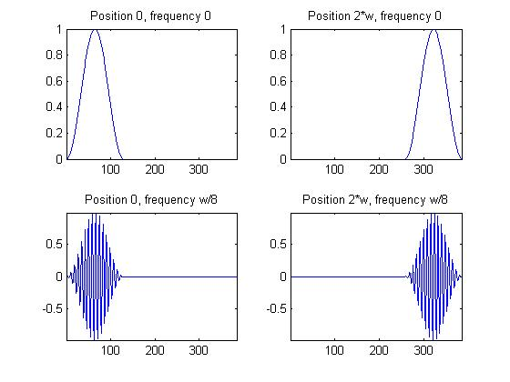

**Figure:-8**

