EXPERIMENT NO. 7

AIM: Write a MATLAB code to Analysis of multi-resolution, wavelet decomposition and reconstruction of audio signals at different levels using different filters

TOOL USED: MATLAB 11

THEORY:
Wavelet Decomposition:
In numerical analysis and functional analysis, a discrete wavelet transform (DWT) is any wavelet transform for which the wavelets are discretely sampled. As with other wavelet transforms, a key advantage it has over Fourier transforms is temporal resolution: it captures both frequency and location information (location in time).
The DWT of a signal is calculated by passing it through a series of filters. First the samples are passed through a low pass filter with impulse response resulting in a convolution of the two:
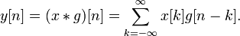
The signal is also decomposed simultaneously using a high-pass filter . The outputs giving the detail coefficients (from the high-pass filter) and approximation coefficients (from the low-pass). It is important that the two filters are related to each other and they are known as a quadrature mirror filter.
However, since half the frequencies of the signal have now been removed, half the samples can be discarded according to Nyquist’s rule. The filter outputs are then sub sampled by 2 (Mallat's and the common notation is the opposite, g- high pass and h- low pass):
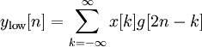
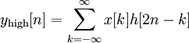

The wavelet decomposition tree can be plotted as:

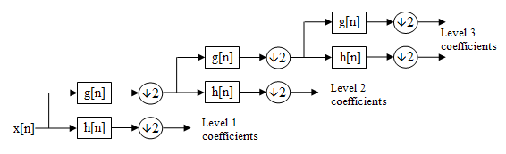

With the sub sampling operator
The above summation can be written more concisely.

Wavelet Reconstruction:
We've learned how the discrete wavelet transform can be used to analyze, or decompose, signals and images. This process is called decomposition or analysis. The other half of the story is how those components can be assembled back into the original signal without loss of information. This process is called reconstruction, or synthesis. The mathematical manipulation that effects synthesis is called the inverse discrete wavelet transform (IDWT).
The wavelet reconstruction tree can be plotted as:
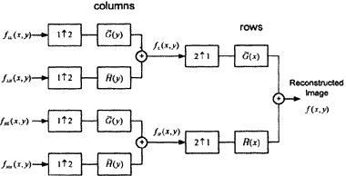
STEPS FOLLOWED:

1. Read the audio signal and get the value of its sampling rate and bit resolution.
2. Play the audio signal using “wavplay” command.
3. Perform DWT on audio signal and get the values of approximation and details..
4.. Plot the decomposed audio signal.
5. Using approximation and details components perform reconstruction by doing up sampling on the signal.
6. Plot the reconstructed signal.

RESULT:
The DWT and IDWT is successfully performed on an audio signal.

