EXPERIMENT NO. 8

AIM: Write a program to plot the absolute threshold of hearing in quiet. Give a plot in terms of a linear Hz scale

APPARATUS USED: MATLAB 11

THEORY:
The absolute threshold of hearing characterizes the amount of energy needed in a pure tone such that it can be detected by a listener in a noiseless environment. The absolute threshold is typically expressed in terms of dB SPL. The frequency dependence of this threshold was quantified as early as 1940, when Fletcher reported test results for a range of listeners that were generated in a National Institutes of Health (NIH) study of typical American hearing acuity.
The quiet threshold is well approximated by the non linear function

Which is representative of a young listener with acute hearing. When applied to signal compression, Tq(f ) could be interpreted naively as a maximum allowable energy level for coding distortions introduced in the frequency domain.
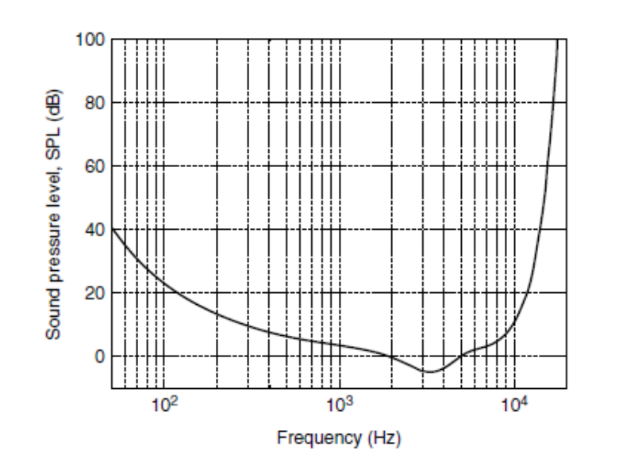

STEPS FOLLOWED:

1. Read the audio signal and get the value of its sampling rate and bit resolution.
2. Play the audio signal using “wavplay” command.
3. Plot graph between sound pressure level and frequency of the signal.

RESULT:
The absolute threshold of hearing is plotted and studied successfully.

