EXPERIMENT NO. 13

AIM: Write a MATLAB code to play an audio file in reverse order.

TOOL USED: MATLAB 11

THEORY:
We can play an audio file in MATLAB using command “wavplay” and “soundsc”. These commands are used to play the audio in original order. If we want to play with aour audio signal and wanted it to play in reverse order the given command is used:
Flipud(A)
If A is a column vector, then flipud(A) returns a vector of the same length with the order of its elements reversed. If A is a row vector, then flipud(A) simply returns A.
If A is the 3-by-2 matrix,
A= 1 4
2 5
3 6
then flipud(A) produces 3 6
2 5
1 4

STEPS FOLLOWED:

1. Read the audio signal and get the value of its sampling rate and bit resolution.
2. Play the audio signal using “wavplay” command.
3. Plot the original audio file.
4.. Reverse the audio signal and write it in other file
5. Play and plot the reverse audio signal.

RESULT:
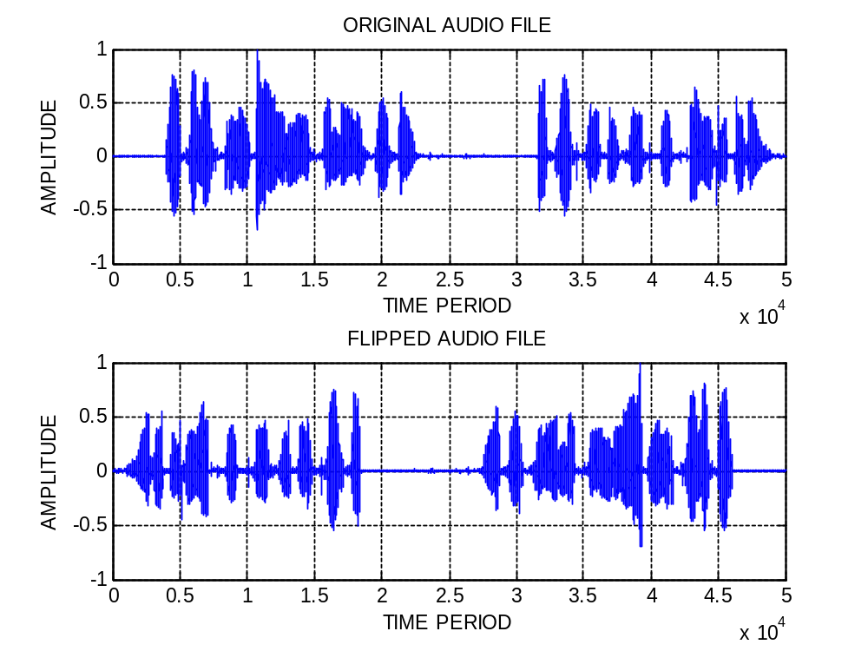
The original signal is played in reverse order and saved in a different file. The plot has been successfully studied. The results are verified according to the human auditory system.

