EXPERIMENT NO. 5

AIM: To play an audio file in reverse order.

APPARATUS USED: MATLAB 7.0, MATLAB R2011b
MATLAB CODE:
[y,Fs,nbits]=wavread('C:\Documents and Settings\student\Desktop\sample')

wavplay(y)

plot(y)

grid on;

xlabel('FREQUENCY');

ylabel('AMPLITUDE');

title('ORIGINAL AUDIO FILE');

z=flipud(y);

wavwrite(z,'C:\Documents and Settings\student\Desktop\sample_flip')

wavplay(z)

figure(2);

plot(z)

grid on;

Xlabel('FREQUENCY');

ylabel('AMPLITUDE');

title('FLIPPED AUDIO FILE');
STEPS FOLLOWED:

1. Open the editor window in MATLAB R2011b.
2. Write the MATLAB code.
3. Read the audio signal.
4. Play the audio signal.
5.Reverse the audio signal and write it in other file.
6. Play and plot the reverse audio signal.

OBSERVATION:

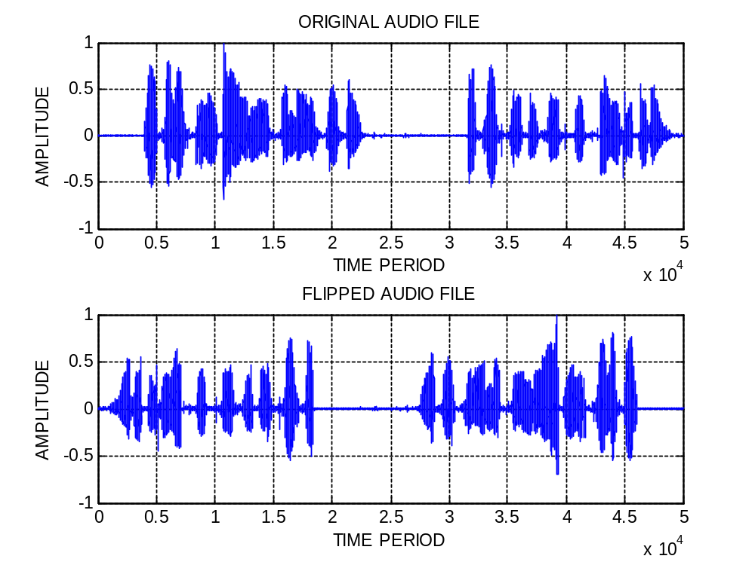

RESULT:
The original signal is played in reverse order and saved in a different file.
The plot has been successfully studied.

