EXPERIMENT NO. 1

AIM: Write a MATLAB program to load, display, and play back Audio files.

TOOL USED: MATLAB 11
THEORY:
Audio signals are generally referred to as signals that are audible to humans. Audio signals usually come from a sound source which vibrates in the audible frequency range. The vibrations push the air to form pressure waves that travels at about 340 meters per second. Our inner ears can receive these pressure signals and send them to our brain for further recognition.
There are numerous ways to classify audio signals. If we consider the source of audio signals, we can classify them into two categories:
- Sounds from animals: Such as human voices, dog's barking, cat's mewing, frog's croaking. (In particular, Bioacoustics is a cross-disciplinary science, which investigates sound production and reception in animals.)
- Sounds from non-animals: Sounds from car engines, thunder, door slamming, music instruments, etc.
If we consider repeated patterns within audio signals, we can classify them into another two categories:
- Quasi-periodic sound: The waveforms consist of similar repeated patterns such that we can perceive the pitch. Examples of such sounds include monophonically playback of most music instruments (such as pianos, violins, guitars, etc) and humans singing/speaking.
- Aperiodic sound: The waveforms do not consists of obvious repeated patterns so we cannot perceive a stable pitch. Examples of such sounds include thunder pounding, hand clapping, unvoiced part in a human's utterance, and so on.
In principle, we can divide each short segment (also known as frame, with a length of about 20 ms) of human's voices into two types:
- Voiced sound: These are produced by the vibration of vocal cords. Since they are produced by the regular vibration of the vocal cords, you can observe the fundamental periods in a frame. Moreover, due to the existence of the fundamental period, you can also perceive a stable pitch.
- Unvoiced sound: These are not produced by the vibration of vocal cords. Instead, they are produced by the rapid flow of air through the mouse, the nose, or the teeth. Since these sounds are produced by the noise-like rapid air flow, we can not observe the fundamental period and no stable pitch can be perceived.
It is very easy to distinguish between these two types of sound. When you pronounce an utterance, just put your hand on your throat to see if you feel the vibration of your vocal cords. If yes, it is voiced; otherwise it is unvoiced. You can also observe the waveforms to see if you can identify the fundamental periods. If yes, it is voiced; otherwise, it is unvoiced.
Audio coding algorithms are used to obtain compact digital representations of high-fidelity (wideband) audio signals for the purpose of efficient transmission or storage. Audio signals can be implemented on MATLAB software with an extension “.wav”. An audio signal can be represented in time domain by sketching signal on time v/s amplitude axis.

ALGORITHM FOLLOWED:

1. Select an audio file with “.wav” extension.
2. Write the MATLAB code to read that audio file.
3. Find the sampling rate and number of bits used to represent a sample.
3. Plot the audio signal in time domain.
4. Play and listen the audio signal at standard sampling rate.

RESULT:
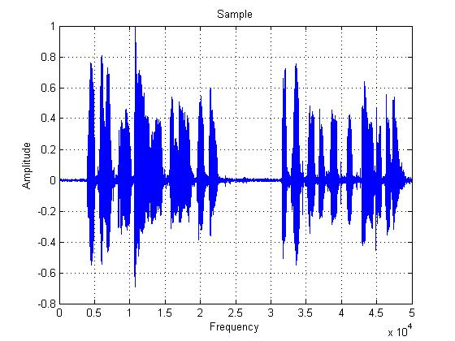
The sampling rate and number of bits used to represent a sample of an audio signal are calculated. The audio file is loaded, displayed and played successfully.

