EXPERIMENT NO. 3

AIM: Up-sampling and down-sampling of audio file and its effect in perceptual properties.

TOOL USED: MATLAB 11
THEORY:
Down sampling by an integer:
In signal processing, down sampling (or "sub sampling") is the process of reducing the sampling rate of a signal. This is usually done to reduce the data rate or the size of the data.
Let “M” denote the down sampling factor.
- Filter the signal to ensure that the sampling theorem is satisfied. This filter should, theoretically, be the sinc filter with frequency cutoff at Π/M. Let the filtered signal be denoted g(k).
- Reduce the data by picking out every sample: h(k)=g(Mk). Data rate reduction occurs in this step.
Up sampling by an integer:
Up sampling is the process of increasing the sampling rate of a signal. For an aesthetically pleasing up sample, an interpolation filter is required.
Let L denote the up sampling factor.
- Add L-1 zeros between each sample in f(k). Or, equivalently define
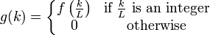
- Filter with a low-pass filter which, theoretically, should be the sinc filter with frequency cut off at Π/L.
STEPS FOLLOWED:

1. Read the given audio signal.
2. Get the values of its sampling rate and bit resolution.
3. Perform down sampling by integer 2.
4. Write the down sampled signal.
5. Plot the down sampled signal
6. Perform up sampling by integer 3
7. Write the up sampled signal.
8. Plot the graph for up sampled signal.

RESULT:
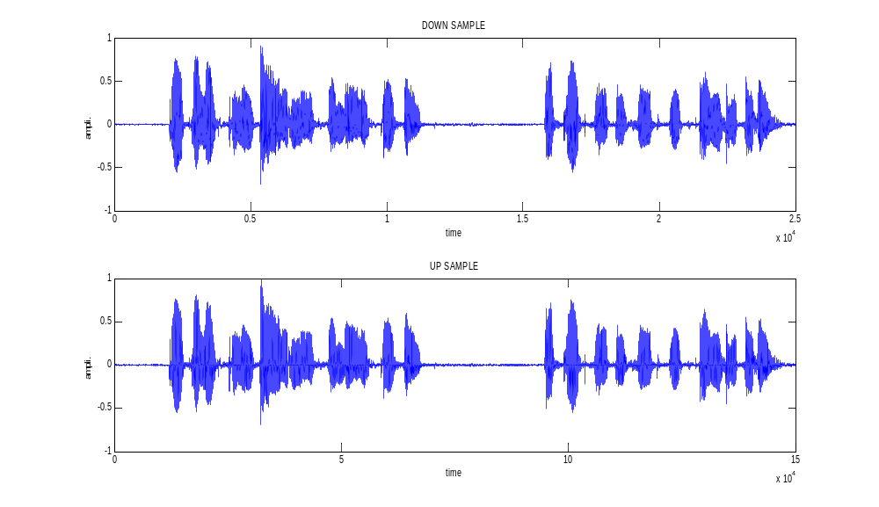
Up sampling and down sampling of an audio signal has been successfully observed and studied.

