Motion estimation is an important part of any video processing system. In this chapter, we are only concerned with the estimation of 2D motion.

Also, 2D motion estimation itself has a wide range of applications, including video compression, video sampling rate conversion, video filtering, etc.

Depending on the intended applications for the resulting 2D motion vectors, motion estimation methods could be very different. For example, for computer vision applications, where the 2D motion vectors are to be used to deduce 3D structure and motion parameters, a sparse set of 2D motion vectors at critical feature points may be sufficient.

On the other hand, for video compression applications, the estimated motion vectors are used to produce a motion-compensated prediction of a frame to be coded from a previously coded reference frame. The ultimate goal is to minimize the total bits used for coding the motion vectors and the prediction errors.

There is a trade-off that one can play between the accuracy of the estimated motion, and the number of bits used to specify the motion. Sometimes, even when the estimated motion is not an accurate representation of the true physical motion, it can still lead to good temporal prediction and in that regard is considered a good estimate.
All the motion estimation algorithms are based on temporal changes in image intensities (more generally color). In fact, the observed 2D motions based on intensity changes may not be the same as the actual 2D motions. To be more precise, the velocity of observed or apparent 2D motion vectors are referred to as optical flow.

Optical flow can be caused not only by object motions, but also camera movements or illumination condition changes.

Optical Flow

2D Motion vs. Optical Flow

The human eye perceives motion by identifying corresponding points at different times. The correspondence is usually determined by assuming that the color or brightness of a point does not change after the motion. It is interesting to note that the observed 2D motion can be different from the actual projected 2D motion under certain circumstances. Figure 6.1 illustrates two special cases.

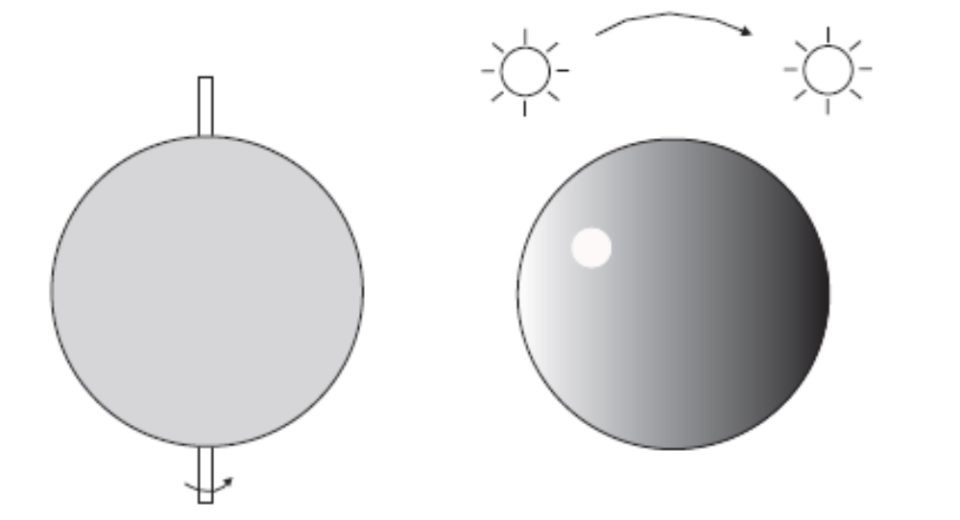

In the first example, a sphere with a uniform at surface is rotating under a constant ambient light. Because every point on the sphere reflects the same color, the eye cannot observe any change in the color pattern of the imaged sphere and thus considers the sphere as being stationary.

In the second example, the sphere is stationary, but is illuminated by a point light source that is rotating around the sphere. The motion of the light source causes the movement of the reflecting light spot on the sphere, which in turn can make the eye believe the sphere, is rotating. The observed or apparent 2D motion is referred to as optical flow in computer vision literature.

The above examples reveal that the optical flow may not be the same as the true 2D motion. When only image color information is available, the best one can hope to estimate accurately is the optical flow.

Optical Flow Equation and Ambiguity in Motion Estimation

Consider a video sequence whose luminance variation is represented by Ψ(x, y,t). Suppose an imaged point (x,y) at time t is moved to (x+dx , y+dy) at time t+dt.

Under the constant intensity assumption introduced the images of the same object point at different times have the same luminance value. Therefore,

Using Taylor's expansion, when dx, dy, dt are small, we have

Combining Eqs. (6.1.1) and (6.1.2) yields

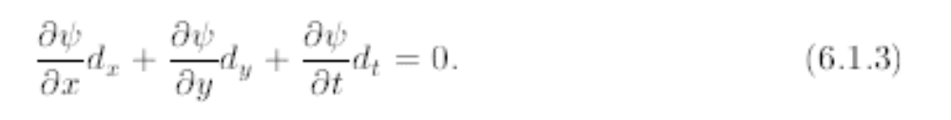

The above equation is written in terms of the motion vector (dx, dy). Dividing both sides by dt yields

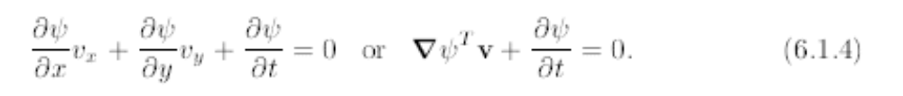

where (vx,vy) represents the velocity vector,

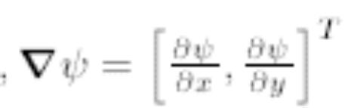

is the spatial gradient vector of (x, y, t). In arriving at the above equation, we have assumed that dt is small, so that vx = dx / dt , vy = dy / dt. The above equation is commonly known as the optical flow equation.

