Sampling of Video Signals

The two spatial dimensions and the temporal dimension are not symmetric in that they have different characteristics and that the visual sensitivities to the spatial and temporal frequencies are different. Although a video signal is continuously varying in space and time, cameras of today cannot capture the entire signal continuously in all three dimensions. Most movie cameras sample the video in the temporal direction, and store a sequence of
analog video frames on films.

In designing a video sampling system, two
Questions to be answered are:
- What is the necessary sampling rate for video?
- Which sampling lattice is the most efficient under a given total sampling rate?

Required Sampling Rates

The very first and fundamental question one needs to answer when designing a video Sampling system, either in 1D, 2D or 3D, is what should be the spatial and temporal sampling resolutions. This is governed by several factors
- the frequency content of the underlying signal,
- visual spatial and temporal cut-off frequencies
- the capture and display device characteristics,
- The affordable processing, storage, and transmission cost.

- Based on the sampling theorem, the sampling rate in each dimension should be at least twice of the highest frequency along that direction. we know that human being cannot observe spatial and temporal variations beyond certain high frequencies. Given that the maximum frequency in the signal could vary significantly, the visual cut-off frequencies, which are the highest spatial and temporal frequencies that can be observed by the HVS( Human Visual system) Should be the driving factor in determining the sampling rates for video. There is no need to accommodate frequency components beyond these values.

- The visual sensitivity depends on the mean-brightness of the display. For TV signals, which are very bright, the visual temporal and spatial thresholds call for a frame rate of over 70 Hz, and a spatial resolution of at least 30 cpd (cycles per degree). At a normal viewing distance of 3 times the screen height, a spatial frequency of 25 cpd translates to about 500 line/frame.

- To sample each line, the horizontal sampling interval should approximately match the vertical interval, so that the resulting pixels are square This leads to about 670 pixel/line for a display with 500 lines and an IAR( image aspect ratio) of 4:3.

- In order to reduce the data rate and consequently the cost for video capture, transmission, and display, interlaced scan was developed, which trades-off the vertical resolution for increased temporal resolution, for a given total data rate (product of the frame rate and line rate).

- For example, in the NTSC analog TV system, 60 fields are captured per second, but each field contains only half the desired number of lines (480/2 active line/field). The total data rate is the same as that with a progressive scan using 30 frame/s and 480 line/frame. By interlacing the lines scanned in each field, it can produce the same quality as a progressive scan using 60 frame/second and 480 line/frame if the underlying scene is stationary.

- But for a high motion scene with special patterns (vertical line patterns), it can lead to the notorious interlacing artifact." The next generation digital TV systems can operate in either the 30 frame/s and 480 line/frame mode, or the 60 field/s and 240 line/field mode.

- The interlaced format is retained mainly for compatibility with the analog TV system.

- The HDTV systems further enhance the visual impact by employing a wider screen size with an IAR of 16:9, and a sampling resolution of 60 frame/s, and 720 line/frame.

- Again, for compatibility purpose, an interlaced format with 60 field/s and 540 line/field can also be used.

- For movies, because of the reduced visual sensitivity in a movie theater where the ambient brightness is kept low, a frame rate of 24 fps (progressive) is usually sufficient. Although the original movie is captured at 24 fps, but when a rotating blade played back, is placed before the projection lens which rotates 3 times per frame, so that the effective playback rate is 72 fps. This is to suppress the flicker artifacts that may be experienced by some acute viewers.

- Old movies are made using a screen IAR of 4:3. For more dramatic visual impact, newer movies are usually made with a IAR of up to 2:1.

- For computer displays, much higher temporal and spatial sampling rates are needed. For example, a SVGA display has a frame rate of 72 fps (progressive) and a spatial resolution of 1024x720 pixels. This is to accommodate the very close viewing distance (normally between 1 and 2 times of the picture height) and the high frequency content of the displayed material (line graphics and text).

Sampling Video in 2D: Progressive vs. Interlaced Scans

Sampling Video in 2D: Progressive vs. Interlaced Scans

We have described the mechanism for raster scan, including both progressive and interlaced scans. It should be clear now that a video raster is actually a sampled version of a 3D video signal in the temporal and vertical directions.

As already hinted, the motivation for using the interlaced scan is to trade off the vertical resolution for an enhanced temporal resolution, given the total number of lines that can be recorded within a given time.

In this section, we attempt to gain more insights to the artifacts associated with these two sampling schemes by analyzing their aliasing patterns in the spectral domain.
To ease the discussion, we ignore the horizontal direction, and consider the video signal as a 2D signal in the space spanned by the temporal and vertical directions.

Let Δt present the field interval and Δy the line interval. Then the sampling lattices employed by the progressive and interlaced scans are as shown in Fig. 3.6(a) and 3.6(b), respectively.

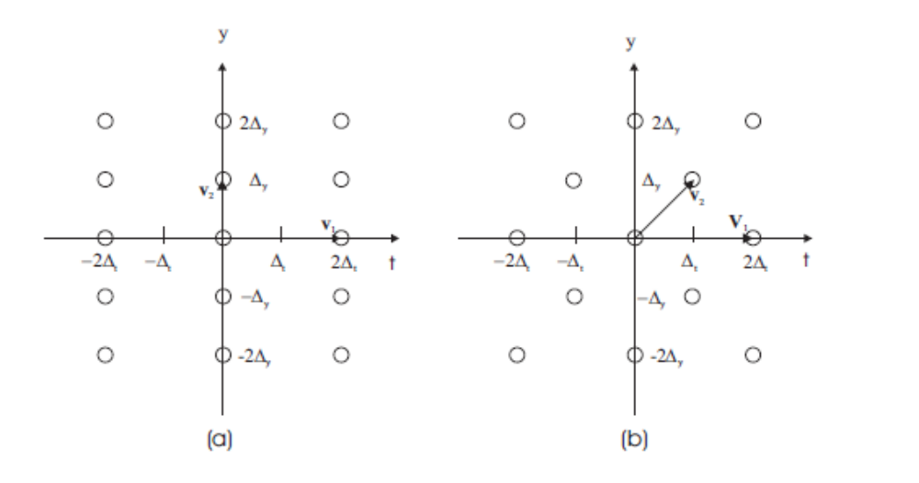

In these figures, we also indicate the basis vectors for generating each lattice. From these basis vectors, we derive the following generating matrices for the original lattices and the reciprocal lattices:

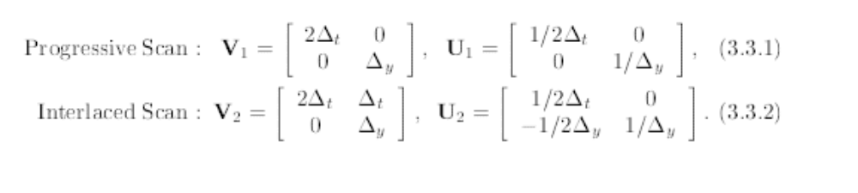

Based on the matrices U1 and U2; we draw the reciprocal lattices in Figs. 3.6 (c) and (d), in which we have highlighted the three points (filled circles) which are nearest to the origin in the first quadrant of the frequency plane. These are the centers of the alias components that are closest to the original signal spectrum, and are the primary causes for perceivable distortion.

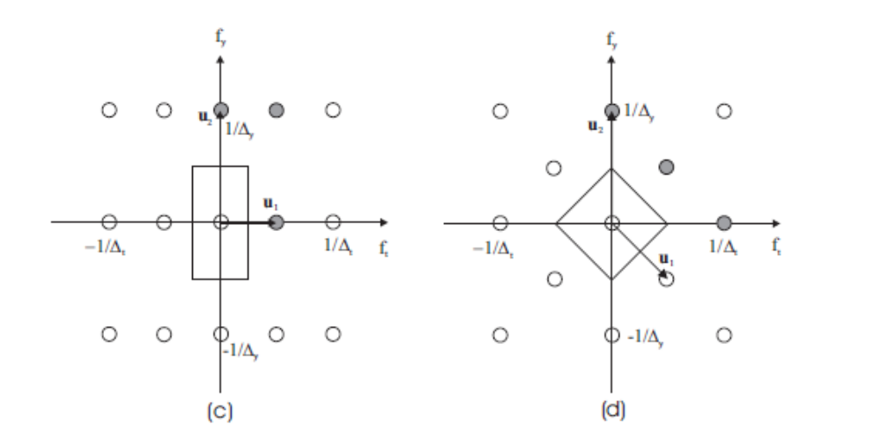

Note that when drawing the above lattices, we have scaled the spatial and temporal dimensions so that a spatial frequency equal to the vertical sampling rate fs;y = 1/Δy is assigned the same length as a temporal frequency equal to the field rate fs;t = 1/Δt. Similarly, the spatial interval Δy and the temporal interval Δt are given the same length.

Ideally, we would like to equate the temporal and spatial
frequencies based on the visual sensitivity, by assigning the same length to the spatial and temporal cut-off frequencies.

Because the spatial and temporal sampling rates are usually chosen based on the respective cut-off frequencies, equating the sampling frequencies in different directions is in general appropriate.

Comparing the original and reciprocal lattices of these two scans, we arrive at
the following observations:

- They have the same sampling density, i.e., d1(Λ) = d2(Λ) = 1/2 Δt Δy
- They have the same nearest aliases, at 1/Δy along the vertical frequency axis. This means that in the absence of motion, the two sampling lattices have the same vertical resolving power. This is because although there is only half the number of lines in each field, when the imaged scene is stationary; the lines sampled in two separate field times appear as if they were sampled at the same time. When there is motion in the scene, however, the vertical resolution of
the interlaced scan is lower than that of the progressive scan.

3. They have different nearest aliases along the temporal frequency axis. For the progressive scan, the first alias occurs at 1/2Δt, while for the interlaced
scan, this occurs at 1/Δt.

4. They have different mixed aliases. The mixed alias is defined as the nearest off-axis alias component. A frequency component that is close to the mixed alias causes inter-line flicker and line crawl. For the progressive scan, the mixed alias occurs at (1/2 Δt , 1/ Δy ), while for the interlaced scan, this occurs at (1/2 Δt , 1/2 Δy ). Because the interlaced scan has a mixed alias that is closer to the origin, the inter-line flicker and line crawl artifacts are more visible in interlaced scans. These are the notorious interlacing artifacts.

