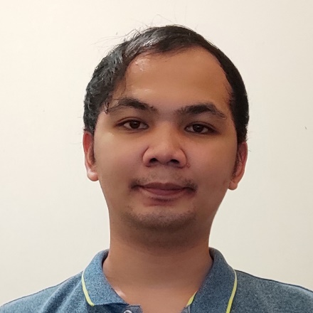**Engr. ALVIN E. GARIN, ECE**

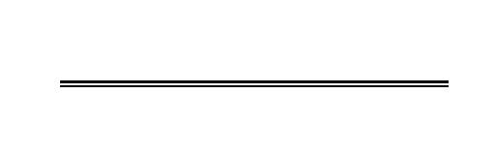7 Ilaya Street Alabang Muntinlupa City

09321242045

garin.alve@gmail.com

**OBJECTIVE:**

To obtain a position as developer in a company that will allow my knowledge and skills to further grow while working in my field of interest and while benefitting the company.

**PERSONAL BACKGROUND:**

Age : 29 years old

Birthdate : December 4, 1993

Birth Place : Mapandan, Pangasinan

Civil Status : Single

Nationality : Filipino

Religion : Roman Catholic

Language/Dialect Spoken : English, Filipino and Pangasinan

**EDUCATIONAL ATTAINMENT:**

**Tertiary:** **Bachelor of Science in Electronics Engineering**

Colegio de Dagupan

Arellano Street, Dagupan City

2011-2016

**SKILLS AND ABILITIES:**

* Able to operate and perform basic repairs of Eagle Test System.
* Able to operate and perform basic repairs of TEL Precio Octo, P8 and P8xl probers.
* Basic knowledge of using batch, HTML, Python.
* Able to perform minor program modification used in Eagle Test System
* Able to perform hardware component level debugging.
* Able to use galaxy/mentor software for data analysis.
* Able to use O+ software for data gathering and analysis.
* Computer literate and able to use Microsoft office software.
* Capable of working independently or as part of a team
* Ability to work under pressure and willing to be trained.

**WORK EXPERIENCE:**

**Allegro Microsystems Philippines Inc.**

Sun Valley Paranaque City

**Probe Engineer**

May 2020– Present

* Check and help update process documents.
* Provide line sustaining support
* Update and/or correct process records
* Check possible program related issues
* Interacts with other group to resolve line issues
* Generates daily,weekly and monthly reports.
* Performs data gathering and analysis
* Improvement projects
* Perform repairs of Eagle test system and TEL Prober
* Debug device to system limitations
* Check test programs for possible improvements for system compatibility issues.

**Probe Technician**

October 2017 – May 2020

* Performs setup and repairs.
* Troubleshoot Eagle Test Systems
* Troubleshoot Precio octo , P8 and P8xL probers.
* Validates rejects.
* Performed hardware qualifications.
* Performs data gathering

**AMKOR TECHNOLOGY PHILIPPINES INC.**

Cupang, Muntinlupa City

**Apprentice Engineer**

February 28, 2017- July 28, 2017

* SEMICONDUCTOR FRONT-OF-LINE NCII CERTIFICATION

Trained on semiconductor front-of-line assembly on die bonder machine ASM 8912AD

**MOOG CONTROLS CORPORATION**

Loakan Road, Baguio City

**ON-THE-JOB TRAINEE**

April 06, 2015 - May 22, 2015

* Assigned at Calibration Department to assist in calibration of tools and monitor incoming and outgoing gauges.

**AWARDS AND ACHIEVEMENTS:**

|  |  |
| --- | --- |
| **BOARD PASSER ECE BOARD EXAM**  October 2016 | **PARTICIPANT**  **35th IECEP Inter-Scholastic Quiz Show**  SM Aura, Taguig City  November 2014 |
| **CHED FULL-MERIT SCHOLAR**  Colegio de Dagupan  2011-2016 | **9th Northern Luzon Electronics Engineering Quiz Show Champion**  Saint Louis University, Baguio City  September 2014 |

**SEMINARS ATTENDED:**

|  |  |
| --- | --- |
| **FIBER OPTICS: THE FUTURE OF INTERNET**  Colegio de Dagupan  Arellano Street Dagupan City  March 26, 2015 | **INDUSTRIAL CONTROL AND AUTOMATION ANDBIOMEDICAL**  **ELECTRONICS**  Colegio de Dagupan  Arellano Street Dagupan City  March 17, 2014 |

*I hereby certify that the above information is true and correct to the best of my knowledge.*



**ALVIN E GARIN**

*Applicant*