Late functional gain after drug-coated balloon angioplasty: First evidence of progressive physiological improvement

Late functional gain after DCB in native vessels

**Rayane Mohand Saidi1, Juan F. Iglesias MD2, Diego Arroyo MD1, Julius Jelisejevas1, Charles Seydoux MD3, Wesley Bennar1, Pascal Meier MD1, Mario Togni MD1,3, Stéphane Cook MD1,3, Dorian Garin MD1**

1Department of Cardiology, University and Hospital Fribourg, 1708 Fribourg, Switzerland

2Cardiology, Geneva University Hospitals, 1211 Geneva, Switzerland

3Cardiology, Cecil Clinic Hirslanden, 1007 Lausanne, Switzerland

**Correspondence:** Dorian Garin, MD  
Cardiology  
University and Hospital Fribourg  
CH- 1708 Fribourg  
Phone: +41263062488  
Email: dorian.garin@icloud.com

**Keywords:** µQFR, coronary physiology, drug-coated balloon, coronary artery disease

**Word count:** 788

**Figures:** 1

**Tables:** 0

Dear Editor,

Drug-coated balloon (DCB) angioplasty demonstrates the unique phenomenon of late lumen enlargement (LLE) whereby vessel dimensions increase over time without permanent scaffolding [1]. While this anatomical finding is well-documented, the temporal evolution of coronary physiology after DCB treatment remains incompletely understood. Previous studies showed fractional flow reserve improves from baseline to post-procedure and remains stable at follow-up [2,3], but no study has demonstrated actual functional improvement from post-procedure to follow-up. We present the first evidence of late functional gain (LFG), defined as progressive physiological improvement after completion of the index procedure, in patients undergoing DCB angioplasty for de novo coronary disease.

This cohort study analyzed consecutive patients who underwent DCB treatment for de novo coronary lesions between January 2018 and December 2024 from the CARDIO-FR registry (NCT04185285). Inclusion criteria comprised patients aged ≥18 years with available baseline, post-procedural, and follow-up coronary angiography performed ≥7 days after the index procedure. Murray’s law-based quantitative flow ratio (μQFR) assessment was performed using AngioPlus Gallery (Pulse Medical Imaging Technology, Shanghai, China) by two independent blinded analysts. DCB procedures followed standard institutional protocols with lesion preparation at operator discretion. Balloon diameter was selected to achieve a balloon-to-vessel ratio between 1.0 and 1.25. LFG was defined as the positive difference between follow-up and post-procedural μQFR. Statistical analyses employed paired t-tests for temporal comparisons and regression analyses for predictor identification.

Among 132 angiograms (66 de novo lesions in 59 patients; mean age 70.1±8.2 years, 22.0% female, 37.3% diabetic), lesion preparation included semi-compliant balloons (88.0%), non-compliant balloons (62.0%), cutting balloons (28.8%), and intravascular lithotripsy (5.1%). Sirolimus-coated balloons were used in 77.2% of procedures.

At median follow-up of 8.5 months, target lesion failure (TLF) occurred in 14 lesions (21.2%). The primary finding was significant LFG: μQFR improved from 87.5±9.1% post-procedure to 89.8±7.0% at follow-up, representing a mean change of 2.3% (95% CI 0.08-4.68; p=0.006). Thirty lesions (60.0%) demonstrated functional gain. After excluding TLF, LFG was 3.5% (95% CI 1.46-6.15; p=0.002). LLE showed an overall change of -0.04±0.50 mm (p=0.62), but when excluding TLF, significant LLE of +0.10±0.30 mm was observed (95% CI 0.01-0.18; p=0.028).

Higher DCB diameter-to-vessel ratio and longer inflation time predicted functional improvement (+1.27%/0.1 ratio increase, p=0.015; +0.41%/second, p=0.011). The predilatation diameter-to-vessel ratio emerged as the strongest binary predictor (OR 17.23; p=0.006), followed by DCB diameter-to-vessel ratio (OR 14.38; p=0.011). Continuous optimization analysis identified an optimal DCB-to-artery ratio of 1.31 (95% CI 1.03-1.45) for maximizing LFG. Lesion preparation characteristics other than diameter-to-vessel ratio, including specialty balloon type, showed no predictive value for functional improvement (all p>0.20). For LLE, only DCB inflation time predicted LLE (+0.011 mm/second; p=0.015).

This study provides the first documentation of LFG after DCB angioplasty, revealing progressive coronary physiology improvement from post-procedure to follow-up. This finding advances our understanding of DCB biology, demonstrating vessel healing extends beyond the index procedure [4]. Unlike drug-eluting stents where FFR deteriorates over time, or plain balloon angioplasty leading to functional decline, DCB achieves progressive physiological improvement through antiproliferative effects, positive vessel remodeling [1], and endothelial function restoration.

Our findings identify two procedural determinants: adequate lesion preparation creating plaque disruption for drug penetration, and optimized DCB delivery through sufficient inflation time and appropriate sizing. Current guidelines recommend DCB sizing at a 0.9-1.3 balloon-to-vessel ratio [5]; our results suggest targeting the upper range may enhance outcomes. The documentation of LFG establishes DCB as a restorative intervention achieving sustained biological vessel healing, particularly valuable where preserving physiological function is paramount.

**Figure 1. Paired analysis of minimum lumen diameter and Murray law-based quantitative flow ratio from post-procedure to follow-up.**

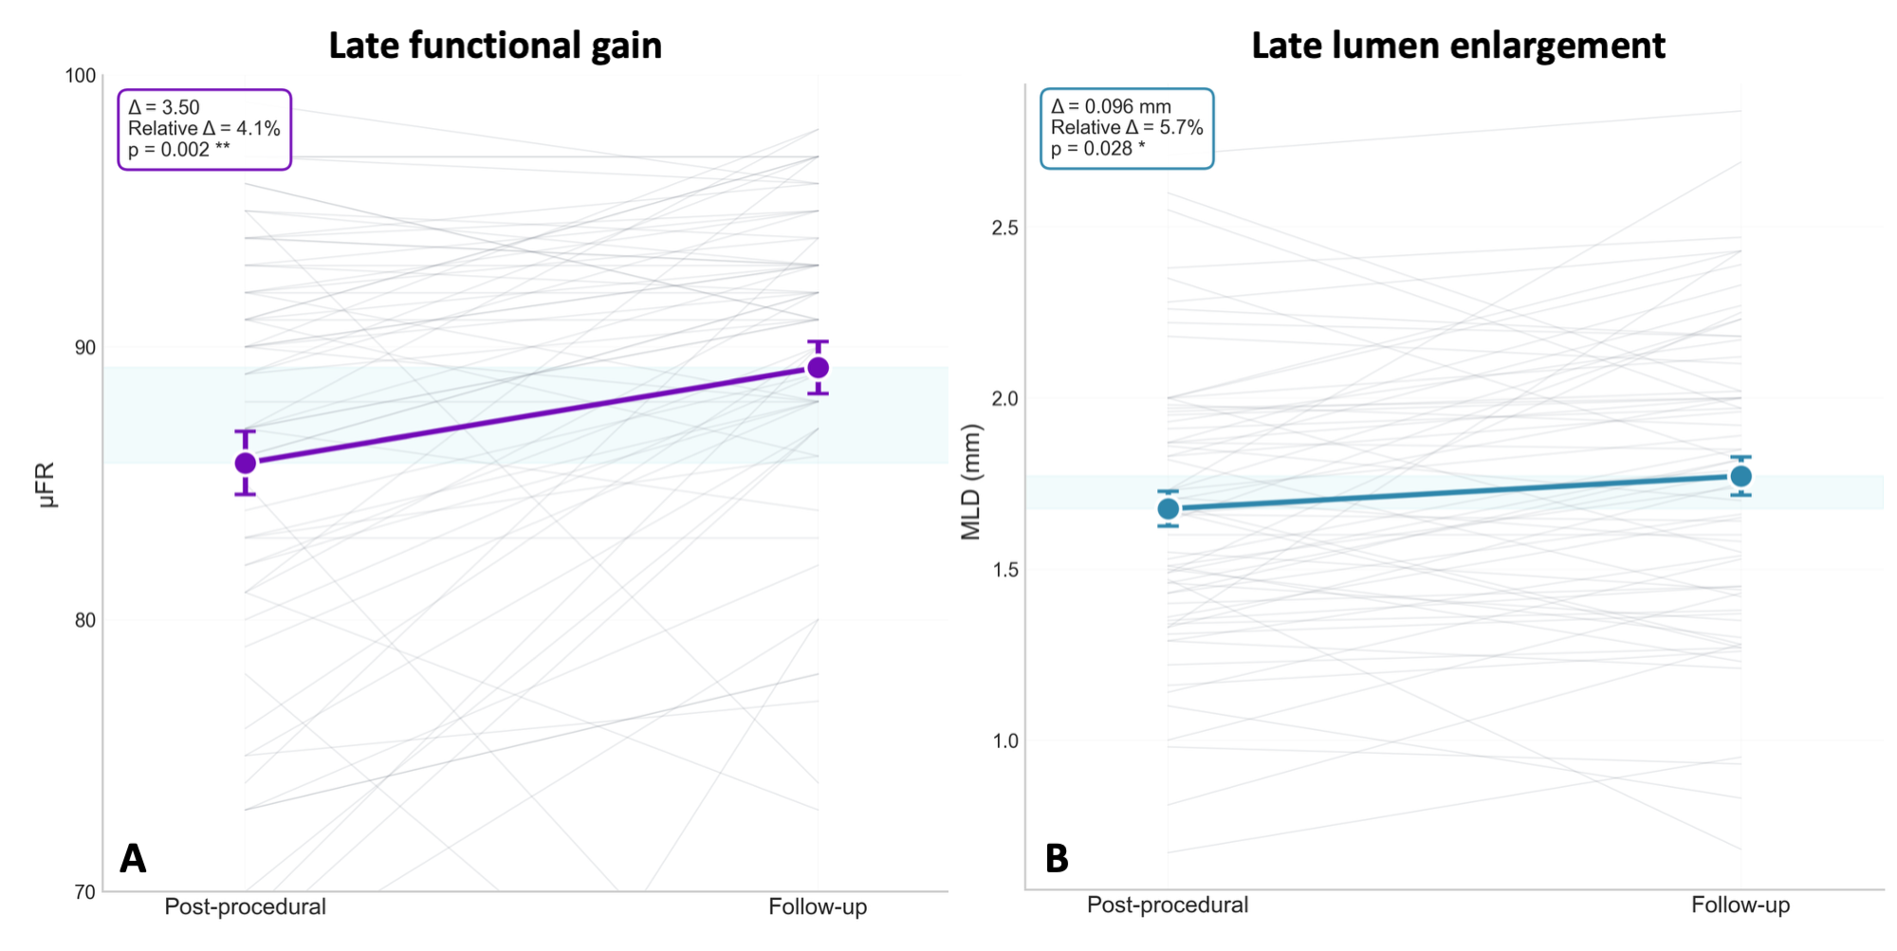

Paired analysis demonstrating temporal changes in late functionnal gain (A) and late lumen enlargement (B) at median follow-up of 8.5 months. Individual patient trajectories shown in gray lines and mean values with standard error bars shown in blue. Absolute and relative changes are displayed.

# References

[1] Kleber FX, Schulz A, Waliszewski M, et al. Local paclitaxel induces late lumen enlargement in coronary arteries after balloon angioplasty. Clinical Research in Cardiology 2015;104:217–25. <https://doi.org/10.1007/s00392-014-0775-2>.

[2] Ann SH, Balbir Singh G, Lim KH, et al. Anatomical and physiological changes after paclitaxel-coated balloon for atherosclerotic de novo coronary lesions: Serial IVUS-VH and FFR study. PLOS ONE 2016;11:e0147057. <https://doi.org/10.1371/journal.pone.0147057>.

[3] Shin E-S, Bang LJ, Jun EJ, et al. Fractional flow reserve-guided coronary angioplasty using paclitaxel-coated balloons without stent implantation: Feasibility, safety and 6-month results by angiography and optical coherence tomography. EuroIntervention 2016;12:e1004–14. <https://doi.org/10.4244/EIJV12I8A165>.

[4] Jeger RV, Eccleshall S, Wan Ahmad WA, et al. Drug-coated balloons for coronary artery disease: Third report of the international DCB consensus group. JACC: Cardiovascular Interventions 2020;13:1391–402. <https://doi.org/10.1016/j.jcin.2020.02.043>.

[5] Fezzi S, Scheller B, Cortese B, et al. Definitions and standardized endpoints for the use of drug-coated balloon in coronary artery disease: Consensus document of the Drug Coated Balloon Academic Research Consortium. European Heart Journal 2025:ehaf029. <https://doi.org/10.1093/eurheartj/ehaf029>.

# Conflict of interest

The authors declare that the research was conducted in the absence of any commercial or financial relationships that could be construed as a potential conflict of interest.

# Author contributions

RSM: writing – original draft (lead), analysis (lead). DA, JFI, WB, MT, PM, SC, JJ: writing – review & editing (equal), data curation (lead), supervision (equal). DG: writing – review & editing (lead), conceptualization (lead), investigation (lead), methodology (lead), supervision (lead).

# Funding

This study was founded by the Fond Scientifique Cardiovasculaire and Fondation Cecil de Recherche Cardiovasculaire.

# Data availability statement

The raw data supporting the conclusions of this article will be made available by the authors on reasonable request.