Agenda:
- Abstract
- Introduction and Motivation
- Basic MAR theory
- Interpretation
- Estimation
- Our workflow
- Results
- Extension - Comparing VAR and MAR

0.
Abstract
Lately, with the invention and rapid development of binary computer systems, humanity gathers and stores massive amounts of data. And it is reasonable to assume that this data is just the reflection of the way the world works. Econometrics allows us to extract and interpret such laws of universe from the data collected. The problem consists of coming up with the best model for extracting and interpreting such knowledge. And if we manage to get decent results, it will help us not only to understand why something happened in the past or happens right now but also forecast the future. This thesis explores one of the methods of extracting such knowledge from the data, specifically Matrix Autoregression (MAR) which is an extension of Vector Autoregression (VAR). Our main focus will be on understanding how MAR works, what is the math behind it, what kind of results it provides and how it is compared to VAR. For our analysis we will take dataset of sectoral employment dynamics in the US.

1.
Introduction

Explain AR

So, what is the Matrix autoregression and why do we need it? To answer this question, we have to understand the framework we’re working on and a simpler VAR model because otherwise it will be hard to get an intuitive sense in MAR.
Let’s say we would like to learn about the sectoral employment dynamics in US. Our data will consist of the number of workers in US states (like Kentucky and Illinois) in different sectors of economy (like construction or retail trade). Such data structure is called multivariate time series. It forms a 3-dimensional data structure where the first dimension is state, second dimension is sector and third dimension is time. Our goal is to examine this tensor for the presence of some pattern which later we can use for example in forecasting.
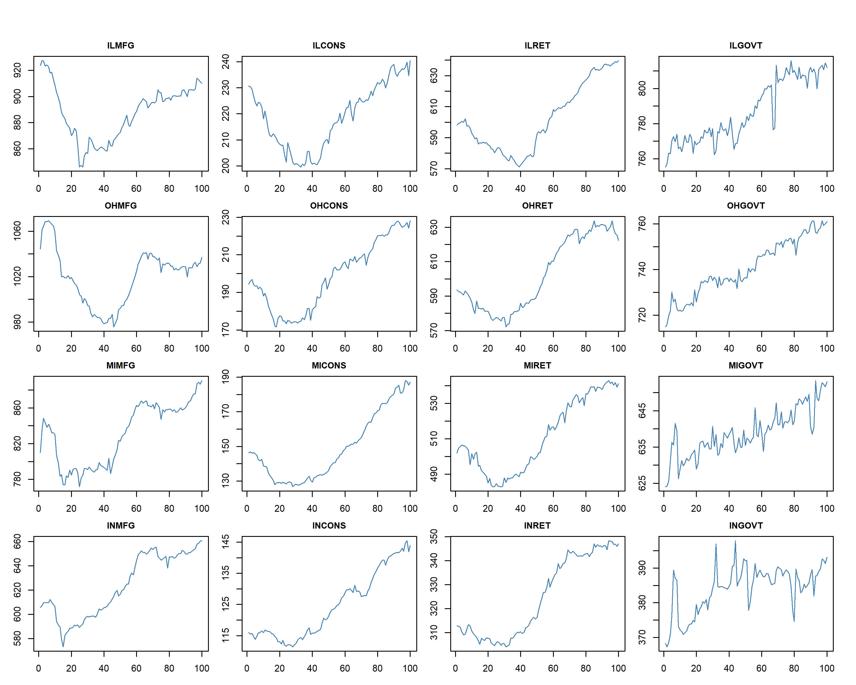
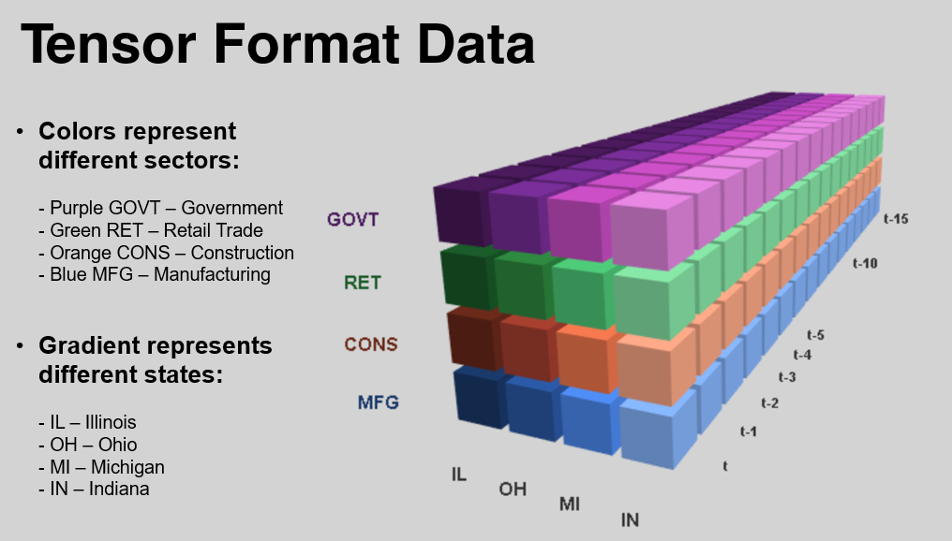 [color the tensor like a heatmap]
One of the ways to do such an examination is vector autoregression.

(Explain var).

There are multiple issues with using VAR. First of all is that the 3d matrix structure is lost, since we stack columns in a vector and analyze the vector. Second issue is the quantity of coefficients we get. For the VAR model we get m2n2 coefficients which is a lot if we decide to increase number of states or sectors.
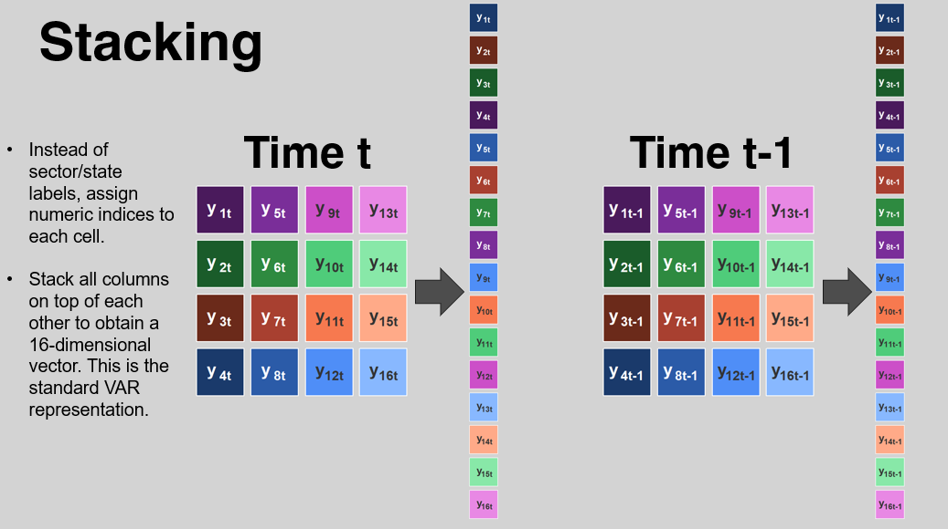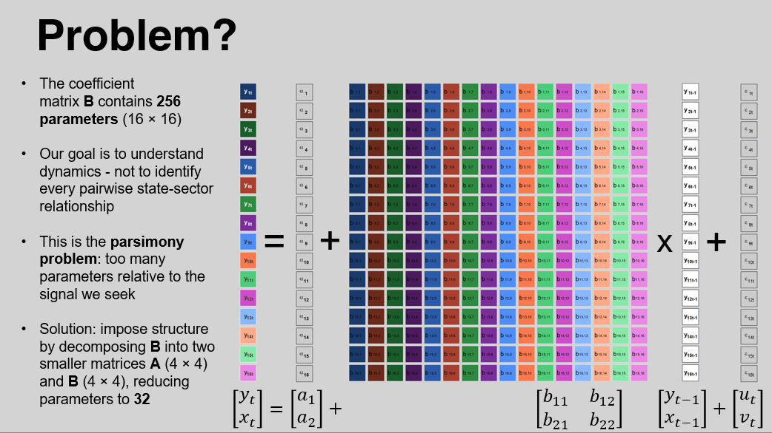
Also, a problem with VAR is that we get coefficients for every state and every sector, most of the times they will not mean anything, be zero or statistically insignificant. MAR gathers these coefficients, creating more valuable ones. Also, overfitting of VAR model is a problem and MAR may be a better approach because of that.

Thus, we introduce MAR.

2.
The Model
MAR – Matrix autoregression. Instead of transforming data to vectors we keep the matrix format and work with it directly.
Math and all other stuff…
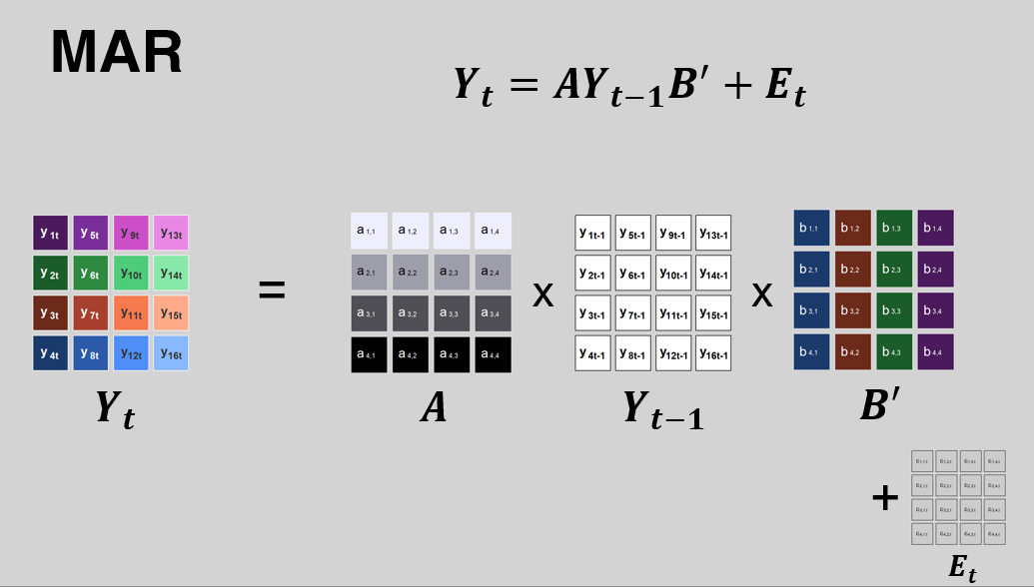
Explain what MAR is:
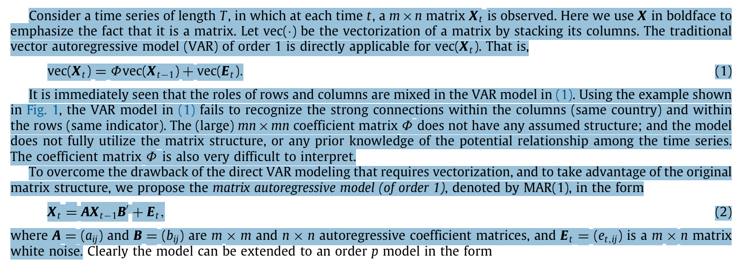
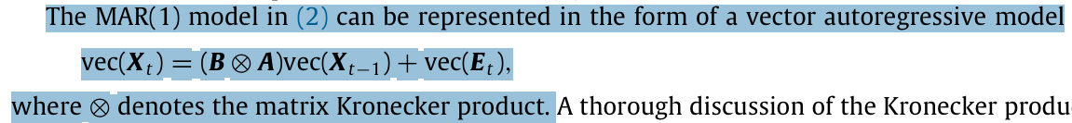

3.
Interpretation
Calculating matrices A and B is nice, but how can we interpret them?

4.
Estimation:
Projection method
Projection method basically consists of two steps. Firstly, we estimate VAR and get vector Ф. Secondly, we solve the “nearest Kronecker product” by approximating Ф^ by a Kronecker product B (X) A.
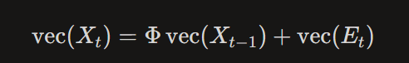

LSE
The LSE (least squares estimator) for A and B defined as the pair that minimizes the total squared Frobenius norm of the residuals.
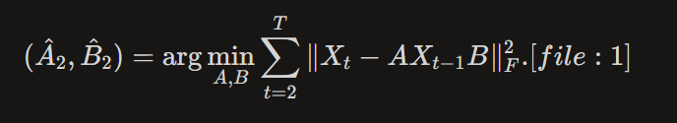

MLE
The main difference in MLE is that the covariance of vec’d errors is separable (Kronecker): row covariance $r$, column covariance $c$.
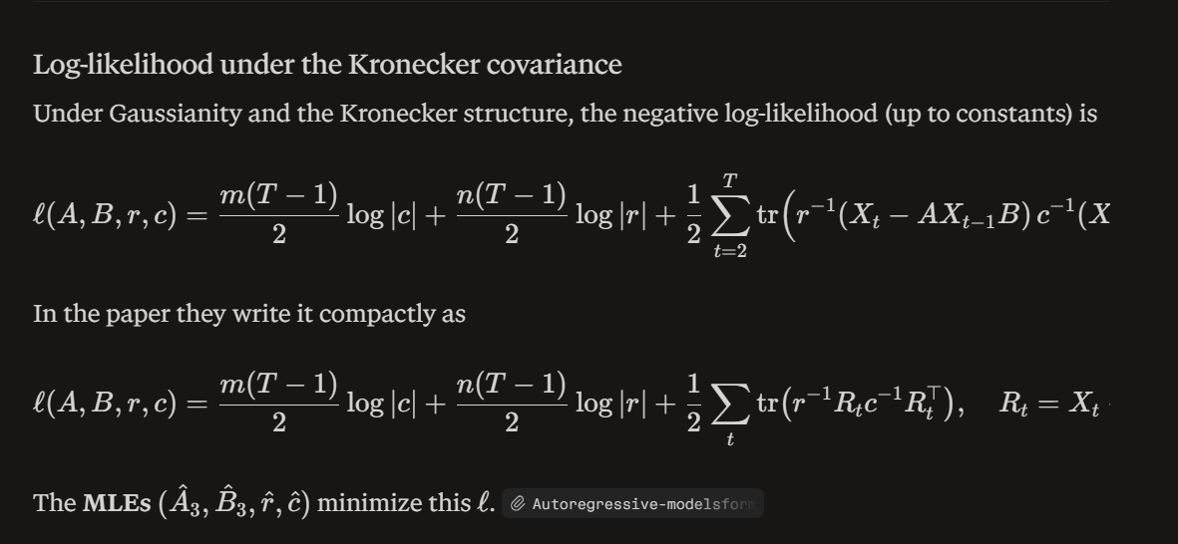

5.
Our workflow

Data preparation
In this thesis we have decided to analyze sectoral employment dynamics in the United States. Our motivation for that was that it’s easy to gather this kind of information (from FRED), it should be reliable since it comes from the burrow of statistics, and it is based on an important theme such as employment which should be more resistant from manipulative movement compared to, for example, stock prices. So, we would be able to analyze more of the nature behavior rather than someone will.
(Remove outliers?)
To prepare our data we had to make sure that its stationary, so our model would work. To achieve that we went through the process of first-differencing. After that to prove that our data is stationary we have completed the ADF test and it indeed happened to be stationary.
Then we packed data in a tensor (3d matrix) structure, so we could use the R library.

Analysis
We have analyzed the data using three mentioned methods. Here are the results.

Interpret the results.

n.
Further development
Having some results and coefficients from the MAR model is good, but how do we check whether they are actually better or worse than VAR? How can we compare MAR and VAR results? Obvious solution for that is a time series cross validation also known as backtesting.
To do that we use Frobenius norm which we used in the projection method.

Conclusion:

