**Charting:**

1. Tree Map for utilization

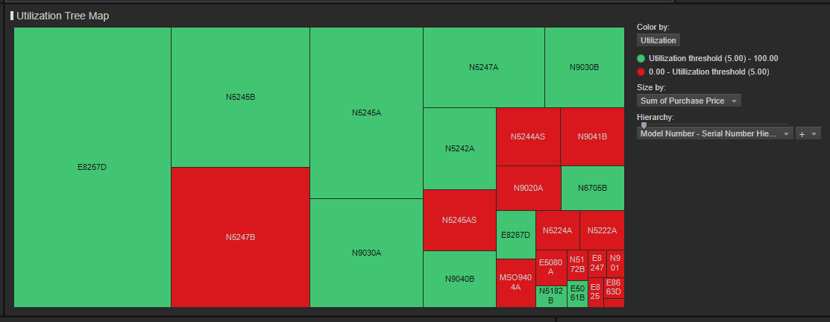

* 1. the utilization tree map where you group by model number, size by the sum of purchase price for a group (model number) and measure utilization over some period. From the data I gave you, I'd measure the utilization for the  two week period 7/13/2021 to 7/27/2021.
  2. In AA we only record the minutes when something is utilized. That means the docs.LastUpdate is not a complete listing of date time, only the times when utilized. this creates a graphing challenge in still showing the unutilized times. Solved by either filling in the data, or magical graphing tools.  Essentially, one has to count the number of rows (minutes) reported for an asset then divide by number of minutes in a reported period (60 min for an hour) to report the % utilization for that period (hour).   So if no rows for an hour, then 0% utilization. If 30 rows for an asset in an hour, then 50% utilization.

1. Bar Charts
   1. Can customer read the chart?
      1. Ability to read the Y-Axis column labels
         1. Often means option for vertical display of label.

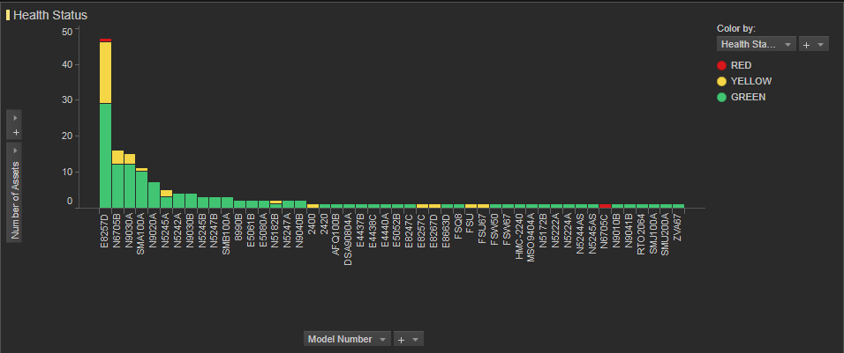

* + 1. Legends and X and Y axis labeling
    2. Title for chart
    3. Setting the appropriate number of digits of resolution for real numbers.
  1. Add reference lines for acceptable performance
     1. 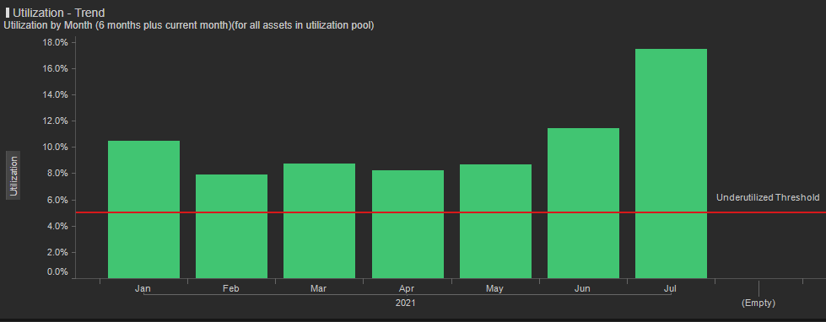
  2. Stacked bar charts, see above.
  3. Aggregation
     1. Especially over different periods of time, day, week, month, quarter, year.

1. Pie Charts
   1. <https://www.perceptualedge.com/articles/visual_business_intelligence/save_the_pies_for_dessert.pdf>
2. Gauges
   1. Charlie wanted simple gauges or thermometers when we put the dashboards together. Spotfire didn’t support, but I used a one column bar chart to approximate, with reference lines to indicate acceptable performance.
3. Health in AA
   1. Too much scrolling to find issues, in and out of individual assets.
   2. Unused parameters listed first (Acceleration)
   3. Suffers from the individual asset mentality vs portfolio of assets aggregation, to find hot spots.
   4. Lots of time to make pretty, but not functional
   5. 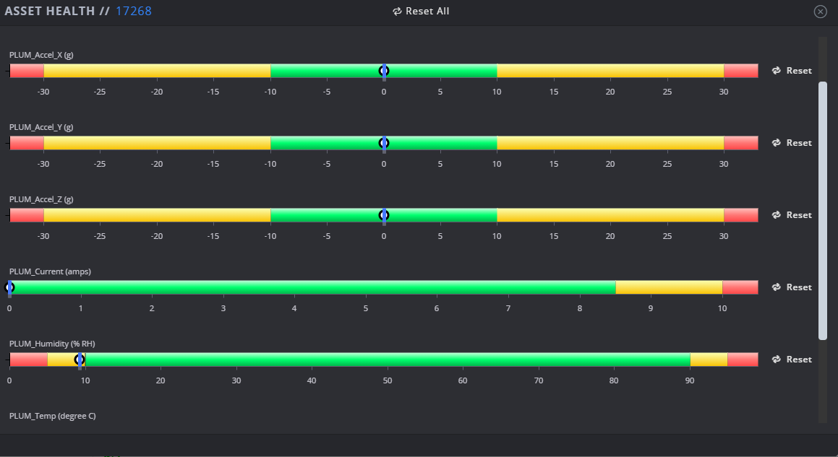
   6. Drills into scatter plot vs time for parameters of interest.
      1. 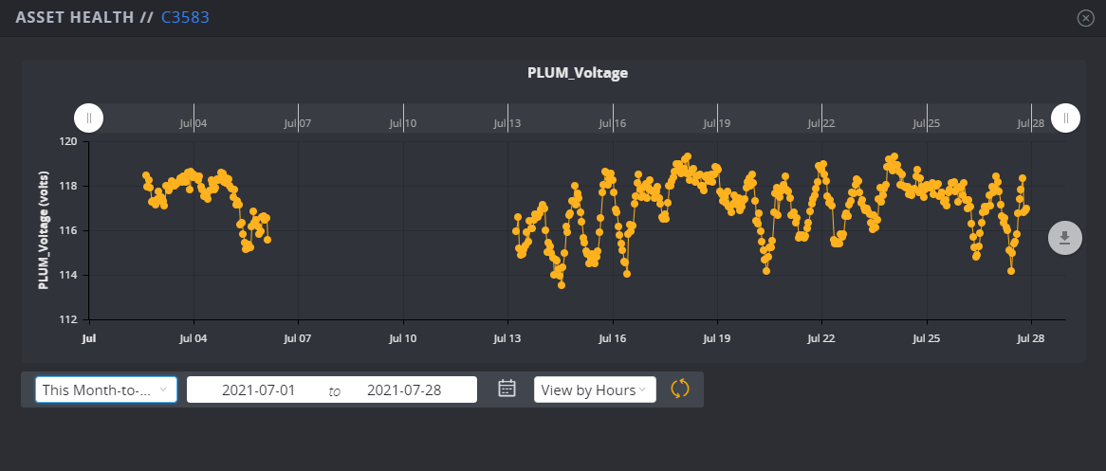
   7. My preference: Forget starting with the individual asset, start with the portfolio, and filter into the individual: Use some filtering to look at all assets with problems, then use more filtering to narrow things down. This graph, with reference lines and multiple assets tells much more, than bouncing in/out of three individual assets.
      1. 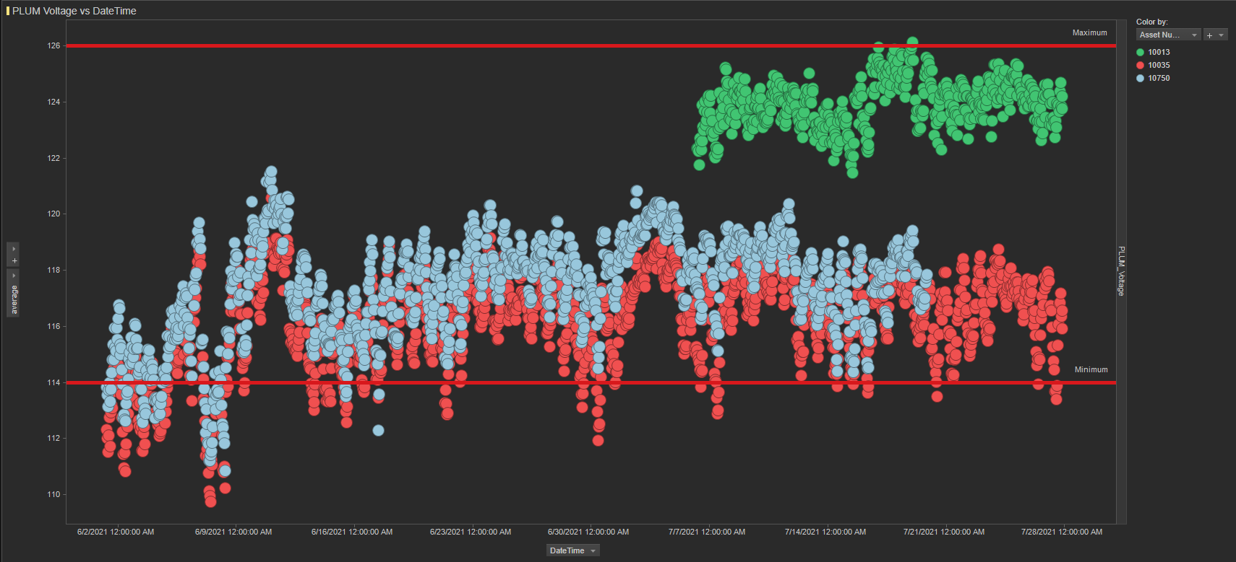
4. Utilization in AA
   1. 