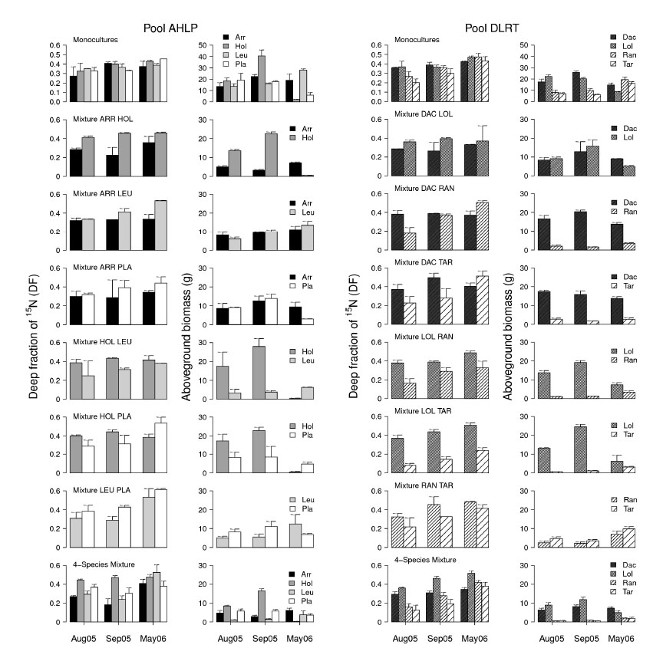

FIG. E1. Fraction of 15N uptake from deep soil (DF) and aboveground biomass per species in all monocultures and mixtures of pool AHLP (left panels) and pool DLRT (right panels). Error bars show standard errors of the mean, monocultures and 2-species mixtures: *n* = 2, 4-species mixtures: *n* = 4 for each bar. See Table 1 (in the main text) for full species names.