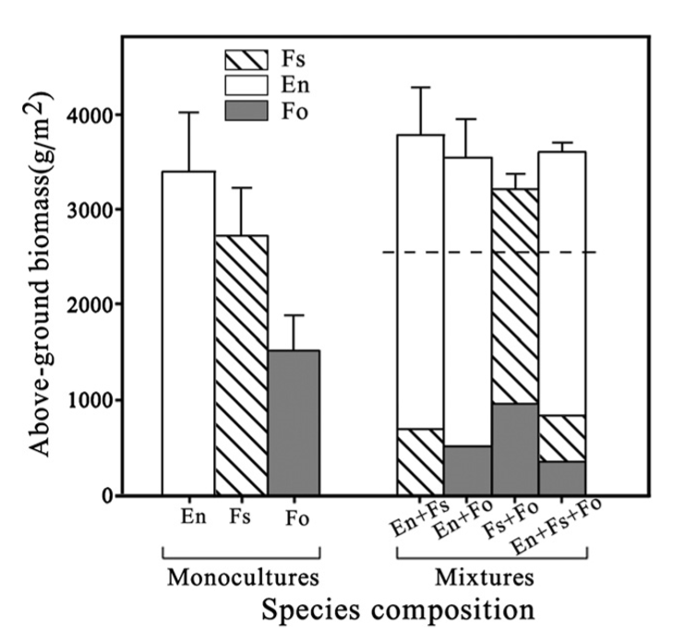

Fig. 1 Above-ground biomass in monocultures of each of the three species (Elymusnutans [En], Festucasinensis [Fs] and Festuca ovina [Fo]) and the above-ground biomass by species in the mixtures. Values are the means across the density and fertilization treatments. Error bars are the standard error. The mean biomass of the monocultures is represented by the dashed line drawn over the data from the mixtures (at 2548 g/m2).