gcloud v2
Cloud-Native Authentication & Audit Infrastructure on AWS
Mohammad Al Ahmad
github.com/garlke0/gcloud
Provisioned entirely with Terraform — no console-created resources

Contents
Contents 1
1. Project Overview 1
1.1 Why managed authentication for v2 1
1.2 What was built 1
2. Account Hardening 1
2.1 Root: MFA on, access keys none 1
2.2 Terraform identity 1
2.3 Does AdministratorAccess contradict least privilege? 1
2.4 MFA and what it does not cover 1
2.5 Verifying the identity Terraform runs as 1
3. Terraform Foundation 1
3.1 Provider pinning 1
3.2 Two similar files, opposite rules 1
3.3 Verifying authentication before building 1
3.4 Lifecycle rehearsal 1
4. Cognito 1
4.1 User pool 1
4.2 App client 1
4.3 Failure: an optional factor with no method 1
4.4 Failure: a tainted resource 1
4.5 Failure: the guardrail deadlock 1
5. KMS — the Key Policy as an Access Boundary 1
5.1 The policy is a replacement, not an addition 1
6. CloudTrail 1
6.1 Log bucket hardening 1
6.2 Bucket policy — least privilege at the resource 1
6.3 Trail settings 1
6.4 Proof that the key policy is a real boundary 1
7. IAM — Scoped Read-Only Access 1
8. Operational Lessons 1
9. Known Gaps 1

1. Project Overview
This project is deliberately split in two halves.
v1 built an authentication system by hand — Flask, PostgreSQL, Argon2id, sessions, account lockout — to understand the primitives rather than call them. It is complete, documented and published.
v2 — this document — rebuilds the same concerns on AWS managed services, and redirects the effort saved into infrastructure security: identity, key management, and audit logging, all provisioned as code.
Building the fundamentals first means every managed service I reach for afterwards is a deliberate choice, not a black box.
One principle runs through both halves: every security layer maps to a specific, named threat. More layers is not more defence — it is more attack surface unless each one earns its place.

1.1 Why managed authentication for v2
Two paths were weighed. Porting the v1 Flask application to Lambda or ECS would preserve the existing code and teach deployment. Adopting Cognito hands password storage, session issuance and lockout to AWS, and turns the project into an infrastructure and security exercise.
Cognito was chosen because it matches the actual job. Companies do not hand-roll authentication; they secure managed services. The objection — that v2 becomes infrastructure rather than application work — is the reason to do it, since v1 already covers the application side, and the resulting scope maps directly onto the AWS Solutions Architect and Security Specialty syllabi.

1.2 What was built
Component | Purpose
Cognito user pool | Password policy, TOTP MFA, account recovery, enumeration defence
Cognito app client | SRP authentication, no client secret, short token lifetimes
KMS customer-managed key | Explicit key policy acting as a second access boundary
CloudTrail | Multi-region API audit logging, KMS-encrypted, integrity-validated
S3 log bucket | Private, versioned, narrowly scoped bucket policy
IAM role | Read-only trail access through temporary credentials

2. Account Hardening
Nothing was built until the account itself was defensible. Four things came first: MFA on the root user, removal of root access keys, a scoped IAM user for Terraform, and a zero-spend budget alarm.

2.1 Root: MFA on, access keys none
The root user cannot be restricted. No IAM policy applies to it, its permissions cannot be scoped down, and there is no fast revoke path if its credentials leak — recovery runs through the account email and can take days. That is the entire argument for never using it day to day.
A root access key is the worst credential shape in AWS: full account power, no policy can deny it, and it sits in a plaintext file the moment the CLI is configured. One was created during setup and deleted immediately.
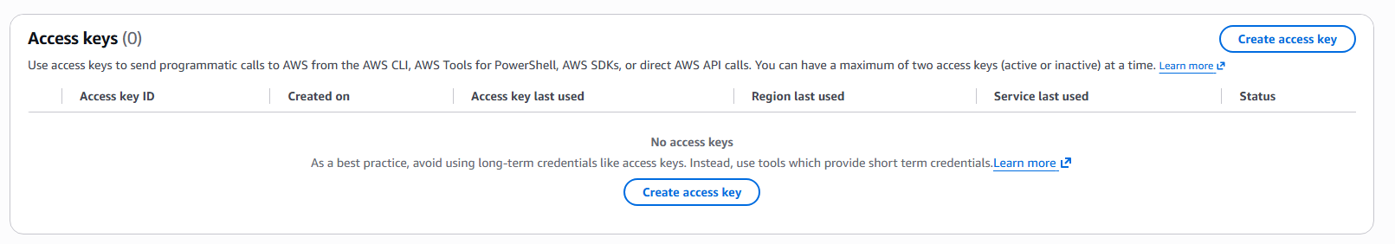
Figure 1 — Root access keys: none. AWS states the preference for short-term credentials directly on this screen.

2.2 Terraform identity
An IAM user, terraform-admin, was created with AdministratorAccess attached through a group rather than directly to the user. Policy attached to a group is policy attached to a role in the organisation, not to a person: when permissions are scoped down later, one attachment changes and every member inherits it. Two grant paths to the same permission would mean revoking one achieves nothing.
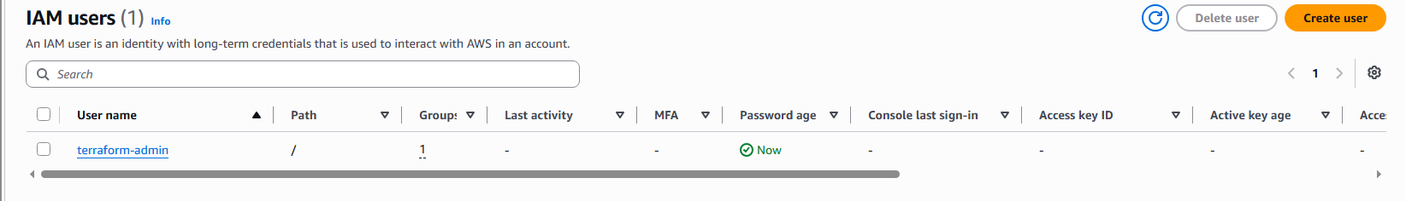
Figure 2 — The IAM users list. Note the empty Access key ID column at this stage.
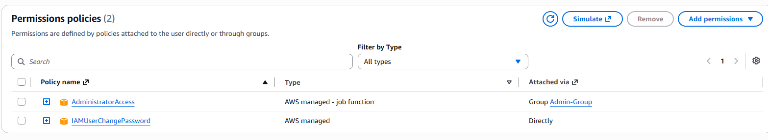
Figure 3 — AdministratorAccess attached via Admin-Group, not directly to the user.

2.3 Does AdministratorAccess contradict least privilege?
Strictly, yes. It is more permission than Terraform needs. It is acceptable as a starting point for one reason: it is revocable and auditable, and root is neither. The violation is bounded and reversible.
The distinction between root and an administrator IAM user is not service power — an admin user can launch anything root can. It is ownership of the account. Root alone can close the account, change the account email, alter the support plan, enable IAM access to billing, enable MFA Delete on S3, and recover from a total IAM lockout.
It only stays acceptable if it does not end there. On day one the exact set of API calls Terraform needs is unknown, because nothing has been built. So the method is the same one used for the Argon2id parameters in v1: measure rather than copy. Build with administrator access, read CloudTrail for the calls actually made, write a scoped policy from that evidence, and swap it in.

2.4 MFA and what it does not cover
MFA was assigned to terraform-admin as a passkey. One property is widely misunderstood and worth stating: MFA on an IAM user gates console sign-in only. It does not apply to access keys — an API call carrying an access key and secret presents no second factor, ever.
Enforcing MFA on API calls requires the aws:MultiFactorAuthPresent policy condition and MFA-backed session tokens, which breaks plain CLI configuration. This user has no console password at all, which is the better shape for an automation identity: no password, no phishing surface, nothing to rotate.
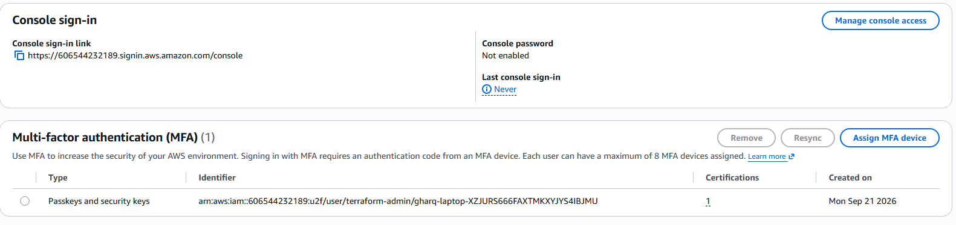
Figure 4 — Console password not enabled; MFA device assigned.

2.5 Verifying the identity Terraform runs as
Before any resource was created, the CLI profile was verified. The returned ARN is the checkpoint — if it had ended in :root, the setup would have been wrong.
aws sts get-caller-identity --profile terraform-admin
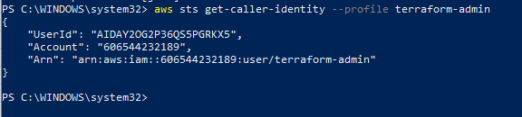
Figure 5 — The ARN ends in user/terraform-admin. The UserId begins with AIDA, a permanent identifier for the user; access key IDs begin with AKIA. The user can rotate keys without the AIDA changing, which is why IAM policies reference the ARN and not the key.

3. Terraform Foundation

3.1 Provider pinning
terraform {
required_providers {
aws = {
source = "hashicorp/aws"
version = "~> 5.0"
}
}
}

provider "aws" {
region = "ap-southeast-1"
profile = "terraform-admin"
}
The profile reference means no credentials appear in the code or in version control. The version constraint accepts any 5.x release but not 6.0, since major releases break syntax.
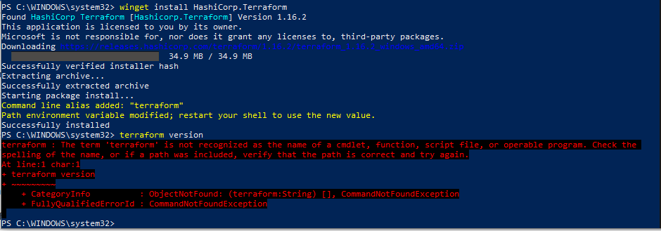
Figure 6 — terraform init. The provider is signed by HashiCorp, and Terraform states its own requirement: the lock file belongs in version control.

3.2 Two similar files, opposite rules
The lock file and the state file look alike and must be treated as opposites.
File | Contents | Committed?
.terraform.lock.hcl | Provider versions and checksums — no secrets | Yes
terraform.tfstate | Everything built, including secret values in plaintext | Never

The lock file guarantees the same provider version on any machine, and its checksum prevents a substituted provider — the same idea as the installer hash verification performed during the CLI install. State holds the secrets.
The .gitignore was written before the first .tf file, deliberately. The state file is generated automatically rather than written by hand, so it is easy not to notice — the same lesson as .env in v1, with higher stakes.
*.tfstate
*.tfstate.*
.terraform/
*.tfvars
!example.tfvars
The exception for example.tfvars exists because the real file carries actual values while the example carries only variable names, so anyone cloning the repository knows what to supply.
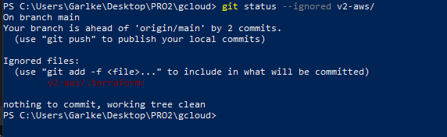
Figure 7 — .terraform/ confirmed ignored; nothing sensitive is staged.

3.3 Verifying authentication before building
terraform init downloads a plugin and never contacts AWS. terraform plan makes a real API call, which is why it was run against an empty configuration first: an authentication failure surfaces here rather than after two hundred lines of HCL.
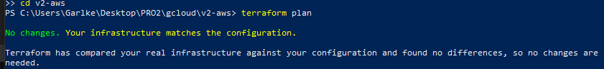
Figure 8 — Authentication verified against a configuration with no resources.

3.4 Lifecycle rehearsal
A disposable S3 bucket was created and destroyed to exercise the full plan → apply → destroy cycle on something that could not cost money or lose data. The plan output is the safety net, and its summary line is checked every time: the number to fear is a destroy that was not requested.
Terraform marks actions with four symbols: + create, − destroy, ~ modify in place, and −/+ destroy and recreate. The last is the dangerous one, because "recreate" on a database means the data is gone.
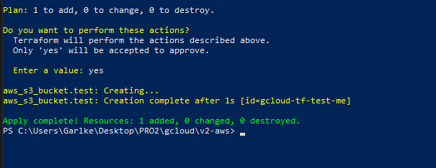
Figure 9 — Create and destroy exercised end to end before touching anything that matters.
Two defaults observed on that bucket became relevant later. S3 applied AES256 encryption without being asked — AWS-managed keys, no control and no audit over their use. And mfa_delete was false, one of the few settings only root can enable: a concrete instance of the root-versus-administrator distinction from section 2.3.

4. Cognito

4.1 User pool
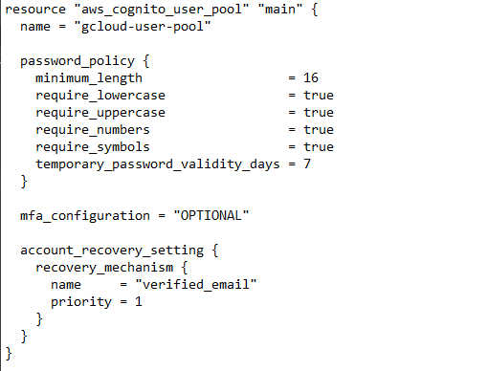
Figure 10 — User pool configuration.
Setting | Value | Reasoning
minimum_length | 16 | v1 enforced 10; 8 is the Cognito default and was rejected as an unexamined default
require_* (all four) | true | Stricter than NIST SP 800-63B recommends — see below
temporary_password_validity_days | 7 | An admin-created password should be used once and replaced
mfa_configuration | OPTIONAL | ON requires every user to enrol before the pool will create
software_token_mfa | enabled | TOTP over SMS: no SIM-swap exposure, no SNS dependency, no per-message cost
account_recovery | verified_email | Recovery is an alternate way in, not a side feature
deletion_protection | ACTIVE | Without it, one destroy silently removes every user

The composition rules deserve an honest note. NIST SP 800-63B dropped mandatory composition requirements because forcing symbol and number classes pushes users toward predictable patterns. Length does more work than class count, and 16 characters combined with all four classes is stricter than necessary. It is kept here because this is a demonstration pool with no real users; a production pool would drop the composition rules and keep the length.
Cognito also offers no breached-password checking in its base tier. That is a genuine capability loss against hand-rolled authentication, and it is the honest cost of a managed service: sane defaults in exchange for the ability to tune past what the vendor exposes.

4.2 App client
Setting | Value | Reasoning
generate_secret | false | Browser code is fully visible; a secret shipped to a public client is not a secret
explicit_auth_flows | SRP + REFRESH | SRP proves knowledge of the password without it leaving the device
refresh_token_validity | 7 days | Default is 30 — a stolen refresh token would be valid for a month
access / id_token_validity | 60 minutes | Bounds the damage of a leaked bearer token
prevent_user_existence_errors | ENABLED | The managed equivalent of the v1 enumeration defence

ALLOW_USER_PASSWORD_AUTH was rejected. It transmits the plaintext password to Cognito over TLS, so a compromised TLS terminator or a logging misconfiguration can observe it. SRP never sends the password at all.
The last row is the sharpest illustration of the whole v1-to-v2 argument. In v1 the enumeration defence was hand-written: identical error text for a wrong password and for a user that does not exist, plus "not available" rather than "taken" at registration. Cognito reduces that to a single boolean field — and knowing exactly what the field does is the reason it was switched on deliberately rather than left at LEGACY.
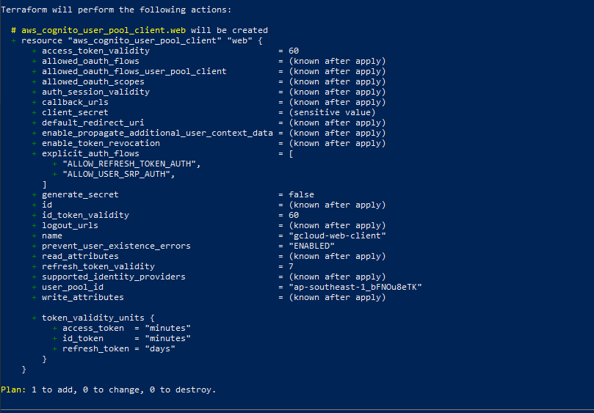
Figure 11 — App client plan output.

4.3 Failure: an optional factor with no method
The first apply created the pool and then failed. The error names the cause precisely.
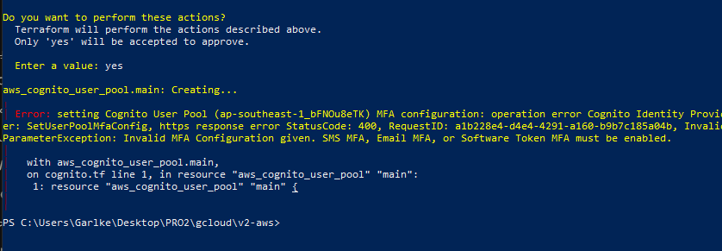
Figure 12 — InvalidParameterException: SMS MFA, Email MFA, or Software Token MFA must be enabled.
Setting mfa_configuration to OPTIONAL declares that MFA is available to users, but declares nothing about what kind. Cognito rejects the combination outright. The mode and the method are one decision, not two, and adding software_token_mfa_configuration resolved it.

4.4 Failure: a tainted resource
After that partial failure, every subsequent plan wanted to replace the pool regardless of what the configuration said. Editing the configuration changed nothing, because the configuration was not the cause.
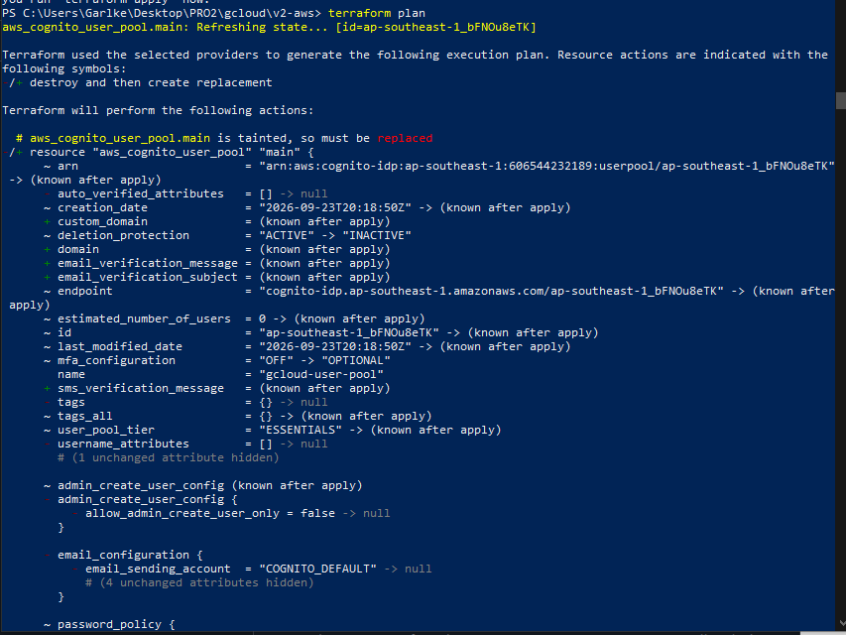
Figure 13 — "is tainted, so must be replaced".
A failed apply can leave a resource that exists in AWS but whose validity Terraform cannot vouch for. It marks that resource tainted, and a tainted resource is replaced on every plan until the mark is cleared with terraform untaint.

4.5 Failure: the guardrail deadlock
Deletion protection had been enabled early, while the configuration was still moving. Changing the MFA settings forced a replacement; replacement means destroy then create; and the destroy was blocked by the protection.
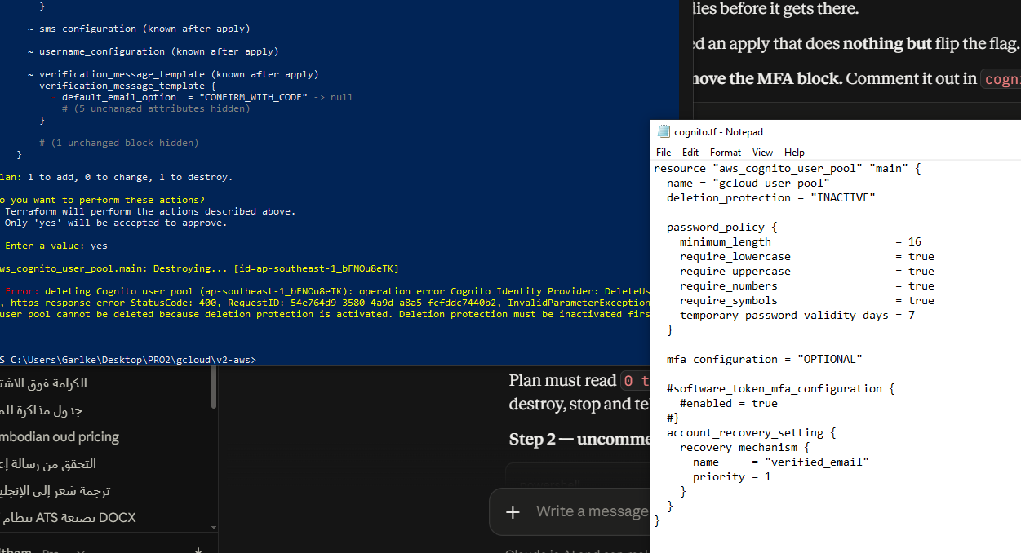
Figure 14 — The user pool cannot be deleted because deletion protection is activated.
The configuration could move neither forward nor back. Resolving it required a sequence of applies changing exactly one variable each: protection off, then the MFA change, then protection back on.
Deletion protection belongs on a configuration that has settled, not on one still being written. Enable the guardrail last.
A second rule came out of the same episode: change one variable per apply. Two simultaneous changes made it impossible to tell which one an error belonged to, and cost several wasted cycles.
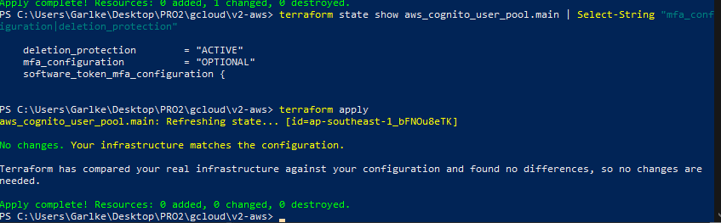
Figure 15 — Final state: deletion protection active, MFA optional, software token enabled.

5. KMS — the Key Policy as an Access Boundary
The disposable bucket in section 3.4 was encrypted with AES256 by default. That works, but the key is invisible: its use cannot be restricted and cannot be audited. A customer-managed key changes what encryption is for.
The key policy is a second access boundary, independent of IAM. An identity with IAM permission over the data still cannot decrypt it without permission over the key.
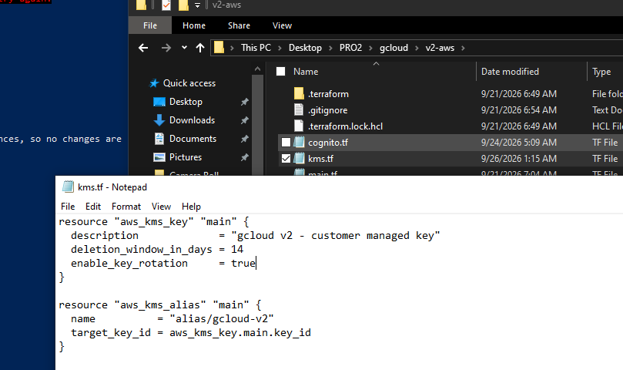
Figure 16 — Key and alias. A key ID is a UUID; the alias is a readable handle that can be repointed at a different key without editing every consumer.
The deletion window is set to 14 days. Deleting a KMS key destroys every ciphertext under it permanently, so AWS enforces a waiting period of 7 to 30 days during which deletion can be cancelled. Fourteen days gives two weeks to notice a mistake without leaving the key in limbo for a month. Annual rotation is enabled: AWS generates new key material each year and retains the old material for decrypting existing data, limiting how much ciphertext exists under any single piece of key material.
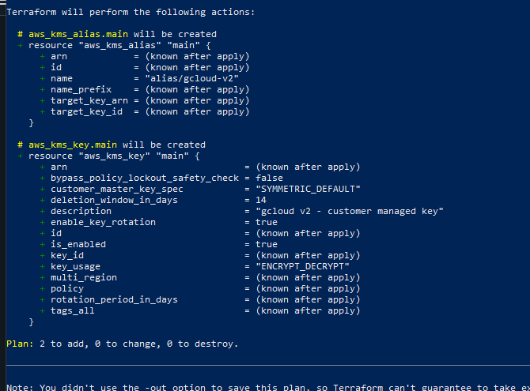
Figure 17 — Plan output. key_usage is constrained to ENCRYPT_DECRYPT, so the key cannot be used for signing.

5.1 The policy is a replacement, not an addition
A key policy replaces the AWS default entirely rather than merging with it. The apply diff shows the default policy identifier being removed. Omitting the account-root statement therefore makes the key permanently unmanageable with no recovery path — which is exactly what Terraform's bypass_policy_lockout_safety_check guards against.
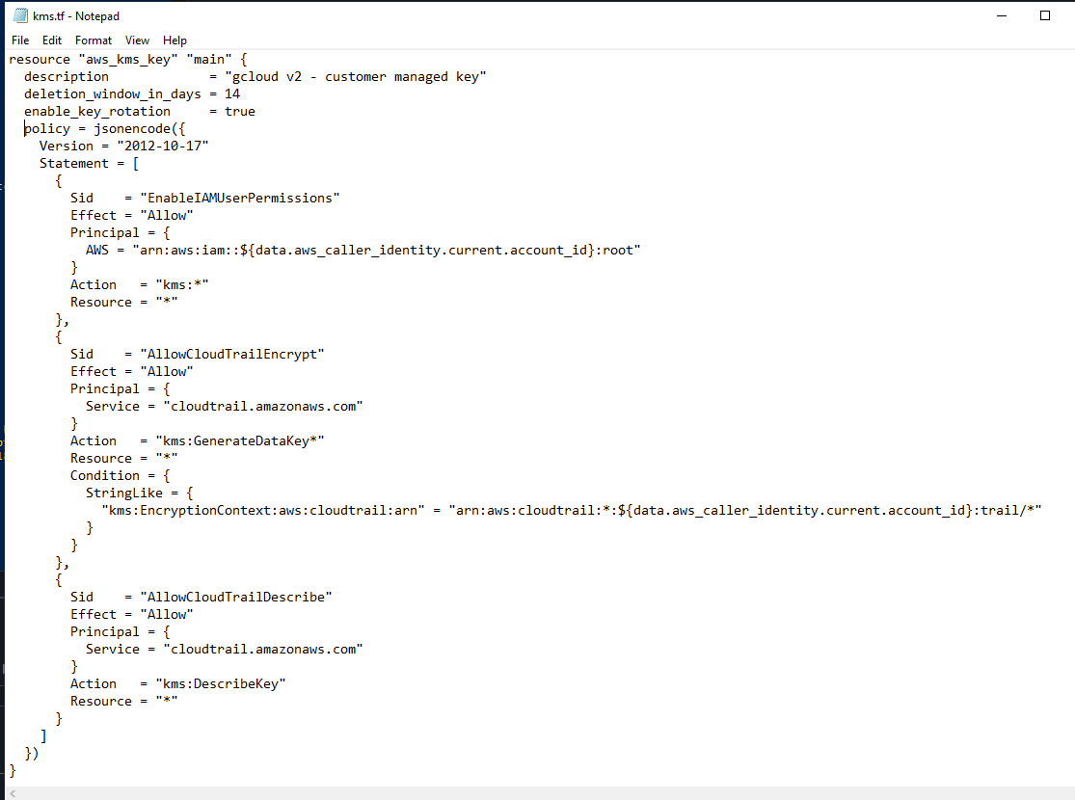
Figure 18 — Three statements: account root administration, CloudTrail encryption, CloudTrail key description.
CloudTrail is granted kms:GenerateDataKey* rather than kms:Encrypt because KMS uses envelope encryption — it generates a per-object data key rather than encrypting objects directly.
The condition on that statement matters more than the action. It requires the encryption context to match a CloudTrail trail in this account. Without it, any AWS account that learns the key ARN could have CloudTrail use the key — the confused deputy problem.

6. CloudTrail
CloudTrail records every API call in the account: who made it, when, from which address, and whether it succeeded. Conceptually it is the audit trail that v1's soft delete preserved, raised to account scope.

6.1 Log bucket hardening
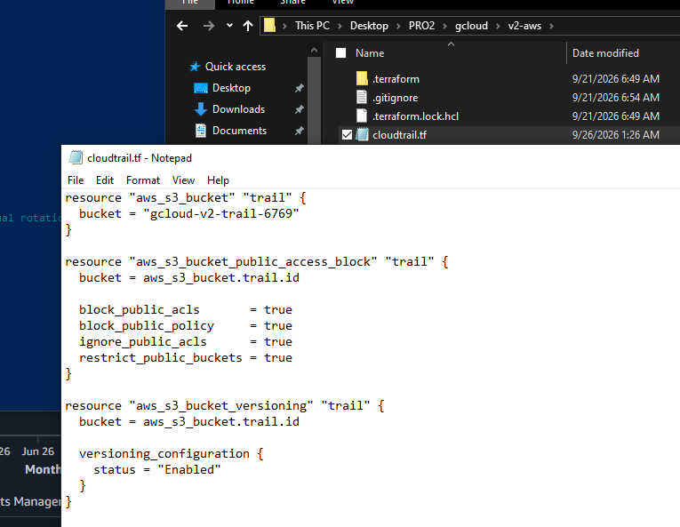
Figure 19 — All four public access block flags, plus versioning.
Trail logs are a complete map of the account's infrastructure and activity, so any public exposure is a reconnaissance gift. Versioning matters for a more specific reason: the first thing an intruder does after acting is delete the evidence, and with versioning enabled an overwrite no longer erases the previous version.
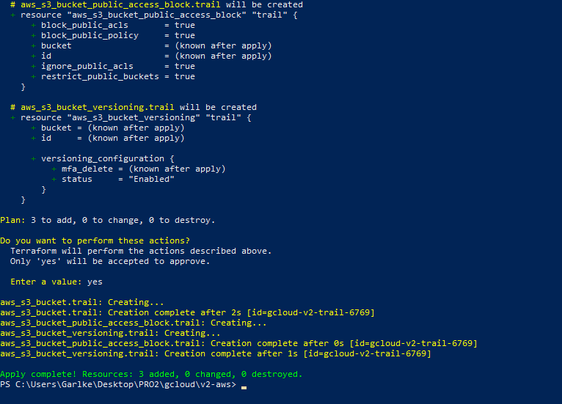
Figure 20 — Bucket, access block and versioning applied. Terraform inferred the ordering from the references in the configuration.

6.2 Bucket policy — least privilege at the resource
The policy grants to a service principal rather than a user, and scopes the write narrowly.
Principal = { Service = "cloudtrail.amazonaws.com" }
Action = "s3:PutObject"
Resource = "<bucket-arn>/AWSLogs/<account-id>/*"
Condition = { StringEquals = {
"s3:x-amz-acl" = "bucket-owner-full-control" } }
CloudTrail can write inside its own prefix and nowhere else — least privilege applied at the resource rather than only at the identity. The ACL condition ensures written objects stay owned by this account.
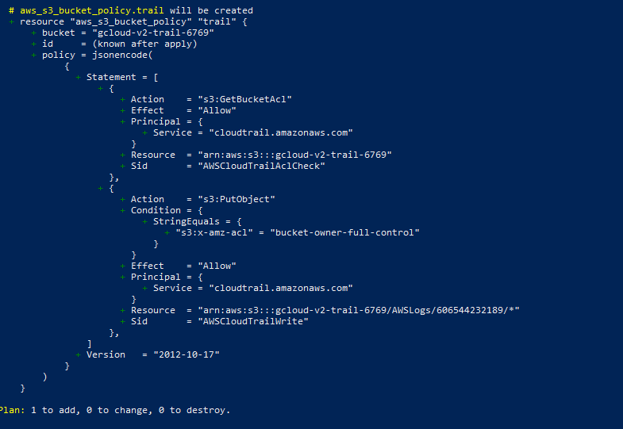
Figure 21 — The account ID comes from a caller-identity data source, so the configuration is not bound to one account. Hardcoding it would make the file unusable elsewhere.

6.3 Trail settings
Setting | Reasoning
is_multi_region_trail | A single-region trail is blind to activity elsewhere; creating resources in an unmonitored region is standard evasion
enable_log_file_validation | CloudTrail hashes and signs delivered logs — this does not prevent tampering, it makes tampering detectable
kms_key_id | Bucket access alone does not grant readability; decryption requires permission on the key as well
depends_on | CloudTrail test-writes during creation, and nothing in the trail block references the bucket policy, so the dependency is declared explicitly

6.4 Proof that the key policy is a real boundary
Creating the trail failed while terraform-admin held AdministratorAccess.
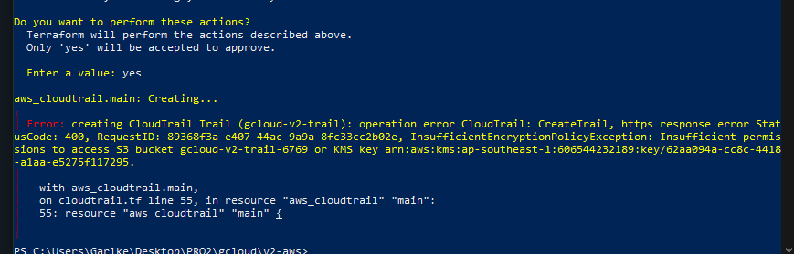
Figure 22 — InsufficientEncryptionPolicyException.
Full IAM administrator rights were not sufficient. Only adding statements to the key policy made the operation succeed — which is the clearest possible demonstration that the two boundaries are independent.
After the policy was extended, the same apply modified the key and created the trail in a single run.

7. IAM — Scoped Read-Only Access
The final component is an investigation role: an identity that can read audit logs and do nothing else.
It is a role rather than a user, which is the substantive difference. A role carries no long-lived access key; credentials are issued by STS and expire, with a default maximum session duration of one hour. Its trust policy answers who may assume it, a separate question from what it may do — and that separation is the point of roles.
Permission | Scope
s3:GetObject, s3:ListBucket | The trail bucket only. No PutObject, no DeleteObject — an investigator reads logs and cannot alter them
kms:Decrypt | One key ARN. Cannot encrypt, cannot schedule key deletion, cannot touch other keys
cloudtrail:DescribeTrails, GetTrailStatus, LookupEvents | Metadata reads for locating and querying events

Both boundaries still apply: even with kms:Decrypt in the role policy, the key policy must independently permit the principal. Neither grant works alone.
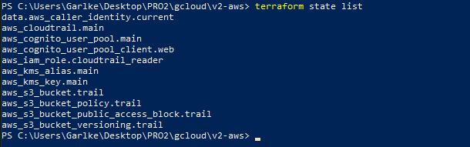
Figure 23 — Resources under management, verified against state rather than assumed.

8. Operational Lessons
The failures in sections 4 and 6 produced more transferable knowledge than the successes, and they are recorded deliberately rather than edited out.
- Enable guardrails last. Deletion protection and immutable attributes interact badly: any change forcing replacement is blocked, and unblocking requires a manual multi-step sequence.
- Change one variable per apply. Two simultaneous changes make it impossible to attribute an error.
- A failed apply can leave state inconsistent with reality. terraform untaint is how you tell Terraform to trust a resource again.
- Write .gitignore before the first .tf file. State is generated automatically, so there is no moment where you consciously decide to create it.
- Read what the tooling tells you. The MFA error, the deletion protection error and the encryption policy error each named their own cause precisely; the AWS console states its preference for short-term credentials on the very screen where long-term keys are created.
- A managed service still requires understanding. Cognito supplies an enumeration defence, but knowing what it defends against is what makes enabling it a decision rather than a default.

9. Known Gaps
Recorded as compromises, not oversights. Nothing in this document is claimed that has not been built and tested.
- terraform-admin still holds AdministratorAccess. Accepted because it is revocable and auditable, unlike root. With CloudTrail now live, the scoped policy can be derived from the calls Terraform actually makes.
- A long-lived access key sits on the development laptop. Access keys never expire; IAM Identity Center or sts:AssumeRole would issue expiring credentials instead.
- State is local and unencrypted. Production practice is an encrypted S3 backend with DynamoDB state locking — the next infrastructure task.
- The KMS key policy still grants account root kms:*, from which IAM permissions derive. The key is therefore not yet a fully independent boundary for administrators, only for service principals and scoped roles.
- MFA on terraform-admin gates console sign-in only and does not apply to API calls made with access keys.

