Michigan Health Information Network Shared Services (MiHIN)

Allie C. Garner
School of Health Professionals
The University of Alabama at Birmingham
HI 617: Principles in Health Informatics
Information Exchange Analysis
Larissa Pierce, MD, MSHI
March 13th, 2025

The Michigan Health Information Network Shared Services (MiHIN) is Michigan's state-designated health information exchange (HIE) (MHINSS, 2025c). Before MiHIN, Michigan faced interoperability barriers and care inefficiencies due to healthcare organizations using a variety of electronic health record (EHR) software (MHINSS, 2025c). MiHIN was initiated in 2005 when Michigan's governor directed state agencies to collaborate with stakeholders to use health information technology (HIT) and HIE to improve health quality and reduce costs in Michigan (MDHHS, 2010). In response, over 200 stakeholders contributed to developing a statewide HIE plan called "MiHIN Conduit to Care". This plan outlined Michigan's incremental approach to HIE and aimed to ensure that HIE would occur statewide, including in underserved areas (MDHHS, 2010). In 2010, Michigan received approximately $14 million under the Health Information Technology for Economic and Clinical Health (HITECH) Act to aid in developing MiHIN (MDHHS, 2010; MHINSS, 2025c). MiHIN adopted a unique, hybrid governance model, with a public/private partnership between the Health Information Technology (HIT) Commission and the MiHIN Board of Directors (MHINSS, 2025c). Under this model, the HIT Commission is responsible for setting statewide policies and overseeing HIE activities, while the MiHIN Board of Directors is responsible for governing HIE infrastructure, operational plans, and financial strategies (MHINSS, 2025c; O'Toole et al., 2013).
MiHIN connects 665 outpatient facilities, 298 nursing facilities, 148 hospitals, and 44 physician organizations, enabling continuity of care to Michigan's population (MHINSS, 2025b). Primary care clinics, laboratories, radiology centers, home health agencies, behavioral health clinics, and pharmacies are also within the MiHIN network (MHINSS, 2025b). Not only does MiHIN improve the quality of individual patient care, but it also aids public health initiatives by sharing health data, including immunization records and syndromic surveillance data, with the Michigan Department of Health and Human Services and local health departments (MHINSS, 2024d). Additionally, federal agencies collaborate with MiHIN to ensure compliance with national healthcare initiatives (MHINSS, 2025b). Overall, MiHIN routes information for more than 13 million patients across 5,637 care entities (MHINSS, 2025b). MiHIN's mission has remained essentially unchanged since its development: to improve the healthcare experience, increase quality, and reduce costs for Michigan residents by facilitating health information exchange and ensuring data is accessible at the point of care (MHINSS, 2024a).
MiHIN offers a variety of tools for information exchange, including MIGateway, Diretto, Care Convene, and InterOp Station (MHINSS, 2024c). The Medical Information Gateway, or MIGateway, is the platform for healthcare providers, allowing them to access Continuity of Care Documents (CCDs), receive Admission, Discharge, Transfer (ADT) notifications, and view unified patient records with data aggregated from the entire network (MHINSS, 2024f). Additionally, MIGateway allows providers to retrieve contact information for other providers of a patient's care team, improving care coordination (MHINSS, 2024f). Diretto, a direct messaging software, can be used as a standalone tool or within MIGateway for secure messaging between providers and patients (MHINSS, 2025a). MIGateway uses Health Level Seven's Version 2 (HL7 V2) messaging standard and HL7's Consolidated Clinical Document Architecture (C-CDA) for information exchange (MHINSS, 2020a; MHINSS, 2020b; MHINSS, 2024b). Specifically, HL7 V2 is the messaging standard for transmitting ADT notifications and longitudinal records, while CCDs are exchanged using the C-CDA standard in XML format (MHINSS, 2020a; MHINSS, 2020b; MHINSS, 2024b).
For example, when a patient is admitted to a hospital, an ADT notification is generated by the hospital's EHR system (MHINSS, 2024b). This notification, specifically an "ADT_A01" HL7 V2 message indicating a patient admission, is sent to MiHIN (MHINSS, 2024b; Caristix, 2025). Upon receiving the ADT message, MiHIN analyzes the message and, in this case, adds additional important information to the message’s custom segment, called the “z-segment” (MHINSS, 2024b). MiHIN then uses its Active Care Relationship Service (ACRS) to identify the patient's care team, including a primary care physician and specialty clinicians. It retrieves contact and delivery preference information from its Health Directory. MiHIN then forwards the updated ADT notification to the care team. Now, the patient's care team is aware of this event that may impact their care plan (MHINSS, 2024b).
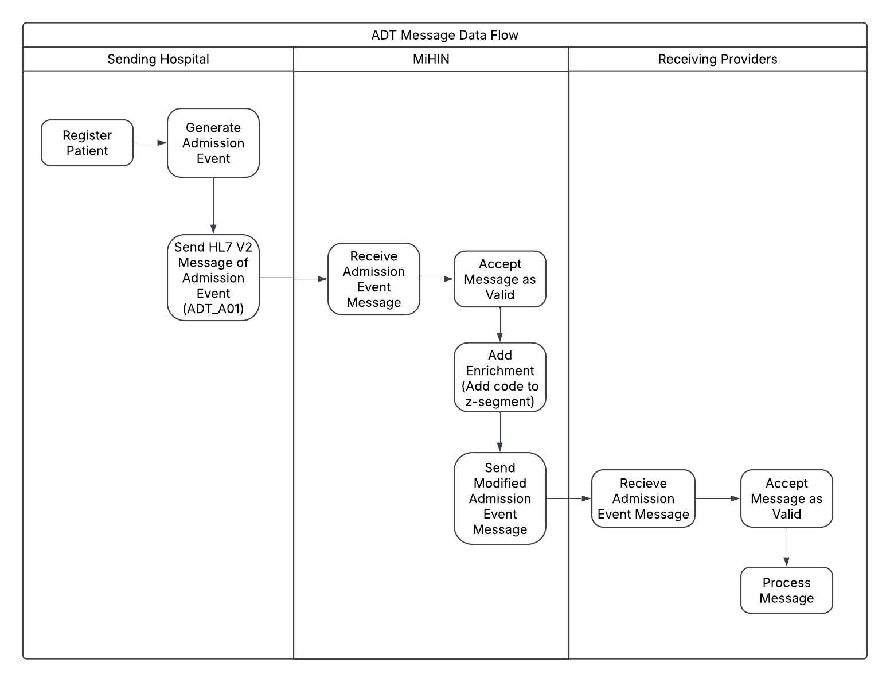

Care Convene and InterOp Station are MiHIN's patient-facing platforms (MHINSS, 2024e; MHINSS, 2023). Care Convene is a virtual health platform that allows patients to conduct on-demand acute virtual visits with physicians and participate in post-surgical follow-up virtual visits (MHINSS, 2024e). Additionally, it provides health reminders and chronic disease management tools, encouraging patients to take an active role in their care (MHINSS, 2024e). InterOp Station enables patients to access their health data from multiple sources while also serving as a platform for authorized payers to exchange historical data with each other (MHINSS, 2023). It is MiHIN's first tool to use HL7's Fast Healthcare Interoperability Resources (FHIR) standard for information exchange. This allows InterOp Station to intake various clinical and claims data types and convert them to FHIR resources within a cohesive, cloud-based environment (MHINSS, 2023).
Using the SWOT analysis method, MiHIN's strengths include its role as a strong state HIE with a broad network of providers from 5,637 care entities. Its numerous information exchange tools support patients, providers, payers, and government agencies, improving care coordination and enabling strong public health support. InterOp Station uses FHIR, which uses RESTful APIs to enable efficient data sharing through modular, web-based standards (HL7, 2025). FHIR is cost-effective, easy to implement, and integrates well with EHRs, mobile apps, and cloud platforms (HL7, 2025). It also meets interoperability requirements set by the 21st Century Cures Act (MHINSS, 2023). FHIR is considered an advancement over previous HL7 standards, combining the best features of HL7 V2, HL7 V3, and CDA (HL7, 2025). Therefore, MiHIN's continued reliance on HL7 V2 for MIGateway could be seen as a weakness. Another potential weakness for MiHIN is the challenge of coordinating governance between public and private stakeholders, which could slow decision-making.
MiHIN's use of FHIR with InterOp Station creates an opportunity to expand FHIR-based information exchange across its platforms. Previous experience would make implementing FHIR in other platforms more efficient and reduce potential challenges. Another opportunity for MiHIN is to collaborate with academic institutions in Michigan to support health research through data sharing. A threat to MiHIN is the Qualified Health Information Networks (QHINs) under The Trusted Exchange Framework and Common Agreement (TEFCA). TEFCA's goal is to establish a unified, nationwide framework for HIE by designating interconnected organizations, or QHINs (CommonWell Health Alliance, 2024). As of February 2024, seven organizations, including CommonWell and Epic, have been officially designated QHINs (Raths, 2024). The national reach of QHINs may attract healthcare providers seeking broader interoperability, potentially diminishing MiHIN's role within Michigan. Epic, one of the most widely used EHR systems in U.S. hospitals, joining TEFCA further strengthens the appeal of QHINs, increasing competition for state-level HIEs like MiHIN (Tieché, 2024). Another threat to MiHIN is cybersecurity risks. Since FHIR operates in a cloud-based environment, InterOp Station is vulnerable to ransomware attacks and breaches caused by cloud misconfigurations (Eddy, 2024).
MiHIN's 2024-2028 strategic plan is centered around four goals: improving capabilities to support comprehensive data needs, providing excellent services to patients and providers, building an innovative and diverse workforce, and supporting behavioral, public, and population health initiatives (MHINSS, 2024a). To align with these goals, MiHIN can further expand FHIR-based information exchange to MIGateway. This advancement would extend FHIR's benefits to providers, improving clinical workflows and provider access to consistent, up-to-date patient data (HL7, 2025). MiHIN should also establish formal partnerships with Michigan universities and research centers, providing de-identified patient data for medical research, public health initiatives, and population health analytics. To address cybersecurity risks, MiHIN should invest in AI-driven threat detection and establish strong cloud security protocols.
MiHIN has established itself as a vital HIE in Michigan, reaching a broad network of providers and offering a variety of data exchange tools. MiHIN has embraced new advancements in health IT, such as integrating FHIR into one of its platforms. Expanding its capabilities and strengthening its network will ensure that MiHIN remains a relevant and effective HIE in the evolving healthcare landscape.

References

Caristix. (2025). HL7 Standard Message / Trigger Event List (HL7 v2.3). Caristix . https://hl7-definition.caristix.com/v2/HL7v2.3/TriggerEvents
CommonWell Health Alliance. (2024, December 11). TEFCA. CommonWell Health Alliance. https://www.commonwellalliance.org/tefca/
Eddy, N. (2024, June 24). 2025’s Biggest Healthcare Cybersecurity Threats. HealthTech. https://healthtechmagazine.net/article/2025/01/healthcare-cybersecurity-threats-2025-perfcon#:~:text=The%20top%20threats%20facing%20healthcare,AI%20and%20large%20language%20models
HL7. (2025). 2.1.20 Introducing HL7 FHIR. HL7.org. https://hl7.org/fhir/summary.html
Michigan Department of Health and Human Services . (2010, April 30). State of Michigan MiHIN Shared Services Strategic Plan. michigan.gov. https://www.michigan.gov/mdhhs/-/media/Project/Websites/mdhhs/Doing-Business-with-MDHHS/Boards-and-Commissions/Health-Information-Technology-Commission/HIT-Annual-Reports/MiHIN_Shared_Services_Strategic_Plan_4-30-10_320156_7.pdf?rev=4215de343d384e248dc7d76f8b1f1543&hash=074D2E4D22F741D4F94A4EB10D9950B2
Michigan Health Information Network Shared Services . (2023, June 5). InterOp Station. MiHIN. https://mihin.org/interop-station-2/
Michigan Health Information Network Shared Services . (2024f, November 14). MIGateway. MiHIN. https://mihin.org/migateway/
Michigan Health Information Network Shared Services. (2020a, July 10). Longitudinal Record Implementation Guide. MiHIN. https://mihin.org/wp-content/uploads/2020/07/MiHIN-UCIG-Longitudinal-Record_v7_7-10-2020.pdf
Michigan Health Information Network Shared Services. (2020b, October 7). Summary of Care Implementation Guide. MiHIN. https://mihin.org/wp-content/uploads/2020/10/MiHIN-UCIG-Ambulatory-Summary-v8-10-07-2020.pdf
Michigan Health Information Network Shared Services. (2024a, April 17). Strategic Plan. MiHIN. https://mihin.org/strategicplan/
Michigan Health Information Network Shared Services. (2024b, May 1). Admission, Discharge, Transfer Notifications Implementation Guide. MiHIN. https://mihin.org/wp-content/uploads/2024/08/MIHIN-UCIG-ADT-Notifications-05-01-2024.pdf
Michigan Health Information Network Shared Services. (2024c, July 30). Products and Use Cases. MiHIN. https://mihin.org/products-list/
Michigan Health Information Network Shared Services. (2024d, November 11). Health information for the State. MiHIN. https://mihin.org/health-information-for-the-state-use-case/
Michigan Health Information Network Shared Services. (2024e, November 15). Care Convene. MiHIN. https://mihin.org/careconvene/
Michigan Health Information Network Shared Services. (2025a, February 3). Direct Secure Messaging. MiHIN. https://mihin.org/diretto/
Michigan Health Information Network Shared Services. (2025b, February 14). Our Network. MiHIN. https://mihin.org/our-network-v22/
Michigan Health Information Network Shared Services. (2025c, February 14). Who We Are. MiHIN. https://mihin.org/who-we-are-v22/
O’Toole, D., O’Toole, S., & Steely, L. (2013). Michigan Health Information Network (MiHIN) Shared Services vs. the HIE Shared Services in Other States vs. the HIE Shared Services in Other States. Transactions of the International Conference on Health Information Technology Advancement, 39.
Raths, D. (2024, February 12). List of TEFCA QHINs Grows to Seven. Healthcare Innovation. https://www.hcinnovationgroup.com/interoperability-hie/trusted-exchange-framework-and-common-agreement-tefca/news/53096295/list-of-tefca-qhins-grows-to-seven
Tieché, M. (2024, January 10). Most common hospital EHR Systems by market share. Definitive Healthcare. https://www.definitivehc.com/blog/most-common-inpatient-ehr-systems

