Example Peer Recovery Services, Inc.
Performance Analysis and Evidence Report
Built from the agency's own entered data — nothing here is estimated

DRAFT - the CARF section map behind this report has NOT been checked against the purchased manual.

Program: Community Integration
Data rows analysed: 0
Generated 2026-09-05

How to read this report
Every figure and every chart below was computed from the Evidence and Data Workbook. Where a sheet is empty, this report says so rather than estimating. Re-run it whenever you enter more data — it is designed to be run monthly, not once.
`python3 _engine/analyze.py example-peer-agency`

1. Is there enough evidence yet?

CARF area 1.M / 1.N. Before any analysis is credible, this says how much real data exists. A surveyor forms the same judgement in the first ten minutes.
Sheet | Rows entered | What it proves | Enough for survey?
03 Drills | 0 | Emergency preparedness actually tested | 4+ per shift per year, one unannounced
04 Incidents | 0 | Incidents captured, reviewed and analysed | Every reportable event
05 Grievances | 0 | Complaints heard and answered on time | Every concern, informal included
06 Record Reviews | 0 | Documentation checked before a payer does | 4 quarters
07 Access and Referrals | 0 | People get in, and how fast | Every referral
08 Satisfaction — persons served | 0 | The people served were asked | 1 annual cycle
09 Satisfaction — stakeholders | 0 | Stakeholders were asked | 1 annual cycle
10 Outcomes — persons served | 0 | Services changed lives measurably | Every person served
11 Personnel | 0 | Staff qualified, trained, supervised | Every employee
12 Financial | 0 | Budget monitored, controls working | 12 months
13 Accessibility | 0 | Barriers found and removed | All 8 areas
14 PI Projects | 0 | Improvement actually happened | 1+ complete with before/after
15 Measure Results | 27 | Performance measured against target | Yes

1 of 13 evidence sheets have any data in them (8%). Empty sheets are not a formatting gap; they are the work that has not happened yet.

2. Where the agency stands against every required item

CARF area All. Every dated obligation in the packet, counted by status. This is the honest answer to "are we ready?".
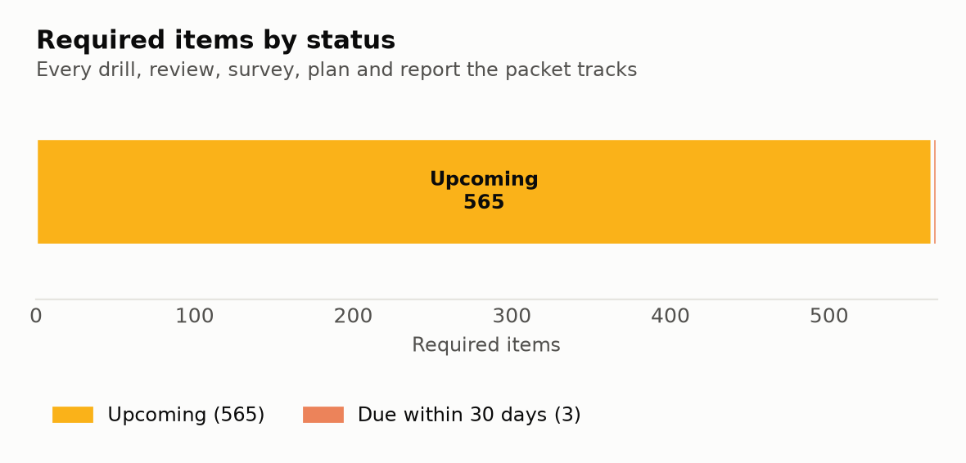
Nothing is overdue. Keep it that way — the calendar is the easiest part of an accreditation to let slip and the easiest for a surveyor to catch.

3. Performance measures against target

CARF area 1.M. Every measure in the Performance Measurement Plan, with its real quarterly result. A measure with no target cannot be passed or failed, and a target you invented and missed is worse than a modest one you met.
ID | Measure | Target | Q1 | Q2 | Q3 | Q4 | Year | Prior year | Met?
E1 | Persons achieving at least one plan goal |  |  |  |  |  |  |  | no data
E2 | Persons whose unpaid natural supports increased |  |  |  |  |  |  |  | no data
E3 | Persons obtaining or maintaining housing (of those with a housing goal) |  |  |  |  |  |  |  | no data
E4 | Persons obtaining employment or education (of those with that goal) |  |  |  |  |  |  |  | no data
E5 | Persons reporting improved quality of life |  |  |  |  |  |  |  | no data
F1 | Average length of service to first goal achievement |  |  |  |  |  |  |  | no data
F2 | Scheduled contacts kept |  |  |  |  |  |  |  | no data
F3 | Active persons served per direct service FTE |  |  |  |  |  |  |  | no data
F4 | Cost per person served |  |  |  |  |  |  |  | no data
A1 | Mean days from referral to first contact |  |  |  |  |  |  |  | no data
A2 | Mean days from first contact to signed plan |  |  |  |  |  |  |  | no data
A3 | Referrals engaged (2+ contacts) |  |  |  |  |  |  |  | no data
A4 | Mean days waited on the waiting list |  |  |  |  |  |  |  | no data
S1 | Overall satisfaction of persons served |  |  |  |  |  |  |  | no data
S2 | Would recommend the service |  |  |  |  |  |  |  | no data
S3 | Survey response rate — persons served |  |  |  |  |  |  |  | no data
S4 | Stakeholder satisfaction |  |  |  |  |  |  |  | no data
B1 | Budget to actual variance |  |  |  |  |  |  |  | no data
B2 | Claim denial rate |  |  |  |  |  |  |  | no data
B3 | Notes completed within the required timeframe |  |  |  |  |  |  |  | no data
B4 | Staff turnover |  |  |  |  |  |  |  | no data
B5 | Staff with all required training current | 100 |  |  |  |  |  |  | no data
B6 | Staff with current credential | 100 |  |  |  |  |  |  | no data
B7 | Critical incidents per 100 service contacts |  |  |  |  |  |  |  | no data
B8 | Grievances resolved within 30 days | 100 |  |  |  |  |  |  | no data
B9 | Record review findings corrected and verified | 100 |  |  |  |  |  |  | no data
B10 | Drills completed on schedule, all shifts | 100 |  |  |  |  |  |  | no data

4. Emergency drills — coverage, not just count

CARF area 1.H. Fire and evacuation drills quarterly on EVERY shift that delivers service, every emergency type in the plan at least annually, and at least one unannounced.
NO DATA ENTERED YET — no drills logged
Nothing has been entered on sheet 03 Drills of the Evidence and Data Workbook. Drill records are among the first things a surveyor asks for, and the most common place an otherwise strong agency is found short.
This is not a formatting problem and it cannot be written around. A surveyor asks for this by name. Enter the real records as they happen and re-run `python3 _engine/analyze.py <slug>`.

5. Critical incidents — trend and follow-through

CARF area 1.H. Incidents aggregated at least quarterly by type, location, time and staff, with a written conclusion even when the conclusion is that no trend exists.
NO DATA ENTERED YET — no incidents logged
Nothing has been entered on sheet 04 Incidents of the Evidence and Data Workbook. An empty incident log is read as an unused log, not as a safe year. If genuinely nothing happened, that fact still has to be recorded and analysed.
This is not a formatting problem and it cannot be written around. A surveyor asks for this by name. Enter the real records as they happen and re-run `python3 _engine/analyze.py <slug>`.

6. Grievances — heard, answered, on time

CARF area 1.K. Written acknowledgment within three business days, a written decision within thirty calendar days, and a quarterly trend analysis.
NO DATA ENTERED YET — no grievances logged
Nothing has been entered on sheet 05 Grievances of the Evidence and Data Workbook. An empty grievance log is one of the strongest negative signals in a survey. It usually means informal concerns are not being captured, not that nobody ever complained.
This is not a formatting problem and it cannot be written around. A surveyor asks for this by name. Enter the real records as they happen and re-run `python3 _engine/analyze.py <slug>`.

7. Quality record review

CARF area 2.H. Records reviewed quarterly against a written tool by someone who did not write the documentation, with every finding tracked to a verified correction.
NO DATA ENTERED YET — no record reviews logged
Nothing has been entered on sheet 06 Record Reviews of the Evidence and Data Workbook. Four quarters of record review is the evidence that the agency polices its own documentation. Without it, the payer or the surveyor does it first.
This is not a formatting problem and it cannot be written around. A surveyor asks for this by name. Enter the real records as they happen and re-run `python3 _engine/analyze.py <slug>`.

8. Access to services

CARF area 2.B. How long people wait, how many engage, and what happens to the people who are turned away.
NO DATA ENTERED YET — no referral data
Nothing has been entered on sheet 07 Access and Referrals of the Evidence and Data Workbook. Access measures (A1-A4) cannot be reported without it, and 'how long from referral to first contact?' is asked in almost every survey.
This is not a formatting problem and it cannot be written around. A surveyor asks for this by name. Enter the real records as they happen and re-run `python3 _engine/analyze.py <slug>`.

9. Satisfaction — persons served and stakeholders

CARF area 1.D. Both groups must be asked, analysed, and told what changed as a result.
NO DATA ENTERED YET — no satisfaction data
Nothing has been entered on sheet 08 / 09 Satisfaction of the Evidence and Data Workbook. Input from persons served AND from other stakeholders are two separate requirements. Both are needed.
This is not a formatting problem and it cannot be written around. A surveyor asks for this by name. Enter the real records as they happen and re-run `python3 _engine/analyze.py <slug>`.

10. Outcomes for the people served

CARF area 1.M / 3.CI. Whether services actually changed lives — goals reached, housing, work, and whether people's unpaid support networks grew.
NO DATA ENTERED YET — no outcome data
Nothing has been entered on sheet 10 Outcomes — persons served of the Evidence and Data Workbook. This sheet produces almost every effectiveness measure. Without it the agency can describe what it did but not what changed.
This is not a formatting problem and it cannot be written around. A surveyor asks for this by name. Enter the real records as they happen and re-run `python3 _engine/analyze.py <slug>`.

11. Workforce compliance

CARF area 1.I / 3.PEER. Credentials verified and current, orientation and competency complete, supervision happening, appraisals done.
NO DATA ENTERED YET — no personnel data
Nothing has been entered on sheet 11 Personnel of the Evidence and Data Workbook. A surveyor pulls three personnel files at random. This sheet tells you in advance which three would hurt.
This is not a formatting problem and it cannot be written around. A surveyor asks for this by name. Enter the real records as they happen and re-run `python3 _engine/analyze.py <slug>`.

12. Accessibility progress

CARF area 1.L. Barriers found across all eight areas, and at least one removed or reduced this year.
NO DATA ENTERED YET — no accessibility data
Nothing has been entered on sheet 13 Accessibility of the Evidence and Data Workbook. An accessibility plan with no identified barriers reads as a plan nobody worked. Every area needs a row, even if the row says 'none identified'.
This is not a formatting problem and it cannot be written around. A surveyor asks for this by name. Enter the real records as they happen and re-run `python3 _engine/analyze.py <slug>`.

13. Performance improvement projects

CARF area 1.N. At least one completed project with before-and-after numbers is what turns "we improve" from a claim into evidence.
NO DATA ENTERED YET — no improvement projects
Nothing has been entered on sheet 14 PI Projects of the Evidence and Data Workbook. This is the evidence that measurement led to change. Without it the quality system stops at counting.
This is not a formatting problem and it cannot be written around. A surveyor asks for this by name. Enter the real records as they happen and re-run `python3 _engine/analyze.py <slug>`.

14. Written conclusions, actions and distribution

CARF area 1.N. The analysis above is data. This section is where leadership says what it MEANS and what will change — and it has to be written by a person, not generated.
THIS SECTION IS DELIBERATELY BLANK. IT IS YOURS TO WRITE.
A generated conclusion would be a fabricated one. The numbers above are real; the judgement about them has to come from the people who run the agency, and a surveyor will ask the CEO to explain it in their own words.
What is working, and how we know
*Name the measure and the evidence.*
_______________________________________________________________________________
_______________________________________________________________________________
What is not working, and the probable cause
*Be specific. "Staffing" is not a cause.*
_______________________________________________________________________________
_______________________________________________________________________________
Where we met target and will now raise it
*Meeting a target is a result, not an endpoint.*
_______________________________________________________________________________
_______________________________________________________________________________
What surprised us
*Surveyors like this question. It shows the analysis was actually read.*
_______________________________________________________________________________
_______________________________________________________________________________
Improvement actions for the coming year
# | Action | Which finding it addresses | Owner | Target date | How we will know it worked
1
2
3

Distribution — the most-missed requirement in the manual
Analysing performance is half of area 1.N. Telling people the results is the other half, and it is where most agencies are found short. Complete this within 90 days.
Audience | Format | Date shared | How it is documented
Personnel | Staff meeting + written summary |  | Minutes, sign-in sheet
Persons served | Plain-language one-page summary |  | Posted + handed out; log
Board of Directors | Full report |  | Minutes
Referral sources and payers | Summary |  | Email record

Prepared by: ________________________ Signature: ________________________ Date: __________
Reviewed by: ________________________ Signature: ________________________ Date: __________

