Final Raspberry Pi lab
This activity puts together everything we have done with the Raspberry Pi:
- basic electronics;
- running GNU/Linux applications in the LXDE environment and the LXTerminal;
- using the Python IDLE editor and shell, and the Turtle Graphics module.

Step 1: draw a traffic light control panel

- Open the IDLE 3 program.
- Click the menu File : New Window to create a blank file.
- Save the file to /home/pi with the name trafficpanel1.py
- Type the code below and save it.
- Hit the F5 key to test it.

from turtle import *

def square(color):
fillcolor(color)
begin_fill()
fd(100)
rt(90)
fd(100)
rt(90)
fd(100)
rt(180)
end_fill()

def draw_panel():
setworldcoordinates(0, 0, 300, 300)
speed(0)
penup()
goto(100, 300)
square('red')
square('yellow')
square('green')

draw_panel()

mainloop()

Step 2: make the control panel interactive

- Use the menu command File : Save as to save the trafficpanel1.py file as trafficpanel2.py
- Add the code between the # step 2 comments and save to trafficpanel2.py.
- Hit the F5 key to test it. Click on the colored squares and note the output in the shell.

from turtle import *

def square(color):
fillcolor(color)
begin_fill()
fd(100)
rt(90)
fd(100)
rt(90)
fd(100)
rt(180)
end_fill()

def draw_panel():
setworldcoordinates(0, 0, 300, 300)
speed(0)
penup()
goto(100, 300)
square('red')
square('yellow')
square('green')

# step 2: type code FROM this line
def switch(x, y):
print('click at y = ', y)
if 0 <= y < 100:
bgcolor('dark green')
elif 100 <= y < 200:
bgcolor('#880')
else:
bgcolor('dark red')

onscreenclick(switch)
# step 2: type code TO this line

draw_panel()

mainloop()

Step 3: build the traffic light circuit
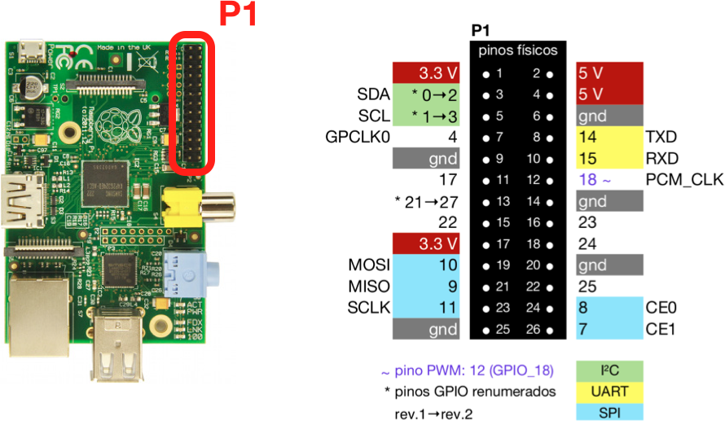

Step 3.1: connect wires from Raspberry Pi to breadboard
- Refer to the picture above to identify the Raspberry Pi GPIO pins 3, 5, 7 and 25.
Note: all these pins are on the left side of the connector (away from the edge of the board).
- Connect a red wire from the Raspberry Pi GPIO pin 3 to column 4 of the breadboard.
- Connect a yellow wire from the Raspberry Pi GPIO pin 5 to column 8 of the breadboard.
- Connect a green wire from the Raspberry Pi GPIO pin 7 to column 12 of the breadboard.
- Connect a blue wire from the Raspberry Pi GPIO pin 25 to the blue line of the breadboard.

Step 3.2: install resistors on breadboard
- Connect a 470Ω (or similar) resistor from column 3 to the blue line of the breadboard.
- Connect a 470Ω (or similar) resistor from column 7 to the blue line of the breadboard.
- Connect a 470Ω (or similar) resistor from column 11 to the blue line of the breadboard.

Step 3.3: install LEDs on breadboard
- Connect a red LED with anode (long lead) in column 4 and
cathode (short lead) in column 3.
- Connect a yellow LED with anode (long lead) in column 8 and
cathode (short lead) in column 7.
- Connect a green LED with anode (long lead) in column 12 and
cathode (short lead) in column 11.

Step 3.4: revise all the connections
Refer to the picture below to make sure everything is connected correctly.
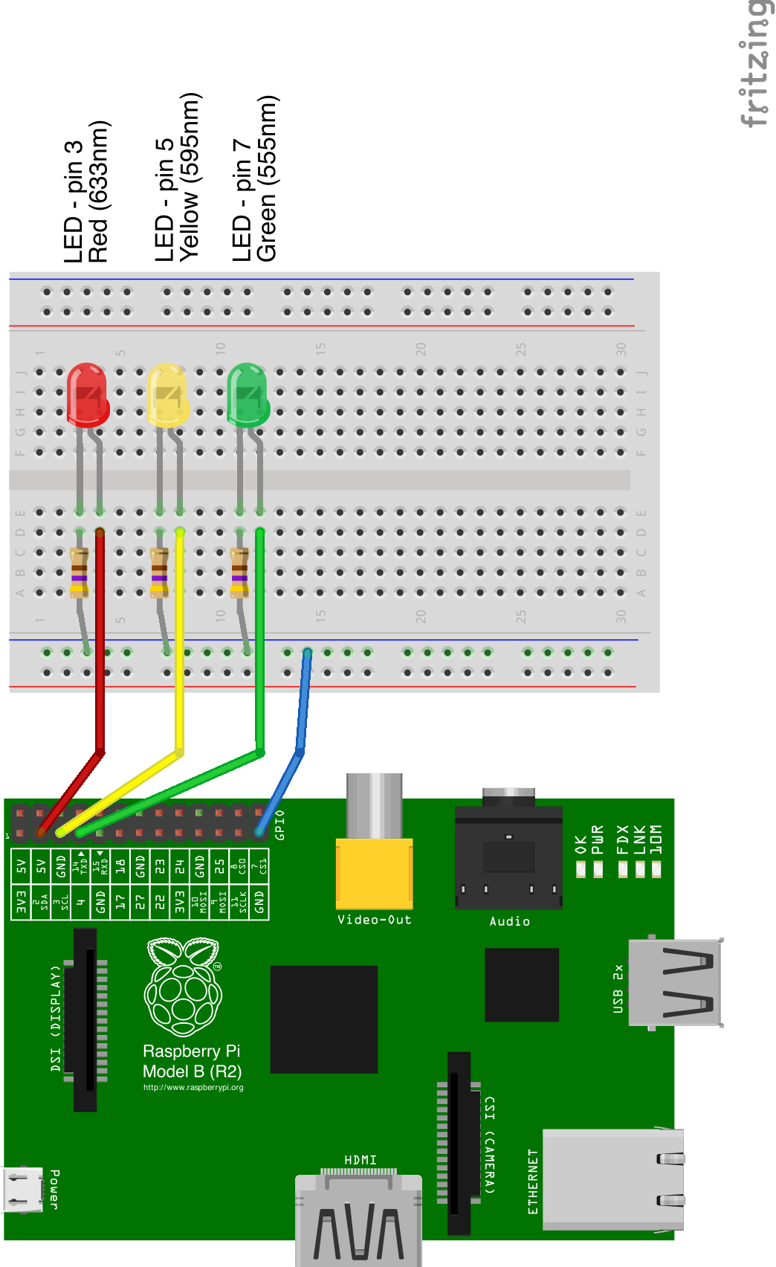

Step 4: write test program to make LEDs blink

Step 4.1: type code for leds.py
- In the IDLE 3 program, click the menu File : New Window to create a new file.
- Save the file to /home/pi with the name leds.py
- Type the code below and save it to leds.py.

from time import sleep
import atexit
import RPi.GPIO as GPIO

atexit.register(GPIO.cleanup)
GPIO.setmode(GPIO.BOARD)

LED_PINS = [('red', 3), ('yellow', 5), ('green', 7)]

def activate(active_color):
for color, pin in LED_PINS:
GPIO.output(pin, color == active_color)

for color, pin in LED_PINS:
GPIO.setup(pin, GPIO.OUT)
GPIO.output(pin, 0)

if __name__=='__main__':

for i in range(3):
for color, pin in LED_PINS:
print color
activate(color)
sleep(.5)

Step 4.2: test the leds.py program
- Open the LXTerminal program.
- At the $ prompt, type: sudo python leds.py
Note: Python programs that control the GPIO pins must be executed by root (the super user, or system administrator). Therefore the program above cannot be tested using F5 from IDLE if you are logged in as the pi user. You must open the terminal and use the sudo command to run the program as root (sudo is short for “super-user do”).

Step 5: Integrate the traffic panel to the LEDs

Step 5.1: Edit the traffic panel program
You need to add just 4 lines to the trafficpanel2.py program to make trafficpanel3.py
- In the IDLE 3 program, open the trafficpanel2.py program.
- Use the menu command File : Save as to save it as trafficpanel3.py in the /home/pi folder.
- Add the 4 lines of code marked with # <-- step 5

from turtle import *
from leds import activate # <-- step 5

def square(color):
fillcolor(color)
begin_fill()
fd(100)
rt(90)
fd(100)
rt(90)
fd(100)
rt(180)
end_fill()

def draw_panel():
setworldcoordinates(0, 0, 300, 300)
speed(0)
penup()
goto(100, 300)
square('red')
square('yellow')
square('green')

# step 2: type code FROM this line
def switch(x, y):
print('click at y = ', y)
if 0 <= y < 100:
bgcolor('dark green')
activate('green') # <-- step 5
elif 100 <= y < 200:
bgcolor('#880')
activate('yellow') # <-- step 5
else:
bgcolor('dark red')
activate('red') # <-- step 5

onscreenclick(switch)
# step 2: type code TO this line

draw_panel()

mainloop()

Step 5.2: test the integrated traffic panel
- Open the LXTerminal program.
- At the $ prompt, type these two lines:
$ xhost +
$ sudo python trafficpanel3.py
- If everything worked, you should be able to control de traffic LEDs by clicking on the colored squares in the graphical interface of trafficpanel3.py

Note: this last step shows how to run a graphical program, trafficpanel3.py as root using sudo. The problem is that we are logged in as the pi user and when we use sudo to run a graphical program as the root user, GNU/Linux will not allow it because another user cannot control the current graphics display. The xhost + command allows other users, including root, to connect to the display.

© 2014 by Luciano Ramalho.

Text, code and images created Luciano Ramalho using LibreOffice and Fritzing.
License: Creative Commons BY-SA (copies and derived works should give credit to the original author and be shared under the same license; commercial use is OK).

Source files available at: http://github.com/garoa/hardware-dojos

