## Summary Of the testing device

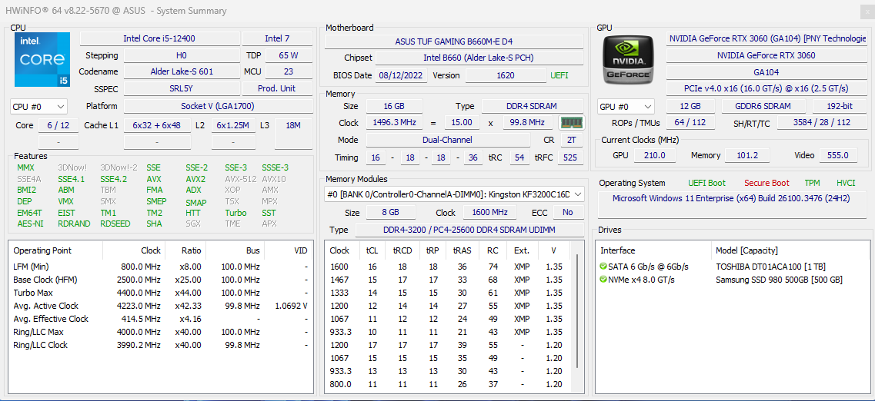

# Testing the CPU performance

**Idle**

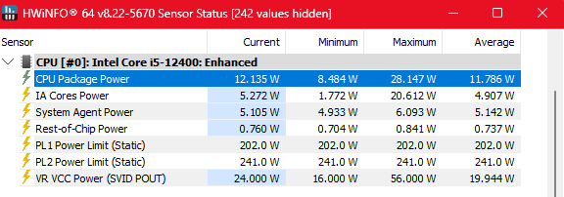

## CPU_256

CPU Time: 0.004 seconds

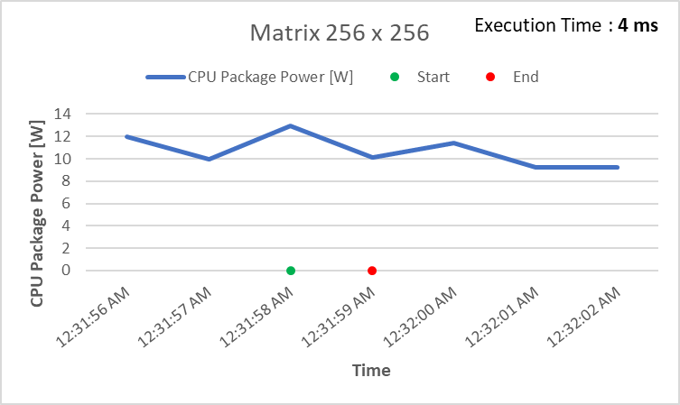

## CPU_1024

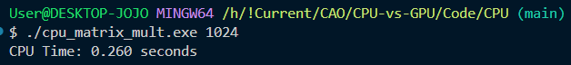

CPU Time: 0.260 seconds

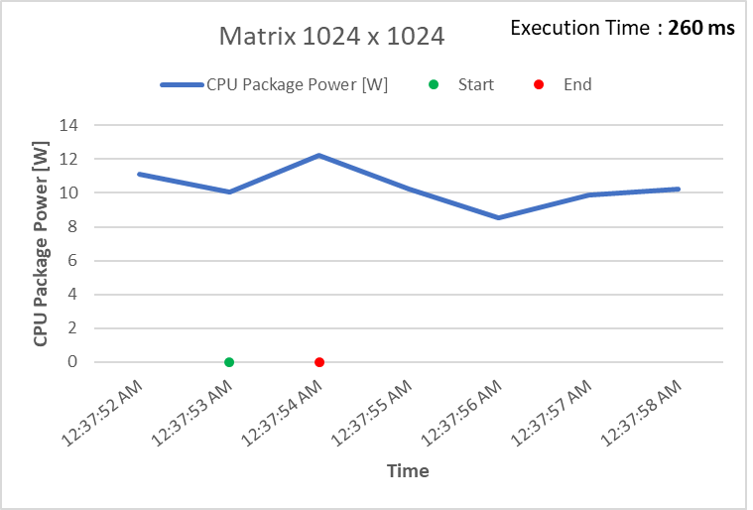

## CPU_2048

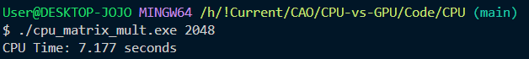

CPU Time: 7.177 seconds

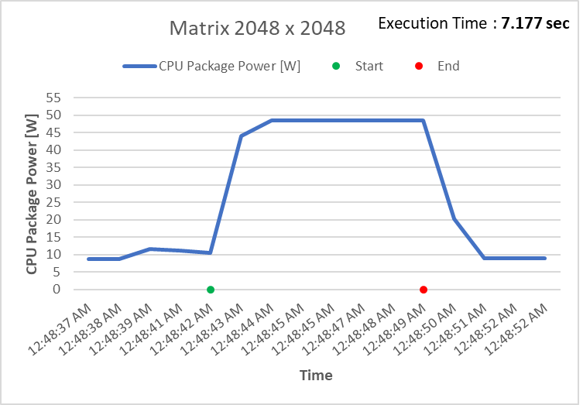

## CPU_ 4096

CPU Time: 156.527 seconds

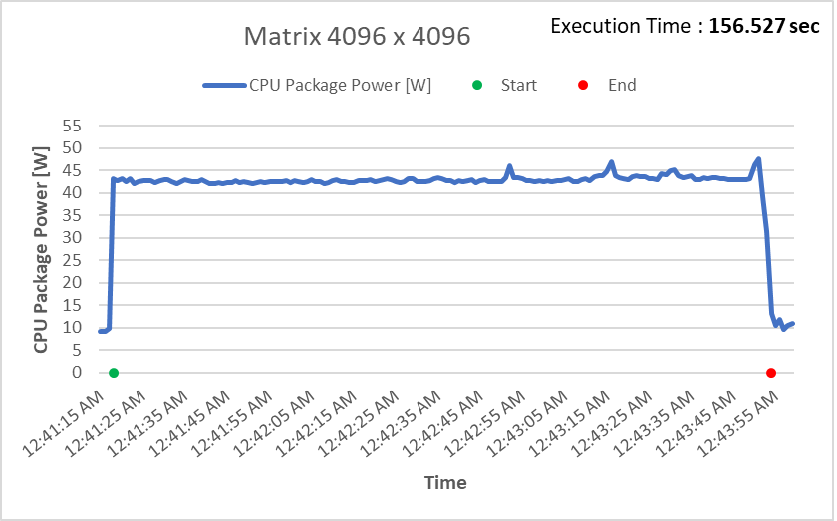

# Testing the GPU performance

**Idle**

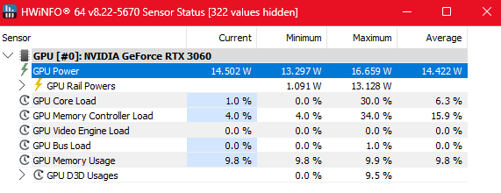

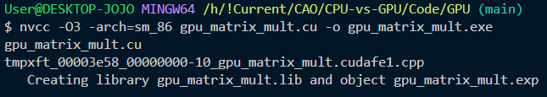

## GPU_256

GPU Time: 1.859 ms

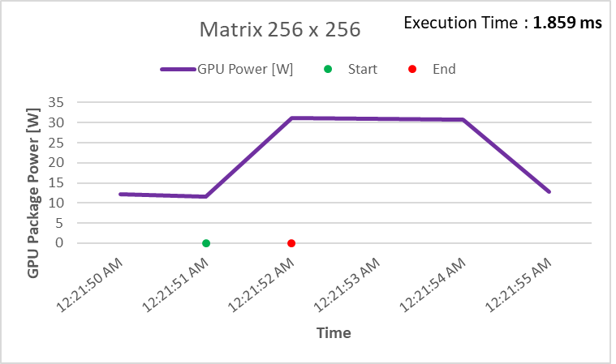

## GPU_1024

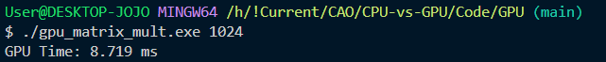

GPU Time: 8.719 ms

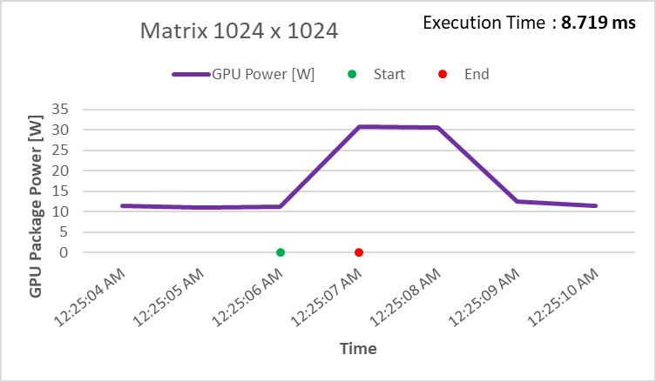

## GPU_2048

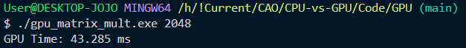

GPU Time: 43.285 ms

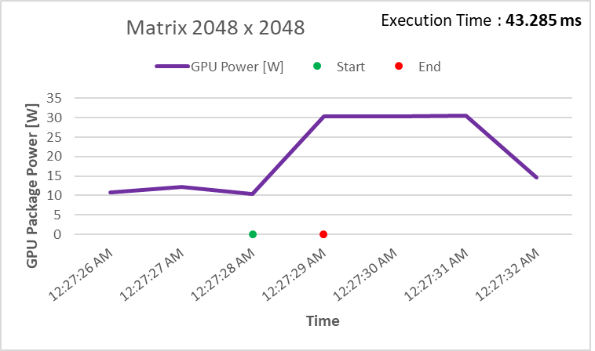

## GPU_ 4096

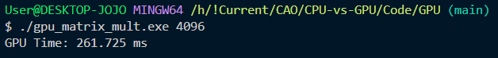

GPU Time: 261.725 ms

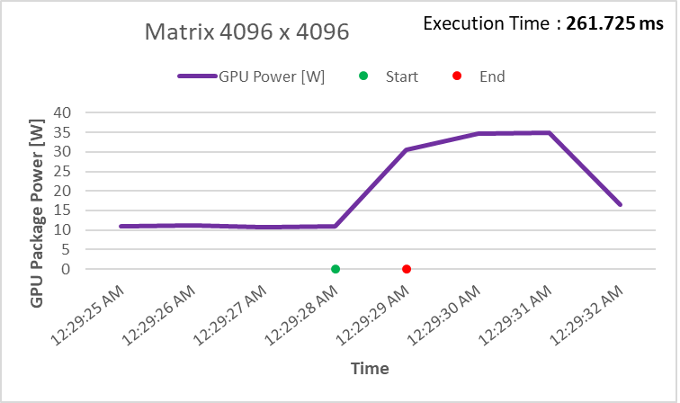

## Overall Comparison

**Power**

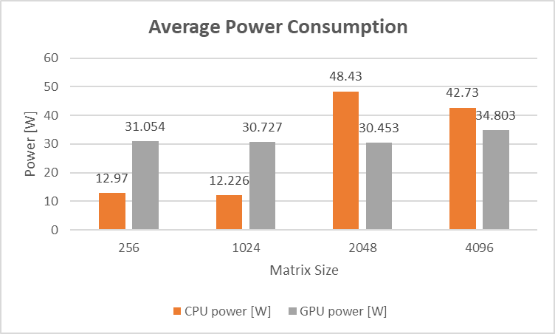

**Time**

