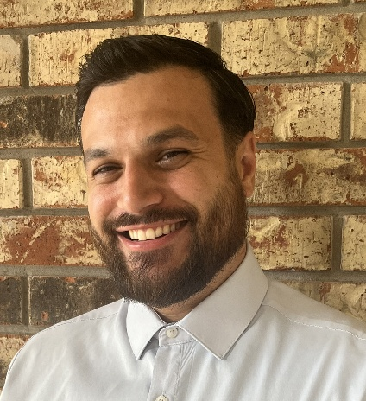

Garret Perez
4026 lotus dr, Pearland TX (346) 604-1635
Garret.p92@gmail.com
SKILLS

ASW

Pocket advantage

Management skills

Mirco strategy

Organized

Task oriented

Takes initiative

West 1 wine and spirits

Creativity

Team Player

EXPERIENCE
October 2018 – March 2021
Sales Representative / District Trainer – Young’s Market Company / RNDC
Managed a designated sales territory, created appealing merchandising displays to enhance consumer engagement. As District Trainer, onboarded and trained new hires on planning, selling, merchandising,
June 2023 – April 2024
Sales Representative – RNDC
Maintained regular contact with accounts to promote wine portfolio, increase sales, and meet supplier goals. Designed custom prints and menus to support promotional efforts. Provided account management and client support, ensuring alignment with brand objectives and overall sales strategy. In multiple states – Florida, Georgia, Texas
April 2024 -January 2025
District Manager Support Representative – Wine & spirits – RNDC
Supported sales and merchandising activities through problem-solving, market surveys, and strategic planning using micro reports. Conducted weekly sales meetings, led team restructuring, managed staffing, and oversaw resets across multiple retail chains. Contributed to territory planning, personnel development, and supplier program execution. Oversaw dedicated merchandiser teams for SPEC’s, Total Wine & More including will-call, POS. Also running Sales support teams aligned with chain account managers. Hotshots, new store setups, team hiring and training. accurate and timely planogram execution. Manage weekly load distribution, build strong store relationships, and drive sales through effective display strategies and upselling initiatives.
January 2025 – current
District Manager sales – Wine – RNDC
Sales District Manager with experience leading sales and merchandising teams across major retail chains including HEB, Kroger, Walmart, Target, and Total Wine & More. Skilled in territory planning, team leadership, staffing, resets, planogram execution, and driving sales through strategic displays, upselling, and supplier program execution. Experienced in building strong retail relationships to grow territory performance.

