Project 1

<Guessing Game>

CIS-5-42409

Name: Garret Koontz

Date: 04/10/2019

**Summary**

Project Size: 104 lines of code

Number of variables: 6

I used the basic concepts we have learned, from increments and decrements, string interpolation, and if-else/ while statements. It took me a few days to finish. It was not that hard to get through. I utilized the text book, online resources like Stack Overflow, and Youtube.

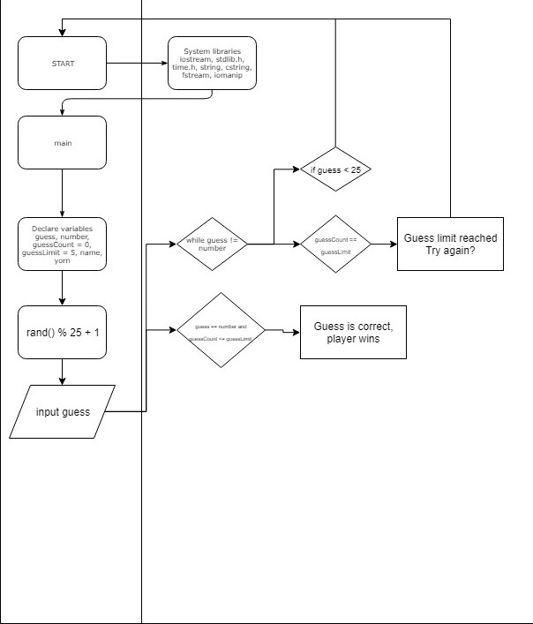**Flowchart / Pseudocode**

**Variables**

|  |  |  |
| --- | --- | --- |
| Type | Name | Purpose |
| int | number | This is the random number that is generated from rand() % 25 + 1 |
|  | guess | The user input |
|  | guessCount | How many guesses the user currently has |
|  | guessLimit | How many guesses you can have |
| string | name | User input |
|  | yorn | User input for yes or no for wanting to try again |

**Reference**

Textbook

Stack Overflow

C++ library websites

**Program**

#include <iostream>

#include <stdlib.h>

#include <time.h>

#include <string>

#include <cstring>

#include <fstream>

#include <iomanip>

using namespace std;

int main() {

int guess,

number,

guessCount = 0,

guessLimit = 5;

string name;

string yorn;

//This is the library function for random number generation.

rerun:

srand(time(NULL));

// This creates the range for where the random number will fall in between.

number = rand() % 25 + 1;

system("cls");

ifstream in;

ofstream out;

string fileIn;

char fileOut[]="highscores.dat";

fileIn = "highscores.dat";

in.open(fileIn.c_str());

out.open(fileOut);

cout << "Hello, welcome to Random Guesser!" << endl;

cout << "~~~~~~~~~~~~~~~~~~~~~~~~~~~~~~~~~" << endl;

cout << endl;

cout << "Enter your name : ";

cin >> name;

cout << "The random number has been generated." << endl;

cout << "It is between 1 and 25." << endl;

cout << "You can guess 5 times." << endl;

// Using this if you wants to play again.

while (guess != number) {

cout << "Enter your guess: " << endl;

cin >> guess;

// If the guess is over 25, it will prompt you to try again.

if (guess > 25){

cout << "Please enter a number between 1 and 25. Try again." << endl;

goto rerun;

}

// If the entered guess is within 1 of the random number, you will get a notice telling you are close to guessing it.

if (guess == number + 1 || guess == number - 1) {

cout << "You are so close!" << endl;

}

guessCount++;

// If the guess is not equal to the number and if you reach the guess limit,

// you lose and it will prompt you if you would like to try again.

if (guess != number && guessCount == guessLimit) {

cout << "Sorry, you reached the guess limit of " << guessLimit << endl;

// You have the option to try again by typing Y for yes or N for no.

// It is not limited to capitalization.

cout << "Would you like to play again? (Y/N)" << endl;

cin >> yorn;

// If Y or y is entered, the program will jump back up to the line called rerun.

if (yorn == "Y" || yorn == "y") {

goto rerun;

// If N or n is entered, the program will terminate.

} else if (yorn == "N" || yorn == "n") {

exit(0);

}

}

}

// If the guess is equal to the random number and if the guess count is less tha nor equal to the guess limit,

// you win the game and have the option to play again.'

if (guess == number || guessCount <= guessLimit) {

cout << "Congrats " << name << "! You win!" << endl;

cout << "The number was " << number << endl;

cout << "It took you " << guessCount << " guesses." << endl;

cout << "Would you like to play again? (Y/N)" << endl;

cin >> yorn;

if (yorn == "Y" || yorn == "y") {

goto rerun;

} else if (yorn == "N" || yorn == "n") {

exit(0);

}

}

in.close();

out.close();

return 0;

}