CS420 Project: Database Normalization and Implementation (3NF)

Project Overview
In this project, you will analyze a poorly designed database table, identify its problems, and transform it into a well-structured database in Third Normal Form (3NF). You will then implement your final design using MySQL.
This project simulates a real-world scenario where data is initially stored in an unorganized format and must be improved for efficiency, consistency, and scalability.

Scenario: Tutoring Center System
A university tutoring center maintains records of tutoring sessions. Currently, all data is stored in a single large table, which leads to redundancy and data anomalies.

Current Table (Unnormalized)
TUTORING_RECORD
(SessionID, SessionDate, SessionTime,
StudentID, StudentName, StudentEmail, Major,
TutorID, TutorName, TutorEmail,
CourseID, CourseTitle, Department,
RoomID, RoomBuilding, RoomCapacity,
SessionType, HourlyRate, DurationMinutes)

Business Rules
- Each tutoring session is uniquely identified by SessionID.
- A student can attend multiple tutoring sessions.
- A tutor can conduct multiple tutoring sessions.
- A course can appear in multiple tutoring sessions.
- A room can host multiple tutoring sessions.
- Each session has exactly:
o one student o one tutor o one course o one room
- Student details depend only on StudentID.
- Tutor details depend only on TutorID.
- Course details depend only on CourseID.
- Room details depend only on RoomID.

Project Tasks

Part 1: Analyze the Current Design
- Identify the primary key of the table.
- Write at least 5 functional dependencies.
- Describe the following anomalies: o one insertion anomaly o one update anomaly o one deletion anomaly
Primary key is SessionID
- SessionID -> SessionDate, SessionTime, SessionType, HourlyRate, DurationMinutes, StudentID, TutorID, CourseID, RoomID
- StudentID -> StudentName, StudentEmail, Major
- TutorID -> TutorName, TutorEmail
- CourseID -> CourseTitle, Department
- RoomID -> RoomBuilding, RoomCapacity
INSERTION – You can’t record a new room util it has a session booked
UPDATE – If a student switches their major you’d have to update every session row they appear in
DELETION – If a student’s only tutoring session is canceled and that row is deleted, the student’s name, email, and major would be lost

Part 2: Normalize to 3NF
- Decompose the table into 3NF relations.
- For each table, clearly specify:
o table name o attributes o primary key (PK) o foreign keys (FK)
SESSION
Attributes: SessionID, SessionDate, SessionTime, SessionType, HourlyRate, DurationMinutes, StudentID, TutorID, CourseID, RoomID
PK: SessionID
FK: StudentID, TutorID, CourseID, RoomID
STUDENT
Attributes: StudentID, StudentName, StudentEmail, Major
PK: TutorID
TUTOR
Attributes: TutorID, TutorName, TutorEmail
PK: TutorID
Course
Attributes: CourseID, CourseTitle, Department
PK: CourseID
ROOM
Attributes: RoomID, RoomBuilding, RoomCapacity
PK: RoomID

Part 3: Implement in MySQL
- Create a database.
- Write SQL statements to: o create all tables o define primary keys o define foreign key constraints o use appropriate data types

Part 4: Insert Sample Data
You must insert at least 5 records into EACH table:
- Student → ≥ 5 rows
- Tutor → ≥ 5 rows
- Course → ≥ 5 rows
- Room → ≥ 5 rows
- Session → ≥ 5 rows
Data Quality Requirements

• Data must be realistic and meaningful
- Foreign key relationships must be valid
- Avoid placeholder values like "abc" or "test"
- Data should show variety (different majors, courses, durations, etc.) Submissions with poor or inconsistent data will lose points.

Part 5: Write Queries
Write and execute the following queries:
- Display all tutoring sessions with:
  - student name o tutor name
  - course title
  - room ID
- List all sessions for a specific student 3. List all sessions conducted by a specific tutor 4. Count the number of sessions:
  - per course or o per room
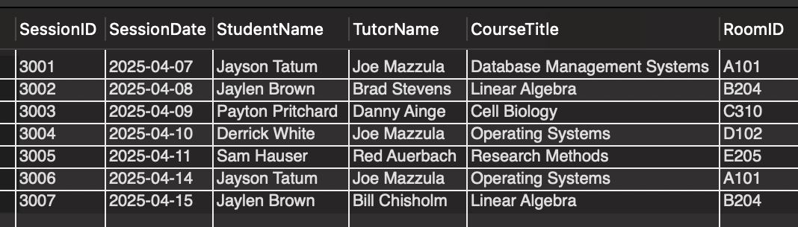
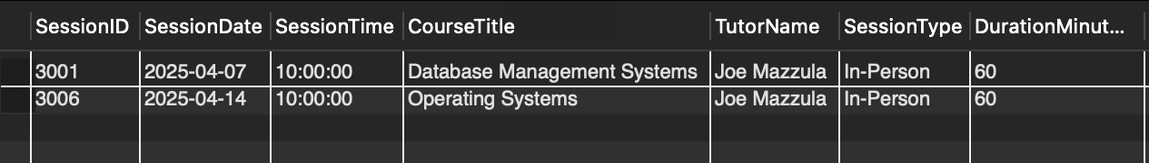
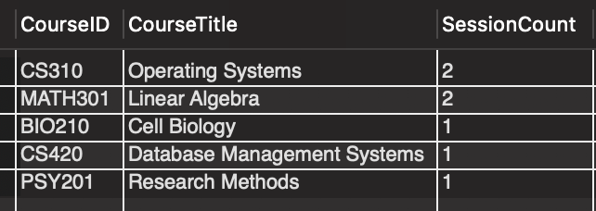
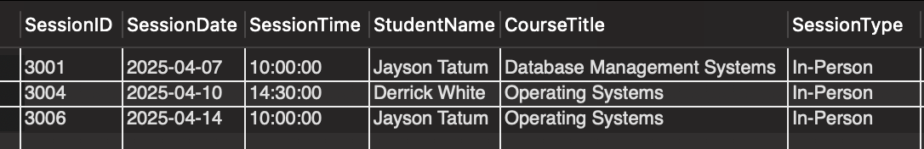
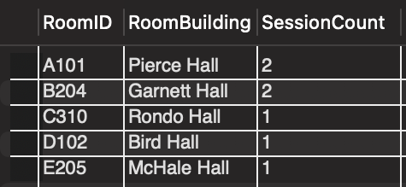
Deliverables
Please upload everything to GitHub. Check list:

Design Document (PDF or Word)
Include:
- functional dependencies
- final 3NF schema
- 2-3 instances for each table

SQL File (.sql)
Include:
- CREATE DATABASE
- CREATE TABLE
- INSERT statements
- Queries

Screenshots
• query results

