Task 1
Hospital
Attribute | Type | Other
hospital_id | Integer | Primary Key
name | String | Name of hospital
address | String (composite) | Composed of street, city, state, zip
phone | String | Phone number
Entity type: Strong, hospital has its own unique identity that does not depend on another entity for its existence or identification
Department
Attribute | Type | Other
dept_name | String | Partial key – only unique within a hospital
hospital_id | Interfer (FK) | Identifying foreign key from Hospital
dept_id | Integer | Surrogate key used for referenceing
Entity type: Weak, department names are only unique within a given hospital. A department cannot exist without a hospital
Doctor
Attribute | Type | Notes
doctor_id | Interger | Primary key
name | String (composit) | Composed of first_name, last_name
specialty | String | Medical specialty
dept_id | Integer (FK) | Foreign key to Department
Entity type: Strong, doctor_id is a globally unique identifier that exist independently of any department assignment.
Patient
Attribute | Type | Notes
patient_id | Integer | Primary key
name | String (composite) | Composed of first_name, last_name
dob | Date | Date of birth
phone | String | Phone number
address | String (composite) | Composed of street, city, state, zip
Entity type: Strong, patient_id is a globally unique identifier and exist independently of any appointment
Appointment
Attribute | Type | Notes
appt_date | Date | Partial key
appt_time | Time | Partial key
appt_id | Integer (PK) | Surrogate key for referencing
patient_id | Integer (FK) | Links to Patient, partial key
doctor_id | Integer(FK) | Links to doctor
Entity type: Weak, appointments don’t exist without patients
Medication
Attribute | Type | Notes
med_id | Integer (PK) | Primary key
name | String | Name of medication
manufacturer | String | Pharmaceutical company
type | String | type of medicaiton
Entity type: Strong, medications exist independently of patients or doctors
Task 2
Relationship | Entities | Cardinality | Participation | Attributes
Contains | Hospital -> Department | 1:N | Hospital: partial  Dept: total | Each department belongs to one hospital. A hospital may have many departments.
Employs | Department-> Doctor | 1:N | Dept: partial  Doctor: total | Each doctor works in one department. A department may have many doctors.
Headed by | Department -> Doctor | 1:1 | Dept: total  Doctor: partial | Each department has one head doctor. A doctor may or may not be a department head.
Supervises | Doctor -> Doctor | 1:N | Both: partial | A doctor may supervise zero or more other doctors. A doctor may have zero or one supervisor.
Has | Patient -> Appointment | 1:N | Patient: partial  Appt: total | Each appointment belongs to one patient. A patient may have one to many appointments.
Conducts | Doctor -> Appointment | 1:N | Doctor: partial  Appt: total | Each appoint involves one doctor. A doctor may conduct many appointments
Prescribes | Appointment <-> Medication | M:N | Both: partial | A medication may be prescribed in many appointments. An appointment may involve many medications

Task 3
Department
Is the key globally unique? No, department names are only unique within a given hospital. Two hospitals may each have a Cardiology department, so dept_name cannot be a global primary key.
Is it existence-dependent? Yes, a department cannot exist without belonging to a hospital. If a hospital is deleted all of its departments are also deleted.
Does it require an identifying relationship? Yes, hospital -> department is the identifying relationship. Dept_name is a partial key and the full identifying key is the combination of dept_name and hospital_id.
Final decision: Weak. Department is locally unique within a hospital. A department cannot independently exist without a hospital.
Appointment
Is the key globally unique? No, an appointment is characterized by its date, time, patient, and doctor. A date-time pair is not globally unique because two patients could have appointments at the same time. A doctor-patient pair is not globally unique because a doctor and patient can have many appointments together. Only combining the date, time, and patient be uniquely identified but we have a surrogate appt_id to allow the appointment to be uniquely identifiable.
Is it existence-dependent? Yes, every appointment must have a patient and a doctor.
Does it require an identifying relationship? Yes the patient has an appointment is the primary identifying relationship.
Final decision: Weak. Appointment requires a patient and a doctor so it cannot be a strong entity.
Task 4
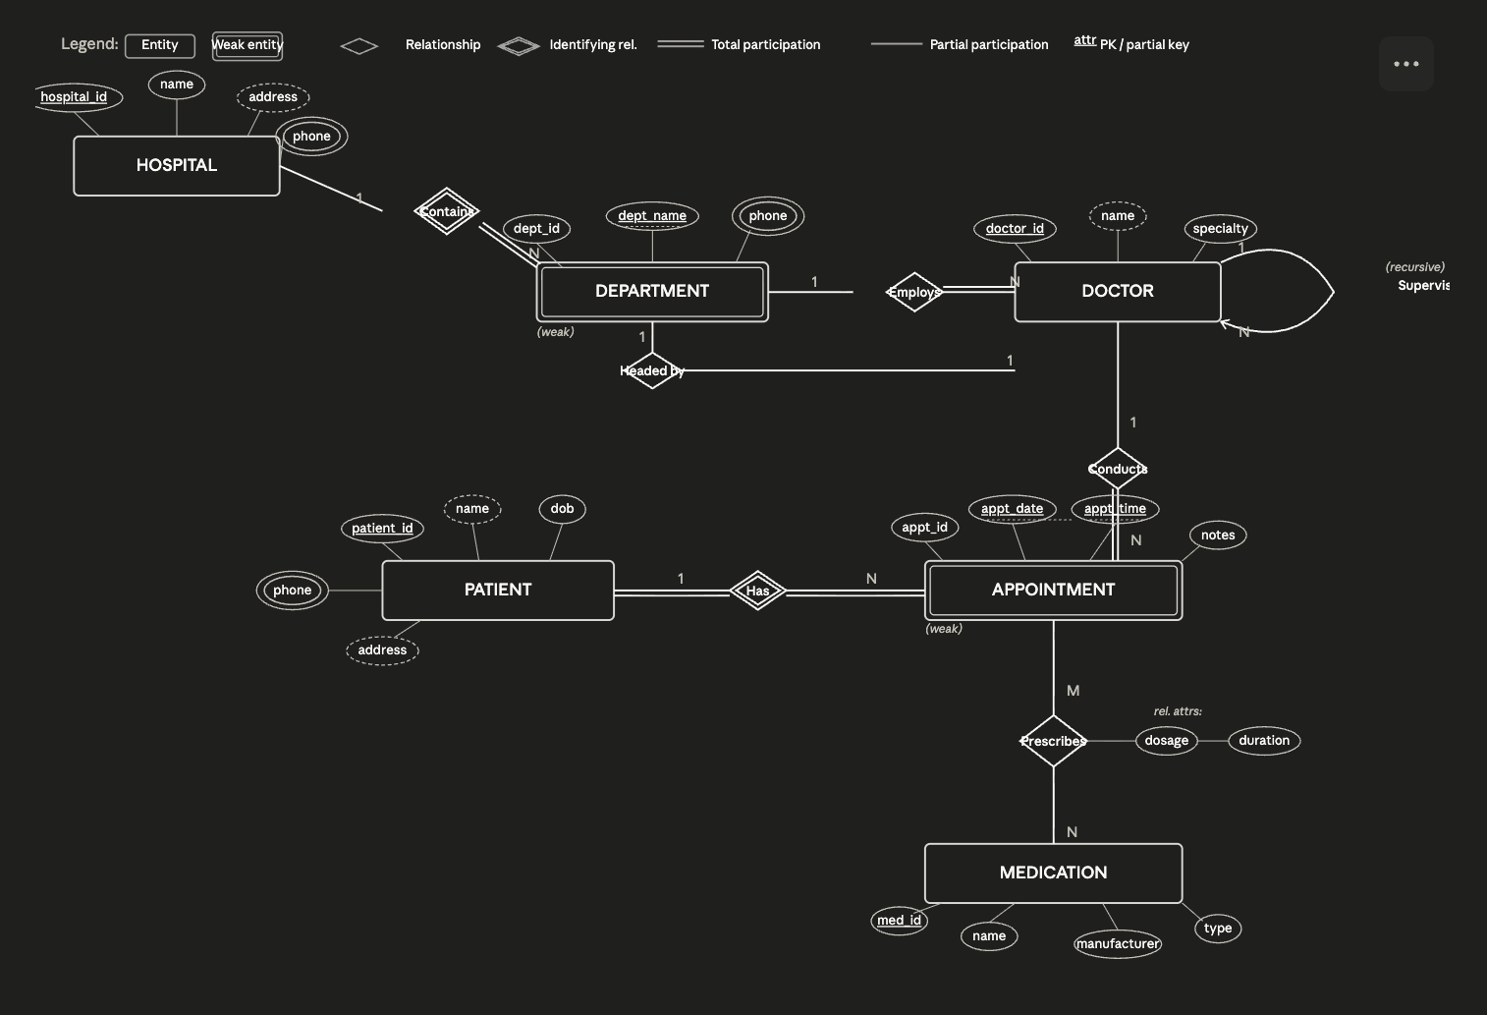
Task 5
Hospital
hospital_id (PK) | name | address | phone
1 | Boston Medical Center | 100 Paul Pierce Way, Boston, MA | 425-555-1100
2 | New Balance Health Center | 200 Kevin Garnett St, Boston, MA | 425-555-1200
3 | New England Regional Medical | 300 Vrabrel Ave, Boston, MA | 425-555-1300
4 | Fenway Hospital | 400 Bill Russel Dr, Boston, MA | 425-555-1400

Department
dept_id (PK) | dept_name | hospital_id (FK)
10 | Cardiology | 1
11 | Pediatrics | 2
12 | Neurology | 1
13 | Orthopedics | 3

Doctor
doctor_id (PK) | name | specialty | phone | dept_id (FK) | supervisor_id (FK)
100 | Dr. Derrick White | Cardiology | 425-555-1101 | 10 | NULL
101 | Dr. Peyton Pritchard | Pediatrics | 425-555-1201 | 11 | 120
102 | Dr. Jaylen Brown | Neurology | 425-555-1102 | 12 | NULL
103 | Dr. Jayson Tatum | Orthopedics | 425-555-1301 | 13 | 140

Patient
patient_id (PK) | name | dob | phone | address
200 | Joe Mazzulla | 10-10-1990 | 425-345-8765 | 123 Celtics Way, Boston, MA
201 | Brad Stevens | 03-15-1982 | 425-476-1345 | 345 Green St, Boston, MA
202 | Danny Ainge | 05-23-1958 | 425-985-0938 | 958 Clover Dr, Boston, MA
203 | Larry Bird | 09-04-1955 | 425-554-4987 | 33 Garden Ave, Boston, MA

Appointment
appt_id (PK) | appt_date | appt_time | notes | patient_id (FK) | doctor_id (FK)
300 | 05-10-2026 | 09:00 | Joe has a broken hand | 200 | 103
301 | 05-10-2026 | 12:00 | Brad is bringing his kid in for a checkup | 201 | 101
302 | 05-10-2026 | 14:00 | Possible dementia checkup | 202 | 102
303 | 05-10-2026 | 15:00 | Heart check up | 203 | 100

Medication
med_id (PK) | name | manufacture | type
400 | mediaction 1 | Big Pharma | Feel good medicine
401 | medication 2 | Medium Pharma | Sleep medicine
402 | medication 3 | Big Pharma | Dementia medicine
403 | medication 4 | Small Pharma | Blood pressure

Prescribes
appt_id (FK) | med_id (FK) | dosage | duration
300 | 400 | 15mg | 30 days
301 | 401 | 5mg | 30 days
302 | 402 | 25mg | 90 days
303 | 403 | 10mg | 45 days

