Density and Neutral Variables

Garrett Finucane

Table of Contents
1. Who is this for?
2. In-situ density
3. (My view of) A physical oceanographer's view of the ocean.
4. Why is in-situ density not neutral?
5. Potential density
6. The Neutral Tangent Plane and Helicity
6.1. The Neutral Tangent Plane
6.2. Helicity
7. Neutral Density
8. Conclusion
9. Other Density Variables
9.1. Omega surfaces
9.2. Topobaric Density
9.3. In-situ density anomaly surfaces
10. Bonus fun figures

Who is this for?
There are a number of densities floating around in the oceanographic world and it can be hard to understand the difference between them. This article aims to be a straightforward primer on oceanographic density for those with little background in physical oceanography. It's also meant to be pretty hand wavey

In-situ density
The in-situ density of seawater is the mass per unit volume of seawater as a function of its salinity, temperature, and pressure (depth). In-situ density in experimentally determined in a lab, and software toolboxes like TEOS-10 (The Equation Of State 10) offer extremely accurate functional forms of in-situ density which anyone can use. Case closed then right? Wrong! While in-situ density is great at giving us the mass per unit volume of any water parcel in the world ocean, oceanographers want alot more than that out of their density. To understand why, we're going to take a step back and look at the broader picture.

(My view of) A physical oceanographer's view of the ocean.
The ocean is on average a meer 4 kilometers deep and has basins which are thousands of kilometers wide. The ocean is a thin film that lies on the crust of the earth. This may lead you to believe that the ocean mixes from vertically from the bottom to the top, but the opposite is true. Beneath the top layer of the ocean, which is mixed by winds and weather, seawater mixes very little and therefore changes very little from the location it was created. Water 1000s of meters deep will often maintain the properties that it had when it was last at the surface. Why doesn't water mix vertically? Because it is stratified by density. Cold salty water which is formed at the poles, sinks to the bottom of the water and becomes even more dense as it is crushed by 1000s of dbar of water above it. Warm, fresh water formed in the tropics sits on top. Much like a cup that contains oil and water, it is hard to mix water which is so different. This allows the physical oceanographer to make a make a very powerful simplification. By assuming that there are neutral surfaces which water can travel through without changing its density, the physical oceanographer can decompose the insanely complex three dimensional circulation of the ocean, into a set of two dimensional neutral surfaces through which water travels on but not across.

Why is in-situ density not neutral?
So now let's return to in-situ density. Consider two adjacent points in the ocean x0 and x1 which have the same in-situ density, but different water properties (s0, t0, p0) and (s1, t1, p1) respectively. These points have the same in-situ density (mass over volume), but does that mean they lie on the same neutral surface? Well if the two points are on the same neutral surface then it should be that they can mix without changing density. Let's pretend that both pieces of water are at the mid point of their two pressures as though they were mixing at their mid point. Without any loss of generality lets assume that the water parcel at x0 is at a lower pressure than the water at x1. This means to meet at their midpoint, the parcel that began at x0 must rise, and the parcel that began at x1 must sink. As the x0 parcel rises it is being crushed by less water above it, expands, and becomes less dense. As the x1 parcel sinks, it is being crushed by more water making it shrink and become more dense. By the time they meet in the middle, the parcel which began at x0 is significantly less dense than the one at x1.This is illustrated in the gif below. We can consider the difference in the densities of these two water parcels at their midpoint a measure of their neutrality. On a perflectly neutral surface, that difference in density would be 0 everywhere.
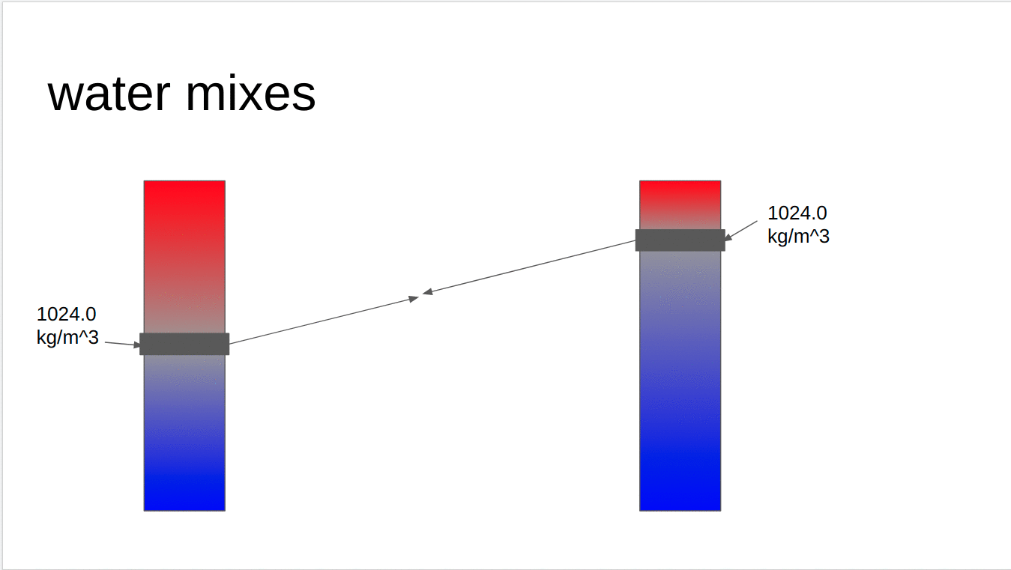
So what does that little thought experiment tell us really? It tells us that lines of constant in-situ density are not neutral surfaces.

Potential density
Next up is the measure of density which is ?the most widely? used. Potential density is the density of a water parcel if it were moved to a reference pressure. Potential density looks at the problems with surfaces of constant in-situ density and says, "The real problem with in-situ density is the effect of pressure on density. Let's use the exact same equation of state, but lets treat them like they are at a reference pressure instead of their actual pressure!" As a result surfaces of constant potential density are far more neutral than surfaces of in-situ density near the reference pressure chosen. However, this does not actually solve the problems outlined in the previous section as two parcels of water which lie on the same neutral surface do not rise/descend to some arbirtrary pressure to mix. In addition, the pressure of water parcels is important, and ignoring it can have some weird effects! Below is a section in the Atlantic ocean of Potential Density with a reference pressure of 0 dbar ($\sigma_0$). Circled in red is a region where water of higher potential density lies above water of lighter potential density. This would imply the water there was actively overturning, however if we were to look at the same chart but with In-situ density contoured, the water would be strictly increasing with depth.
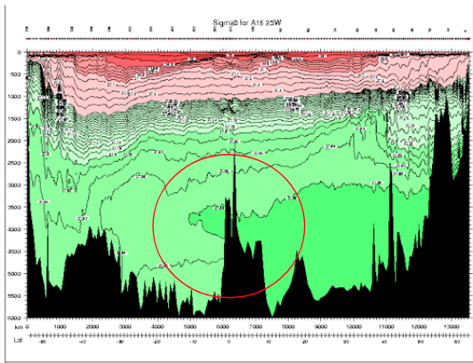

The Neutral Tangent Plane and Helicity
Ok. We've seen how those first two density variables aren't the most neutral but how do we construct a better one. The answer may appear simple; construct a surface that is perfectly neutral upon which water parcels would never experience a restoring force when they travel on it. The thing stopping us is going to be a thorn in our side going forward and it's called helicity. But first, a definition:

The Neutral Tangent Plane
Quickly and informally, we can define the neutral tangent plane as the path between two water columns upon which a water parcel would undergo no restoring force. Practically if we would like to find the neutral tangent plane which passes through (S0,T0,p0) and an adjacent water column with salinity, temperature and pressure (Si,Ti,pi), we want to find where $\rho(S_0,T_0,\frac{p_i+p_0}{2})=\rho(S_i,T_i,\frac{p_i+p_0}{2})$.

Helicity
In a just world, if we followed the neutral tangent plane throughout the ocean we would be traveling along a perfectly neutral surface which we could label a certain density and go home. But the ocean is a cruel mistress. If you follow the neutral tangent plane through the ocean, hopping from one profile to the next, in a big circle, when you return to where you started you will be at a different pressure forming a big corkscrew or helix and that is helicity. erfectly neutral surfaces are not well-defined meaning that at any given point in space there are multiple (maybe infinite) solutions for their depth. This isn't due to a lack of resolution in our sampling of the ocean, it's just due to the complex multivalued nature of the equation of state. An explanation of the math is out of the scope of this paper (check out ), but I think intuitively it makes some sense. Water doesn't travel along perfect surfaces throughout the ocean. As it travels it undergoes changes as it is mixed and modified…
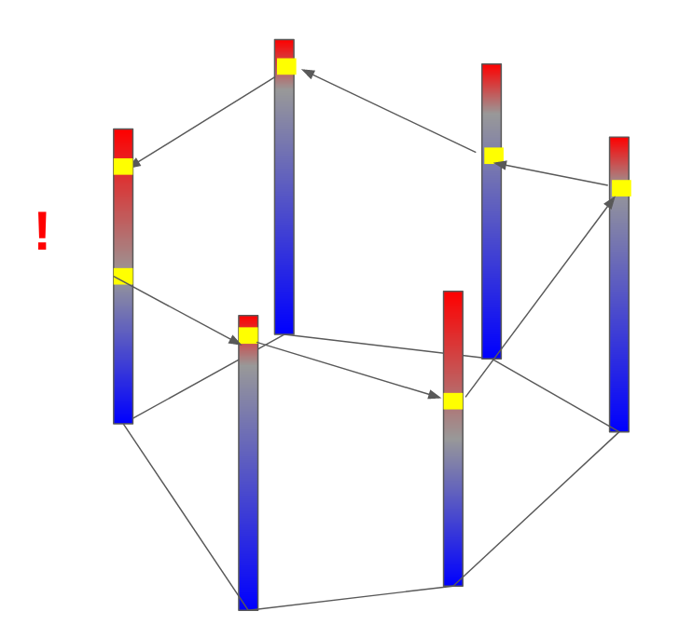

Neutral Density
Helicity. Blech. But we are working oceanographers and helicity will not defeat us! We still want a density variables whose surfaces of constant density are well defined as neutral as possible so we just have to make some tradeoffs! Enter neutral density! Neutral density was made in __ by Jacket and Macdougall and here's a summarized (and simplified) recipe to create it.
- Pick a reference global climatology. In their 1997 paper, Jackett and McDougall use the Leviticus climatology, but really we could use any climatology which provides us profiles of temperature and salinity throughout the world ocean.
- Choose a start point. Once we have a global climatoloy we can select a single profile we will be using as a reference and label it with our new density variable. One fun thing to note here is that the labelling doesn't really matter that much as long as it is increasing (I think?).
- Spread throughout the ocean! Now comes the hard work. Beginning with the reference profile we chose, for each labelled depth we can find the neutral tangent plane between that point on the reference profile, and each adjacent profile in the climatology. We can then repeat this process for each profile we just labelled and the profiles surrounding it. If we repeat this process throughout our entire climatology we will assemble a global set of approximate neutral surfaces that all pass through our reference profile. Then for every point in our climatology we know where on our reference profile it is approximately neutral to and can label it with the associated density that we labelled on the reference profile.
- Profit. So now we have created a global climatology of neutral density, but that doesn't yet help someone to wants to know the neutral density for their latest experiment. If someone comes to us with information about the temperature, salinity, pressure, latitude and longitude of some piece of water in the ocean we know that that piece of water is surrounded (most of the time) by profiles in our global climatology. We can then solve the discrete neutral relation for what pressure on those surrounding profiles is neutral to the given water parcel. Each of the pressures on our reference profiles is associated with a labelled neutral density, and we can then take an average of those answers, weighted by the distance of the input information to each of the reference profiles, to find the neutral density of the supplied water parcel.

Conclusion
Thanks for reading! I hope yuo got something out of this write up. My favorite part about density and neutral densities is the underlying tension between the oceanographers' desire for a measure of density which splits the ocean into well-defined surfaces upon which water travels throughout the ocean, and the reality that those don't really exist. Throw in the fact that the more complex density variables can be substansially more computationally expensive than the equation of state and it becomes clear that an oceanographer has to make a careful choice about what density variable is best for each problem they are working on.

Other Density Variables
Here are some one sentence descriptions of other density variables for fun.

Omega surfaces
Treat surfaces as an optimization problem and minimize error everywhere.

Topobaric Density
Pretend helicity does not exist and do fancy topology to find better density variable.

In-situ density anomaly surfaces
Consider difference from a reference salinity and temperature. Very cool and fun two thumbs up.

Bonus fun figures

