**Stop-Wait Summary Doc**

*Design*

Sender FSM: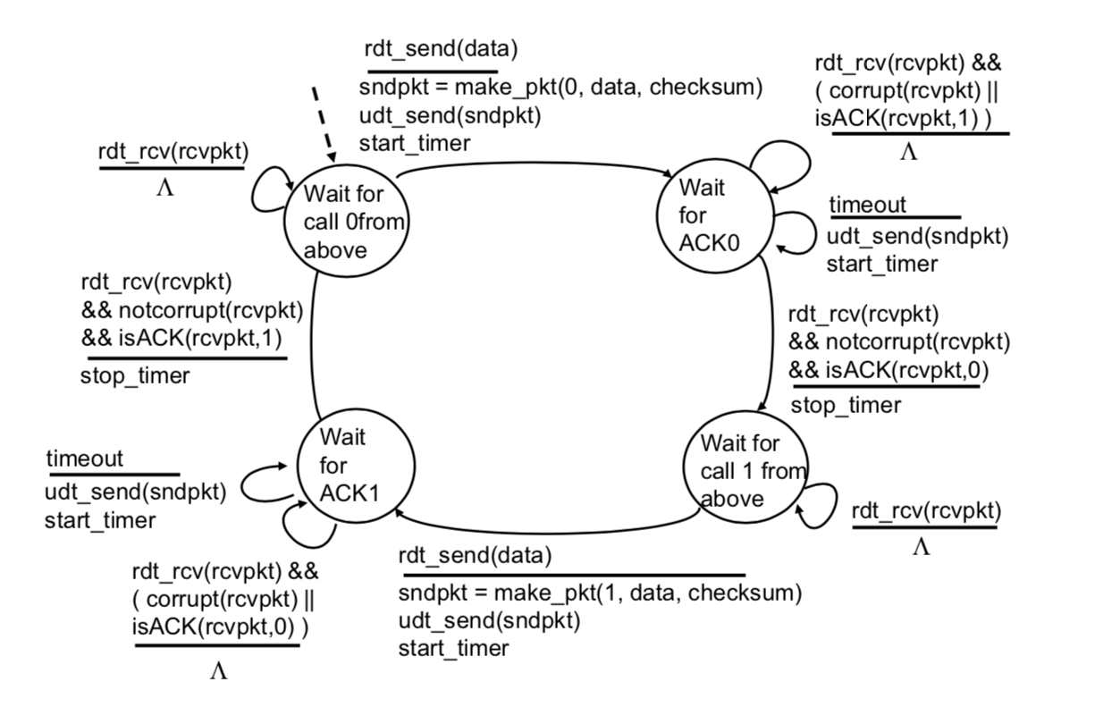

Receiver FSM: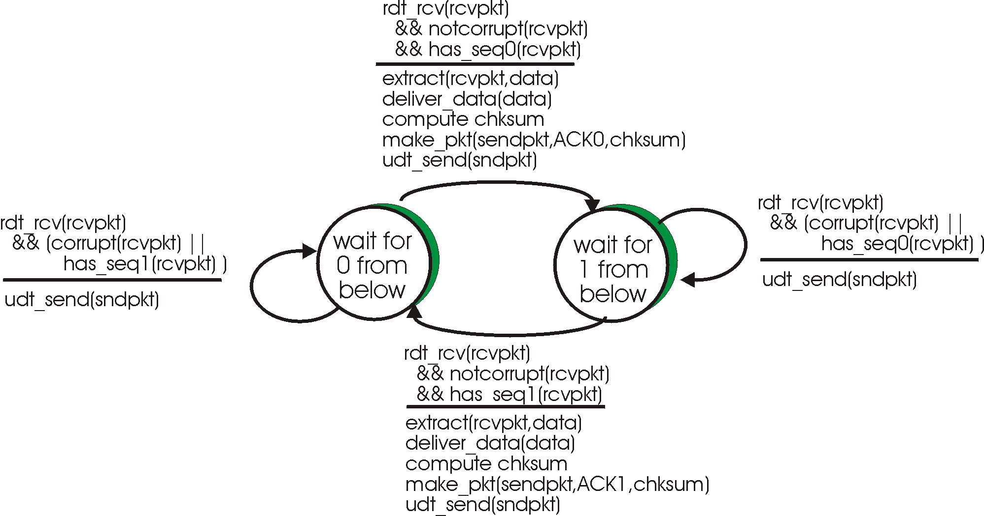

*General Design Procedure:*

I started by implementing this as a unidirectional implementation based on the FSMs above. The sender and receiver struct both kept track of the last packet sent and the last ack returned, respectively. For new packets, the sender would set the seqnum to the opposite (0 or 1) of the last packet sent and the receiver would expect the seqnum opposite to the ack num of the last ack returned. If the receiver received an out of order or corrupted packet it would return a NAK by resending the last ack returned.

*Sample Output*

Key:

Corrupted ACK/NACK Packet Event

Corrupted ACK/NACK Packet Response

Lost ACK/NACK Packet Event

Lost ACK/NACK Packet Response

Corrupted Data Packet Event

Corrupted Data Packet Response

Lost Data Packet Event

Lost Data Packet Response

Output:

----- Network Simulator Version 1.1 --------

Enter the number of messages to simulate: 11

Enter packet loss probability [enter 0.0 for no loss]:0.1

Enter packet corruption probability [0.0 for no corruption]:0.3

Enter average time between messages from sender's layer5 [ > 0.0]:1000.0

Enter TRACE:2

EVENT time: 696.571045, type: 1, fromlayer5 entity: 0

[696.571045 A_output() Seq: 0] --> Sending new packet to B

EVENT time: 701.979919, type: 2, fromlayer3 entity: 1

[701.979919 B_input() Seq: 0] --> B received valid packet from A. Sending Ack: 0

TOLAYER3: packet being corrupted

EVENT time: 706.738098, type: 2, fromlayer3 entity: 0

[706.738098 A_input() Ack: 0] --> ACK from B is corrupted/invalid. Ignoring

EVENT time: 726.571045, type: 0, timerinterrupt entity: 0

[726.571045 A_timerintterupt()] --> Resending packet 0 from A

EVENT time: 736.099182, type: 2, fromlayer3 entity: 1

[736.099182 B_input() Seq: 0] --> B received corrupted/unordered packet from A. Resending Ack: 0

EVENT time: 745.802429, type: 2, fromlayer3 entity: 0

[745.802429 A_input() Ack: 0] --> Recieved valid ACK from B

EVENT time: 1966.186157, type: 1, fromlayer5 entity: 0

[1966.186157 A_output() Seq: 1] --> Sending new packet to B

EVENT time: 1975.974609, type: 2, fromlayer3 entity: 1

[1975.974609 B_input() Seq: 1] --> B received valid packet from A. Sending Ack: 1

TOLAYER3: packet being lost

EVENT time: 1996.186157, type: 0, timerinterrupt entity: 0

[1996.186157 A_timerintterupt()] --> Resending packet 1 from A

EVENT time: 2003.139526, type: 2, fromlayer3 entity: 1

[2003.139526 B_input() Seq: 1] --> B received corrupted/unordered packet from A. Resending Ack: 1

EVENT time: 2004.153198, type: 2, fromlayer3 entity: 0

[2004.153198 A_input() Ack: 1] --> Recieved valid ACK from B

EVENT time: 3866.870605, type: 1, fromlayer5 entity: 0

[3866.870605 A_output() Seq: 0] --> Sending new packet to B

EVENT time: 3876.321533, type: 2, fromlayer3 entity: 1

[3876.321533 B_input() Seq: 0] --> B received valid packet from A. Sending Ack: 0

EVENT time: 3877.538330, type: 2, fromlayer3 entity: 0

[3877.538330 A_input() Ack: 0] --> Recieved valid ACK from B

EVENT time: 5315.140625, type: 1, fromlayer5 entity: 0

[5315.140625 A_output() Seq: 1] --> Sending new packet to B

TOLAYER3: packet being corrupted

EVENT time: 5325.117676, type: 2, fromlayer3 entity: 1

[5325.117676 B_input() Seq: 1] --> B received corrupted/unordered packet from A. Resending Ack: 0

EVENT time: 5333.584961, type: 2, fromlayer3 entity: 0

[5333.584961 A_input() Ack: 0] --> ACK from B is corrupted/invalid. Ignoring

EVENT time: 5345.140625, type: 0, timerinterrupt entity: 0

[5345.140625 A_timerintterupt()] --> Resending packet 1 from A

EVENT time: 5348.423828, type: 2, fromlayer3 entity: 1

[5348.423828 B_input() Seq: 1] --> B received valid packet from A. Sending Ack: 1

TOLAYER3: packet being corrupted

EVENT time: 5350.829102, type: 2, fromlayer3 entity: 0

[5350.829102 A_input() Ack: 1] --> ACK from B is corrupted/invalid. Ignoring

EVENT time: 5375.140625, type: 0, timerinterrupt entity: 0

[5375.140625 A_timerintterupt()] --> Resending packet 1 from A

EVENT time: 5376.500488, type: 2, fromlayer3 entity: 1

[5376.500488 B_input() Seq: 1] --> B received corrupted/unordered packet from A. Resending Ack: 1

EVENT time: 5383.807617, type: 2, fromlayer3 entity: 0

[5383.807617 A_input() Ack: 1] --> Recieved valid ACK from B

EVENT time: 6415.539551, type: 1, fromlayer5 entity: 0

[6415.539551 A_output() Seq: 0] --> Sending new packet to B

EVENT time: 6424.482422, type: 2, fromlayer3 entity: 1

[6424.482422 B_input() Seq: 0] --> B received valid packet from A. Sending Ack: 0

TOLAYER3: packet being lost

EVENT time: 6445.539551, type: 0, timerinterrupt entity: 0

[6445.539551 A_timerintterupt()] --> Resending packet 0 from A

EVENT time: 6453.713379, type: 2, fromlayer3 entity: 1

[6453.713379 B_input() Seq: 0] --> B received corrupted/unordered packet from A. Resending Ack: 0

TOLAYER3: packet being corrupted

EVENT time: 6455.033691, type: 2, fromlayer3 entity: 0

[6455.033691 A_input() Ack: 0] --> ACK from B is corrupted/invalid. Ignoring

EVENT time: 6475.539551, type: 0, timerinterrupt entity: 0

[6475.539551 A_timerintterupt()] --> Resending packet 0 from A

TOLAYER3: packet being lost

EVENT time: 6505.539551, type: 0, timerinterrupt entity: 0

[6505.539551 A_timerintterupt()] --> Resending packet 0 from A

EVENT time: 6512.487793, type: 2, fromlayer3 entity: 1

[6512.487793 B_input() Seq: 0] --> B received corrupted/unordered packet from A. Resending Ack: 0

EVENT time: 6519.674805, type: 2, fromlayer3 entity: 0

[6519.674805 A_input() Ack: 0] --> Recieved valid ACK from B

EVENT time: 6560.355957, type: 1, fromlayer5 entity: 0

[6560.355957 A_output() Seq: 1] --> Sending new packet to B

EVENT time: 6564.231934, type: 2, fromlayer3 entity: 1

[6564.231934 B_input() Seq: 1] --> B received valid packet from A. Sending Ack: 1

TOLAYER3: packet being corrupted

EVENT time: 6573.921875, type: 2, fromlayer3 entity: 0

[6573.921875 A_input() Ack: 1] --> ACK from B is corrupted/invalid. Ignoring

EVENT time: 6590.355957, type: 0, timerinterrupt entity: 0

[6590.355957 A_timerintterupt()] --> Resending packet 1 from A

EVENT time: 6596.763184, type: 2, fromlayer3 entity: 1

[6596.763184 B_input() Seq: 1] --> B received corrupted/unordered packet from A. Resending Ack: 1

EVENT time: 6600.675781, type: 2, fromlayer3 entity: 0

[6600.675781 A_input() Ack: 1] --> Recieved valid ACK from B

EVENT time: 6833.072266, type: 1, fromlayer5 entity: 0

[6833.072266 A_output() Seq: 0] --> Sending new packet to B

EVENT time: 6837.543457, type: 2, fromlayer3 entity: 1

[6837.543457 B_input() Seq: 0] --> B received valid packet from A. Sending Ack: 0

EVENT time: 6845.238281, type: 2, fromlayer3 entity: 0

[6845.238281 A_input() Ack: 0] --> Recieved valid ACK from B

EVENT time: 7057.309082, type: 1, fromlayer5 entity: 0

[7057.309082 A_output() Seq: 1] --> Sending new packet to B

TOLAYER3: packet being corrupted

EVENT time: 7058.700195, type: 2, fromlayer3 entity: 1

[7058.700195 B_input() Seq: 1] --> B received corrupted/unordered packet from A. Resending Ack: 0

TOLAYER3: packet being corrupted

EVENT time: 7068.648926, type: 2, fromlayer3 entity: 0

[7068.648926 A_input() Ack: 0] --> ACK from B is corrupted/invalid. Ignoring

EVENT time: 7087.309082, type: 0, timerinterrupt entity: 0

[7087.309082 A_timerintterupt()] --> Resending packet 1 from A

EVENT time: 7091.484375, type: 2, fromlayer3 entity: 1

[7091.484375 B_input() Seq: 1] --> B received valid packet from A. Sending Ack: 1

EVENT time: 7099.360352, type: 2, fromlayer3 entity: 0

[7099.360352 A_input() Ack: 1] --> Recieved valid ACK from B

EVENT time: 7549.153809, type: 1, fromlayer5 entity: 0

[7549.153809 A_output() Seq: 0] --> Sending new packet to B

TOLAYER3: packet being lost

EVENT time: 7579.153809, type: 0, timerinterrupt entity: 0

[7579.153809 A_timerintterupt()] --> Resending packet 0 from A

TOLAYER3: packet being corrupted

EVENT time: 7585.957031, type: 2, fromlayer3 entity: 1

[7585.957031 B_input() Seq: 0] --> B received corrupted/unordered packet from A. Resending Ack: 1

TOLAYER3: packet being corrupted

EVENT time: 7593.611816, type: 2, fromlayer3 entity: 0

[7593.611816 A_input() Ack: 1] --> ACK from B is corrupted/invalid. Ignoring

EVENT time: 7609.153809, type: 0, timerinterrupt entity: 0

[7609.153809 A_timerintterupt()] --> Resending packet 0 from A

TOLAYER3: packet being corrupted

EVENT time: 7610.199707, type: 2, fromlayer3 entity: 1

[7610.199707 B_input() Seq: 0] --> B received corrupted/unordered packet from A. Resending Ack: 1

EVENT time: 7614.461426, type: 2, fromlayer3 entity: 0

[7614.461426 A_input() Ack: 1] --> ACK from B is corrupted/invalid. Ignoring

EVENT time: 7639.153809, type: 0, timerinterrupt entity: 0

[7639.153809 A_timerintterupt()] --> Resending packet 0 from A

TOLAYER3: packet being lost

EVENT time: 7669.153809, type: 0, timerinterrupt entity: 0

[7669.153809 A_timerintterupt()] --> Resending packet 0 from A

TOLAYER3: packet being corrupted

EVENT time: 7677.999512, type: 2, fromlayer3 entity: 1

[7677.999512 B_input() Seq: 0] --> B received corrupted/unordered packet from A. Resending Ack: 1

EVENT time: 7684.130371, type: 2, fromlayer3 entity: 0

[7684.130371 A_input() Ack: 1] --> ACK from B is corrupted/invalid. Ignoring

EVENT time: 7699.153809, type: 0, timerinterrupt entity: 0

[7699.153809 A_timerintterupt()] --> Resending packet 0 from A

EVENT time: 7705.677246, type: 2, fromlayer3 entity: 1

[7705.677246 B_input() Seq: 0] --> B received valid packet from A. Sending Ack: 0

TOLAYER3: packet being corrupted

EVENT time: 7715.153320, type: 2, fromlayer3 entity: 0

[7715.153320 A_input() Ack: 0] --> ACK from B is corrupted/invalid. Ignoring

EVENT time: 7729.153809, type: 0, timerinterrupt entity: 0

[7729.153809 A_timerintterupt()] --> Resending packet 0 from A

EVENT time: 7735.189941, type: 2, fromlayer3 entity: 1

[7735.189941 B_input() Seq: 0] --> B received corrupted/unordered packet from A. Resending Ack: 0

EVENT time: 7741.451660, type: 2, fromlayer3 entity: 0

[7741.451660 A_input() Ack: 0] --> Recieved valid ACK from B

EVENT time: 9466.698242, type: 1, fromlayer5 entity: 0

[9466.698242 A_output() Seq: 1] --> Sending new packet to B

TOLAYER3: packet being corrupted

EVENT time: 9468.742188, type: 2, fromlayer3 entity: 1

[9468.742188 B_input() Seq: 1] --> B received corrupted/unordered packet from A. Resending Ack: 0

TOLAYER3: packet being lost

EVENT time: 9496.698242, type: 0, timerinterrupt entity: 0

[9496.698242 A_timerintterupt()] --> Resending packet 1 from A

EVENT time: 9505.847656, type: 2, fromlayer3 entity: 1

[9505.847656 B_input() Seq: 1] --> B received valid packet from A. Sending Ack: 1

EVENT time: 9509.123047, type: 2, fromlayer3 entity: 0

[9509.123047 A_input() Ack: 1] --> Recieved valid ACK from B

EVENT time: 11000.929688, type: 1, fromlayer5 entity: 0

[11000.929688 A_output() Seq: 0] --> Sending new packet to B

EVENT time: 11003.459961, type: 2, fromlayer3 entity: 1

Simulator terminated at time 11003.459961

after sending 11 msgs from layer5

10 successful ACKs were recieved from the reciever

Process finished with exit code 0