The data and analysis files can be downloaded from: <https://bit.ly/31OiaJg>

**Materials**

Homeostasis

The human body has an amazing capacity to speed up or slow down physiological processes when changes occur in internal states. This ability is defined as homeostasis. The most sophisticated system in our body which carries out homeostasis is the endocrine system. This is a series of glands in our body which produce hormones. The endocrine system operates on a principle similar to a home heating unit. A thermostat detects the need for heat, turns on the furnace when the temperature is too low, and then turns off the furnace when the temperature is again normal.

One example is the hormone vasopressin, which causes the capillaries to constrict. When the body suffers severe bleeding due to an injury, the amount of this hormone is drastically increased. This helps to slow down blood flow by closing off small blood vessels. Thus, blood flow to the injured area is reduced. The antidiuretic hormone, ADH, helps the body conserve water by directing the kidneys to reabsorb water. A normal amount of ADH tells the kidneys to reabsorb all but one liter of water daily. However, when the body becomes dehydrated from water loss due to perspiration during hot weather, more ADH is released telling the kidneys to reabsorb more water than usual to make up for that loss.

Sometimes the production of a hormone in the body may be either overactive or underactive, regardless of internal needs. If it is overactive, it is called “hyper-” and if it is underactive “hypo-”. For example, hyperthyroid conditions produce too much growth while hypothyroid conditions produce stunted growth.

Idea Units for Homeostasis

1. The human body has an amazing capacity to speed up physiological processes.
2. The human body has an amazing capacity to slow down physiological processes.
3. (the body) does this when changes occur in the internal states.
4. This ability is defined as homeostasis.
5. The most sophisticated system in our body is the endocrine system.
6. (the endocrine system) carries out homeostasis.
7. (the endocrine system) is a series of glands in our body.
8. (the glands) produce hormones.
9. The endocrine system operates on a principle similar to a home heating unit.
10. A thermostat detects the need for heat.
11. (a thermostat) turns on the furnace when the temperature is too low.
12. (a thermostat) turns off the furnace when the temperature is again normal.
13. Vasopressin causes the capillaries to constrict.
14. When the body suffers severe bleeding due to an injury, the amount of this hormone is drastically increased.
15. [releasing of the hormone] helps to slow down blood flow
16. [Vasopressin slows blood flow] by closing off small blood vessels.
17. Thus, blood flow to the injured area is reduced.
18. The antidiuretic hormone, ADH, helps the body conserve water.
19. (ADH does this) by directing the kidneys to reabsorb water.
20. A normal amount of ADH tells the kidneys to reabsorb all but one liter of water daily.
21. However, when the body becomes dehydrated, more ADH is released.
22. (more ADH) tells the kidneys to reabsorb more water than usual.
23. (reabsorbing more water than usual) makes up for that loss.
24. Sometimes the production of a hormone in the body may be overactive.
25. Sometimes the production of a hormone in the body may be underactive.
26. (It can be overactive/underactive) regardless of internal needs.
27. If it is overactive, it is called “hyper-”
28. If it is underactive “hypo-”
29. Hyperthyroid conditions produce too much growth.
30. Hypothyroid conditions produce stunted growth.

**Verbatim questions for Homeostasis used in Experiment 1**

**Question:** What is homeostasis?

**Answer:** The ability to speed up or slow down physiological processes when changes occur in internal states

**Question:** When is the level of vasopressin increased?

**Answer:** When the body suffers from severe bleeding due to injury

**Question:** How much water does a normal amount of ADH tell the body to reabsorb per day?

**Answer:** All but one liter

**Question:** What does the body do when it is dehydrated?

**Answer:** It releases more ADH

**Question:** What prefix is given if a hormone in the body is overactive?

**Answer:** hyper

**Inference questions for Homeostasis used in Experiment 1**

**Question:** If the glands of the endocrine system stopped working, homeostasis would no longer be possible. Why?

**Answer:** The appropriate hormones would no longer be released

**Question:** Ghrelin is a hormone that makes us hungry. If a person has hyperactive Ghrelin production, what can we conclude about the amount of hormone released?

**Answer:** It is overactive. (Or over released, produce an excess of Ghrelin)

**Question:** The number of restroom breaks during a summer game of kickball might tend to be inversely related to the temperature outside. Why would this be a legitimate theory?

**Answer:** When the body dehydrates from water loss due to perspiration during hot weather, more ADH is released telling the kidneys to reabsorb more water than usual.

**Question:** How is the release of vasopressin and ADH similar?

**Answer:** Both are released when body fluid (blood or water) is lost.

**Question:** If a child’s thyroid hormone production were underactive, what would happen to his/her growth?

**Answer:** It would be stunted

**Question:** Which hormone closes off small blood vessels?

**Answer:** Vasopressin

Make-up of Human Blood

The four components that make up blood serve many functions in the human body. Plasma, one of these components, acts as a sort of transport system. Plasma is about 90% water and contains various chemical compounds in liquid form. These compounds are mostly proteins, but plasma also contains amino acids, minerals and vitamins.

The other three components of blood are actually cell-like in form. Red blood cells contain an iron-rich protein called hemoglobin. Hemoglobin combines with oxygen in the lungs and releases the oxygen to cells in the body. Red blood cells are unusual because they have no nuclei.

The white blood cells are mainly disease fighters. They are able to surround, take into themselves, and digest bacteria and other foreign materials. When there is an infection somewhere within the body, white blood cells move toward it and begin to destroy the surrounding organisms that are causing the infection. White blood cells are less numerous than red blood cells. There is about one white blood cells for every 6,000 red blood cells.

The blood platelets are an important part of the process that stops blood flow from a wound. They begin a series of chemical reactions that form the protein, fibrin. The fibrin forms a meshwork of microscopic fibers. These fibers trap blood cells and create a clot. The clot closes off the cut or wound so that bleeding stops and the wound begins to heal.

Idea Units for Make-up of Human Blood

1. Four components make up blood
2. (The four components) serve many functions in the human body
3. Plasma (is) one of these components
4. (Plasma) acts as a sort of transport system
5. Plasma is about 90% water
6. (Plasma) contains various chemical compounds in liquid form
7. (Plasma) compounds are mostly proteins
8. Plasma contains amino acids, minerals and vitamins
9. The other three components of blood are cell-like in form
10. Red blood cells contain an iron-rich protein called hemoglobin
11. Hemoglobin combines with oxygen in the lungs
12. (Hemoglobin) releases oxygen to cells in the body
13. (Red blood cells) have no nuclei
14. White blood cells are mainly disease fighters
15. (White blood cells) are able to surround (bacteria)
16. (White blood cells) take into themselves (bacteria)
17. (White blood cells) digest bacteria and other foreign materials
18. (White blood cells) begin to destroy the surrounding organisms that are causing the infection
19. White blood cells are less numerous than red blood cells.
20. There is about one white blood cells for every 6,000 red blood cells
21. The blood platelets are an important part of the process that stops blood flow from a wound
22. (Blood platelets) begin a series of chemical reactions that form the protein, fibrin
23. Fibrin forms a meshwork of microscopic fibers
24. These fibers trap blood cells
25. (Fibers) create a clot
26. The clot closes off the cut or wound / wound heals
27. Bleeding stops

**Verbatim questions for Make-up of Human Blood used in Experiment 2**

**Question:** How many components make up the blood?

**Answer:** Four components make up blood

**Question:** What percentage of plasma is water?

**Answer:** Plasma is 90% water

**Question:** Aside from proteins, name two other compounds contained in plasma?

**Answer:** Amino acids, minerals, and vitamins (only need 2)

**Question:** What is the iron-rich protein contained in red blood cells called?

**Answer:** Hemoglobin

**Question:** What happens when hemoglobin combines with oxygen?

**Answer:** Oxygen is released to cells in the body

**Question:** Why are red blood cells unusual?

**Answer:** They have no nuclei

**Question:** What is the main function of white blood cells?

**Answer:** Fight disease

**Question:** For every white blood cell, how many red blood cells are there?

**Answer:** 6,000

**Question:** Blood platelets begin chemical reactions to produce which protein?

**Answer:** Fibrin

**Question:** Blood platelets are an important part of what process?

**Answer:** Stopping blood flow from wound or clotting

**Inference questions for Make-up of Human Blood used in Experiment 2**

**Question:** What would happen if blood did not contain white blood cells and bacteria was introduced to the body?

**Answer:** The body would not be able to fight off the bacteria

**Question:** What would happen to the blood flow from a wound if the body had no fibrin?

**Answer:** The body would not clot and bleeding would not stop because fibrin forms a meshwork of microscopic fibers that trap blood cells and create a clot to stop bleeding

**Question:** Which blood component is most dependent on water?

**Answer:** Plasma because it is 90% water

**Question:** An iron deficiency would be most harmful to what blood component?

**Answer:** Red blood cells

Kinds of Muscle Tissue

Vertebrates have three kinds of muscle tissue within their body systems. Striated muscle, also

called skeletal muscle, moves the bones of the body. It is called striated muscle because under

microscopic analysis the tissue looks striped or striated in appearance. Striated muscle can also

be controlled by the thinking part of the brain. If you want to raise your hand, you can will it to

happen and impulses are sent to your arm muscles from your brain. The muscles that move the

bones of the skeleton are always arranged in pairs. The members of each pair have opposite

effects. When one member of the pair, the flexor muscle, contracts, a joint closes. The other

member of the pair, the extensor muscle, relaxes and the joint opens.

Smooth muscle is found within the internal organs such as the stomach, intestines and

arteries. Their primary form of movement is by contraction. For example, the arteries contract or

relax to regulate blood pressure and the flow of blood. Smooth muscles, unlike striated muscles,

appear to have a very finely consistent surface. These muscles are not under your conscious

control since nerve impulses are automatically sent from the autonomic nervous system, causing

contraction.

Cardiac muscle is highly specialized muscle found only in the heart. It contracts

rhythmically all the time. The heart contains, embedded within the cardiac muscle, a special area

of heart tissue that causes the heart muscle to contract. This area is called the “pacemaker”

because it regulates the heartbeat.

Idea Units for Kinds of Muscle Tissue

1. Vertebrates have three kinds of muscle tissue within their body systems
2. Striated muscle (is) also called skeletal muscle
3. (Skeletal) moves the bones of the body
4. It is called striated muscle because under microscopic analysis the tissue looks striped or striated in appearance
5. Striated muscle can also be controlled by the thinking part of the brain.
6. The muscles that move the bones of the skeleton are always arranged in pairs
7. The members of each pair have opposite effects
8. one member of the pair (is) the flexor muscle
9. (When the flexor muscle) contracts, a joint closes
10. The other member of the pair (is) the extensor muscle
11. (the extensor muscle) relaxes and the joint opens
12. Smooth muscle is found within the internal organs
13. (internal organs include) the stomach, intestines and arteries
14. Their (organs) primary form of movement is by contraction
15. Arteries contract or relax to regulate blood pressure
16. (arteries contract/relax to control) the flow of blood
17. Smooth muscles, unlike striated muscles, appear to have a very finely consistent surface
18. (Smooth) muscles are not under your conscious control
19. Nerve impulses are automatically sent from the autonomic nervous system
20. (Nerve impulses) cause contraction
21. Cardiac muscle is highly specialized muscle
22. (Cardiac muscle is) found only in the heart
23. It (cardiac muscle) contracts rhythmically all the time
24. The heart contains a special area of tissue
25. (Special area of heart tissue) causes the heart muscle to contract
26. This area is called the “pacemaker"
27. It regulates the heartbeat.

**Verbatim questions for Kinds of Muscle Tissue Used in Experiment 2**

**Question:** How many kinds of muscle tissue to vertebrates have in their bodies?

**Answer:** There are 3 kinds of muscle

**Question:** What is striated muscle?

**Answer:** Striated muscle is also called skeletal muscle

**Question:** What does striated muscle do?

**Answer:** Straited muscle moves the bones of the body

**Question:** Why is it called striated muscle?

**Answer:** Under a microscope, the tissue looks striped or striated

**Question:** What happens when the flexor muscle contracts?

**Answer:** A joint closes

**Question:** Where can smooth muscle be found?

**Answer:** Within the internal organs

**Question:** What is the primary form of movement for smooth muscle?

**Answer:** Contraction

**Question:** What system causes smooth muscles to contract?

**Answer:** Nerve impulses from the autonomic nervous system

**Question:** What is the area of tissue in the heart that makes the muscle contract called?

**Answer:** Pacemaker

**Question:** What specialized muscle is found only in the heart?

**Answer:** Cardiac

**Inference questions for Kinds of Muscle Tissue Used in Experiment 2**

**Question:** What are the two kinds of muscle tissue that are under involuntary control?

**Answer:** Smooth and cardiac muscle

**Question:** What would be the result of having muscles that move the skeleton not be in pairs?

**Answer:** Joints would not be able to open and close because when one member of the pair, the flexor muscle, contracts, a joint closes. When the other member of the pair, the extensor muscle, relaxes and the joint opens.

**Question:** If the part of the brain that controls thinking is damaged, which type of muscle would not function properly?

**Answer:** Striated or Skeletal Muscle

**Question:** What type of movement allows the intestines to function?

**Answer:** Contraction

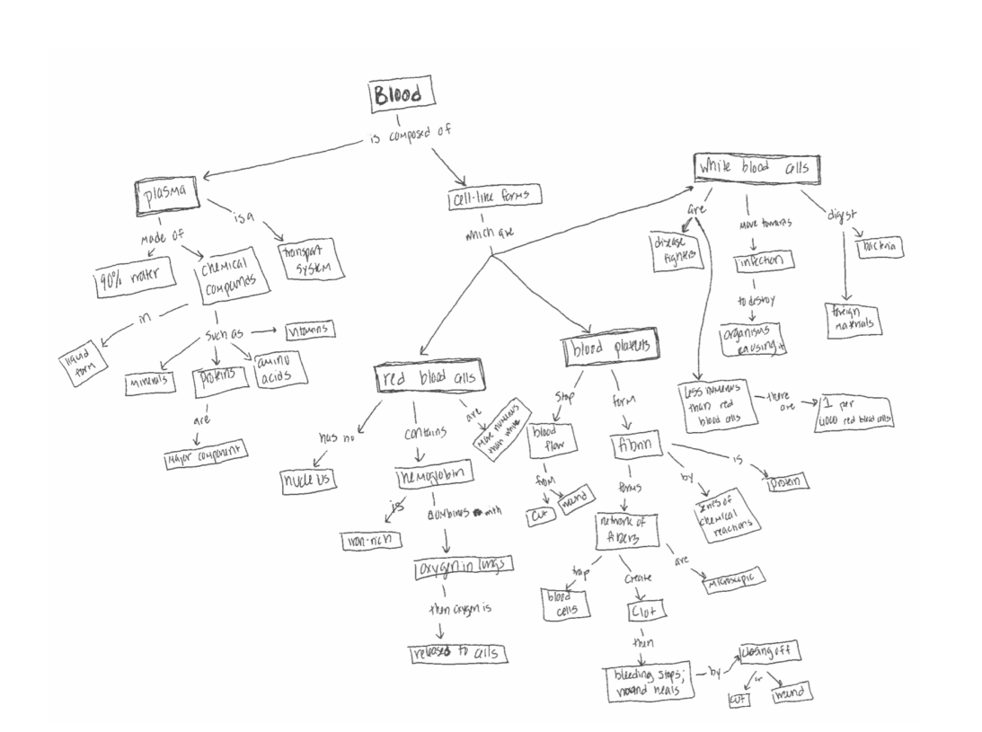

*Figure A1.* The example of a concept map that participants used to guide the construction of their concept maps in Experiment 1 (taken from Karpicke & Blunt, 2011).

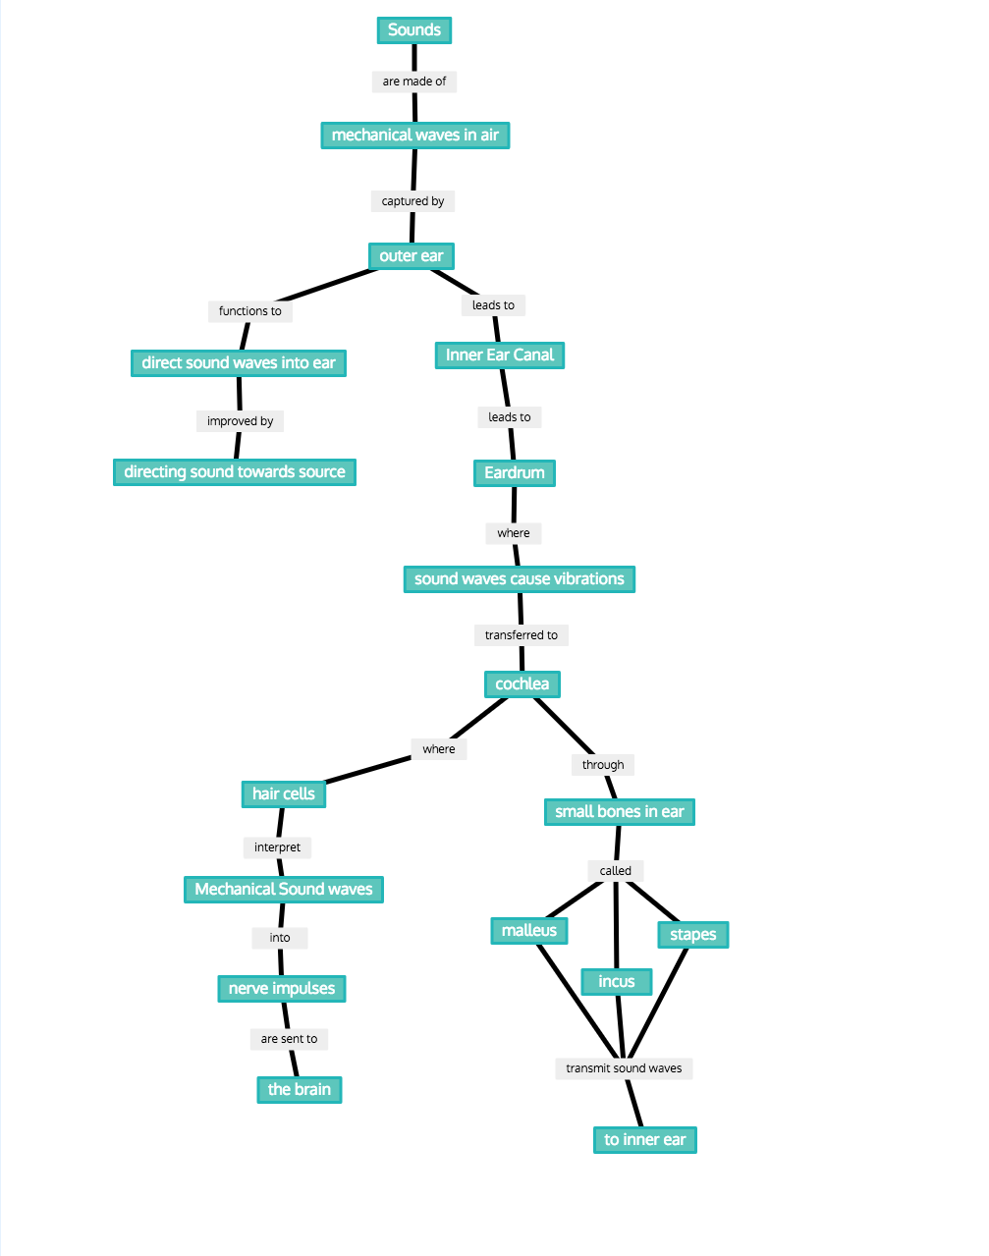

*Figure A2*. The example concept map that participants used to guide the construction of their concept maps in Experiment 2 (adapted from Blunt & Karpicke, 2014).