Garrett’s Workshop

GW4208B “RAM128”
  - RAM Expansion Card for Apple II series

User’s Guide

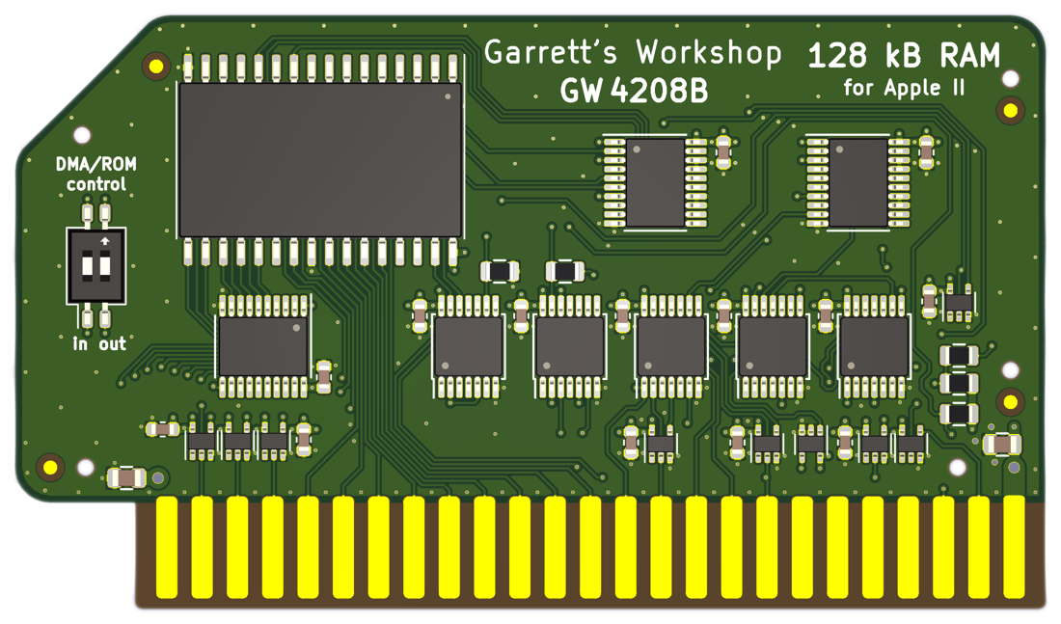

Overview
The RAM128 (GW4208B) RAM expansion card provides the Apple II, II+, and IIe with 128 kB of Language Card and Saturn-compatible expansion memory.

Low-Power, SRAM-Based Design
Thanks to a modern, low-power design, RAM128 uses a maximum of 0.01 watts when idle (2 mA @ 5V) and 0.1W in active use (20 mA @ 5V). Unlike other Apple II expansion RAM cards, which are built with vintage asynchronous DRAM chips, RAM128 uses modern SRAM. This design allows for low power consumption and improved reliability over other memory cards using 15+ year old chips.

Ecologically Friendly, Gold-Plated PCB
RAM128 is built with a lead-free, 4-layer, ENIG gold-plated PCB and is fully EU RoHS-compliant. All units are tested extensively before shipment, and only new parts are used to build RAM128.

Open-Source Design
RAM128’s design is fully open-source. The schematics, board layouts, and GAL firmware are all freely available for commercial and noncommercial use. To download the design files, visit the Garrett's Workshop GitHub page: https://github.com/garrettsworkshop

Installation
RAM128 must be installed into one of the Apple II’s seven or eight peripheral card slots. Ensure that RAM128 is inserted in the correct orientation, with the component side of the card facing away from the power supply. When installed in the correct orientation, the small notch on the card points toward the front of the Apple II machine.

Compatibility Notes

Apple IIgs and Apple IIe compatibility
RAM128 is compatible with Apple II, II+, and, with some limitations, is compatible with Apple IIe and IIgs. In the Apple II and II+, RAM128 is best used in Slot 0, the slot in which most applications expect to find Saturn or Language Card-type memory.
RAM128 is compatible with Apple IIe and IIgs with some limitations. Most applications for these machines do not utilize Saturn-type memory cards like the RAM128, and instead work with the RAM expansion slots native to these machines—auxiliary RAMWorks-type memory on the IIe, and expansion memory on the Apple IIgs. Nevertheless, RAM128 is somewhat compatible with the Apple IIe and Apple IIgs.
The Apple IIe has no Slot 0, and instead has built-in language card memory. Therefore, RAM128 must be installed into Slot 1-7. In this configuration, RAM128 is technically compatible with the Apple IIe. However, many applications written for the Apple II and II+ which utilize Saturn-type memory are hard-coded to only look for Saturn memory in Slot 0. These applications will not be able to utilize the RAM128. On the Apple IIgs, in addition to the caveats applicable to the Apple IIe, RAM128 is only usable in 1 MHz “slow” mode. With the IIgs set to 2.8 MHz “fast” mode or with an accelerator, the Apple IIgs will not be able to utilize the RAM128’s memory.

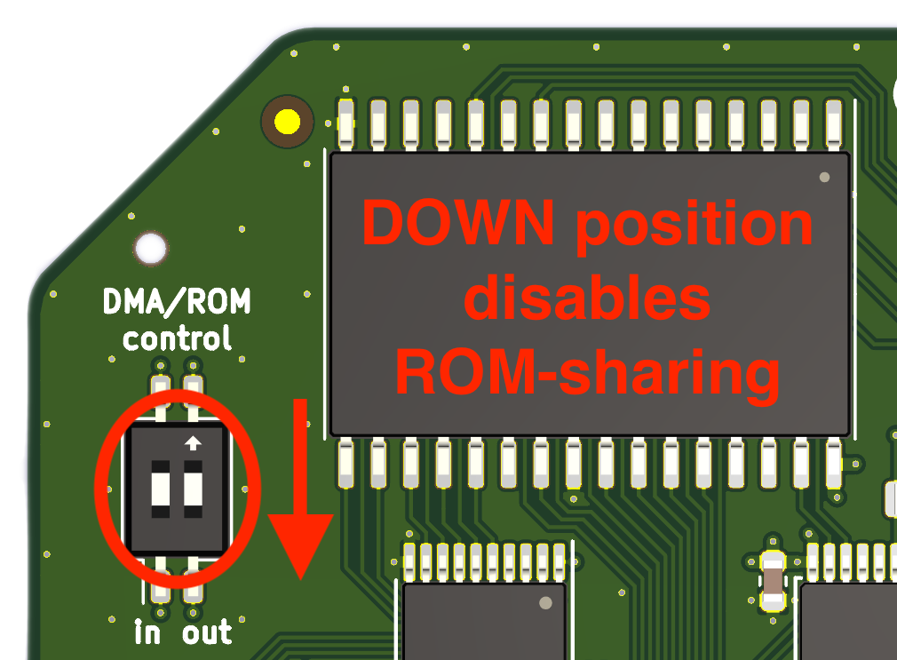
ROM-Sharing Protocol Support
The “B” revision of the RAM128 card (model number GW4208B) supports the so-called “ROM-sharing” protocol. This allows the RAM128 to coexist with an always-enabled ROM card such as the MultiROM. By default, the ROM-sharing protocol is enabled, but this may cause issues in with DMA-enabled expansion cards. In general, an empty slot should be left between the RAM128 and any DMA-enabled peripheral card, otherwise the ROM-sharing protocol should be disabled. To disable the ROM-sharing functionality, the two DIP switches on the card should be set to the lower position (further away from the “ON” text). With both switches in the upper position, the ROM-sharing functionality is enabled.

Technical Specifications

Physical Dimensions
Parameter | Value
Height | $$35.687 mm±0.2 mm$$
Width | $$42.672 mm±0.2 mm$$
Thickness | $$<8 mm$$
Weight | $$< 28 g$$

Electrical Specifications
Specifications are valid over temperature range of $0 °C-85 °C$ and $V_{CC} = 4.5 V-5.5 V$.
Parameter | Value | Conditions
${V_{IH}}_{min}$ | $$2.0 V$$
${V_{IL}}_{max}$ | $$0.8 V$$
${V_{OH}}_{min}$ | $$3.8 V$$ | $$I_{OH} = -6 mA$$
${V_{OL}}_{max}$ | $$0.5 V$$ | $$I_{OL} = 6 mA$$
Output Slew Rate | $$<1.5V/{ns}$$
${I_{I}}_{max}$ | $$± 20 μA$$ | $$V_{in} = 0 V-5.5 V$$
${C_{IO}}_{max}$ | $$60 pF$$ | address bus A[15:0], /WE
${C_{IO}}_{max}$ | $$60 pF$$ | data bus D[15:0]
${C_{IO}}_{max}$ | $$20 pF$$ | all other signals
${I_{CC}}_{max}$ | $$20 mA$$

