Garrett’s Workshop

GW4203B “RAM2E II”

RAM Expansion Card for Apple IIe

User’s Guide

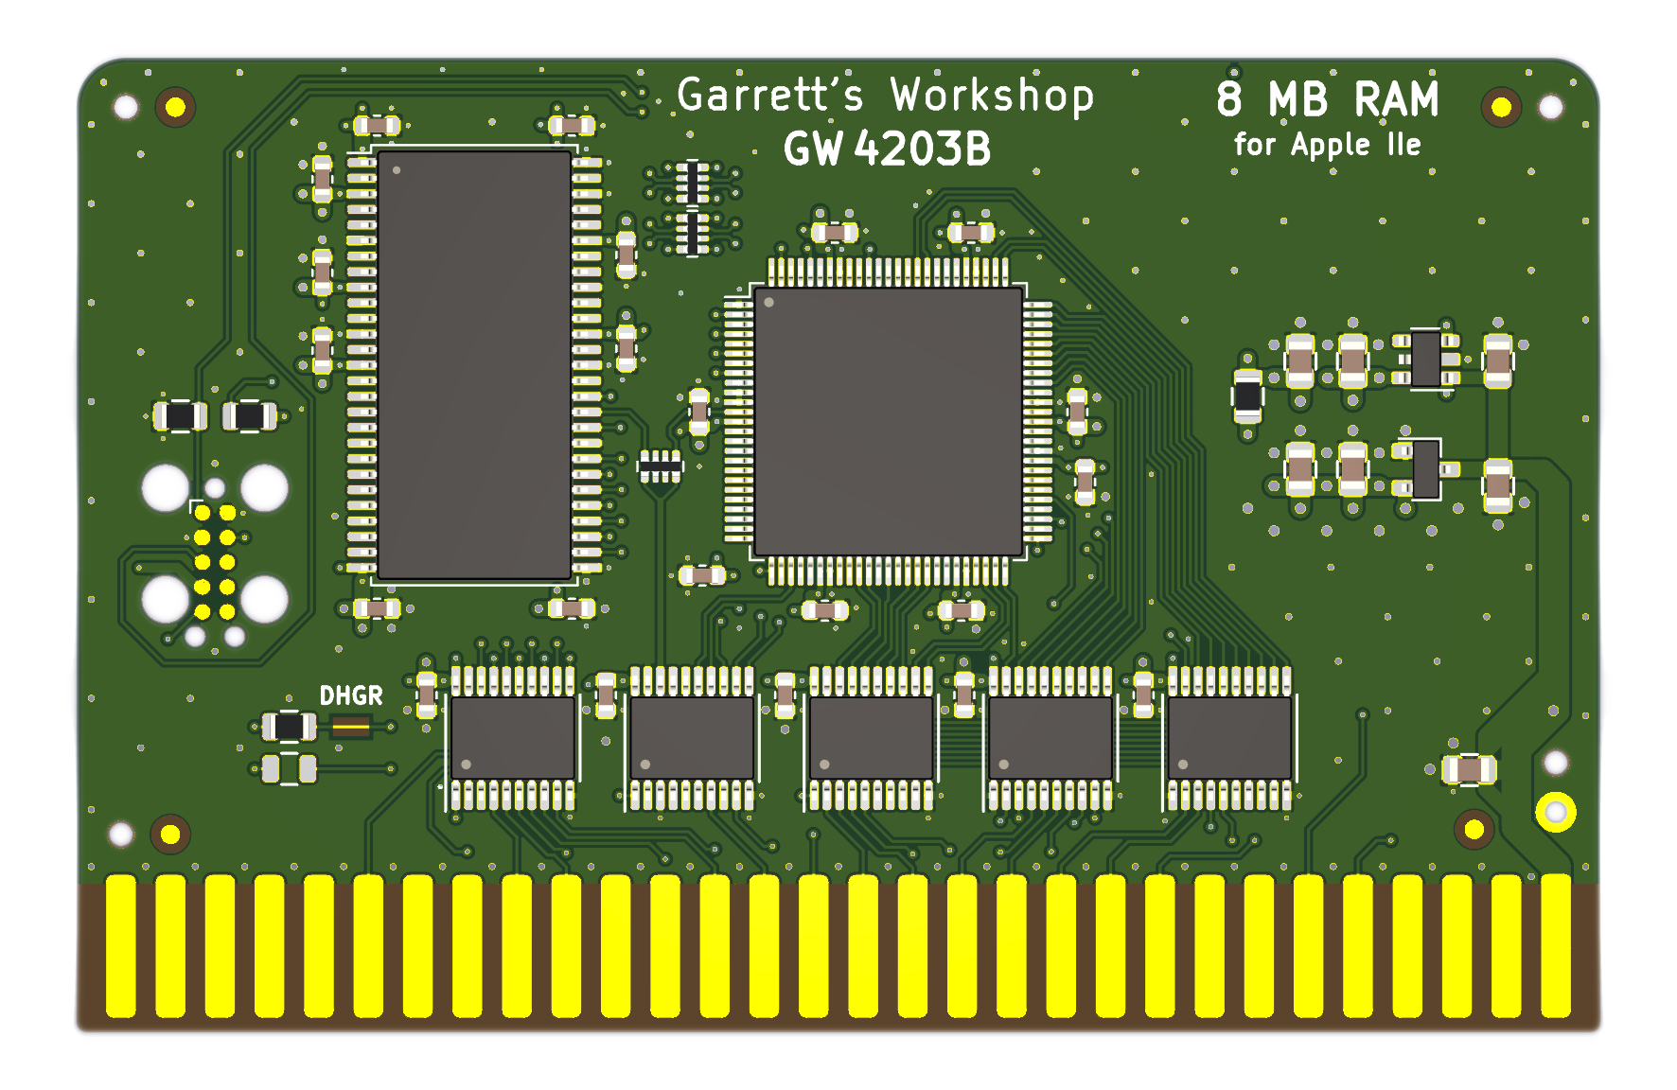

# Overview

RAM2E II (GW4203B) provides the Apple IIe with 8 MB of auxiliary memory and enables double-high-resolution graphics and 80-column text display modes.

## Low-Power, SDRAM-Based Design

Thanks to a modern, low-power design, RAM2E II uses only 0.2 watts (40 mA @ 5V) in typical use and 0.4 watts (80 mA @ 5V) in heavy use with an accelerator[1]. In contrast, a typical 80-column card consumes over 1 watt of power, and a 1 MB RAMWorks III consumes 2 watts or more. Unlike other IIe auxiliary memory cards, which are built with vintage asynchronous DRAM chips, RAM2E II uses modern SDRAM. This design allows for low power consumption and improved reliability over other memory cards using 15+ year old chips.

## Small Size, Low-Profile

RAM2E II features a small board outline and is the thinnest Apple IIe auxiliary memory card ever produced, at under 4mm thin. Small and thin dimensions improve the mechanical compatibility between RAM2E II and peripheral cards installed into the IIe's Slot 1.

## Adjustable Capacity, Highly Compatible

RAM2E II is highly compatible with existing software that utilizes RAMWorks memory standard. An adjustable capacity feature allows the memory size to be set to 64 kB, 512 kB, 1 MB, 4 MB, or 8 MB, improving compatibility with software expecting a particular memory capacity. Capacity settings can be set temporarily or saved in nonvolatile memory. The capacity adjustment utility is available on our website: <http://garrettsworkshop.com>

## Ecologically Friendly, Gold-Plated PCB

RAM2E II is built with a lead-free, ENIG gold-plated, 4-layer PCB and is fully EU RoHS-compliant. All units are tested extensively before shipment, and only new parts are used to build RAM2E II.

## Open-Source Design

RAM2E II's design is fully open-source. The schematics, board layouts, CPLD firmware, and utility software are all freely available for commercial and noncommercial use. To download the design files, visit the Garrett's Workshop GitHub page: <https://github.com/garrettsworkshop>

## Note for Revision A Apple IIe Owners

If you own the uncommon revision A Apple IIe and are interested in RAM2E II, please read this! RAM2E II requires a small modification to be compatible with the with the rev. A Apple IIe. The modification consists of removal of the “DHGR” jumper resistor or cutting the associated jumper trace.

Revision A machines can be identified by their part number “820-0064-A” printed at the top of the motherboard near the slots. If you have a rev. A Apple IIe, please contact us before purchasing and we can make the modification before shipping your RAM2E unit. However, do note that with the modification made, RAM2E II will not support the double-high-resolution graphics display mode.

## Note for A2Heaven VGA Scaler Owners

If you own the A2Heaven VGA Scaler and are interested in RAM2E II, please read this! There is a slight incompatibility between RAM2E II and the A2Heaven VGA Scaler as shipped.

As owners of the VGA Scaler will know, a long jumper wire is required to connect the VGA Scaler to the Apple IIe’s 14.318 MHz clock signal. This arrangement causes glitches in the 14 MHz clock signal and is therefore not compatible with RAM2E II. The solution to the problem is to use a special cable to connect the VGA Scaler to the 14 MHz clock in place of the cable supplied with the VGA Scaler. Please let us know if you plan to use RAM2E II with the VGA Scaler and we can include the requisite hardware to address the problem.

A more technical description of the issue with the A2Heaven VGA Scaler follows: The incompatibility involves the mishandling of the Apple II’s 14.318 MHz master clock signal by the VGA Scaler. The VGA Scaler connects to the 14.318 MHz clock through a long wire. The addition to the clock signal line of this wire in combination with the input capacitance of the VGA Scaler’s FPGA causes significant distortion to the clock waveform. This distortion includes ringing and long rise times. While the slower response time of the ICs in the Apple IIe makes the Apple itself insensitive to this distortion of the clock signal, a more modern card such as RAM2E II is susceptible to these clock signal artifacts. In our testing, the jumper wire arrangement can cause instability and periodic memory errors in RAM2E II. Adding an additional series resistance to the clock wire going to the VGA Scaler minimizes the impact of the wire arrangement and allows the system to run stably.

# Installation

RAM2E II must be installed into the Apple IIe auxiliary slot. Do not install the card into one of the seven expansion card slots. Also ensure that RAM2E II is inserted in the correct orientation. Markings on the card indicate the side which must face towards the power supply of the Apple IIe.

# Changing RAM Capacity

In order to maximize compatibility, the memory capacity of RAM2E II can be changed to 64 kilobytes, 512 kilobytes, 1 megabyte, 4 megabytes, or 8 megabytes. The capacity can be set either temporarily until the Apple IIe is powered off, or in nonvolatile memory where the setting will persist.

Capacity adjustment is accomplished using the “GWRAM” utility program available for download from our website at <http://garrettsworkshop.com/files/GWRAM/GWRAM.po>. The program is packaged as a 140 kB .po format disk image containing the GWRAM utility and ProDOS 2.4.2.

After launching GWRAM on an Apple IIe with a RAM2E II card, the following menu is shown:

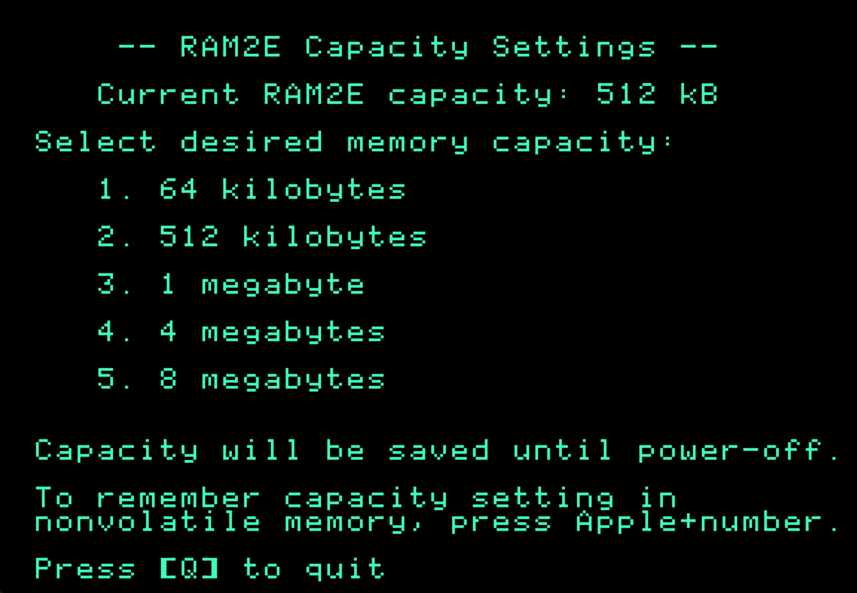

For example, by pressing the “1” key, the capacity can be set to 64 kilobytes until the computer is powered off. By pressing Apple+1 (open-Apple or closed-Apple), the 64 kilobyte capacity setting can be saved in nonvolatile memory as well, so that it is restored on power-up.

# Technical Specifications

## Physical Dimensions

|  |  |
| --- | --- |
| **Parameter** | **Value** |
| **Height** |  |
| **Width** |  |
| **Thickness** |  |
| **Weight** |  |

## Electrical Specifications

Specifications are valid over temperature range of and .

|  |  |  |
| --- | --- | --- |
| **Parameter** | **Value** | **Conditions** |
|  |  |  |
|  |  |  |
|  |  |  |
|  |  |  |
| **Output Slew Rate** |  |  |
|  |  |  |
|  |  | data bus MD[7:0], C14M clock signal |
|  | all other signals |
|  |  |  |

1. Maximum power consumption measured with quadruple-unrolled auxiliary RAM read/write loop running on FastCHIP IIe accelerator at 16.6 MHz.