Garrett’s Workshop

GW4203B “RAM2E II”

RAM Expansion Card for Apple IIe

User’s Guide

# Overview

RAM2E II (GW4203B) provides the Apple IIe's with 8 MB of auxiliary memory and enables double-high-resolution graphics and 80-column text display modes.

## Low-Power, SDRAM-Based Design

Thanks to a modern, low-power design, RAM2E II uses a maximum of 0.2 watts when idle (40 mA @ 5V) and 0.3W in active use (60 mA @ 5V). Unlike other IIe auxiliary memory cards, which are built with vintage asynchronous DRAM chips, RAM2E II uses modern SDRAM. This design allows for low power consumption and improved reliability over other memory cards using 15+ year old chips.

## Small Size, Low-Profile

RAM2E II features a small board outline and is the thinnest Apple IIe auxiliary memory card ever produced, at under 4mm thin. Small and thin dimensions improve the mechanical compatibility between RAM2E II and peripheral cards installed into the IIe's Slot 1.

## Adjustable Capacity, Highly Compatible

RAM2E II is highly compatible with existing software. An adjustable capacity feature allows the memory size to be set to 64 kB, 512 kB, 1 MB, 4 MB, or 8 MB, improving compatibility with software which expecting a particular memory capacity. Capacity settings can be set temporarily or saved in nonvolatile memory. The capacity adjustment utility is available on our website, <http://garrettsworkshop.com>.

## Ecologically Friendly, Gold-Plated PCB

RAM2E II features a lead-free, ENIG gold-plated, 4-layer PCB and is fully EU RoHS-compliant. All units are tested extensively before shipment. Only new parts are used to build RAM2E II, and all RAM2E II cards are manufactured in our semi-automated facility in Columbus, Ohio, in the United States.

## Open-Source Design

RAM2E II's design is fully open-source. The schematics, board layouts, CPLD firmware, and utility software are all freely available for commercial and noncommercial use. To download the design files, visit the Garrett's Workshop GitHub page, <https://github.com/garrettsworkshop>.

# Installation

GW4203B must be installed into the Apple IIe auxiliary slot. Do not install the card into one of the seven expansion card slots. Also ensure that GW4203B is inserted in the correct orientation. Markings on the card indicate the side which must face towards the power supply of the Apple IIe.

# Changing RAM Capacity

In order to maximize compatibility, the memory capacity of RAM2E II can be changed to 64 kilobytes, 512 kilobytes, 1 megabyte, 4 megabytes, or 8 megabytes. The capacity can be set either temporarily until the Apple IIe is powered off, or in nonvolatile memory where the setting will persist.

Capacity adjustment is accomplished using the “GWRAM” utility program available for download at from our website, at <http://garrettsworkshop.com/files/GWRAMutil.po>. The program is packaged as a 140 kB .po format disk image containing the GWRAM utility and ProDOS 2.4.2.

After launching the program on an Apple IIe equipped with a RAM2E II card, the following menu is presented:

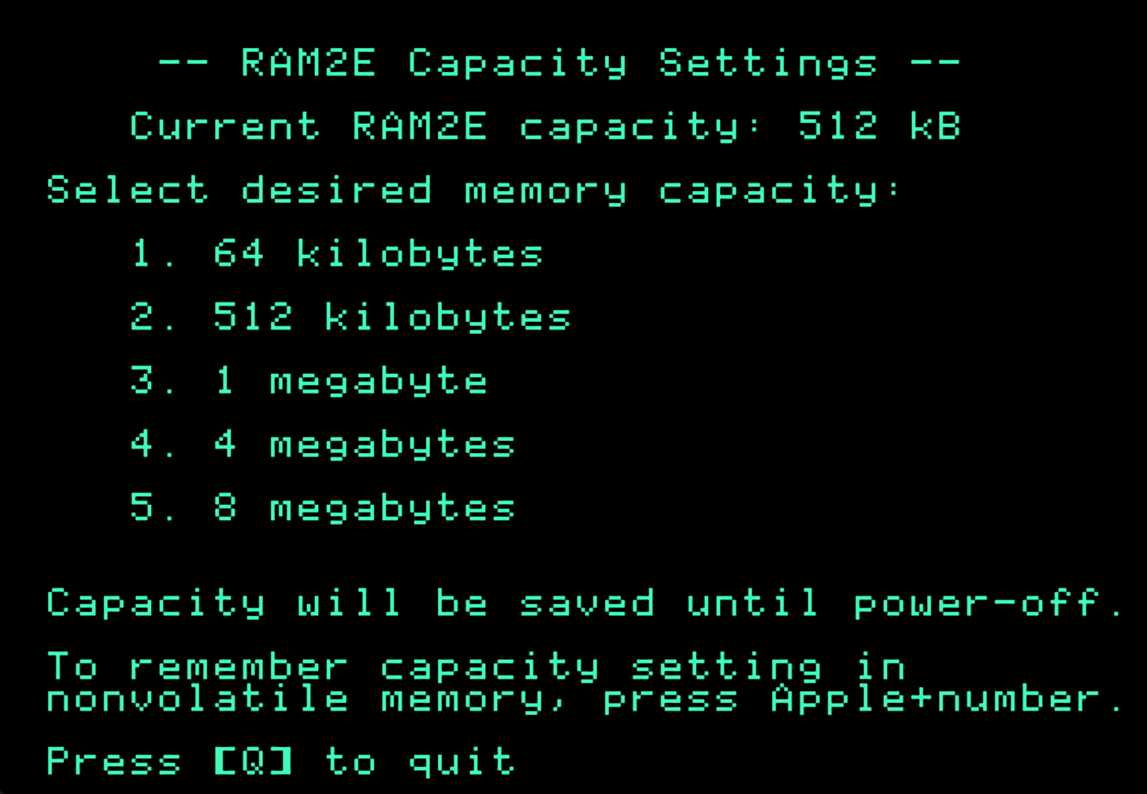

For example, by pressing the “1” key, the capacity can be set to 64 kilobytes until the computer is powered off. By pressing Apple+1 (open-Apple or closed-Apple), the 64 kilobyte capacity setting can be saved in nonvolatile memory as well, so that it is restored on power-up.

# Theory of Operation

The operation of RAM2E II is somewhat different from that of other expansion RAM cards for the Apple IIe. While other cards are implemented with asynchronous DRAM chips, RAM2E II uses modern synchronous DRAM (SDRAM).

Since the IIe’s memory expansion slot was designed for use with asynchronous DRAM, additional circuitry on the RAM2E II card is required to interface the IIe with SDRAM. There are numerous differences between asynchronous DRAM and SDRAM, but the most significant is that in SDRAM, operation is pipelined over multiple clock cycles. Although SDRAM is a much newer technology than asynchronous DRAM, and therefore much faster, multiple clock cycle “steps” are required to perform an SDRAM access.

RAM2E II’s logic circuitry is implemented in a single CPLD which runs from the Apple IIe’s 14.31818 MHz master clock signal. A buffered copy of this clock is supplied to both the RAM2E II’s CPLD and its SDRAM. The RAM2E II translates auxiliary memory and 80-column video access commands issued by the Apple II into SDRAM commands which implement the same functionality.

RAM2E II also supports a proprietary command set which allows software to adjust the RAM capacity and access other features. For more information on this command set, see the RAM2E and GWRAM utility program source code on the Garrett’s Workshop GitHub page, at <http://github.com/garrettsworkshop>.