Garrett’s Workshop

GW4201D “RAM2GS II”

RAM Expansion Card for Apple IIgs

User’s Guide

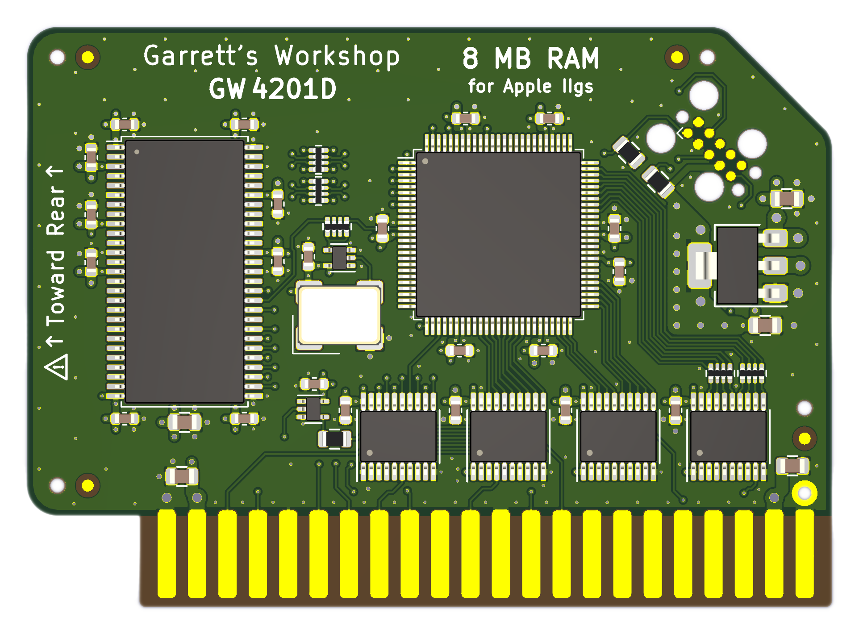

# Overview

RAM2GS II (GW4201D) expands the Apple IIgs's fast memory to 8 MB.

## Low-Power, SDRAM-Based Design

Thanks to a modern, low-power design, RAM2GS II uses a maximum of 0.15 watts when idle (30 mA @ 5V) and 0.4W in active use (80 mA @ 5V). Unlike other IIgs RAM expansion cards, which are built with vintage asynchronous DRAM chips, RAM2GS II uses modern SDRAM. This design allows for low power consumption and improved reliability over other memory cards using 15+ year old chips.

## Small Size, Low-Profile

RAM2GS II features a small board outline and is the thinnest Apple IIgs expansion memory card ever produced, at under 4.5 mm thin. Small and thin dimensions improve the mechanical compatibility between RAM2GS II and peripheral cards installed into the IIgs's Slot 7.

## Adjustable Capacity, Highly Compatible

The Apple IIgs can utilize up to 8 MB of fast memory, but due to limitations of the Apple IIgs hardware, not all 8 MB is considered "DMA-compatible." Only 4 MB of the 8 MB provided by an expansion RAM card such as the RAM2GS II is DMA-compatible, and peripheral cards which use DMA are not able to access expansion memory beyond 4 MB. RAM2GS II implements an adjustable capacity feature, allowing the user to select between fully DMA-compatible 4 MB capacity, or partially DMA-compatible 8MB capacity. Capacity settings can be set temporarily or saved in nonvolatile memory. The capacity adjustment utility is available on our website: <http://garrettsworkshop.com>

## Ecologically Friendly, Gold-Plated PCB

RAM2GS II is built with a lead-free, ENIG gold-plated, 4-layer PCB and is fully EU RoHS-compliant. All units are tested extensively before shipment, and only new parts are used to build RAM2GS II.

## Open-Source Design

RAM2GS II's design is fully open-source. The schematics, board layouts, CPLD firmware, and utility software are all freely available for commercial and noncommercial use. To download the design files, visit the Garrett's Workshop GitHub page: <https://github.com/garrettsworkshop>

# Compatibility Notes

## 8 MB RAM Disk Support on ROM03 Apple IIgs

A defect in the ROM03 firmware of the Apple IIgs prevents initialization of a RAM disk on machines with 8 MB of RAM. Consequently, it is impossible to create a RAM disk of any size on an 8 MB ROM03 machine without resorting to software beyond the machine’s built-in ROM firmware. This issue does not affect ROM01 systems, which are able to initialize the RAM disk correctly on large-memory systems. GS/OS 6.0.4 works around this issue by directly initializing the RAM disk without calling the ROM. After booting GS/OS, the RAM disk will be correctly initialized for any subsequent operations, even after rebooting into ProDOS. The current suggested workaround for ROM03 users who would like to use the RAM disk is to either boot GS/OS to initialize the RAM disk, or to set the RAM capacity of the RAM2GS II card to 4 MB.

# Installation

RAM2GS must be installed into the Apple IIgs memory expansion slot. Do not install RAM2GS into one of the seven expansion card slots. Also ensure that RAM2GS is inserted in the correct orientation. Markings on the card indicate the side which is to face towards the rear ports and slots of the IIgs.

# Changing RAM Capacity

In order to maximize compatibility, the memory capacity of RAM2GS II can be changed to either 4 megabytes or 8 megabytes. The capacity can be set either temporarily until the Apple IIgs is powered off, or in nonvolatile memory where the setting will persist.

Capacity adjustment is accomplished using the “GWRAM” utility program available for download from our website at <http://garrettsworkshop.com/files/GWRAM.po>. The program is packaged as a 140 kB .po format disk image containing the GWRAM utility and ProDOS 2.4.2.

After launching the program on an Apple IIgs equipped with a RAM2GS II card, the following menu is presented:

By pressing the “1” key, the capacity can be set to 4 megabytes until the computer is powered off, and by pressing the “2” key, the capacity can be set to 8 megabytes. By pressing Apple+1 or Apple+2 (open-Apple or closed-Apple), the corresponding setting can be saved in nonvolatile memory as well, so that it is restored on power-up. After changing the capacity, it is required to reset your Apple IIgs using the keyboard for the setting change to take effect.

# Technical Specifications

## Physical Dimensions

|  |  |
| --- | --- |
| **Parameter** | **Value** |
| **Height** |  |
| **Width** |  |
| **Thickness** |  |
| **Weight** |  |

## Electrical Specifications

Specifications are valid over temperature range of and .

|  |  |  |
| --- | --- | --- |
| **Parameter** | **Value** | **Conditions** |
|  |  |  |
|  |  |  |
|  |  |  |
|  |  |  |
| **Output Slew Rate** |  |  |
|  |  |  |
|  |  | data bus D[7:0] |
|  | all other signals |
|  |  |  |

# Information for Developers: Theory of Operation

The operation of RAM2GS II is somewhat different from that of other expansion RAM cards for the Apple IIgs. While other cards are implemented with asynchronous DRAM chips, RAM2GS II uses modern synchronous DRAM (SDRAM).

Since the IIgs’s memory expansion slot was designed for use with asynchronous DRAM, additional circuitry on the RAM2GS II card is required to interface the IIgs with SDRAM. There are numerous differences between asynchronous DRAM and SDRAM, but the most significant is that in SDRAM, operation is pipelined over multiple clock cycles. Although SDRAM is a much newer technology than asynchronous DRAM, and therefore much faster, multiple clock cycle “steps” are required to perform an SDRAM access.

No sufficiently fast clock signal is supplied by the Apple IIgs to the memory expansion card, so the RAM2GS II coordinates SDRAM access using an onboard 60 MHz clock oscillator. RAM2GS II, running at 60 MHz, detects and responds to memory access and refresh commands given by the Apple IIgs and issues corresponding SDRAM commands to complete the request.

RAM2GS II also supports a proprietary command set which allows software to adjust the RAM capacity and access other features. For more information on this command set, see the RAM2GS and GWRAM utility program source code on the Garrett’s Workshop GitHub page at <http://github.com/garrettsworkshop>.