**Name**: *Garrett Tracy*

**Personal Portfolio**: *fall2018garrett.w3expressions.org/PersonalPortfolio/index.html*

**Peer Review Screenshot**:

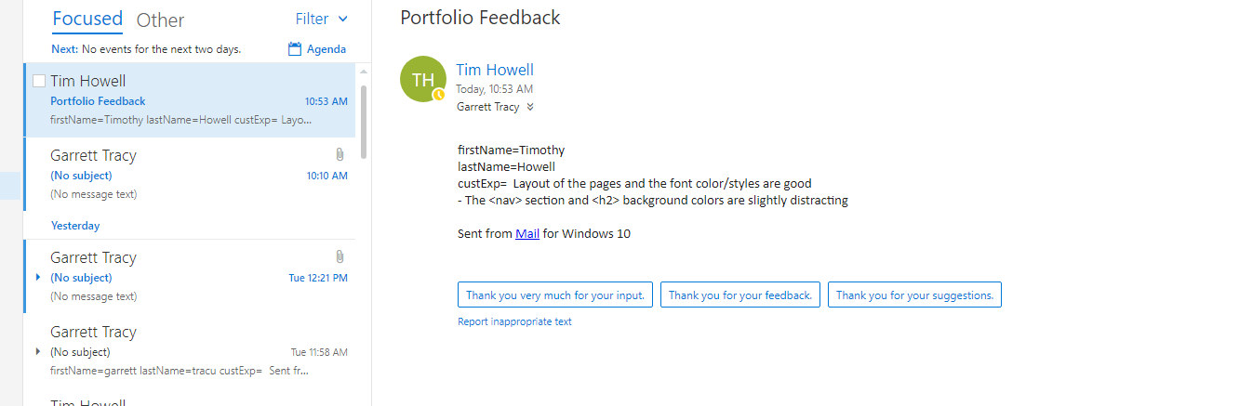**My Response to the Peer Review**:

*I appreciated the insight on the color scheme, I will go back and re-work the colors so that they are more muted.*

**Browser Compatibility (Chrome, Firefox, and Edge) Comments**:

*Differences from chrome*

***Firefox:***

*CONTACT*

*Comment box and submit button have changed their intended position and looks a bit jumbled.*

*picture appears to bleed into footer element on contact page*

***IE***

*CONTACT*

*Form does not retain design structure*

*Icons are no longer resized*

*Footer is no longer Center aligned*

*List style type none is not in effect (there is a pointed list in the nav section)*

*Color for nav section is incorrect! Changed from Cyan to Orange*

*image does not have a border radius*

*image appears as if it is apart of the footer element*

*PROJECTS*

*Box has disappeared*

*border has disappeared*

*text is no longer center aligned*

*EXPERIENCE!*

*Table no longer encompasses the width of the page*

*WELCOME!*

*Pictures are not properly resized and take over the home page*

*Footer has been shifted to the left corner*

*box and border are gone!*

**Screenshots of Desktop/Tablet and Mobile Viewports**:

