Telemetry System for Magic Application
Technical Documentation

1. Purpose & Objectives
This technical documentation defines the architecture, component design, functional behavior, operational model, and implementation roadmap for the Telemetry System supporting the Magic trading application. The system provides near real-time visibility into application logs, FIX message flows, order and execution activity, rejection patterns, latency indicators, and natural language access through Copilot or Microsoft Teams. The design emphasizes streaming-first processing, low operational overhead, and strict avoidance of persistent raw log storage.

2. Problem statement and solution scope
Problem Statement:
- Limited visibility into live trading activity and application health during production hours.
- Difficulty identifying rejects, execution failures, latency spikes, and protocol-level issues quickly.
- Reactive troubleshooting based on manual log inspection rather than proactive monitoring and alerting.
- Limited ability for support, development, and operations teams to ask natural language questions about live telemetry.
The Day-1 scope covers real-time and periodic log monitoring, FIX message parsing, trade metrics, rejection analytics, alerting, callback notifications to Magic, and query access through Copilot or Teams. Future scope includes binary protocol parsing, longer-term telemetry retention, log replay, historical forensics, and more advanced analytics. Raw sensitive log content is not persisted as part of the core design.

3. Design Principles
- Agent-based deployment: A lightweight Telemetry Agent runs close to the Magic application to minimize integration complexity and reduce network dependency for log observation.
- Streaming-first processing: Telemetry is parsed and aggregated as logs are produced, enabling timely metrics and alerts without requiring batch ingestion.
- No raw log persistence: The system avoids storing sensitive raw logs and instead retains derived metrics, counters, summaries, and structured events.
- Low overhead: File monitoring, parsing, and aggregation must use bounded CPU and memory so the agent does not interfere with trading workloads.
- Modular extensibility: Parsers, rules, callback handlers, and query adapters should be independently configurable and replaceable.
- Operational resilience: The system must tolerate log rotation, transient backend unavailability, malformed messages, and restart scenarios.

4. High-Level Architecture
The architecture is composed of a Telemetry Agent deployed alongside each Magic application instance and a centralized Telemetry Backend Service. The agent tails and periodically scans configured log files, detects log rotation, parses FIX messages, aggregates trade metrics, evaluates alert rules, and dispatches callbacks to Magic when critical conditions are detected. The backend receives structured telemetry from one or more agents, maintains in-memory metric views, exposes query APIs, and integrates with Copilot or Microsoft Teams for natural language access.

4.1 Component Responsibilities
Component | Primary Responsibility | Key Outputs
Log Monitor | Observes configured log files using real-time tailing and interval-based reads while handling rotation. | New log lines, file offsets, rotation events.
Parser Engine | Parses FIX messages on Day-1 and supports pluggable binary parsers on Day-2. | Structured message fields, parse errors, protocol metadata.
Metrics Aggregator | Maintains rolling counters and calculated indicators for orders, rejects, executions, reasons, and latency. | Metric snapshots, rolling windows, derived KPIs.
Rule Engine | Evaluates configured thresholds and critical patterns against telemetry streams. | Alerts, severity levels, matched rule context.
Callback Dispatcher | Sends real-time callback notifications to Magic or downstream operational handlers. | Callback events, delivery status, retry outcomes.
Telemetry Backend | Receives structured telemetry, maintains in-memory views, and exposes query APIs. | Aggregated metrics, query results, integration responses.

5. Functional Requirements
- Log monitoring: Support real-time tailing and interval-based file reading with configurable paths, polling intervals, file offset tracking, and log rotation handling.
- Parsing engine: Provide Day-1 FIX parsing with validation of required tags, extraction of order and execution identifiers, and graceful handling of malformed lines. The parser interface must allow Day-2 binary protocol support.
- Metrics: Maintain rolling and current metrics for orders, rejections, executions, rejection reasons, and latency calculations. Metrics should be grouped by configurable dimensions such as application instance, session, symbol, order type, and rejection reason where available.
- Queries: Expose query APIs that support filtering, aggregation, and natural language access through Copilot or Microsoft Teams.
- Alerting: Detect critical patterns in real time, including elevated reject rates, repeated execution issues, parser failures, latency thresholds, missing log activity, or configured error signatures.
- Callbacks: Dispatch alert and status notifications back to Magic using the agreed callback protocol, with delivery tracking and retry behavior.

6. Non-Functional Requirements
- Performance: The agent must process log updates with low latency and bounded CPU usage. Parsing and aggregation should avoid blocking the Magic process.
- Reliability: The system must continue operating through malformed messages, log rotation, temporary backend outages, and agent restarts.
- Security: Raw sensitive logs must not be persisted. Derived metrics and structured events should exclude unnecessary sensitive content.
- Scalability: The backend must support multiple agents and horizontal scaling as additional Magic instances are onboarded.
- Configurability: Log paths, parser selection, alert thresholds, callback endpoints, aggregation windows, and query dimensions must be configurable without code changes where practical.
- Observability: The telemetry system itself should expose health indicators such as agent heartbeat, parse error count, backend connectivity, callback failures, and queue depth.

7. Telemetry Agent Design
The Telemetry Agent is a modular process deployed alongside the Magic application. It contains a Log Monitor, Parser Engine, Metrics Aggregator, Rule Engine, and Callback Dispatcher. Each module should be independently configurable and should communicate through structured in-memory events. The agent should maintain only the minimum state required for offset tracking, rolling metrics, alert evaluation, retry handling, and health reporting.

7.1 Agent Processing Flow
- The Log Monitor detects new log content through tailing or interval-based reads.
- The Parser Engine classifies the line, attempts FIX parsing, and emits structured message events or parse error events.
- The Metrics Aggregator updates rolling counters, latency calculations, and grouped trade analytics.
- The Rule Engine evaluates thresholds, patterns, and state transitions against current telemetry.
- The Callback Dispatcher sends critical notifications to Magic and records delivery outcomes.
- The Backend Publisher forwards structured telemetry snapshots and events to the centralized backend.

7.2 Sequence Flows

7.2.1 Log Ingestion and Metric Publication Flow
- Magic writes an application or FIX protocol line to the configured log file.
- The Log Monitor detects appended content and reads from the last committed file offset.
- The Parser Engine identifies whether the line contains a FIX message, operational log entry, or unsupported format.
- For FIX messages, the parser extracts key fields such as message type, order identifier, execution identifier, symbol, side, quantity, status, rejection reason, and timestamps where available.
- The Metrics Aggregator updates rolling counters and latency calculations for the relevant instance, session, and aggregation window.
- The Rule Engine evaluates whether the new event changes alert state or crosses a configured threshold.
- The Backend Publisher sends a structured telemetry event or metric snapshot to the Telemetry Backend.
- The backend updates its in-memory metric views and makes the new information available through query APIs and natural language integrations.

7.2.2 Alert and Callback Flow
- The Rule Engine detects a critical condition such as elevated reject rate, repeated parser failures, missing heartbeat, or latency breach.
- The agent creates an alert event with severity, rule name, matched condition, affected Magic instance, timestamp, and supporting metric context.
- The Callback Dispatcher sends the alert to the configured Magic callback endpoint.
- If the callback succeeds, the agent records delivery status and includes the alert in the next backend publication.
- If the callback fails, the dispatcher retries according to configured retry limits and backoff policy.
- The backend exposes the alert through alert query APIs and natural language summaries.
- When the condition clears or drops below threshold, the Rule Engine emits a resolved alert state.

7.2.3 Natural Language Query Flow
- A user asks a telemetry question in Copilot or Microsoft Teams, such as “Why are orders rejecting for Magic today?”
- The natural language adapter identifies the requested intent, time range, filters, and aggregation dimensions.
- The adapter converts the question into a structured backend query.
- The Telemetry Backend evaluates the query against current in-memory metric views and recent alert state.
- The backend returns structured results with counts, grouped rejection reasons, affected sessions, and relevant time windows.
- The adapter formats the response as a concise operational summary with supporting metrics.

8. Backend & Query Layer
The Telemetry Backend Service receives structured telemetry from agents, maintains in-memory metric views, processes structured queries, and exposes APIs for Copilot and Microsoft Teams integration. It should support filtering, aggregation, and summarization across application instance, time window, FIX session, order state, rejection reason, and other configured dimensions. The backend should be horizontally scalable and should not require raw log persistence for Day-1 operation.

8.1 Suggested Service Interfaces
Interface | Purpose | Example Response Content
Telemetry ingestion | Accepts structured events, metric snapshots, heartbeats, and alert notifications from agents. | Accepted status, validation errors, ingestion timestamp.
Metrics query | Returns aggregated metrics for a requested time window and filter set. | Order count, reject count, execution count, latency summary.
Alert query | Returns active and recent alerts with severity, rule name, and affected instance. | Alert status, matched condition, last occurrence.
Natural language adapter | Maps Copilot or Teams questions to structured backend queries. | Human-readable summary, supporting metric values, filter interpretation.
Health endpoint | Reports backend and agent connectivity health. | Agent heartbeat, queue depth, callback failure count.

8.2 API Examples
The following examples illustrate the expected shape of Day-1 service interactions. Endpoint names and field names are illustrative and should be finalized during API design.

8.2.1 Telemetry Ingestion Example
Request | Response
POST /telemetry/events  {  "agentId": "magic-agent-sg-01",  "application": "Magic",  "instanceId": "magic-prod-01",  "eventType": "fix.execution_report",  "timestampUtc": "2026-06-12T04:00:00Z",  "fields": {  "msgType": "8",  "orderId": "ORD-10001",  "execId": "EXEC-90001",  "symbol": "ABC",  "ordStatus": "Rejected",  "rejectReason": "PriceExceedsLimit"  }  } | 202 Accepted  {  "status": "accepted",  "eventId": "evt-7f21",  "receivedAtUtc": "2026-06-12T04:00:01Z"  }

8.2.2 Metrics Query Example
Request | Response
POST /telemetry/query/metrics  {  "timeRange": {  "fromUtc": "2026-06-12T03:30:00Z",  "toUtc": "2026-06-12T04:00:00Z"  },  "filters": {  "application": "Magic",  "instanceId": "magic-prod-01"  },  "groupBy": ["rejectReason"],  "metrics": ["orders", "executions", "rejections", "rejectRate"]  } | 200 OK  {  "orders": 1250,  "executions": 1188,  "rejections": 62,  "rejectRate": 0.0496,  "groups": [  { "rejectReason": "PriceExceedsLimit", "count": 35 },  { "rejectReason": "UnknownSymbol", "count": 18 },  { "rejectReason": "Other", "count": 9 }  ]  }

8.2.3 Alert Query Example
Request | Response
GET /telemetry/alerts?status=active&application=Magic&instanceId=magic-prod-01 | 200 OK  {  "alerts": [  {  "alertId": "alert-1024",  "severity": "critical",  "ruleName": "HighRejectRate",  "status": "active",  "matchedCondition": "rejectRate > 0.05 for 5 minutes",  "lastObservedUtc": "2026-06-12T04:00:00Z"  }  ]  }

8.2.4 Agent Health Example
Request | Response
GET /telemetry/health/agents/magic-agent-sg-01 | 200 OK  {  "agentId": "magic-agent-sg-01",  "status": "healthy",  "lastHeartbeatUtc": "2026-06-12T04:00:02Z",  "logReadLagMs": 120,  "parseErrorCountLast5Min": 2,  "callbackFailuresLast5Min": 0,  "publishQueueDepth": 4  }

8.2.5 Magic Callback Example
Callback Payload | Expected Acknowledgement
POST /magic/callbacks/telemetry-alerts  {  "alertId": "alert-1024",  "severity": "critical",  "application": "Magic",  "instanceId": "magic-prod-01",  "ruleName": "HighRejectRate",  "summary": "Reject rate exceeded configured threshold for the last 5 minutes.",  "observedValue": 0.064,  "threshold": 0.05,  "timestampUtc": "2026-06-12T04:00:00Z"  } | 200 OK  {  "status": "received",  "correlationId": "cb-5531"  }

8.2.6 Natural Language Query Example
User Question | Structured Query | Generated Summary
Why are Magic orders rejecting in the last 30 minutes? | {  "intent": "rejection_summary",  "timeRange": "last_30_minutes",  "filters": { "application": "Magic" },  "groupBy": ["rejectReason", "instanceId"]  } | Magic recorded 62 rejected orders in the last 30 minutes. The largest rejection category was PriceExceedsLimit with 35 occurrences, followed by UnknownSymbol with 18 occurrences. The active HighRejectRate alert remains open for magic-prod-01.

9. Day-1 vs Day-2 Roadmap
Phase | Scope | Outcome
Day-1 | FIX parsing, log monitoring, core metrics, query APIs, alerts, callbacks, and operational health checks. | Production-ready real-time telemetry for Magic FIX activity and support workflows.
Day-2 | Binary protocol parsing, persistence options, historical replay, long-term analytics, and advanced anomaly detection. | Expanded protocol coverage and forensic analysis capability.
Future Enhancements | Advanced dashboards, richer Teams workflows, adaptive thresholds, and trend analysis. | Improved proactive operations and broader analytics adoption.

10. Deployment and Operations
The Telemetry Agent should be deployed per Magic application instance or per host, depending on log ownership and process isolation requirements. Configuration should define monitored log paths, file read mode, parser type, backend endpoint, callback endpoint, alert thresholds, aggregation windows, and retry limits. Operational runbooks should cover agent restart, backend connectivity loss, callback failures, parser error spikes, and missing heartbeat scenarios.

10.1 Monitoring and Health Signals
- Agent heartbeat and last successful backend publish time.
- Log read lag, file offset progress, and rotation detection events.
- Parser success rate, malformed message count, and unsupported protocol count.
- Metric aggregation queue depth and publish latency.
- Callback delivery success, retry count, and failed callback count.
- Backend availability, ingestion throughput, and query response latency.

11. Open Questions and Decisions Required
- What are the expected FIX throughput and peak log volume per Magic instance?
- What callback protocol should Magic support for Day-1 alerts and status updates?
- Which authentication and authorization model should be used for backend APIs and Teams or Copilot access?
- What deployment topology is preferred: one agent per application instance, one agent per host, or another model?
- Which alert thresholds should be configured initially for reject rate, latency, parser failures, and missing activity?
- Which telemetry dimensions are mandatory for query filtering and aggregation?
- What data retention approach, if any, is required for Day-2 historical analysis?

Appendix A: Architecture Diagrams

High-Level System Architecture
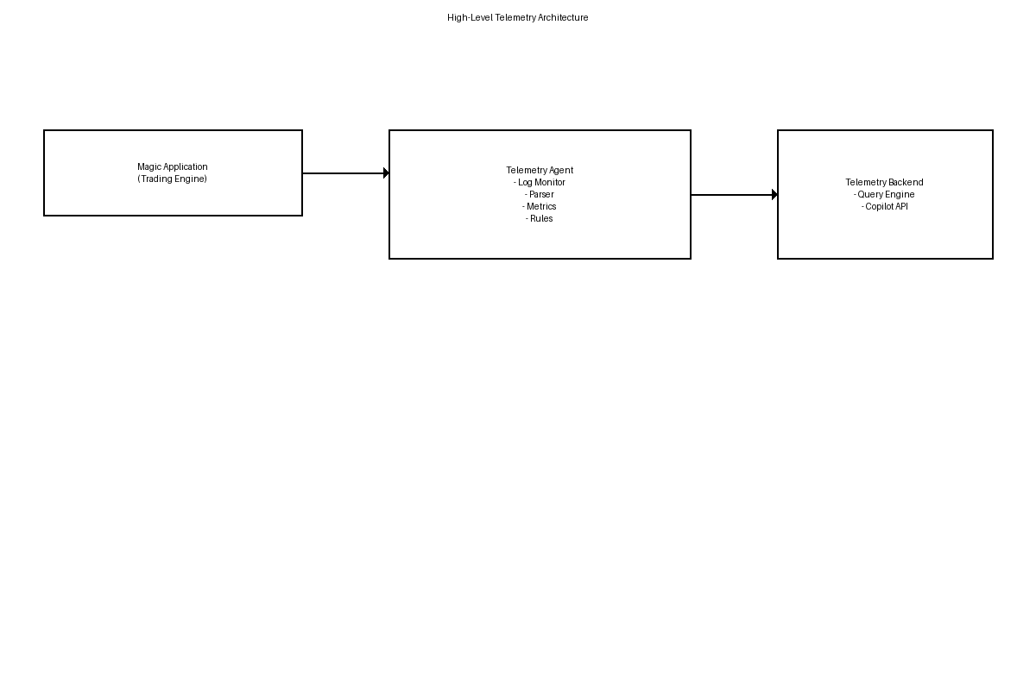

Production Deployment Architecture
