Travis Garrison

2022-11-22

IT FDN 110 A - Foundations of Programming: Python

Assignment 06 – Functions

**GitHub**

Page: <https://garrisont.github.io/IntroToProg-Python/>

Assignment 06: <https://github.com/garrisont/IntroToProg-Python/tree/main/Assignment06>

Module 6 – Functions

# Introduction

The base task is roughly the same as in assignment 5 (read/modify/write a to-do text file), however this time we needed to finish a partially completed script. The partially created script makes use of classes and functions however some of the functions are merely placeholders.

Figure - Starter script with placeholder functions

## Review of existing code (#TODO)

I started the task by reviewing the list of #TODO comments in PyCharm.

Figure - PyCharm #TODO summary

There were five functions that appeared to need completing; add_data_to_list, remove_data_from_list, write_data_to_file, input_new_task_and_priority and input_task_to_remove.

## Individual test files

The placeholder functions happen to be exactly the tasks our assignment 05 script completed, so I started by copying snippets of the assignment 05 script into stand alone testing files.

Figure - Test file strategy



Figure - Test file results

## Inserting / testing

Once all the basic functions had been tested as stand alone files I inserted the code into their respective functions and appended the #TODO: with a # >> Done << marker.

Figure - Code inserted into actual function

## Global variables

The “starter” script came with several suggested global variables, however I opted not use them in my functions as that seemed like it might lead to confusion with “shadowing” of global variables.

I checked for existing usage and deleted the variables not already used in other (existing) functions.

Figure - Remaining global variables.

# Assigned script

For the most part finishing the assigned script appeared to be a matter of moving sections from assignment 05 into assignment 06. The one complication for me was that my strategy in 05 was to make use of .json files, this wasn’t going to work well with the starting script so I rewrote the write_data_to_file sections from 05.

Figure - add_data_to_list

Figure - remove_data_from_list

Figure - write_data_to_file

Figure - input_new_task_and_priority

Figure - input_task_to_remove

## Results

Figure - Running in PyCharm

Figure - Running from the command line

Figure - .txt file results

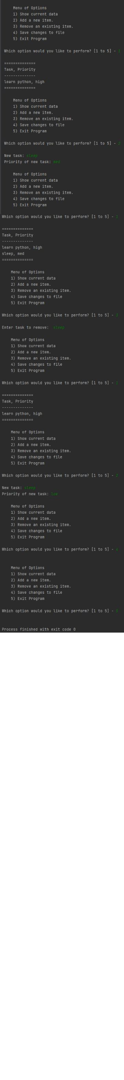

Figure - PyCharm output (long...)

Figure - Output (ToDoList.txt) after PyCharm run

Figure - Assignment running from command line

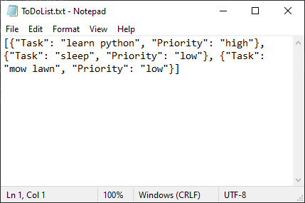

Figure - Results of command line run