Installation-Guide

Table of contents

Start the program

# 

# Start the program

Start the programm by ….

The Window “Network Adress Calculator” pops up.

1.1 Define a Network

In the first step you can choose between adding a new Network or importing an xml file. Therefore you can either click on the button “Add Network” or “Import”. 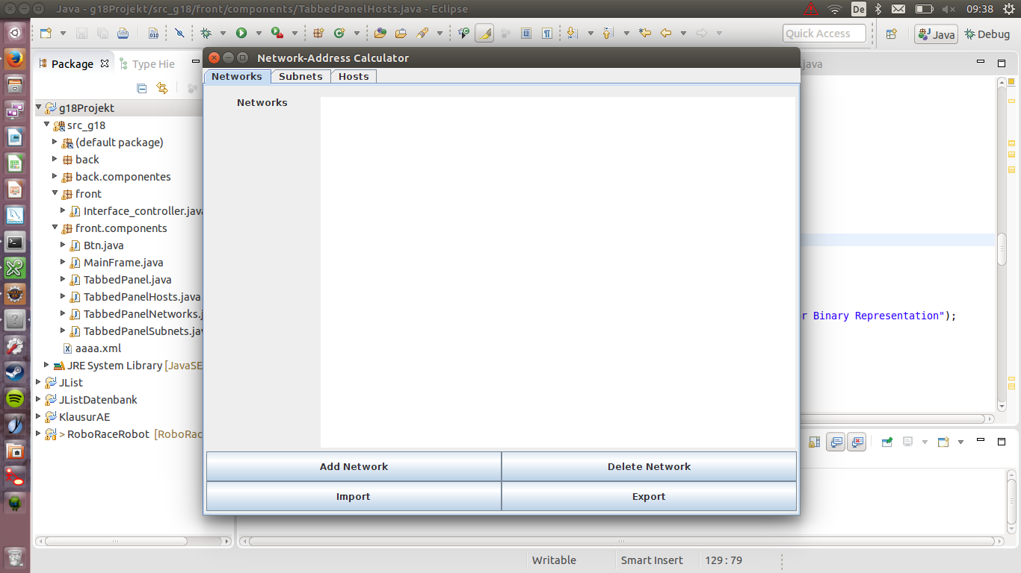

You can also delete a network or export a xml file.

(Abb.1.1).

By clicking on “Add Network” an new Dialog opens and request you to type in the Network Adress(IP) and the Prefix. After you inserted the Numbers please click “ok” (Abb. 1.2).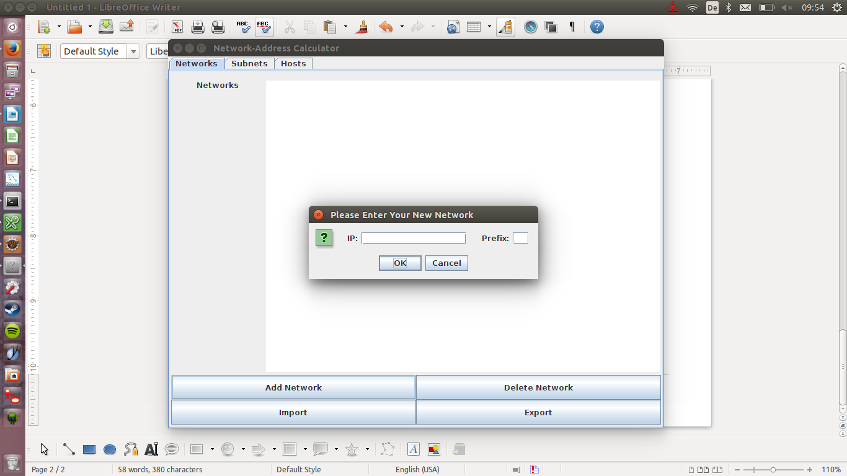

(Abbildung 1.1) (Abbildung 1.2)

As you can see now, the network-Adress is added to the “Network-Window”(Abb. 1.3).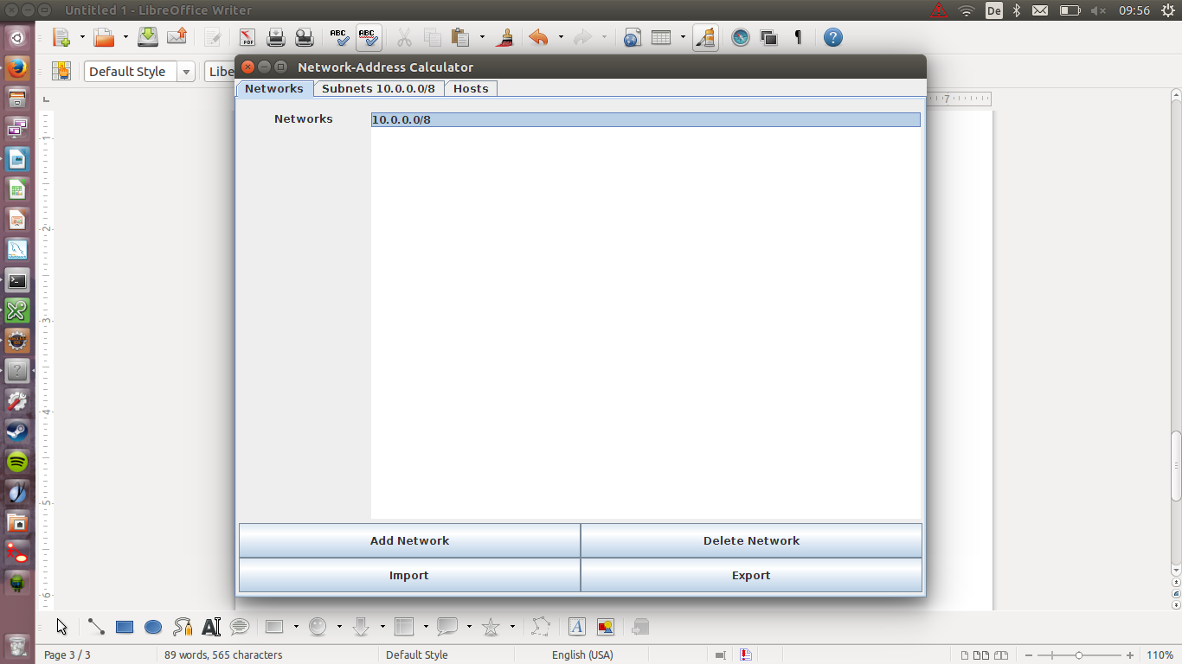

(Abbildung 1.3)

2.1 Set up a Subnet

By clicking on the added network-address, the tab, at the top of the main window, adopts the IP.

Just click on the tab “Subnet-(IP)”. By typing in the IP Adress in the first step, the subnet takes over the values and gives you directly the information about your network (Abb. 2.1)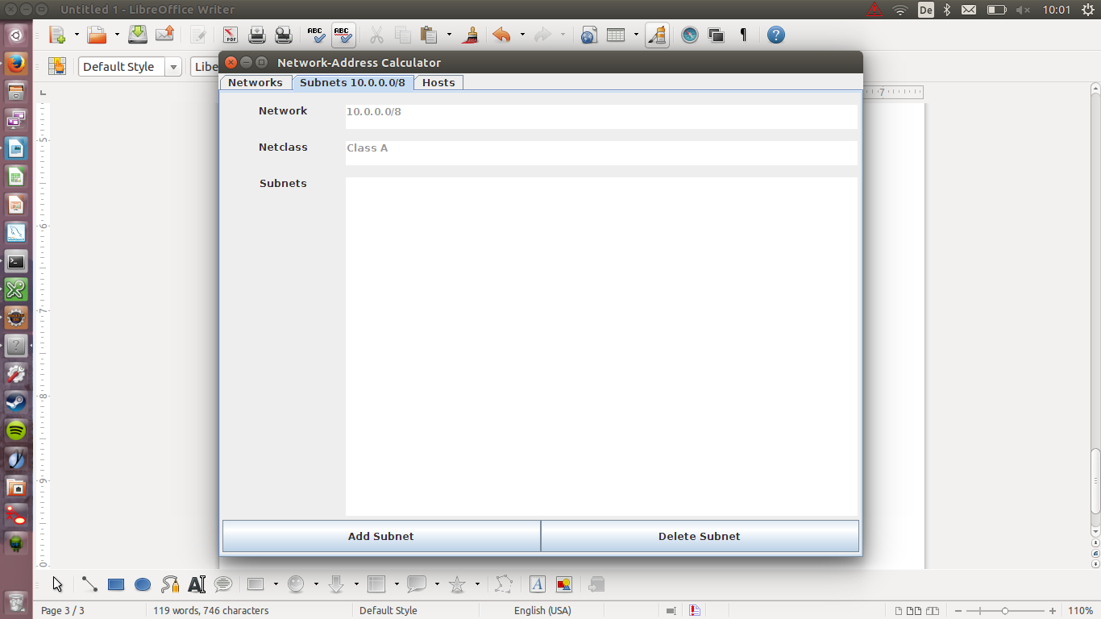

(Abbildung 2.1)

The first time you click the button “Add Subnet” , you can type in the needed information.

After typing in the prefix, the programm will automatically calculate how many hosts and how many subnets you can use .(Abb. 2.2)

If you continue to press the button “Add Subnet”, the next subnet is calculated and shown.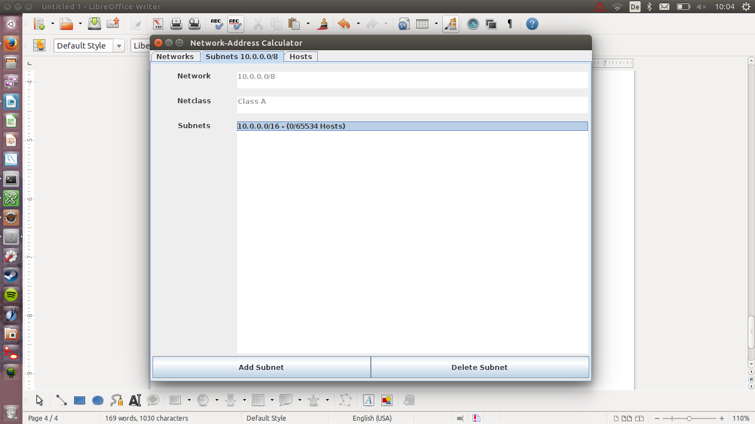

The information needed for the host, is given by the subnet. Please mark the wanted subnet and click on the “Hosts” - tab.

(Abbildung 2.2).

3.1 Declare a Host

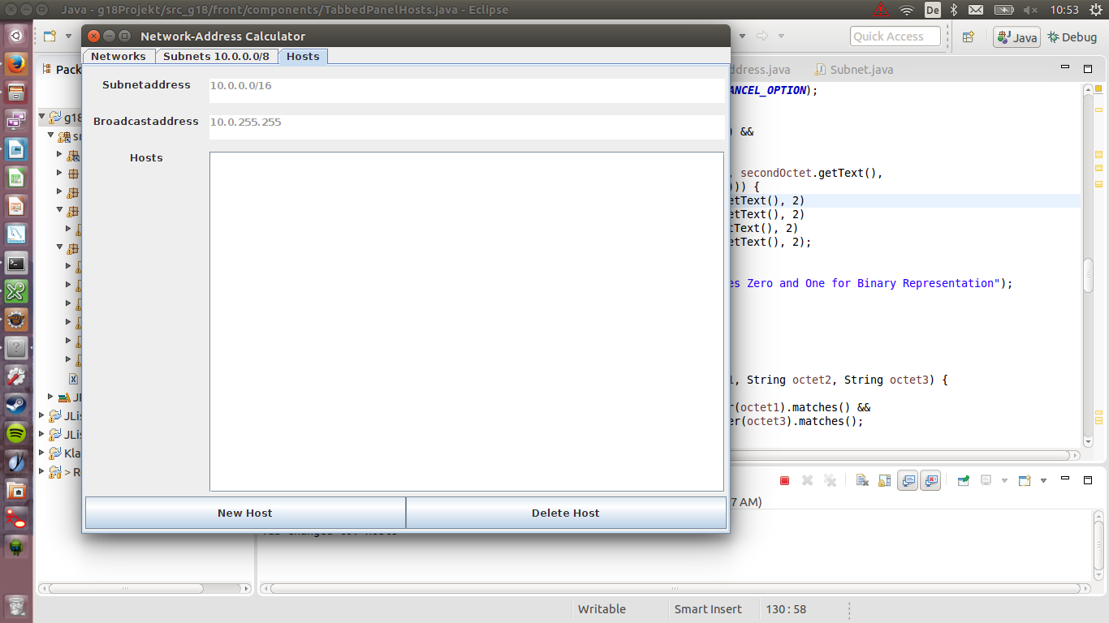

As you can see you are directly getting the subnetaddress and broadcastadress (Abb. 3.1).

If you want to give the host an ip-address press the button “new Host”. An dialog opens, which requests either an ip-address in decimal-notation or in binary-values (Abb.3.2).

(Abbildung 3.1)

(Abbildung 3.2)