Network-address calculator

*Installation-Guide*

Projektgruppe : Ariadne Riga, Luca Bernhardt, Samuel Nazari, Thorge

Dammann

Fach : IT-Systeme/AE

Abgabe : 19.12.2014

Install the program

# 

# Install the program

1. Before you start the program you should check which version of Java you have installed. If you don’t have any, please install Java 7.
2. To execute the jar-File please change your directory in to the path of the file.
   1. *Change directory :*
      1. *cd ~/yourPath/*
   2. *Execute Jar-File :* 
      1. *java - jar theNameofTheFile.jar*

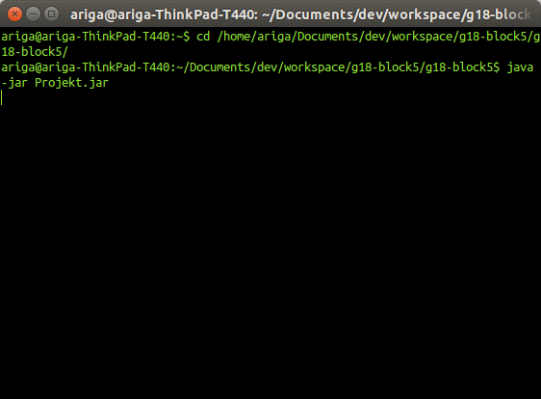

3. The program starts automatically after executing the jar-File.