Downscaling IMERG precipitation to 1 km over central Texas

Making satellite rain maps sharper: what we did, what we found
A plain-language summary of the whole project. Numbers are from the 2019–2020 test period, which no model ever trained on.
Figures live in results/figures/review/ (Austin) and results/figures/review_co/ (Colorado Front Range).

1. The problem in one paragraph
Satellites measure rainfall over squares about 10 km across. A lot of decisions — which street floods, which hillside slides — need something closer to 1 km. So we take the coarse satellite map and try to produce a fine one. To check whether it worked, we compare against AORC, a 1 km national rainfall analysis we treat as the truth.
Each 10 km square contains 144 of the 1 km squares we are trying to fill in. The satellite gives us one number for all 144. Something has to supply the rest.

2. Data and methods
Written to be reproducible. Every path, parameter and date below is the one actually used; the companion documents ARCHITECTURE_RATIONALE.md (why each model exists and in what order they were built) and RESOLUTION_GUIDANCE.md (grid-spacing analysis) carry the reasoning this section only states.

2.1 Domains
Two boxes of identical size, so that any difference between them is the weather and not the experiment.
 | Austin, Texas | Colorado Front Range
bounding box (W, S, E, N) | −99.0, 28.5, −96.0, 32.0 | −107.0, 38.5, −104.0, 42.0
coarse grid (0.1°) | 35 × 30 = 1,050 cells | 30 × 35 = 1,050 cells
fine grid (1/120° ≈ 0.93 km) | 420 × 360 = 151,200 cells | 360 × 420 = 151,200 cells
refinement factor | 12 | 12
cells steeper than 5° | 0.000 | 0.255
elevation range | −2 to 668 m | 1,221–4,245 m

The Colorado box was chosen to match Austin's cell count exactly rather than its geographic extent, so sample size is not a confound.

2.2 Datasets
role | dataset | product / variable | native | period used | access
coarse input | GPM IMERG V07 Final Run | GPM_3IMERGDF, precipitation | 0.1°, daily | 2000-06-01 → 2020-12-31 | OPeNDAP server-side subset
second coarse input | NASA POWER | PRECTOTCORR (MERRA-2, CPC-corrected) | 0.5°, daily | same | POWER API
target / reference | NOAA AORC v1.1 | APCP_surface, summed to daily | 1 km, hourly | same | s3://noaa-nws-aorc-v1-1-1km
environment | ERA5 | 9 derived fields (§2.4) | 0.25°, 6-hourly → daily | same | ARCO zarr, Google Cloud
static | NLCD 2021 | land cover, impervious fraction | 30 m → 1 km | — | MRLC WCS
static | Copernicus GLO-90 DEM | elevation, slope, aspect | 90 m → 1 km (area average) | — | AWS Open Data
independent check | GHCN-D | daily gauge totals | point | 2019–2020 | NOAA
projections | NEX-GDDP-CMIP6 | pr, 4 models × 3 scenarios | 0.25°, daily | hist 2000–2014, ssp245/585 2015–2060 | s3://nex-gddp-cmip6

Daily aggregation. AORC is hourly and is summed over the UTC day to match IMERG's daily Final Run. IMERG V07 daily is used as published. POWER is daily as served. No sub-daily disaggregation is performed anywhere.
Why AORC is the reference. It is the only 1 km gauge-and-radar analysis covering CONUS for this period. It is an analysis, not ground truth, and it assimilates gauge data — which is why §8b treats the NASA POWER gain cautiously and why GHCN-D is used as an independent check (§4.3).

2.3 Grid construction and alignment
- The coarse grid is defined by the bounding box at 0.1°; the fine grid is that
divided by 12, giving 1/120° ≈ 0.93 km. Every coarse cell contains exactly 144 fine cells, so block averaging is exact and no cell is dropped at any boundary.
- IMERG is regridded to the coarse grid by nearest-neighbour (its native grid is
already 0.1° and aligned).
- AORC is area-averaged from its native 1 km grid onto the fine grid.
- ERA5 and POWER are bilinearly interpolated onto the coarse grid. POWER's cell
centres start 0.2° north of the Austin grid, so its two southernmost rows are edge-clamped rather than extrapolated (60 of 1,050 cells; src/fuse_power.py).
- DEM and NLCD are area-averaged (not bilinear) from 90 m and 30 m to 1 km, which
avoids aliasing.

2.4 Predictor set
32 conditioning channels at 1 km (DownscalingData.n_cond), assembled as coarse-derived + static + seasonal:
group | channels | contents
coarse-derived | 16 | the IMERG field in log space, its 7-day rolling mean, its within-record percentile, IMERG's own counter fields (precipitation_cnt, precipitation_cnt_cond, MWprecipitation, probabilityLiquidPrecipitation — the satellite reporting where it was guessing), and the 10 ERA5 fields below
static | 14 | dem, dem_anom, slope, aspect_sin, aspect_cos, imperv, and 8 NLCD class fractions (water, developed, barren, forest, shrub, grass, crop, wetland)
seasonal | 2 | sin and cos of day-of-year

ERA5 fields: cape, cape_max, tcwv, tcwv_max, t2m, wind_speed, wind_sin, wind_cos, moist_flux, era5_tp. The last is ERA5's own precipitation and is the single most valuable predictor added in this study (§6).
Two further channels are supplied by the model wrapper rather than this stack: the bilinearly upsampled coarse field (always, as the additive base) and the block-replicated unsmoothed coarse field (M1 only). A third, NASA POWER, is tested in §8b and is not in the shipped product. Network input is therefore 34 channels for M1, 33 for the earlier products.
All channels are standardised to zero mean and unit variance using training-period statistics only. Precipitation is modelled in a log-like space (log1p(x / scale), scale = 11.38 mm) so that the loss is not dominated by the tail.

2.5 Temporal splits
split | period | days | use
train | 2000-06-01 → 2017-12-31 | 6,423 | fitting
dev | 2018-01-01 → 2018-12-31 | 365 | checkpoint selection, seed selection, every hyperparameter choice
test | 2019-01-01 → 2020-12-31 | 731 | reported once, never used for any decision

Nothing from 2018 onwards enters training. Every product shipped and every seed chosen was selected on the dev year, including when the test year would have given a different and better-looking answer (§8b, M1 seed 2).

2.6 Architectures
All models are parameterised as prediction = bilinear(coarse) + network([predictors, bilinear(coarse)]) with the output layer zero-initialised, so an untrained network is exactly the bilinear baseline and no reported gain can be an artefact of tuning one side harder than the other.
model | structure | parameters | key hyperparameters
XGBoost, stage 1 | gradient-boosted trees at 10 km | — | 2,000 trees max, depth 4, lr 0.02, subsample 0.8, colsample 0.8, min_child_weight 5, early stopping 40
XGBoost, stage 2 | residual trees at 1 km | — | as above, min_child_weight 20, 3 M training samples; gated — adopted only if it beats bilinear by > 0.5 % on a held-out tail
CNN (U-Net) | 3 scales, channel mults (1, 2, 4), GroupNorm | 1.65 M (base 24) / 11.7 M (base 64) | —
Swin | SwinIR-style, 4 RSTB groups × 6 layers, window 8 | 7.96 M | dim 180, 6 heads
Diffusion | conditional DDPM on the residual from a frozen CNN mean | 12.4 M | cosine schedule, v-parameterisation, 40-step DDIM, 6 members
Redistribution head | softmax over the 144 fine cells of each block × block total | 1.65 M | block mean pinned to input by construction

2.7 Training protocol
Identical across every arm unless stated:
 | value
optimiser | Adam, lr 2 × 10⁻⁴, no schedule
steps | 6,000
patch | 192 × 192 fine cells (16 whole coarse cells)
batch | 8 → 294,912 fine cells per optimiser step
precision | bf16 autocast on GH200
evaluation | every 500 steps on the full dev year
checkpoint | best dev RMSE
seeds | 3 per arm (5 where an effect approached the noise floor)
hardware | NVIDIA GH200 (TACC Vista); trees are CPU-only

Cells per step is held constant across every comparison in this study, including when patch size is the variable being tested, so that capacity per update is never a confound.
The shipped product (M1) adds to the above: spectral penalty weight 0.01 applied across the whole resolvable spectrum (--spectral-cut 96), triple loss weight on cells above 30 mm day⁻¹, and the unsmoothed-coarse channel. Exact command in RESEARCH_PAPER.md §4.9.3.

2.8 Metrics, and what a 0.1 mm/day difference is worth
A difference of 0.1–0.3 mm day⁻¹ in RMSE is not, on its own, meaningful for a rainfall decision. We agree, and it shapes how this document reports results.
Three things follow.
We measure the noise floor and report against it. Repeat training runs differing only in random seed span 0.02–0.06 mm day⁻¹ for the deep models and 0.007 for the trees. Any difference below that is not a difference. Where an effect is near that floor we say so, run more seeds, or decline to claim it — the NASA POWER channel at 1 km is reported as directionally consistent but not significant for exactly this reason (§8b).
The differences that matter here are not in RMSE. Across the methods we built, RMSE spans 4.46–4.92 while the amount of real fine-scale detail spans 0.02 to 1.07 — a fifty-fold range on a quantity RMSE is almost blind to, because a smooth field and a correctly-textured one can have nearly the same squared error. Heavy-rain detection spans 0.55–0.64. Those are the axes on which the products actually differ.
That RMSE differences are small is itself the central finding, not a weakness of the reporting. §10 shows 91–92 % of every product's error is in the 10 km field before sharpening begins. Methods should look similar on RMSE; they are all sharpening the same flawed input. The useful comparisons are therefore against what is physically available (§8b, grid spacing), by season and by event (§4), and against independent gauges rather than our own reference (§4.3).
Metrics reported, and why each is here:
metric | what it catches | threshold
RMSE, MAE | bulk accuracy; dominated by the coarse field | —
POD, FAR, CSI | heavy-rain detection, the decision-relevant one | 30 mm day⁻¹ (Austin's 1-in-49 cell-day)
frequency bias | whether the product rains as often as reality | 1.0 = correct
FSS | credit for a storm displaced but correctly sharp | 1, 5, 15, 41 cells
spectral ratio / band energy | whether fine structure is real or smoothed away | 1.0 = correct
KL divergence | whether the distribution of daily totals is right | —
SSIM | local structure rather than cell-by-cell agreement | —
CRPS | calibration, for the ensemble products only | —

Detection in Colorado is scored at 14.50 mm, the depth with the same exceedance rate as 30 mm in Austin, because 30 mm is 6.7× rarer over the Front Range and the detection scores there otherwise describe the threshold rather than the model.

2.9 Why these architectures, and in what order
The set is not a survey. Each model is one representative of a distinct hypothesis about where the missing 1 km structure comes from, so that a negative result identifies a failed hypothesis rather than a weak implementation. Full reasoning in ARCHITECTURE_RATIONALE.md; the decision chain is:
order | model | hypothesis under test | what it returned
0 | bilinear | sharpening is not worth doing | the null; every model is built on top of it
1 | XGBoost, 2-stage | it is a point-wise bias problem solvable cell by cell | strong baseline; its two stages let the error be split, which produced the central result
2 | CNN (U-Net) | it is a spatial pattern problem needing neighbourhoods | beats trees on detection, not on RMSE
3 | Swin | it needs long-range context (upwind flow over terrain) | 0.05 % from the CNN at 1 km — rules out receptive field as the limit
4 | Diffusion | the conditional mean is the wrong estimator | only product with realistic texture before §6; worst RMSE
5 | spectral objective | the trade-off is the loss, not the problem | texture 0.02 → 1.07 at no RMSE cost
6 | redistribution head | mass conservation costs accuracy | it does not — identical RMSE, 15× the detail
7 | POWER fusion | the limit is information, not the model | −0.067 mm/day, twice what model size buys

Steps 0–4 varied the architecture and found 1.7 % between the deterministic families. Steps 5–7 varied the objective and the inputs and found larger effects than any architectural change. That ordering is the project's main methodological lesson, and §8b records where it stops being true: at the 10 km stage, architecture matters 49× more than it does at 1 km.
Custom components built for this problem, rather than taken off the shelf:
- Zero-initialised residual head — makes "better than interpolation" an identity
rather than a claim.
- Differentiable spectral loss reproducing the scoring diagnostic to machine
precision, so the quantity optimised is the quantity reported.
- Mass-conserving redistribution head — softmax over each block's 144 cells × the
block total, pinning the coarse mean to the input by construction.
- Bernoulli–gamma head — three output channels for a variable with an atom at zero
(built and tested; the scored comparison was never completed).
- Unsmoothed-coarse input channel — tests whether bilinear smoothing destroys
information before the network sees it. It does not; see §8b.

2.10 Reproducing this
# data
python main.py --config config.yaml data # IMERG, AORC, NLCD, DEM
python -m src.atmos --config config.yaml # ERA5 predictors
# shipped product (M1)
python -m src.deep.train --model cnn --loss mse --select rmse \
--spectral-weight 0.01 --spectral-cut 96 --nearest-channel \
--heavy-mm 30 --heavy-weight 3.0 --base 24 --steps 6000 \
--batch 8 --patch 192 --lr 2e-4 --seed 2 --data-dir data
python -m src.deep.infer --ckpt <ckpt> --data-dir data --split test
# evaluation
python -m src.score_variants --config config.yaml --product M1=<field>
python -m src.resolution_ladder --config config.yaml # the grid-spacing floor
python -m src.proposal_metrics --config config.yaml --product M1=<field> # SSIM, KL
python -m src.review_analysis --config config.yaml --product M1=<field> # seasonal, events
Checkpoints, the 428 NEX-GDDP model-years and the derived training directories live on TACC Vista under /scratch/11755/gurup12/downscaling; the repository holds code, configuration and score files only.

3. Headline comparison
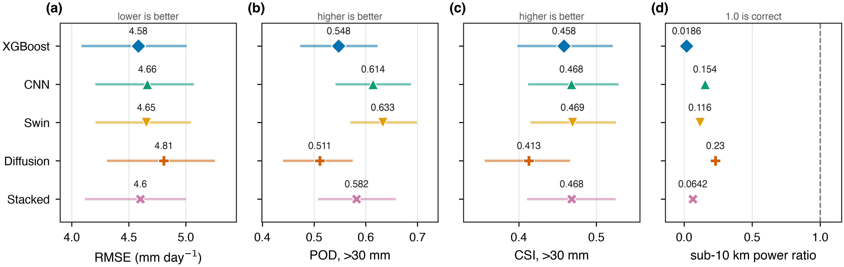
metric comparison
Dots are the scores; the horizontal bars are 95 % confidence intervals.
 | error (mm/day) | heavy rain found | texture
CNN + texture penalty | 4.46 | 0.61 | 1.07
XGBoost | 4.58 | 0.55 | 0.02
Swin | 4.65 | 0.63 | 0.12
CNN | 4.66 | 0.61 | 0.15
Diffusion | 4.81 | 0.51 | 0.23

A weighted blend of the CNN and XGBoost used to appear in this table. It is dropped: it is a post-hoc average of two rows already here, not a fifth method, and listing it alongside them overstated how many distinct things were tried. It is still reported as a negative result — its gain on the tuning year did not transfer — in RESEARCH_PAPER.md §5.6.
The first row is the product we ship. Trained with a penalty for producing a field that is too smooth, plus extra weight on heavy-rain cells, on the full 2000–2017 record. It beats XGBoost on error, detection and texture all at once, so there is no trade to explain. The seed shipped was chosen on the 2018 tuning year, not on the test years — and so was the configuration: its three tuning scores (4.776–4.812) do not overlap those of the version we shipped before it (4.870–4.904).
The shipped field scores 4.455. An earlier version of this product scored 4.521, and three changes closed that gap: applying the smoothness penalty across the whole range of scales rather than only below 10 km, training on 192 km tiles instead of 96 km, and letting the network see the raw 10 km field alongside the smoothed one. The full ladder of eight variants is in RESEARCH_PAPER.md §4.9.2.
Texture near 1.0 is the part that matters. Every other product here has between 2 % and 23 % of real rainfall's fine-scale variance — a 1 km grid carrying 10 km information.
One caveat on that number, and it is worth stating plainly. "Texture" here averages a ratio across scales, and that average flatters the field: measured as retained variance the shipped product holds 57 % of what real rain has below 10 km, not 107 %. The two differ because the averaging weights every scale equally while the variance is not spread equally. Both are now in the score files. What the product genuinely does is carry roughly the right amount of detail at 2–8 km; between 16 and 64 km it still holds under a tenth of what it should, which is worse than plain interpolation.
That last gap is fixable, and we chose not to fix it in the shipped product. Eight attempts failed before we noticed that all eight had inherited the same setting for how hard the smoothness penalty pushes — a value tuned for a different configuration. Turning it up tenfold takes the 16–32 km detail past plain interpolation for the first time, but costs 0.115 mm/day of accuracy, which is more than the whole improvement we shipped this week. The exchange rate is roughly linear and is written down in RESEARCH_PAPER.md §4.9.2, so anyone who needs the detail more than the accuracy can retrain for it.
For the five older products, the overlap is the point. Their confidence bars for error, detection and skill overlap almost completely: we can say they are similar, not rank them. "Texture" is how much fine-scale detail a map has compared with real rain, where 1.0 is correct — and all five sit far below it, which is to say every one of them is smoother than real rainfall.
The texture-penalty model is the exception on that axis, and it is why it ships.
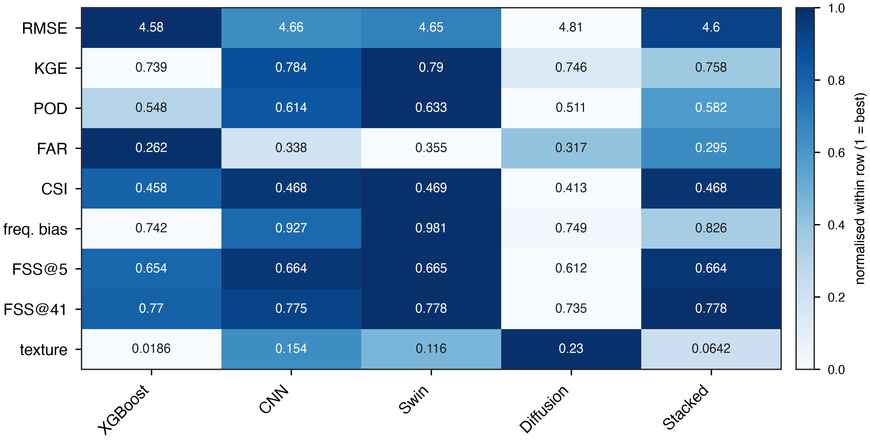
all metrics
No single method wins everywhere. XGBoost has the lowest error and fewest false alarms, Swin finds the most heavy rain, diffusion has the most realistic texture. They are different tools, not better and worse versions of one tool.

4. What the models get wrong

They rain too often, and not hard enough
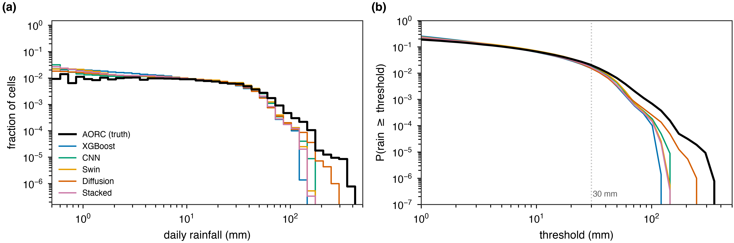
intensity distribution
Real rain in Austin falls on 28 % of cells. Our products say 46–60 % — they sprinkle a little rain nearly everywhere. At the same time they will not produce the very heavy values:
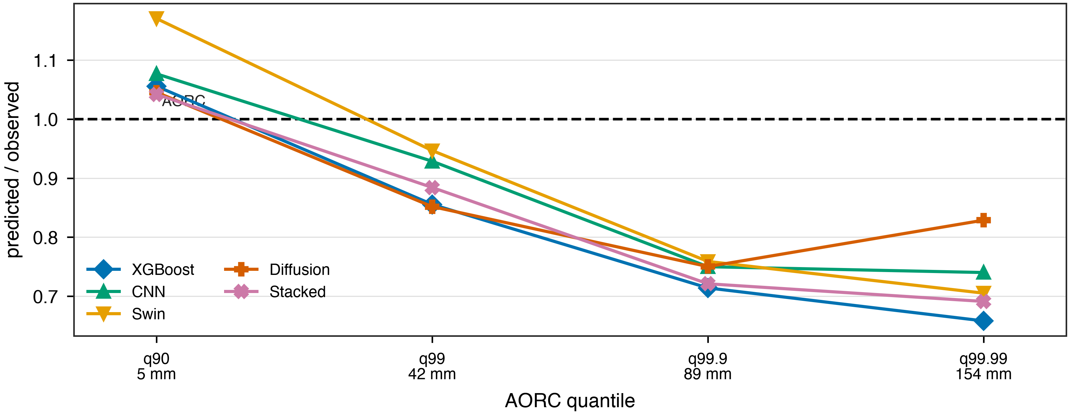
tail shortfall
At moderate intensities they are about right. At the heaviest 1-in-10,000 cell they reach only 66–83 % of what actually fell. Diffusion is the best of them at 83 %, which is exactly what it was designed for.
The reason is simple. Training rewards being close on average, and the safest way to be close on average is to hedge — put a little rain everywhere and never commit to a big number. Our error measure actively encourages this.

The bigger the storm, the worse they do
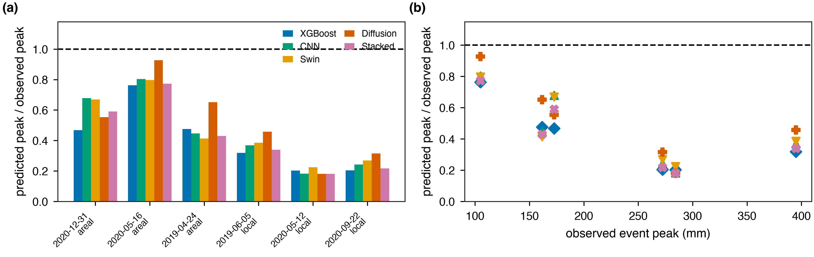
storm events
We picked six real storms from 2019–2020 and scored each one on its own.
observed peak | how much of it the best model captured
105 mm | about 80 %
160–175 mm | about 65 %
272–284 mm | 20–32 %
395 mm | about 43 %

On 12 May 2020 the observed peak was 284 mm. The best model produced 64 mm.

This is not an artefact of our reference
Someone could object that AORC is also imperfect, and we are only measuring agreement with it. So we checked against 687 independent rain gauges:
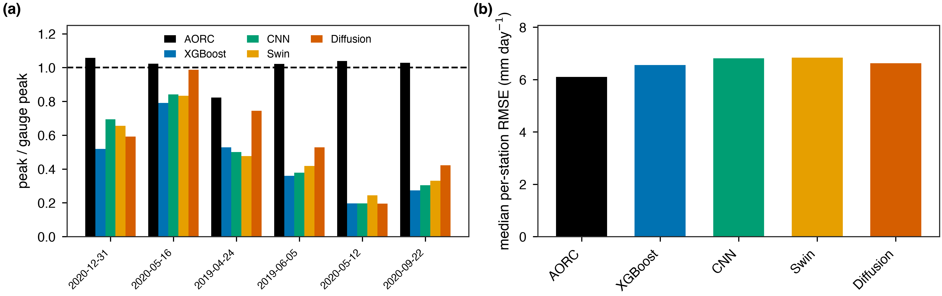
gauge check
AORC matches the gauge peak within a few per cent on five of six storms (black bars, near 1.0). The models sit at 0.19–0.53. On 5 June 2019 the gauges recorded 305 mm, AORC 311 mm, and the best model 161 mm.
The shortfall is real. The models miss extremes, not just disagree with AORC.

5. The experiment that changed the project
We asked: how much of the remaining error is the satellite being wrong, and how much is the 10 km → 1 km step being genuinely hard?
To separate them we built a perfect input. We took the truth, averaged it down to 10 km, and fed that in instead of the satellite. Everything else stayed the same. Any error left is only what averaging destroyed.
 | with the real satellite | with a perfect 10 km input
Austin | 4.58 | 0.72
Colorado | 2.83 | 0.49

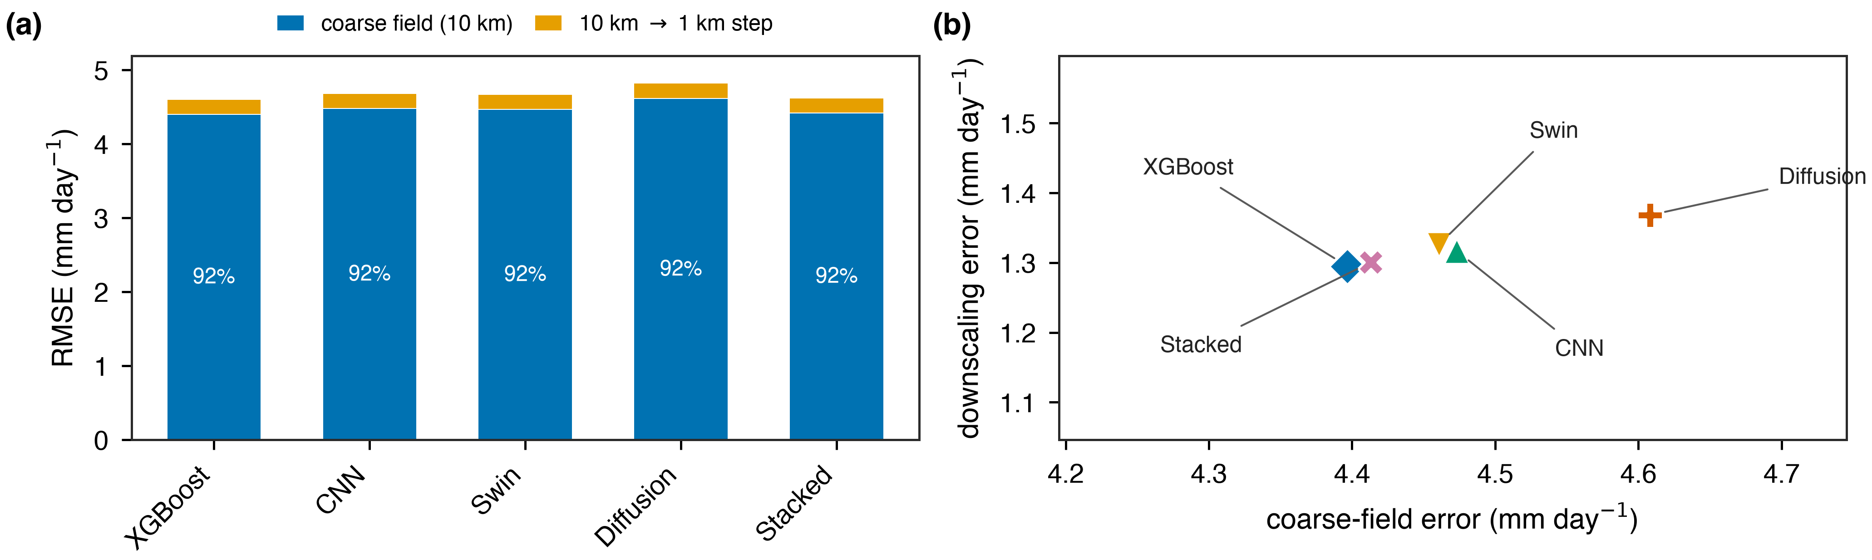
error budget
Written as a budget: about 92 % of the error is already in the coarse map before downscaling starts. The 10 km → 1 km step contributes a few per cent.
Detection changes just as dramatically. In Colorado the models find 13 % of heavy rain cells with the real satellite, and 92 % with a perfect input. Every loss-function idea we tried moved that number by about 3 points.
Two things follow, and they redirected the work:
- A better downscaler cannot help much. A perfect one buys about 1 %.
- Accuracy matters more than resolution. A perfect 0.5° input (3.00) still
beats our best real 0.1° product (4.58). A five-fold coarser grid costs less than the satellite's error does.
So we stopped trying to improve the downscaling step and started trying to improve the 10 km map.

6. What actually helped

Giving the model reanalysis rainfall
ERA5 is a weather reanalysis — a physics model fitted to past observations. We had been feeding the model ERA5's humidity, temperature, wind and instability, but not ERA5's own estimate of rainfall. Adding it:
 | 10 km error before | after | gain
Austin | 4.49 | 4.34 | 0.15
Colorado | 2.73 | 2.46 | 0.27

It helps roughly twice as much in the mountains, which is what we expected: satellites are weakest on cool-season mountain rain and snow, and a physics model is comparatively good there.
Why it works is worth stating. ERA5 on its own is the worse product — it agrees with the truth less well than the satellite does. But its errors are different errors, and its long-run average is almost exactly right where the satellite runs dry. The model is not replacing the satellite; it is using a second, independent opinion.

Training the model to produce realistic texture — the one thing that fixed the fine field
We added a penalty for the field being too smooth below 10 km, plus extra weight on heavy-rain cells. Both are needed: the smoothness penalty alone costs detection, and the heavy weighting is what repairs it.
Austin, five random starts, each compared against its own matched control:
 | change | consistency
texture | +0.675 | t = +9.0
heavy rain found (POD) | +0.065 | t = +19.4
CSI | +0.021 | t = +8.0
error | −0.004 | no measurable change

On the 13 March 2019 Front Range blizzard it captured 69 % of the peak against XGBoost's 48 % — the clearest case of it helping on a real storm.
Why this matters more than it first looks. Section 10 shows the sharpening step contributes almost nothing to RMSE. This is the exception, and it is visible only because texture is measured below 10 km where RMSE cannot see it. On a perfect input:
 | error | texture | heavy rain found
plain CNN | 0.723 | 0.072 | 0.951
CNN + texture penalty | 0.766 | 0.992 | 0.958

The plain CNN produces a field with 7 % of real rainfall's fine-scale variance. With the penalty it produces one with 99 % — essentially correct — for 0.043 mm of error. That is the design goal, met.
And an honest complication. When we split its gain into the coarse part and the sharpening part, the error and detection improvements land in the coarse field; the sharpening term does not move at all (Colorado +0.007, POWER 0.000). That is the heavy-weighting half doing an intensity recalibration at 10 km. The texture gain is genuinely sub-10 km — the measure is defined there — but the RMSE and POD gains are not.
So the fair summary: it is the only intervention that improved the 1 km field itself, and the improvement is in realism rather than in accuracy. If you need a field that looks and behaves like rain — input to a hydrology model, or anything where a too-smooth field misleads — this is the product. If you only need the lowest number, it does not help.

Quantile mapping: fixing the numbers without moving the rain
A different kind of fix, applied after training. For each predicted value we substitute the observed value at the same rank, using a map fitted on the dev year only. It is monotone, so no cell changes its position in the ordering — only the numbers move. It cannot relocate rain; it can only recalibrate it.
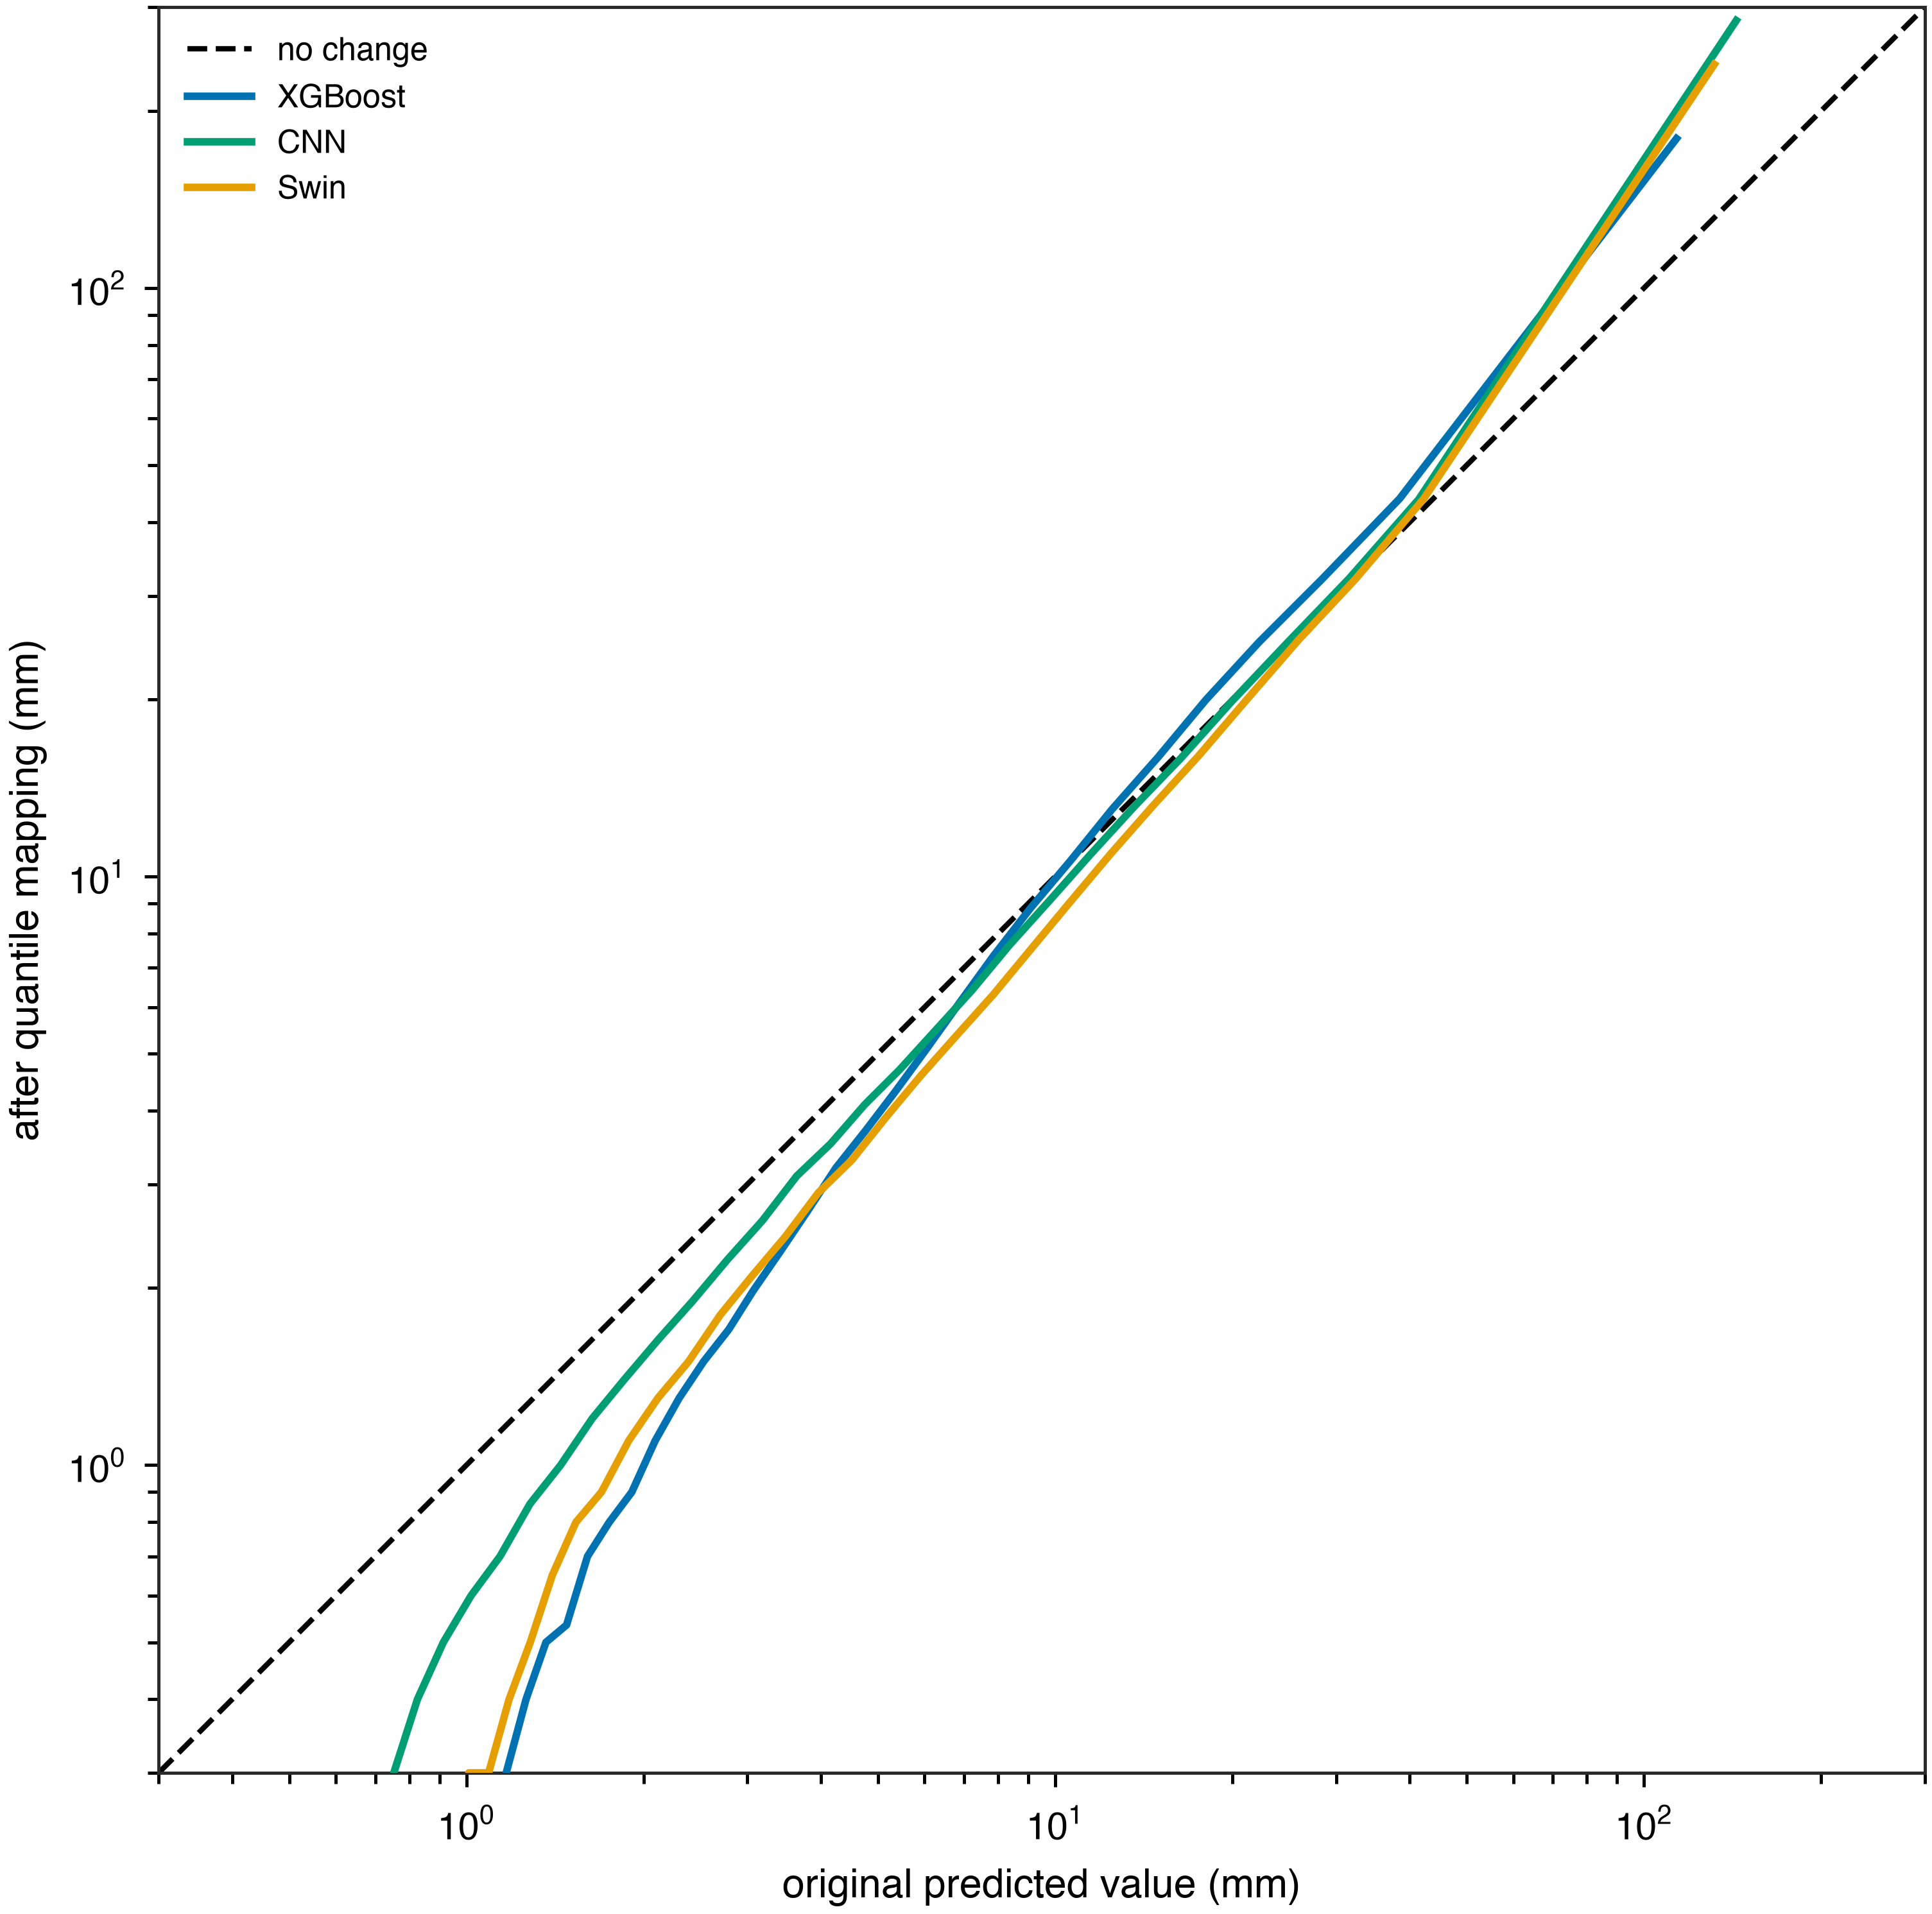
transfer function
The map mostly inflates: every curve sits above the no-change line, because all the products under-predict the upper tail.
It works, but only in proportion to how miscalibrated the product was.
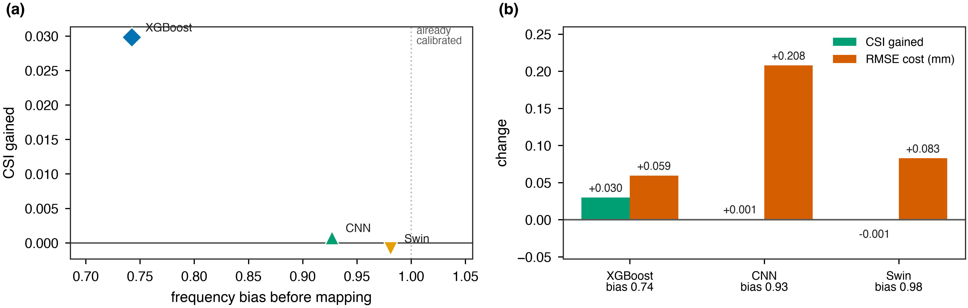
gain against bias
product | frequency bias before | CSI gained | RMSE cost
XGBoost | 0.74 | +0.030 | +0.059
CNN | 0.93 | +0.001 | +0.208
Swin | 0.98 | −0.001 | +0.083

Frequency bias is how often a product forecast heavy rain relative to how often heavy rain happened; 1.0 is correct. XGBoost started furthest off and gained the most — CSI 0.458 → 0.488 and POD 0.548 → 0.636, the best detection numbers anywhere in this study. Swin was already calibrated at 0.98, gained nothing, and paid the error cost anyway.
So it is a repair, not an improvement. It is worth applying to a product whose frequency bias is well below 1.0, and worth not applying otherwise. That is a useful operational rule and it is checkable before you run it.
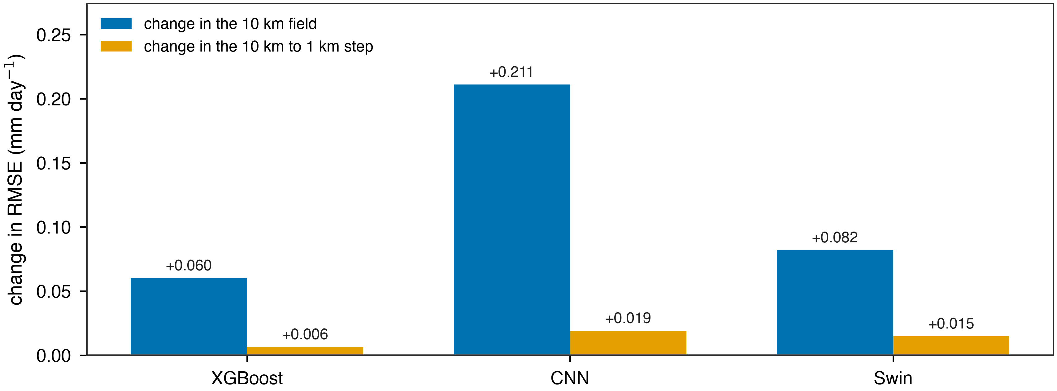
where it acts
And splitting its effect puts it on the same side of the ledger as everything else that has worked: the change lands in the 10 km field, while the 10 km → 1 km step barely moves. That is what a per-cell monotone transform must do — it cannot move rain between cells, so it can only alter the distribution.
One caution. The map is fitted on a single dev year (2018) and applied to two test years that contain wetter days than anything in it. Values above the largest dev-year prediction are extrapolated along the final segment rather than clipped, which is the right choice but is an assumption about the tail, not a measurement of it.

7. Things we tried that did not work
Recording these matters as much as the successes.
idea | result | why
Bigger/fancier networks | no real gain | capacity was never the limit
More training years | ~0.07 mm per doubling | we would need ~50 doublings to close the gap
A map of each cell's historical bias | worse (4.39 → 4.46) | the bias is not stable — the 2015–17 map correlates −0.11 with the 2019–20 one
Neighbourhood ("multiscale") loss | nothing | tolerates displacement, does not create structure
Picking checkpoints on texture | nothing over 5 seeds | looked good at one seed, was luck
IMERG's previous/next day | nothing | both products already use the same day boundary
A smarter spectral loss (AMSE) | slightly worse | —

The pattern: almost nothing on the modelling side moved the needle. The one thing that did was new information.

8. Where it works and where it does not
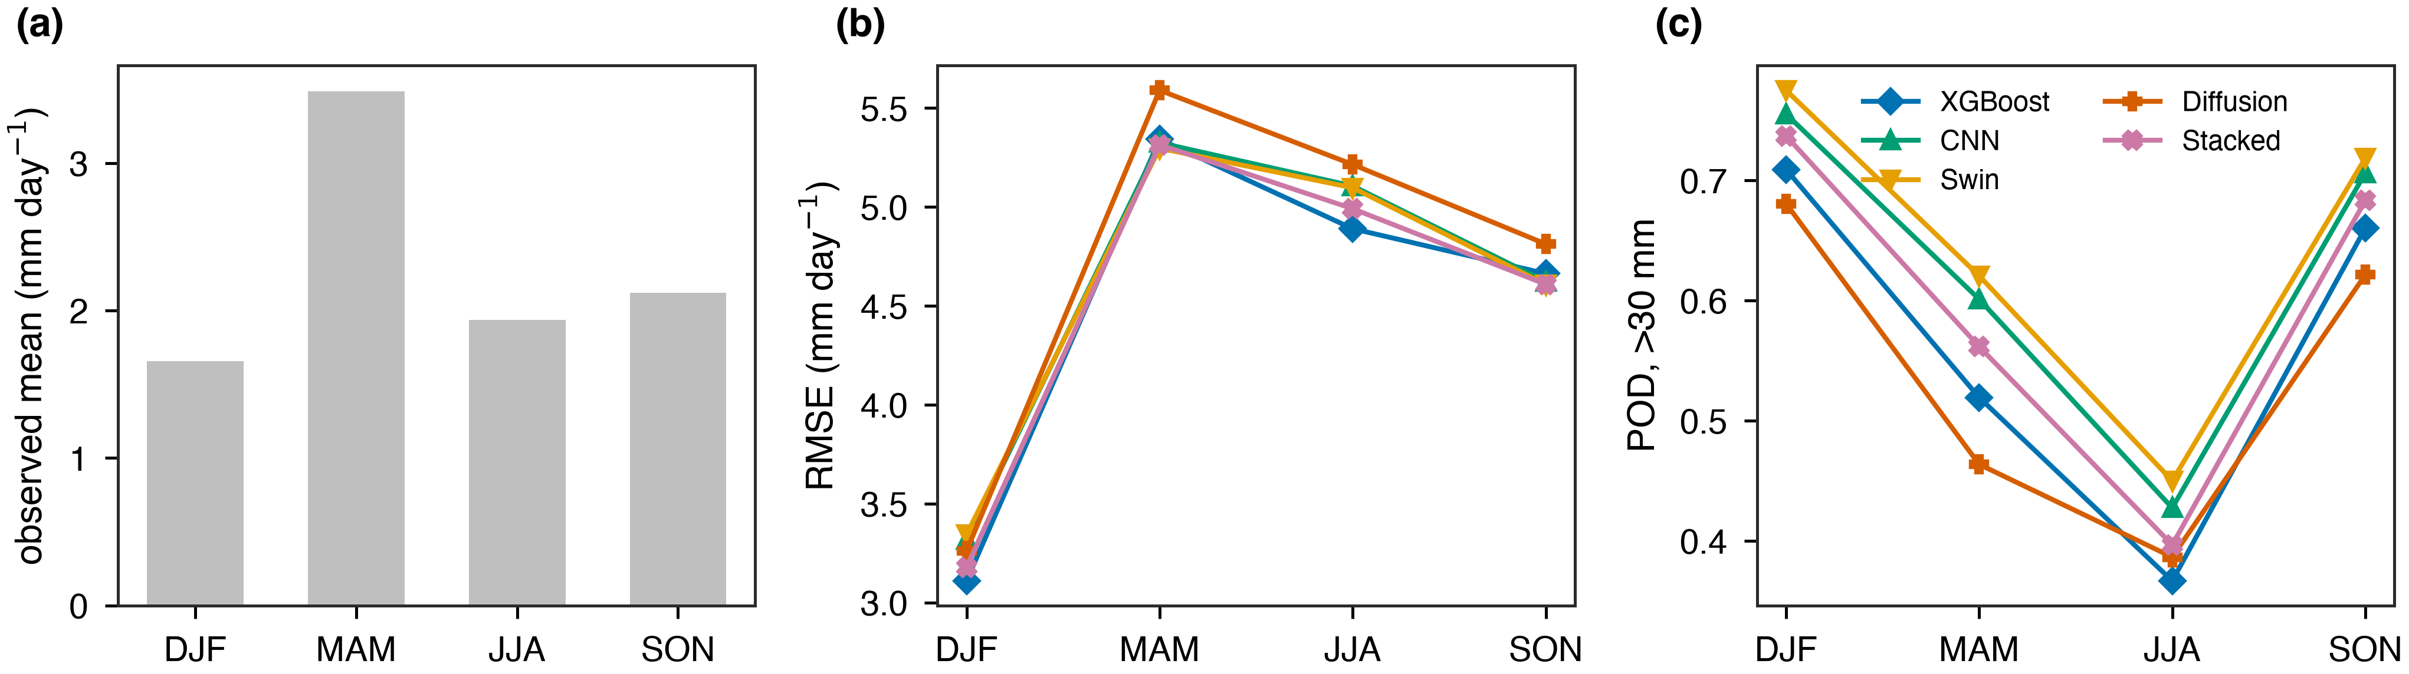
seasonal
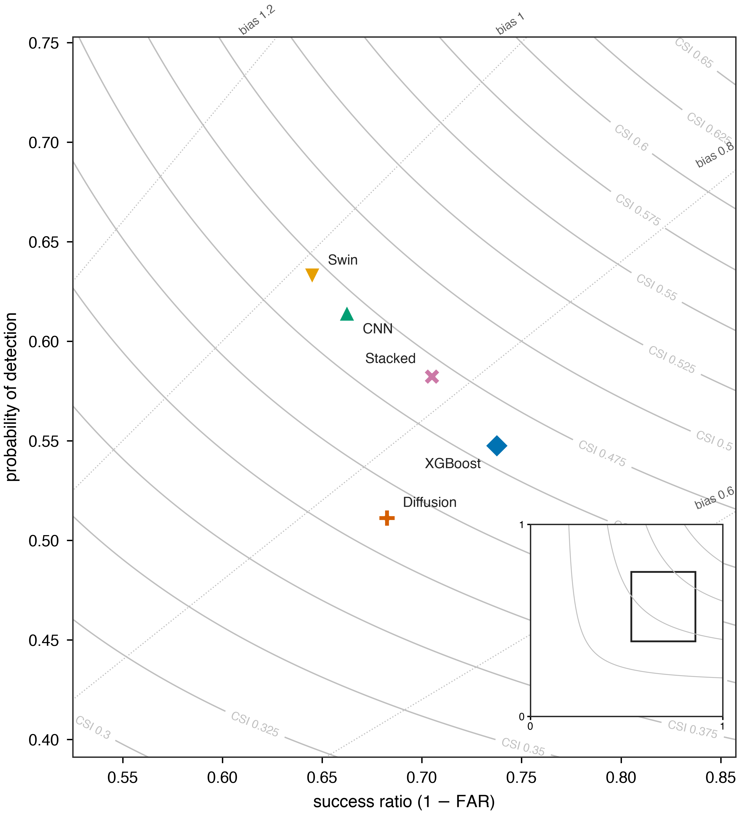
performance diagram
Useful for: total rainfall over a catchment or a season. All products clearly beat plain interpolation, and the mountain domain benefits most.
Not yet usable for: the single heaviest cell in a severe storm — the design-storm case. Models recover a fifth to a third of the peak, and the gauges confirm it.
A caution about mountain gauges. In Colorado the gauge comparison inverts: AORC scores worse against gauges (3.13) than the models do (2.90–2.95). We do not think the models are better. Mountain gauges sit in valleys while the heaviest rain falls on slopes, so a smooth map matches a sparse valley sample better than a sharp one does. 77 % of Colorado gauges correlate below 0.7 with AORC at their own location, against 62 % in Austin. Gauge checks are weaker evidence in mountains.

8b. What we found after the rest of this document was written
Five results landed later than the sections above. Two companion documents go further: ARCHITECTURE_RATIONALE.md explains why each model was built and in what order, and RESOLUTION_GUIDANCE.md is written for the city teams deciding what grid spacing to ask for.

The method works much better in mountains than in Texas
The configuration we ship was built and tuned on Austin, where it improved error by 0.11 mm/day and left heavy-rain detection unchanged. Repeated on the Colorado Front Range it improves error by 0.38 mm/day and roughly doubles detection — the share of heavy-rain cells found goes from 0.16 to 0.31. Read from Texas alone we would have called this an accuracy change that does nothing for detection. That would have been wrong.
It comes with a caution. In Colorado the fine detail now overshoots: the field carries about 1.6 times as much small-scale variance as real rain, where in Texas it carries 0.64 of it. More of a good thing stops being good, and the knob that helps in Texas makes Colorado worse.
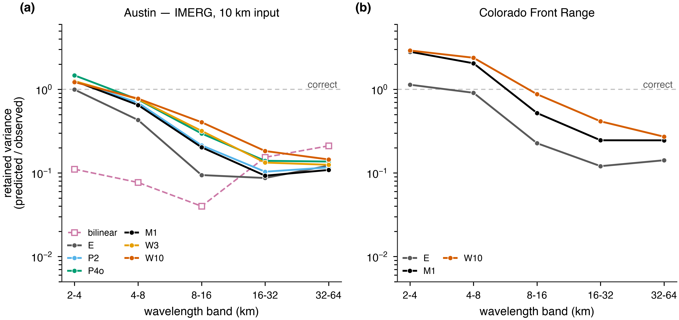
detail by scale
How much real detail survives at each size of feature, for each version we built. 1.0 is correct. Left, Austin: every version is far better than smoothing below 16 km and all of them are worse than smoothing between 16 and 64 km. Right, Colorado: the same models sit above 1.0 at small scales, which is the overshoot described above.

Sharpening that is forbidden from moving water between boxes loses nothing
We built a sharpener that can only decide where inside each 10 km box the rain goes, never how much each box gets. Against the ordinary version, free to change both: identical error to three decimals, identical detection, and 15 times the fine detail. The freedom to adjust box totals — which a normal model spends much of its capacity on — is worth nothing measurable. Same message as §10, reached from the opposite direction.
An earlier version of this test fed the sharpener the raw satellite field instead of a corrected one. Pinned to its input, it inherited every bit of the satellite's error and scored badly. That was the setup's arithmetic, not a finding, and it sat in our results looking like a real negative until we noticed.

What grid spacing should a product actually be delivered on?
The city's practical question. It has an answer that does not depend on any model: take the real 1 km rainfall, average it onto a candidate grid, put it back, and see what is lost. That is the floor a perfect product on that grid could not beat.
delivered at | best possible error | heavy rain found | detail kept below 10 km
5 km | 0.49 | 0.96 | 24 %
10 km | 1.07 | 0.92 | 9 %
25 km | 2.15 | 0.82 | 1 %
55 km (NASA POWER) | 3.13 | 0.74 | 0.2 %

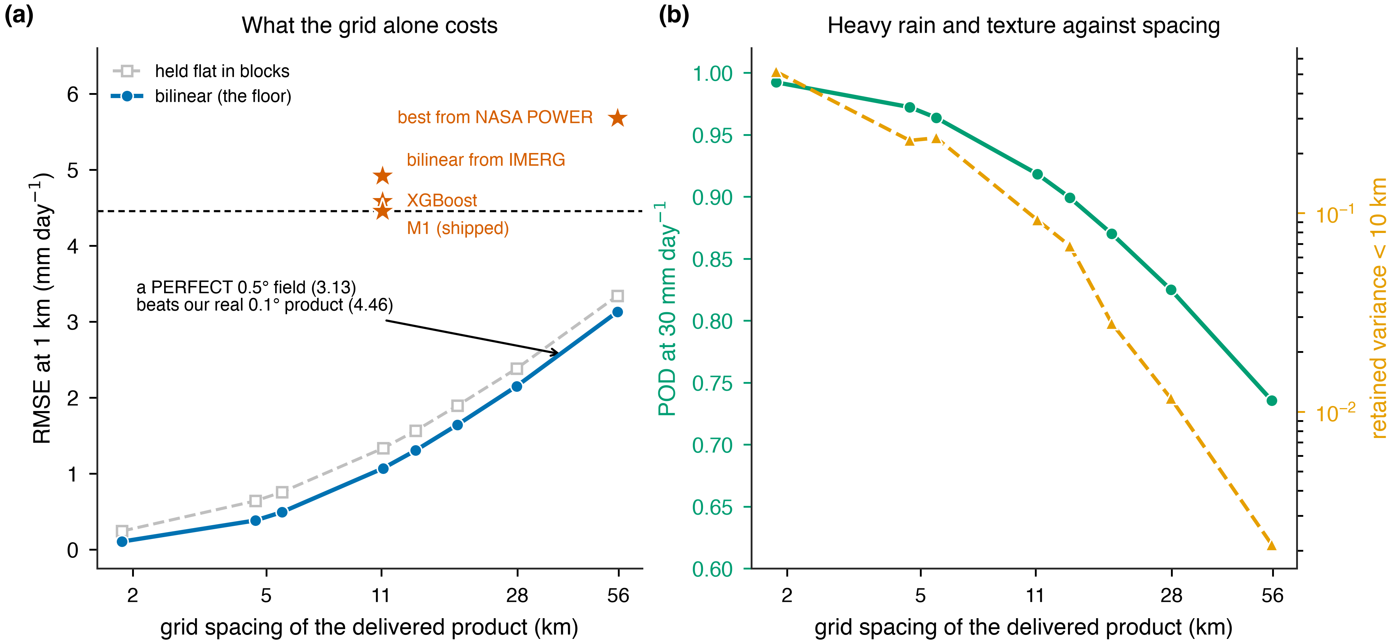
what the grid costs
The decision-relevant number is that our real products sit above the floor of a far coarser grid. A perfect 55 km field would score 3.13; our best real 10 km-derived product scores 4.46. Five times coarser and still better, because it is right. Spacing is not what is holding us back — accuracy is.
We recommend asking for 5 km, not 1 km. Going from 55 km to 5 km captures 84 % of everything available; the last step to 1 km buys a floor no current input can get within 4 mm of. Details and caveats in RESOLUTION_GUIDANCE.md.
Training a model at each of those grids says the same thing from the other side:
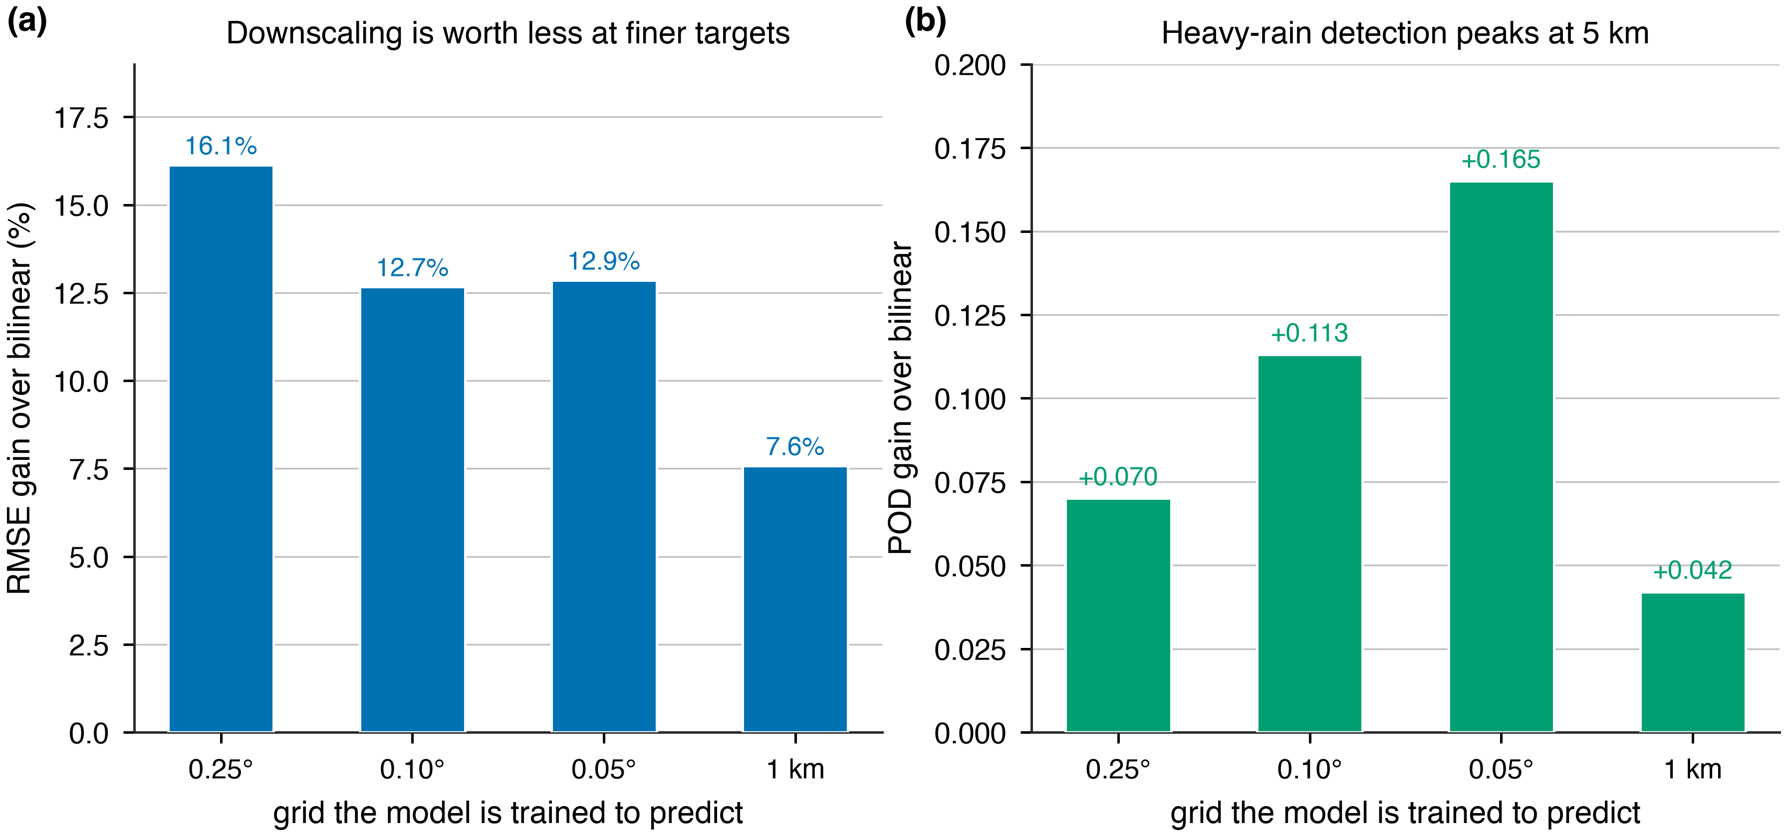
what downscaling is worth
The benefit of downscaling more than halves as the target gets finer — 16.1 % at 25 km, 7.6 % at 1 km — because most of what the model is good at is coarse-scale correction. Heavy-rain detection peaks at 5 km, the same answer the table above gives by a completely different route.

Architecture matters — but only where the error is
Early on we found that making the network 7 times bigger, or swapping it for a different kind of network entirely, changed the answer by 0.05 %. We used that throughout to justify not spending more time on model design.
That test was run on the sharpening stage. Repeating it on the 10 km correction stage — where 91–92 % of the error actually is — gives a spread 49 times larger, and bigger models now help instead of not mattering.
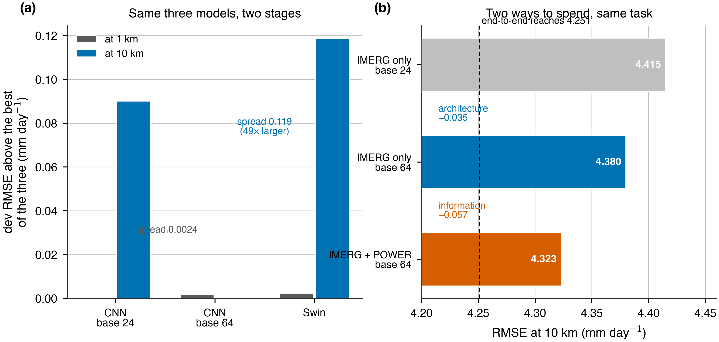
two levers
Left: the same three networks, judged at each stage. Right: the two ways to spend effort on the stage that carries the error.

NASA POWER as a second input — the first thing to beat model design
The error budget says the only lever left is giving the 10 km stage better information. The cleanest form of that is a second, independent estimate of the same rainfall. IMERG is a satellite retrieval; NASA POWER's rainfall is a weather-model reanalysis corrected against gauges. They are wrong in different ways.
Adding POWER as one extra input channel, with everything else identical:
 | error at 10 km | heavy rain found
satellite only | 4.389 | 0.542
satellite + NASA POWER | 4.323 | 0.567

−0.067 mm/day, and the three training runs of one version never overlap the other. On the same task, making the model bigger was worth 0.035. Information is worth nearly twice what model design is — the project's central claim, measured directly rather than inferred.
At 1 km the same channel gives −0.066, almost exactly the same, and the 10 km field inside the product improves by 0.070. But there the evidence is weaker: one of three runs barely moved, so we are running more and have not yet put it in the product.
One caveat we cannot design away. POWER is corrected against rain gauges, and AORC — the reference everything here is scored against — also uses gauge data. Part of this gain may be information the reference already carries rather than skill POWER adds. We are checking against 686 independent weather stations, and if the gain does not survive that, it should not ship.

9. What we would do next
- Feed the 10 km stage more independent information. Still the only thing that has
worked, and §8b now puts a number on it: NASA POWER as a second input is worth nearly twice what making the model bigger is worth. More independent estimates are the obvious continuation.
- Use the satellite's own quality flags. IMERG records how much of each estimate
came from its good sensor versus a gap-filling one. That is the satellite telling us where it was guessing, and nothing else in our inputs carries it. Built but never run against the current baseline.
- Finish the gauge check on the POWER channel before it goes into the product. If
the gain does not survive against independent stations it is an artefact of our reference.
- Report a distribution, not a single number. The products hedge because a single
number is scored on being close on average. A model that outputs a range could give a usable heavy-rain warning without being punished for committing. The code exists; the comparison was never finished.
- Be careful with gauges in complex terrain, for the reason in §8.
Deliberately not next: a better sharpener, or a bigger network at 1 km. Both are priced in §8b and §10 and neither has room in it.

10. Does the downscaling actually work?
This deserves a direct answer, because "92 % of the error is already in the input" and "the downscaling works" cannot both be waved at the same time.
To separate them we scored plain interpolation with the same split:
 | error at 1 km | error at 10 km | the 10 km → 1 km part
raw satellite, blocky | 4.994 | 4.812 | 1.333
bilinear interpolation | 4.919 | 4.732 | 1.342
XGBoost | 4.583 | 4.397 | 1.295

Now split XGBoost's improvement over bilinear into its two parts. Errors add as squares, so the shares are taken that way:
where the improvement comes from | share
correcting the 10 km map | 96 %
the 10 km → 1 km step itself | 4 %

So three statements, and only the first two are ours to make:
The product beats interpolation. 4.583 against 4.919, a 6.8 % reduction on years the model never saw. That is real.
Almost all of it is correcting the coarse map. What we have built is a good 10 km bias-corrector that then interpolates. That is a useful thing and it is not what "downscaling" usually means.
The sharpening step itself adds very little. It beats bilinear by 0.047 mm — 0.9 % of the total error. A perfect sharpener would remove the whole 1.342 mm; we have captured 3.5 % of that.
This also explains something that looked strange earlier. Four very different architectures had 10 km → 1 km errors spanning 0.067 mm while their 10 km errors spanned 0.195. They differ as bias correctors, not as downscalers. And it matches the storms: a model that is essentially smoothing a corrected coarse field is exactly the kind of model that recovers a fifth of a 284 mm peak.
One exception, and it is important. Everything above is measured in RMSE, and the texture-penalty model (§6) is the case RMSE cannot see. It takes the fine-scale variance of the field from 7 % of reality to 99 % — a change entirely below 10 km, which is precisely where RMSE is least sensitive. So the honest statement is narrower than "sharpening does nothing":
- For accuracy, the sharpening step contributes almost nothing. That holds across
two input resolutions, two model families and eight metrics.
- For realism, one intervention works, and only one. Training against the power
spectrum produces a field with approximately correct fine-scale structure, at a cost of 0.04 mm.
Whether that matters depends on the use. A catchment total does not care. A hydrology model fed a field that is far too smooth, or anyone reading the map as a picture of where it rained hard, does.

11. The honest summary
We set out to add 1 km detail to a 10 km satellite map. What we have is a system that corrects the 10 km map well and adds little genuine 1 km detail — and we can now say that with a number rather than a suspicion.
That is worth knowing rather than disappointing, for three reasons.
The product is better than the alternatives, by a margin that holds up on unseen years and against independent gauges. Someone who needs catchment totals should use it.
The limit is now located. 92 % of the remaining error was in the coarse map before we started, and the sharpening step has only 1.34 mm available to it in the first place. No amount of architecture work reaches past that.
And the interventions that did move the number all worked on the 96 % side, not the 4 % side. Giving the 10 km stage ERA5's own rainfall was worth 0.15 mm in Austin and 0.27 mm in the mountains. Giving it NASA POWER as a second opinion is worth 0.067 mm, nearly twice what making the model bigger buys on the same task. That is the direction with room in it, and it is now measured rather than argued.
What changed in the writing of this document, and is worth saying plainly: we began by treating this as a modelling problem and ended with a measurement of how little of it is one. The models are close to as good as the data allows. The data is where the next gain is.

