UTS – Blockhain Telkom University

**UTS Submission Guideline:** 

1. Make Github account & update on GDocs

2. Create UTS folder in your Git

3. Reproduce LAB 1, 2 and 3

4. Put Contract Codes in UTS Folder

**Theme: Hands on Lab with Ethereum Developer Guide**

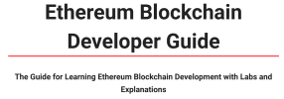Download PDF here

**Task: Reproduce the LABs in the Guide**

Read the Developer Guide End to End

Reproduce LAB 1: Deposit/Withdraw Ether Reproduce LAB 2 : Shared Wallet

Reproduce LAB 3: Supply Chain

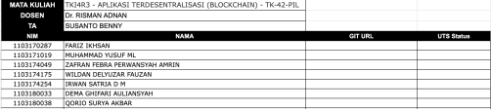

5. Make Technical Documentation 6. Update UTS Status (100%, 50%, Done) 7. URL for GDocs Submission below:

https://docs.google.com/spreadsheets/d/1WlF zJ8koedHpJbXBW99LH6NVgRRdl9o l5FnROf7u4Q/edit?usp=sharing

1 6