Ethereum Blockchain

Developer Guide

The Guide for Learning Ethereum Blockchain Development with Labs and Explanations

*Thomas Wiesner*

*Copyright © 2016 - 2021 <a href="https://vomtom.at">Thomas Wiesner</a>*

Table of contents

*Table of contents*

*1. Practical Ethereum Development 7 1.1 Why This Guide Exists 7 1.2 Are You The Right Audience 8 1.3 What You Will Learn 8 1.4 I saw you also do Video-Courses? 8 1.5 Work in Progress 11*

*2. License and Re-Use 11 3. Your First Transaction 12 3.1 Lab: Download, Install and Use a Wallet to Create a Transaction 12 3.2 Installing MetaMask 14 3.3 Setup MetaMask 16 3.4 Get Test-Net Ether 21 3.5 Track Ether 29 3.6 Congratulations 33 4. Send Ether between Accounts 34 4.1 Lab: Send Ether between Accounts 34 4.2 Create a new MetaMask Account 35 4.3 Transfer Ether from Account 1 to Account 2 38 4.4 Track the Transaction using Etherscan 44 4.5 Congratulations 51 5. Remix 52 5.1 Lab: Write your first Smart Contract 52 5.2 Setup Remix 54 5.3 Create Your First Smart Contract 59 5.4 Deploy Smart Contract 62 5.5 Interact with the Smart Contract 68 5.6 Congratulations 72 6. Blockchain Networks 73 6.1 Lab: Use different Blockchain Networks 73 6.2 Smart Contract Example 75 6.3 Injected Web3 76 6.4 The JavaScript VM in Remix 82 6.5 Web3 Provider 85 6.6 Congratulations 93*

*- 2/447 - Copyright © 2016 - 2021 <a href="https://vomtom.at">Thomas Wiesner</a>*

*Table of contents*

*7. Simple Variables 94 7.1 Lab: Solidity Basics 94 7.2 Understanding (Unsigned) Integers 95 7.3 Boolean Types in Solidity 106 7.4 Integer Overflow and Underflow 109 7.5 Address Types 116 7.6 String Types 121 7.7 Congratulations 124*

*8. LAB: Deposit/Withdraw Ether 125 8.1 Lab: Smart Contract Self Managing Funds 125 8.2 Smart Contract 126 8.3 Deploy and Use the Smart Contract 128 8.4 Withdraw Ether From Smart Contract 133 8.5 Withdraw To Specific Account 138 8.6 Withdrawal Locking 142 8.7 Congratulations 144*

*9. Smart Contract Life-Cycle 145 9.1 Lab: Starting, Pausing and Destroying/Stopping Smart Contracts 145 9.2 Sample Smart Contract 146 9.3 The Constructor 151 9.4 Pausing Smart Contract 157 9.5 Destroy Smart Contracts using* selfdestruct *159 9.6 Congratulations 164*

*10. Simple Mappings Introduction 165 10.1 Lab: Mappings and Structs 165 10.2 Smart Contract 166 10.3 Access Mapping Variables 171 10.4 Address Keys in Mappings 173*

*11. Mappings and Structs 179 11.1 Mappings and Structs 179 11.2 Basic Smart Contract 181 11.3 Understand the Limitations 184 11.4 Add a Mapping 189 11.5 Add partial Withdrawals 201 11.6 Add Structs 206*

*12. Exception Handling 212 12.1 Exception Handling: Require, Assert and Revert in Solidity 212 12.2 The Smart Contract 213*

*- 3/447 - Copyright © 2016 - 2021 <a href="https://vomtom.at">Thomas Wiesner</a>*

*Table of contents*

*12.3 Try the Smart Contract 216 12.4 Add a Require 218 12.5 Assert to check Invariants 220 12.6 Understanding Try/Catch 223*

*13. Fallback Function / Constructor / View and Pure 226 13.1 Fallback Function, View/Pure Functions, Constructor 226 13.2 Contract Example 227 13.3 The Receive Fallback Function 236 13.4 The Solidity Constructor 239 13.5 View and Pure Functions in Solidity 248*

*14. LAB: Shared Wallet 254 14.1 Project Shared Wallet 254 14.2 We Define the Basic Smart Contract 255 14.3 Permissions: Allow only the Owner to Withdraw Ether 256 14.4 Use Re-Usable Smart Contracts from OpenZeppelin 257 14.5 Permissions: Add Allowances for External Roles 258 14.6 Improve/Fix Allowance to avoid Double-Spending 259 14.7 Improve Smart Contract Structure 260 14.8 Add Events in the Allowances Smart Contract 261 14.9 Add Events in the SharedWallet Smart Contract 262 14.10 Add the SafeMath Library safeguard Mathematical Operations 263 14.11 Remove the Renounce Ownership functionality 264 14.12 Move the Smart Contracts into separate Files 265 14.13 Finishing Words 268*

*15. LAB: Supply Chain Project 269 15.1 Project Supply Chain 269 15.2 The ItemManager Smart Contract 271 15.3 Item Smart Contract 272 15.4 Ownable Functionality 274 15.5 Install Truffle 275 15.6 Add Contracts 278 15.7 Modify HTML 280 15.8 Connect with MetaMask 282 15.9 Listen to Payments 286 15.10 Unit Test 289 15.11 Congratulations 291*

*16. LAB: ERC20 Token Sale 292 16.1 Project Tokenization Overview 292*

*- 4/447 - Copyright © 2016 - 2021 <a href="https://vomtom.at">Thomas Wiesner</a>*

*Table of contents*

*16.2 Truffle Initialization 294 16.3 ERC20 Smart Contract 296 16.4 Migration and Compilation 297 16.5 Unit Test ERC20 298 16.6 Add Crowdsale Contracts 303 16.7 Change the UnitTests To Support TokenSales 305 16.8 Crowdsale Unit-Test 307 16.9 Add in a Kyc Mockup 311 16.10 Frontend: Load Contracts to React 313 16.11 Update KYC 317 16.12 Deploy Smart Contracts With MetaMask 319 16.13 Buy Coffee Tokens 331 16.14 Deployment with Infura 342*

*17. LEARN: Proxies and Upgrades 348 17.1 Upgrade Smart Contract and Smart Contract Proxies 348 17.2 Introduction 349 17.3 The Problematic Smart Contract 350 17.4 Overview of Standards for Smart Contract Upgrades 353 17.5 Eternal Storage without Proxy 354 17.6 The First Proxy Contract 361 17.7 Understanding Storage and Storage Collisions 370 17.8 EIP-897: The first real Proxy 372 17.9 EIP-1822: Proxies without Storage Collision without common Storage Contracts 375 17.10 EIP-1967 Standard Proxy Storage Slots 380 17.11 EIP-1538: Transparent Contract Standard 381 17.12 EIP-2535: Diamond Standard 382 17.13 Metamorphosis Smart Contracts using CREATE2 388 17.14 Conclusion 401*

*18. LEARN: ERC721 Tokens with OpenZeppelin Presets 402 18.1 ERC721 with Physical Asset Shipping Part 1 402 18.2 The Project Idea 403 18.3 Truffle Setup 407 18.4 OpenZeppelin Preset Contracts 409 18.5 Token Time Based Locking 415 18.6 Unit Testing the ERC721 Token 421 18.7 Final Words and Next Part 424*

*19. LEARN: ERC721 Token Secondary Sales Roylaties 425 19.1 ERC721 Part 2: Secondary Sales Royalties 425*

*- 5/447 - Copyright © 2016 - 2021 <a href="https://vomtom.at">Thomas Wiesner</a>*

*Table of contents*

*19.2 The Token Improvement 426 19.3 Minimal ERC721 Token 428 19.4 Adding a Migration for the ERC721 Token 430 19.5 Secondary Royalties on OpenSea 434 19.6 Secondary Royalties on Rarible 438 19.7 Secondary Royalties on Mintable (ERC2981) 443 19.8 Token URI 445 19.9 Final Words 446*

*- 6/447 - Copyright © 2016 - 2021 <a href="https://vomtom.at">Thomas Wiesner</a>*

*1. Practical Ethereum Development*

1. Practical Ethereum Development

*Heyo! So, you thought "Blockchains" are a cool thing? You have no idea where to start? This whole thing is too hard to figure out with weird YouTube tutorials and outdated sites?*

*Guess what!?*

*You're at the right place! And with my help you're developing your own Smart Contracts in no time!*

1.1 Why This Guide Exists

*When I started with Blockchain development back in 2016, the landscape for tutorials was very very very scarce. There were many tools, almost all only half-working. And no real guides. There was no Remix, no MetaMask, no Infura, no Truffle, no Academies, no ConsenSys. No nothing back then. My start was AlethZero. It crashed every few minutes or so and some whacky guides on how to compile Smart Contracts.*

*And for the entirety of 2016 the price of Ether was between $1 and $7.*

*AlethZero in Action*

*AlethZero in Action from this YouTube Video*

*What I was looking for was a practical guide that takes me through typical steps as a Smart Contract and DApp developer. Something that takes me through the pitfalls. Something I can relate to as a developer.*

*I'm not trying to do something shady. I'm not trying to build another Silk Road. This guide is not about Libertarianism. I'm not a cryptography researcher.*

*- 7/447 - Copyright © 2016 - 2021 <a href="https://vomtom.at">Thomas Wiesner</a>*

*1.2 Are You The Right Audience*

*I am a CTO with a strong development background trying to do practical stuff with that technology. I am not trying to make anyone geek out on how much it will f\*ck up our traditional world of finance.*

*I didn't have any of those guides. And I set out to change that. Already in 2016. But my first attempts were not great. In fact, they were very bad. Now, 15 video courses later, hundreds of hours spend on creating tutorials and video materials (if not thousands of hours!), I believe it reached a point where I have a framework for learning this stuff. And showing it to others. And I want to keep going.*

*When you're a traditional (web-)dev, then it's quite a bit of new material to learn and dig through. The traditional trust-model changed: the underlaying flow of registration/authentication is almost reversed. Tools are different. Language is different. Boundaries of what's possible are narrower. The business goals may be the same, but the way to reach them is skewed, for the lack of a better word.*

*And this guide shall be your new best friend.*

1.2 Are You The Right Audience

*It's certainly not a complete reference or covers the Solidity documentation front2back. You won't get a PhD after working through my code examples. But it gives you a deep understanding of the technologies behind famous DeFi-projects like Uniswap, ERC20 and ERC721 Tokens, Blockchain Supply Chain Solutions, and many more things. Scalable things. Trustable things. Enterprise'ey workflows. Stuff that I would expect a developer would bring when he wants to be hired.*

*Not me*

*That's not me. That's a foto I blatantly copied from unsplash. If you*

*made it this far, why not just go and do your first transaction in the*

*next chapter?! Photo by Campaign Creators on Unsplash*

*How hard will it be to go through the guide? That depends on your prior knowledge about web development. If you're a total beginner: never written a single line of JavaScript, never heard of RESTful APIs? Then better look somewhere else. Blockchains are not the best way to get started with development, it's hard to access and many underlaying ideas require fundamental understanding of how the web works.*

*If you are a C, C#, C++, Java, etc programmer with 20 years on your shoulders, you'll probably have an easy time. If you come from PHP, some things will be new, some things might look easy.*

*One thing I can promise you: I'll try to show you "the right way"*™￰ *to do things in an ever changing and more-than-ever demanding environment and I hope it will be enough to spark your interest to learn more about selected topics.*

1.3 What You Will Learn

*In these labs we're going through quite a bit and I'm not going to bullet-point every single tech and principle you're touching. Suffice to say, you'll have a workflow to develop your own projects. You'll have a fundamental understanding of Solidity. And you'll know the boundaries you're operating under (also called limitations).*

*At the end we'll run through a few full projects with Solidity on the Blockchain side and React on the Frontend side.*

1.4 I saw you also do Video-Courses?

*When you're looking to learn something, you can choose between with 4 different types of materials: Tutorials, How-To's, a full Reference and a theoretical explanation.*

*- 8/447 - Copyright © 2016 - 2021 <a href="https://vomtom.at">Thomas Wiesner</a>*

*1.4 I saw you also do Video-Courses?*

*- 9/447 - Copyright © 2016 - 2021 <a href="https://vomtom.at">Thomas Wiesner</a>*

*1.4 I saw you also do Video-Courses?*

*A school book about physics would be the classical "Theoretical Explanation". Yawn.*

*What's the difference between a Tutorial and a How-To?*

*A tutorial is learning oriented and a how-to is problem oriented. A tutorial is great for studying and a how-to is great to solve a specific problem when you're working. You wouldn't go to stackoverflow to learn a new skill, would you? And you would not take a 24h Udemy course to get that damn regex filter fixed, right?*

*The Solidity Documentation is a Reference, in my opinion. A pretty good one. Almost a Tutorial. What it lacks is teaching also about Blockchains and the tooling.*

*So, why an official (video) course on top of this guide?*

*This guide is a tutorial but it doesn't include a lot of theoretical knowledge. And it also doesn't include me directly showing, on video, how things are done.*

*This guide strips away most of the theoretical part and basically contains all the labs from of the video course Ethereum Blockchain Development.*

*If videos are your thing, then check it out. I made it with my colleague and friend Ravinder Deol, who's just as much of a Blockchain enthusiast as I am.*

*Now a little self promo: We will take you from beginner to master. Here’s why:*

*•*

*This course is taught by the Co-Creator Of The Industry Standard Ethereum Certification.*

*•*

*This course been updated to be 2021 Ready, so you’ll be learning with all the latest tools.*

*•*

*This course does not cut any corners, you will learn by building Real-World Projects in our labs.*

*•*

*We’ve taught over 100,000 students in the cryptocurrency & blockchain ecosystem.*

*•*

*Save Yourself Over $10K, but still get access to the same materials as live bootcamps.*

*•*

*This course is Constantly Updated with new content, projects and modules.*

*- 10/447 - Copyright © 2016 - 2021 <a href="https://vomtom.at">Thomas Wiesner</a>*

*1.5 Work in Progress*

*It's also a best-seller on Udemy and was picked up and transformed into corporate trainings and a book and instructor-led trainings, translated to chinese, probably pirated a few times, and more.*

1.5 Work in Progress

*Currently this written guide is a work in progress. I will update the following list as more and more chapters are being converted:*

*Your First Transaction With MetaMask*

*Your First Smart Contract with Remix*

*Using different Blockchain Networks*

*Solidity Basics: Integers, Boolean, Addresses, Strings*

*LAB: Escrow - Deposit and Withdrawals*

*Smart Contracts Life-Cycle: Starting, Pausing, Destroying Smart Contracts*

*Understanding Mappings and Structs*

*Exception Handling*

*Constructor and Fallback Functions*

*Solidity Advanced: Modifier, Inheritance, Constructors, Fallback*

*Events and Return Variables*

*LAB: Create a Shared Wallet*

*LAB: Event Triggers / Supply Chain Example with Truffle 5 and Unit Tests*

*Understand and Use Go-Ethereum Private Networks*

*LAB: Asset Tokenization using OpenZeppelin and Truffle*

*Work in Progress*

*Please note, this site is a "work in progress" for the course "Ethereum Blockchain Developer Bootcamp With Solidity (2021)"* 2. License and Re-Use

*All my materials are original materials and it took several hundred hours to put them together. I didn't do it to earn money in the first place, but I am also not doing it solely for someone else to make money off my back.*

*I offer sub-license agreements for commercial use and educational use. Reach out to me at thomas at vomtom dot at. Last update: April 17, 2021*

*- 11/447 - Copyright © 2016 - 2021 <a href="https://vomtom.at">Thomas Wiesner</a>*

*3. Your First Transaction*

3. Your First Transaction

3.1 Lab: Download, Install and Use a Wallet to Create a Transaction

*In this lab we are going to install MetaMask and create our first transaction.*

*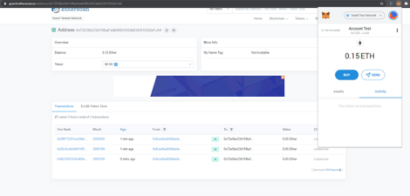*

3.1.1 What You Know At The End Of The Lab

ခ螺 *How to Get Free Ether To Test Transactions*

ခ *How To Securely Store Your Funds With Your Own Wallet*

ခ *Interact With Different Blockchains*

ခ茶 *Industry Standard Way To Connect To Blockchains*

ခ吝 *Understand Public Information With Block Explorers*

3.1.2 Prerequisites - You need:

*1. 2.*

*Chrome or Firefox browser.*

*An Internet connection*

*Brave Browser*

*If you are using a Brave Browser and you run into problems, then try to use Chrome instead.*

3.1.3 Videos

ခ *Full Video Walkthrough: https://www.udemy.com/course/blockchain-developer/?referralCode=E8611DF99D7E491DFD96*

3.1.4 Get Started

ခ ခ ခ *Let's get started by Installing MetaMask*

*- 12/447 - Copyright © 2016 - 2021 <a href="https://vomtom.at">Thomas Wiesner</a>*

*Last update: April 23, 2021*

*3.1.4 Get Started*

*- 13/447 - Copyright © 2016 - 2021 <a href="https://vomtom.at">Thomas Wiesner</a>*

3.2 Installing MetaMask

*3.2 Installing MetaMask*

*Firstly, we are going to install MetaMask. That is a browser plugin which can securely store private keys and connect to different blockchains.*

*How this exactly works is something we discuss later. For now we just play around.*

3.2.1 Download MetaMask

*Open https://metamask.io and download the plugin for your browser*

*- 14/447 - Copyright © 2016 - 2021 <a href="https://vomtom.at">Thomas Wiesner</a>*

*3.2.1 Download MetaMask*

*Perfect, that's it. Now, let's setup MetaMask and make it secure.*

*Last update: April 17, 2021*

*- 15/447 - Copyright © 2016 - 2021 <a href="https://vomtom.at">Thomas Wiesner</a>*

*3.3 Setup MetaMask*

3.3 Setup MetaMask

*When you install MetaMask, then it will automatically open up a "setup" page.*

*Hit "Begin" and walk through the setup-wizard. Let's create a new Wallet!*

3.3.1 Statistical Information

*If you want to send statistical information, is totally up to you, both is fine:*

*- 16/447 - Copyright © 2016 - 2021 <a href="https://vomtom.at">Thomas Wiesner</a>*

3.3.2 Set a Password

*3.3.2 Set a Password*

*Create a new strong password. This password is used to encrypt your private keys. What private keys are exactly is discussed in a later section of the course, suffice to say though, they give access to all your Ether. So, better have a strong password here:*

*- 17/447 - Copyright © 2016 - 2021 <a href="https://vomtom.at">Thomas Wiesner</a>*

*3.3.3 Backup Phrase*

*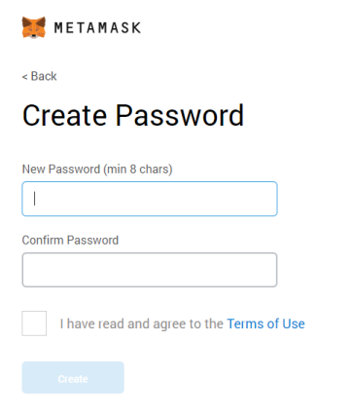*

3.3.3 Backup Phrase

*It would be better to safely store the secret phrase, but for sake of simplicity, let's just skip this for now:*

*- 18/447 - Copyright © 2016 - 2021 <a href="https://vomtom.at">Thomas Wiesner</a>*

*Seed Phrase*

*3.3.4 Final Screen*

*A seed phrase (or here: Backup Phrase) is usually a number of human-readable words (e.g. 12 words). This represents the "master key" to regain access to all your accounts. It is a simple algorithm to create a number of private keys based on your backup phrase. Don't worry if you don't know yet what this means - just remember: Never (like* never ever*) give out your seed phrase!*

3.3.4 Final Screen

*And you should be greeted with this screen:*

*- 19/447 - Copyright © 2016 - 2021 <a href="https://vomtom.at">Thomas Wiesner</a>*

*3.3.4 Final Screen*

*Let's see now how we can use MetaMask to transfer Ether...*

*Last update: April 17, 2021*

*- 20/447 - Copyright © 2016 - 2021 <a href="https://vomtom.at">Thomas Wiesner</a>*

3.4 Get Test-Net Ether

*3.4 Get Test-Net Ether*

*If you have never worked with blockchains before, then the first confusing this you will encounter is: There is not one blockchain, but many different blockchains. I am talking about Ethereum Blockchains.*

*It's like having different databases. But only one is considered the "Main" Database, or "Mainnet".*

*There are also other blockchains, for testing different aspects. Each of those have usually a name and a specific network and chain id. There is no central list of them, because everyone can open their own blockchain, but here's a good overview.*

*In this tutorial, we will use either Ropsten or Görli to get Test-Ether and start a transaction.*

3.4.1 Get Görli Test-Ether

*Switch the network to Goerli.*

*Network Selection*

*Attention here: some of the pictures have "Ropsten" selected, but the Ropsten test-network had a couple of hiccups, so I recommend Goerli instead!*

*List of ETH Testnet Faucets*

*Sometimes Faucets don't work as expected. Unfortunately there is nothing much that I can do about it. It is time intensive to run a faucet and usually it doesn't pay off economically. Here is a list of Faucets in case the one here doesn't work, you can probably switch to another one:*

*Ropsten: https://faucet.metamask.io*

*Rinkeby: https://faucet.rinkeby.io https://www.rinkebyfaucet.com https://app.mycrypto.com/faucet https://faucets.chain.link/ rinkeby*

*Kovan: https://gitter.im/kovan-testnet/faucet basically post your eth address in the gitter chat*

*Görli: https://goerli-faucet.slock.it/index.html https://faucet.goerli.mudit.blog*

*Another "special edition" Faucet is maintained by Keir "Blockchain-Gandalf" Finlow-Bates, who also wrote a great book about Blockchains. He tries to maintain it as good as possible and it outputs Ropsten Ether: https://moonborrow.com*

*Kintsugi (Eth2.0): https://kintsugi.themerge.dev*

*- 21/447 - Copyright © 2016 - 2021 <a href="https://vomtom.at">Thomas Wiesner</a>*

*3.4.1 Get Görli Test-Ether*

*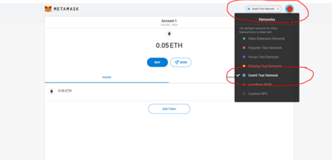*

*Hit "BUY"*

*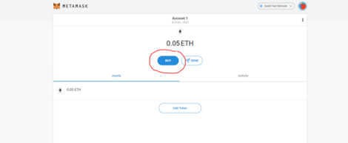Click on "Get Ether"*

*- 22/447 - Copyright © 2016 - 2021 <a href="https://vomtom.at">Thomas Wiesner</a>*

*3.4.1 Get Görli Test-Ether*

*A new website should open up. That's the faucet to get Ether. A Faucet is like a "get free Ether" -- site. The Ethers are having no value, they are running under a "test" Blockchain, but they are great for getting your feet wet with transactions and how Wallets work.*

*- 23/447 - Copyright © 2016 - 2021 <a href="https://vomtom.at">Thomas Wiesner</a>*

*3.4.1 Get Görli Test-Ether*

*Copy your Address from MetaMask by clicking directly on the address:*

*- 24/447 - Copyright © 2016 - 2021 <a href="https://vomtom.at">Thomas Wiesner</a>*

*3.4.1 Get Görli Test-Ether*

*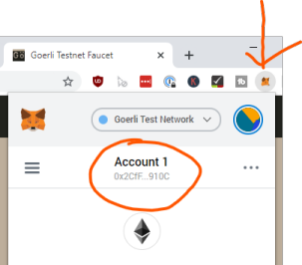*

*Paste it into the Goerli Faucet Value Field and hit "I'm not a robot" and "Request 0.05 GÖETH"*

*- 25/447 - Copyright © 2016 - 2021 <a href="https://vomtom.at">Thomas Wiesner</a>*

*Wait until the popup appears...*

*3.4.1 Get Görli Test-Ether*

*- 26/447 - Copyright © 2016 - 2021 <a href="https://vomtom.at">Thomas Wiesner</a>*

*3.4.1 Get Görli Test-Ether*

*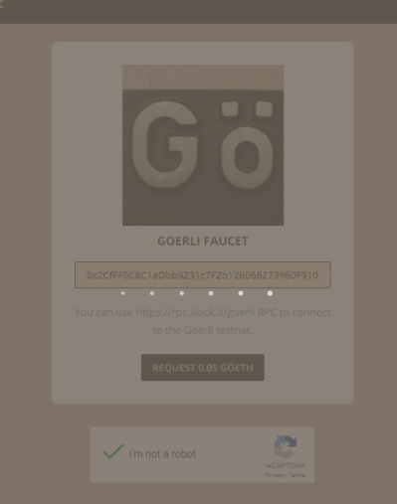*

*- 27/447 - Copyright © 2016 - 2021 <a href="https://vomtom.at">Thomas Wiesner</a>*

*3.4.1 Get Görli Test-Ether*

*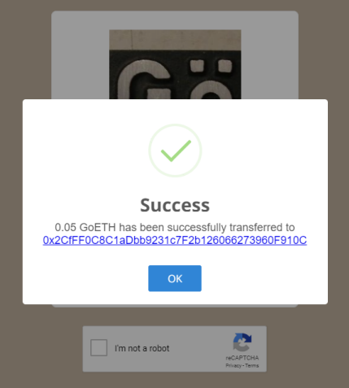*

*Don't click the link of the transaction, most likely it will not really work anyways. Let's track our Incoming Transaction in the next step!*

*Last update: January 23, 2022*

*- 28/447 - Copyright © 2016 - 2021 <a href="https://vomtom.at">Thomas Wiesner</a>*

3.5 Track Ether

*3.5 Track Ether*

*You might have heard it: all information on the Ethereum Blockchain is publicly visible information. So, if someone sends a transaction from A to B, then this is visible to all participants in the network.*

*There is specialized software to track those transactions, so called "Block explorers". One of them is Etherscan. Go to https://etherscan.io/ and click the Ethereum logo at the top right and choose Goerli testnet.*

*You should be at https://goerli.etherscan.io/. Copy and paste your address or copy the transaction hash from the previous step and paste it, either way, you should find a transaction that leads back to your wallet address:*

*- 29/447 - Copyright © 2016 - 2021 <a href="https://vomtom.at">Thomas Wiesner</a>*

*3.5 Track Ether*

*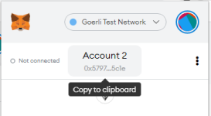*

*- 30/447 - Copyright © 2016 - 2021 <a href="https://vomtom.at">Thomas Wiesner</a>*

*3.5 Track Ether*

*You should see your transaction with the success message and all the details of the transaction.*

*Now open MetaMask from your browser and you should see some ETH in your wallet on a test-net. Video / Screenshots difference*

*Note: I have 0.15ETH in my wallet, because I did this procedure 3 times for the screenshots.*

*- 31/447 - Copyright © 2016 - 2021 <a href="https://vomtom.at">Thomas Wiesner</a>*

*3.5 Track Ether*

*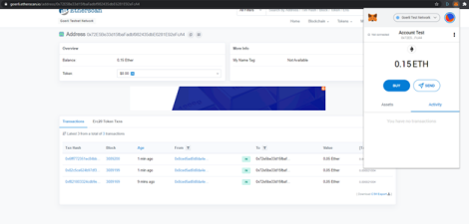That's it. You have now installed a wallet and you have your first Ether ready. Let's carry on with the next steps!*

*Last update: April 17, 2021*

*- 32/447 - Copyright © 2016 - 2021 <a href="https://vomtom.at">Thomas Wiesner</a>*

*3.6 Congratulations*

3.6 Congratulations

Congratulations, LAB is completed

*From the Course "Ethereum Blockchain Developer -- Build Projects in Solidity"*

*FULL COURSE: https://www.udemy.com/course/blockchain-developer/?referralCode=E8611DF99D7E491DFD96 Last update: April 17, 2021*

*- 33/447 - Copyright © 2016 - 2021 <a href="https://vomtom.at">Thomas Wiesner</a>*

*4. Send Ether between Accounts*

4. Send Ether between Accounts

4.1 Lab: Send Ether between Accounts

*In this lab you are going to send your first Ether between Accounts.*

4.1.1 What You Know At The End Of The Lab

ခ￰ *How to Create new Accounts in MetaMask*

ခ *Send Money to different Accounts using MetaMask*

ခ *Observe the Transaction using Etherscan.*

4.1.2 Prerequisites - You need:

*1. 2.*

*Chrome or Firefox browser.*

*An Internet connection*

*3.*

*Completed the Previous Lab with MetaMask and some Test-Ether*

4.1.3 Videos

ခ *Full Video Walkthrough: https://www.udemy.com/course/blockchain-developer/?referralCode=E8611DF99D7E491DFD96*

4.1.4 Get Started

ခ ခ ခ *Let's get started by Creating a new Account*

*Last update: January 3, 2022*

*- 34/447 - Copyright © 2016 - 2021 <a href="https://vomtom.at">Thomas Wiesner</a>*

*4.2 Create a new MetaMask Account*

4.2 Create a new MetaMask Account

*What we're trying to do in this lab is send some Ether from one account to another. But we don't want to waste the Ether. So, we are sending the Ether between two of our test accounts that we create ourselves.*

*First, we need to create another account in MetaMask:*

*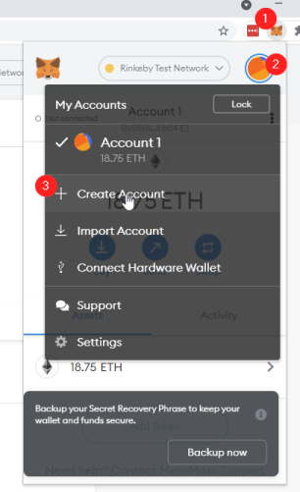*

*1.*

*Open the MetaMask Plugin*

*2.*

*Click on the little Account-Avatar on the top right corner*

*3.*

*Hit "Create Account"*

*- 35/447 - Copyright © 2016 - 2021 <a href="https://vomtom.at">Thomas Wiesner</a>*

*4.2 Create a new MetaMask Account*

*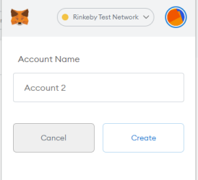*

*Hit "Create", you can leave the name to "Account 2" or whatever the default name is.*

*- 36/447 - Copyright © 2016 - 2021 <a href="https://vomtom.at">Thomas Wiesner</a>*

*4.2 Create a new MetaMask Account*

*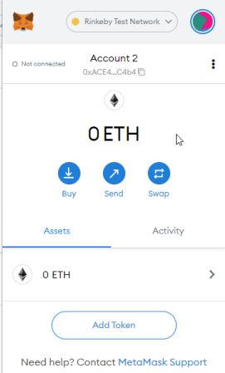*

*You now have two accounts. Now we can send Ether from one account to the other.*

*Last update: September 6, 2021*

*- 37/447 - Copyright © 2016 - 2021 <a href="https://vomtom.at">Thomas Wiesner</a>*

*4.3 Transfer Ether from Account 1 to Account 2*

4.3 Transfer Ether from Account 1 to Account 2

*You have two accounts now in MetaMask. You can switch between them. If you followed the previous tutorial, then you already have test-ether in your Account 1. Time to send some Ether from Account 1 to Account 2!*

*Switch back to Account 1:*

*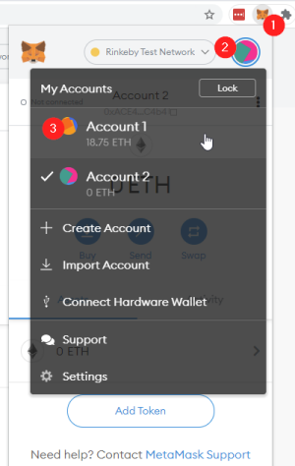*

*1.*

*Open the MetaMask Extension*

*2.*

*Click on the little Account avatar in the top right corner*

*3.*

*Switch back to Account 1.*

*- 38/447 - Copyright © 2016 - 2021 <a href="https://vomtom.at">Thomas Wiesner</a>*

*4.3 Transfer Ether from Account 1 to Account 2*

*No Ether*

*If your Account 1 doesn't show any ether at all, run through the previous tutorial first to get some Ether on the Testnet. It doesn't have to be Ropsten, but on some network you need Ether, otherwise you can't complete this tutorial. Previous Tutorial*

*Click on the Send button:*

*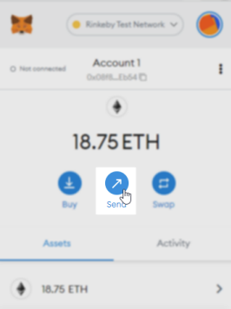*

*This will open up the Send-Page. Hit "Transfer Between my Accounts", because we want to transfer here between our Ethereum Accounts we have in MetaMask.*

*Transfer to other Account*

*Of course, if you have to transfer Ether to different other Accounts, you can just paste the Ethereum Address into the input field, or even scan a QR code. We do this later on some time. Also feel free to just give it a try yourself. You can, for example, copy and paste your own Ethereum Address and skip the "Transfer between my Accounts" functionality.*

*- 39/447 - Copyright © 2016 - 2021 <a href="https://vomtom.at">Thomas Wiesner</a>*

*4.3 Transfer Ether from Account 1 to Account 2*

*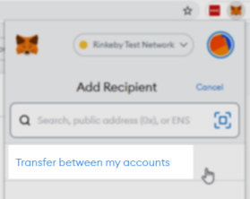*

*Select Account 2:*

**

*Ether 0.1 Eth and hit next:*

*- 40/447 - Copyright © 2016 - 2021 <a href="https://vomtom.at">Thomas Wiesner</a>*

*4.3 Transfer Ether from Account 1 to Account 2*

**

*Then have a look at the gas-cost overview. It might look a little bit different for you, but the essence is: You send 0.1 Eth, but it's not entirely for free. In this case the transfer costs (gas costs) amount to 0.000032 Eth:*

*- 41/447 - Copyright © 2016 - 2021 <a href="https://vomtom.at">Thomas Wiesner</a>*

*4.3 Transfer Ether from Account 1 to Account 2*

**

*Then simply hit "confirm". Now we can track the transaction using a Block Explorer. A Block Explorer is a public website that crawls the blockchain for new transactions and show them on a public website. Etherscan is one of many block explorers.*

*- 42/447 - Copyright © 2016 - 2021 <a href="https://vomtom.at">Thomas Wiesner</a>*

*4.3 Transfer Ether from Account 1 to Account 2*

**

*We do this next!*

*Last update: September 6, 2021*

*- 43/447 - Copyright © 2016 - 2021 <a href="https://vomtom.at">Thomas Wiesner</a>*

*4.4 Track the Transaction using Etherscan*

4.4 Track the Transaction using Etherscan

*Now your MetaMask probably looks like this:*

**

*or, if the transaction already successfully mined, like this:*

*- 44/447 - Copyright © 2016 - 2021 <a href="https://vomtom.at">Thomas Wiesner</a>*

*4.4 Track the Transaction using Etherscan*

**

*If you click on the entry (you might need to scroll down a bit), then you can open up a little modal window:*

*- 45/447 - Copyright © 2016 - 2021 <a href="https://vomtom.at">Thomas Wiesner</a>*

*4.4 Track the Transaction using Etherscan*

**

*There are a few things you can see:*

*1.*

*The Nonce. The Nonce is an ever increasing number on Ethereum that depicts how many transactions were sent from this account. Nonce 0 = First transaction* ခ*.*

*2.*

*Amount: We sent 0.1 Eth away*

*3.*

*Gas: Simple transactions need 21000 gas (the gas stipend). More on that a little later, don't worry for now. 4.*

*Base Fee and Priority Fee (Tip): We need to pay for gas with Eth. Its like using Water or Electricity and you need cash to pay for it. We're covering it later as well.*

*5.*

*Total: The total amount we paid for it.*

*Basefee and Tip*

*Since EIP-1559 we don't just do gas anymore, its broken down into a basefee that gets burned and a tip that goes to miners. It's still very similar to the previous gas auctions, just not everything goes to miners. More on that later as well.*

*But there is still some information missing. Like e.g. the block number or other transactions that were included in the block. That's something that block explorers can tell us! If you open up the link to Etherscan you can directly go to the transaction:*

*- 46/447 - Copyright © 2016 - 2021 <a href="https://vomtom.at">Thomas Wiesner</a>*

*4.4 Track the Transaction using Etherscan*

**

*- 47/447 - Copyright © 2016 - 2021 <a href="https://vomtom.at">Thomas Wiesner</a>*

*4.4 Track the Transaction using Etherscan*

*If you just want to see my transaction, you can click here: https://rinkeby.etherscan.io/tx/*

*0xf5ab95d1cdcf15ae84caa852fffee502dcaae1c7dc86e4fafab790b5d5d37f5b*

*You can also click on the little "Click here to see more" link:*

*- 48/447 - Copyright © 2016 - 2021 <a href="https://vomtom.at">Thomas Wiesner</a>*

*4.4 Track the Transaction using Etherscan*

*You see all the information about the transaction, including in which block it was included and many more things we cover later in the course.*

*- 49/447 - Copyright © 2016 - 2021 <a href="https://vomtom.at">Thomas Wiesner</a>*

*Last update: September 6, 2021*

*4.4 Track the Transaction using Etherscan*

*- 50/447 - Copyright © 2016 - 2021 <a href="https://vomtom.at">Thomas Wiesner</a>*

*4.5 Congratulations*

4.5 Congratulations

Congratulations, LAB is completed

*From the Course "Ethereum Blockchain Developer -- Build Projects in Solidity"*

*FULL COURSE: https://www.udemy.com/course/blockchain-developer/?referralCode=E8611DF99D7E491DFD96 Last update: September 6, 2021*

*- 51/447 - Copyright © 2016 - 2021 <a href="https://vomtom.at">Thomas Wiesner</a>*

*5. Remix*

5. Remix

5.1 Lab: Write your first Smart Contract

*In this lab you are going to write your very first smart contract. We are also going to deploy it to a blockchain.*

5.1.1 What You Know At The End Of The Lab

ခ￰ *Understand Remix IDE and the Tooling*

*- 52/447 - Copyright © 2016 - 2021 <a href="https://vomtom.at">Thomas Wiesner</a>*

*5.1.2 Prerequisites - You need:*

က⏲￰ *Get started with Smart Contract Development Fast and Easy*

⚙￰ *Setup Remix the right way*

�� *No matter if you want to write in Solidity 0.5.x, 0.6.x, 0.7.x or 0.8.x!*

ခ *Connect MetaMask and Remix to deploy to Görli*

5.1.2 Prerequisites - You need:

*1. 2.*

*Chrome or Firefox browser.*

*An Internet connection*

*3.*

*Completed the Previous Lab with MetaMask and some Test-Ether*

5.1.3 Videos

ခ *Full Video Walkthrough: https://www.udemy.com/course/blockchain-developer/?referralCode=E8611DF99D7E491DFD96*

5.1.4 Get Started

ခ ခ ခ *Let's get started by Setting up Remix*

*Last update: September 6, 2021*

*- 53/447 - Copyright © 2016 - 2021 <a href="https://vomtom.at">Thomas Wiesner</a>*

5.2 Setup Remix

*5.2 Setup Remix*

*First we need to setup Remix to have the correct plugins installed, activated and configured. Before we do that, some general information!*

*What's Remix anyways?*

*Remix, previously known as Browser-Solidity, is a browser based development environment for Smart Contracts. It comes with compilers for different solidity versions and a blockchain simulation. It also has plenty of other plugins. It's a great way to get started!*

*HTTP vs HTTPS*

*Be careful with the https vs http domain. Remix stores edited files in localstorage of the browser. If your smart contracts are suddenly gone, look at the protocol.*

*In this course we work with http, not https. This is especially important later when we do private blockchains which require CORS to be setup correctly.*

5.2.1 Open Remix

*Go to http://remix.ethereum.org. You should be greeted with the following page:*

*- 54/447 - Copyright © 2016 - 2021 <a href="https://vomtom.at">Thomas Wiesner</a>*

*5.2.1 Open Remix*

*If the popup shows up for you, then feel free to accept if you have no concerns over privacy violations. For our course we can do that.*

*- 55/447 - Copyright © 2016 - 2021 <a href="https://vomtom.at">Thomas Wiesner</a>*

*5.2.2 Plugins*

*Updates from Video*

*In the video we are using an older version of Remix. Currently, by default, Remix starts with the dark theme. In the videos you see the light theme. You can change this in the settings: Bottom left, scroll down, theme light.*

*More importantly, in the videos we had to enable plugins. The most important plugins are now enabled by default. Below we're still making sure they are enabled, just in case.*

5.2.2 Plugins

*Remix is built with a pluggable architecture. All functions are done via plugins. The Compiler is a plugin, the blockchain connection is a plugin, the debugging functionality is a plugin and there are a lot of other plugins that might be useful.*

*What you need in the next few chapters are*

*1. 2.*

*The Solidity compiler*

*The "Deploy & Run Transactions" Plugin*

**

5.2.3 Enable Plugins

If the plugins are not showing up yet*, then click on the plugin symbol and enable them:*

*- 56/447 - Copyright © 2016 - 2021 <a href="https://vomtom.at">Thomas Wiesner</a>*

*5.2.4 Configure the Compiler*

**

*And find the two plugins and activate them:*

**

5.2.4 Configure the Compiler

*In this chapter we are working with Solidity 0.8.1. The compiler will normally switch automatically based on the* pragma *line in your solidity files. But you can set a specific version, if necessary.*

*If you don't know what that is and don't want to wait several videos to understand what a pragma line is: In layman terms, it's here to configure your compiler. For example there's a version pragma, that tells the compiler "Hey, this source is made for compiler version XYZ". That's what we're going to use. Need more information? Either wait, or read the official docs*

*- 57/447 - Copyright © 2016 - 2021 <a href="https://vomtom.at">Thomas Wiesner</a>*

*5.2.4 Configure the Compiler*

*Switch Compiler Version*

*If it is necessary to switch compiler versions manually, you can always do this. You can either follow along in the videos, then use the compiler version the videos are using. Or you follow along this guide and use this solidity version.*

*New Compiler versions are published very frequently. It is very normal to find "outdated" solidity files around. Some very popular projects are using older solidity versions.*

*Make sure "auto-compile" is enabled:*

**

*Great! You're all set! Let's create your first file in the next section!*

*Last update: September 6, 2021*

*- 58/447 - Copyright © 2016 - 2021 <a href="https://vomtom.at">Thomas Wiesner</a>*

5.3 Create Your First Smart Contract

*5.3 Create Your First Smart Contract*

*Now we are creating a new file and inserting some Solidity code. Don't worry if you don't fully understand everything - we have to start somewhere and we're here to play around. Just follow along, I promise everything will be clear later on!*

5.3.1 Create A New File

*Click on the plus icon in the code-editor and create a new file, name it "MyContract.sol". The sol-extension stands for Solidity. *

**

*- 59/447 - Copyright © 2016 - 2021 <a href="https://vomtom.at">Thomas Wiesner</a>*

*5.3.1 Create A New File*

*- 60/447 - Copyright © 2016 - 2021 <a href="https://vomtom.at">Thomas Wiesner</a>*

5.3.2 Add Solidity Hello World Code *Now add the following code to the file:*

// SPDX-License-Identifier: GPL-3.0

pragma solidity ^0.8.1;

contract MyContract {

string public myString = 'hello world'; }

*5.3.2 Add Solidity Hello World Code*

*It should look like this and the "Compiler" Plugin should have a green checkmark badge. That's the icon in the left side panel:*

*Wondering what that all means?*

*This is a very basic version of a Smart Contract. Let's go through it line by line:*

// SPDX-License-Identifier: GPL-3.0 *: The The Software Package Data Exchange® (SPDX®) identifier is there to clearly communicate the license under which the Solidity file will be made available. Well, if you make it available. But you should. Smart Contracts transparency and trust greatly benefit from the source being published and sometimes it's not 100% clear under which license the source is out in the wild. The SPDX identifier is optional, but recommended.*

pragma solidity ^0.8.1 *: The* pragma *keyword is for the compiler to enable certain features or check certain things. The version pragma is a safety measure, to let the compiler know for which compiler version the Solidity file was written for. It follows the SemVer versioning standard. ^0.8.1 means >=0.8.1 and <0.9.0.*

contract MyContract *: That's the actual beginning of the Smart Contract. Like a Class in almost any other programming language.*

string public myString = 'hello world' *: That is a storage variable. It's public and Solidity will automatically generate a getter function for it - you'll see that in a minute!*

*Perfect! Let's proceed to deploy this Smart Contract to a Blockchain!*

*Last update: September 6, 2021*

*- 61/447 - Copyright © 2016 - 2021 <a href="https://vomtom.at">Thomas Wiesner</a>*

5.4 Deploy Smart Contract

*5.4 Deploy Smart Contract*

*Now it's time to deploy our Smart Contract. We will do this to a real blockchain. In the previous video we got our first Ether on a Test-Network. We will use them now to deploy the smart contract.*

5.4.1 Connect MetaMask to Remix

*Switch over to the "Deploy & Run Transactions" Plugin. We need to configure it, so it uses our MetaMask Wallet to access the Blockchain.*

*As soon as you do this, MetaMask should pop up and ask you to connect your account to Remix.*

*- 62/447 - Copyright © 2016 - 2021 <a href="https://vomtom.at">Thomas Wiesner</a>*

*Click "Next" and the "Connect":*

*5.4.1 Connect MetaMask to Remix*

*- 63/447 - Copyright © 2016 - 2021 <a href="https://vomtom.at">Thomas Wiesner</a>*

*5.4.1 Connect MetaMask to Remix*

**

*Now your account should pop-up in the dropdown under the Environment Selection:*

*- 64/447 - Copyright © 2016 - 2021 <a href="https://vomtom.at">Thomas Wiesner</a>*

*5.4.2 Deploy the Smart Contract*

*Account not showing up?*

*If your account doesn't show up, or MetaMask doesn't pop up, try to reload the page. There are sometimes caching issues.*

5.4.2 Deploy the Smart Contract

*Let's deploy the Smart Contract now. First, make sure the correct Smart Contract is selected in the Dropdown: *

*Then simply hit "Deploy":*

*- 65/447 - Copyright © 2016 - 2021 <a href="https://vomtom.at">Thomas Wiesner</a>*

*5.4.2 Deploy the Smart Contract*

**

*This should trigger MetaMask to ask you if you really want to send this transaction. Make sure the Görli Test-Network is selected and then simply hit "Confirm". If you selected the wrong network, then cancel the transaction, switch the network in MetaMask and hit "Deploy" again.*

*- 66/447 - Copyright © 2016 - 2021 <a href="https://vomtom.at">Thomas Wiesner</a>*

*5.4.2 Deploy the Smart Contract*

**

*Perfect, now the transaction is on the way of getting mined. In the next section we will follow the transaction and interact with our smart contract!*

*Last update: September 6, 2021*

*- 67/447 - Copyright © 2016 - 2021 <a href="https://vomtom.at">Thomas Wiesner</a>*

*5.5 Interact with the Smart Contract*

5.5 Interact with the Smart Contract

*Now let's see if we can interact with the smart contract. Of course, at this point you have no idea what interaction actually means, so, let's just follow along.*

5.5.1 Wait For Contract Readiness

*First, we need to wait until the transaction is mined. We sent a transaction to the network, but before it's mined the contract won't be ready for any interaction. This can sometimes take a while, and sometimes it's really fast.*

*Wait until MetaMask sais the Contract Deployment is complete. Open the MetaMask plugin in the top-right corner of Chrome, then check if the Smart Contract was already deployed:*

**

*Wait until it says*

*"Contract Deployment" without a pending flag*

*Open MetaMask and go into the Ether Details*

*You will also see in Remix that the Contract is now ready:*

*- 68/447 - Copyright © 2016 - 2021 <a href="https://vomtom.at">Thomas Wiesner</a>*

5.5.2 Interact With The Smart Contract

*5.5.2 Interact With The Smart Contract*

*Now it's time to start our first interaction. In Remix we don't have to do any low-level things, it conveniently shows us buttons and input fields. You will later see how that works under the hood. We are covering it in the videos about the ABI Array.*

*Open the Dropdown on the left side:*

*- 69/447 - Copyright © 2016 - 2021 <a href="https://vomtom.at">Thomas Wiesner</a>*

*5.5.2 Interact With The Smart Contract*

*So that you can interact with the newly deployed Smart Contract:*

*- 70/447 - Copyright © 2016 - 2021 <a href="https://vomtom.at">Thomas Wiesner</a>*

*5.5.2 Interact With The Smart Contract*

**

*Hit the "myString" Button and you will hopefully see that it returns "hello world" correctly.*

**

*This is it, your very first smart contract using Remix and the Görli Test-Network.*

*Last update: September 6, 2021*

*- 71/447 - Copyright © 2016 - 2021 <a href="https://vomtom.at">Thomas Wiesner</a>*

*5.6 Congratulations*

5.6 Congratulations

Congratulations, LAB is completed

*From the Course "Ethereum Blockchain Developer -- Build Projects in Solidity"*

*FULL COURSE: https://www.udemy.com/course/blockchain-developer/?referralCode=E8611DF99D7E491DFD96 Last update: September 6, 2021*

*- 72/447 - Copyright © 2016 - 2021 <a href="https://vomtom.at">Thomas Wiesner</a>*

*6. Blockchain Networks*

6. Blockchain Networks

6.1 Lab: Use different Blockchain Networks

*In this lab you are going to switch between different Blockchains. You are also setting up your own Development Blockchain. - 73/447 - Copyright © 2016 - 2021 <a href="https://vomtom.at">Thomas Wiesner</a>*

*6.1.1 What You Know At The End Of The Lab*

*It's a natural continuation from the previous Lab. We're going to deploy again to Görli, but we're also deploying to the JavaScript Virtual Machine. Then we're also directly connecting to a local Blockchain node, circumventing MetaMask and deploy our Smart Contract there in Ganache.*

*If all of that doesn't tell you anything - PERFECT! Follow along!*

6.1.1 What You Know At The End Of The Lab

ခ￰ *Understand Different Connection Methods*

က⏲￰ *Download, Install and use Ganache*

⚙￰ *Use JavaScript VM, Injected Web3 and Web3 Provider*

ခ *Understand why Ganache is useful*

6.1.2 Prerequisites - You need:

*1. 2.*

*Chrome or Firefox browser.*

*An Internet connection*

*3.*

*About 15 Minutes of your precious time* က⌛

6.1.3 Videos

ခ *Full Video Walkthrough: https://www.udemy.com/course/blockchain-developer/?referralCode=E8611DF99D7E491DFD96*

6.1.4 Get Started

ခ ခ ခ *Let's get started by Starting With A Smart Contract*

*Last update: April 23, 2021*

*- 74/447 - Copyright © 2016 - 2021 <a href="https://vomtom.at">Thomas Wiesner</a>*

6.2 Smart Contract Example

*6.2 Smart Contract Example*

*We have to start with something, so we're going to use the exact same Smart Contract as we used in our previous Lab.*

6.2.1 Simple Smart Contract

*If you still have Remix open from the previous Lab, then you can keep re-using that smart contract, otherwise create a new file and paste the following content:*

MyContract.sol

// SPDX-License-Identifier: GPL-3.0

pragma solidity ^0.8.1;

contract MyContract {

string public myString = 'hello world';

}

*Alright, let's deploy to Görli via MetaMask.*

*Try yourself!*

*Before you go to the next Lesson, try yourself to deploy to Görli via MetaMask.*

*Last update: April 17, 2021*

*- 75/447 - Copyright © 2016 - 2021 <a href="https://vomtom.at">Thomas Wiesner</a>*

6.3 Injected Web3 *Tried yourself?*

*6.3 Injected Web3*

*Did you try yourself before you opened this page? Did it work? Then directly try to see the difference when you deploy to the JavaScript VM and skip to the next page.*

*Alright, now we're going to deploy to Görli via MetaMask! This should look all too familiar from the previous Lab.*

6.3.1 Connect MetaMask to Remix

*Switch over to the "Deploy & Run Transactions" Plugin. We need to configure it, so it uses our MetaMask Wallet to access the Blockchain.*

*As soon as you do this, MetaMask should pop up and ask you to connect your account to Remix.*

*- 76/447 - Copyright © 2016 - 2021 <a href="https://vomtom.at">Thomas Wiesner</a>*

*Click "Next" and the "Connect":*

*6.3.1 Connect MetaMask to Remix*

*- 77/447 - Copyright © 2016 - 2021 <a href="https://vomtom.at">Thomas Wiesner</a>*

*6.3.1 Connect MetaMask to Remix*

**

*Now your account should pop-up in the dropdown under the Environment Selection:*

*- 78/447 - Copyright © 2016 - 2021 <a href="https://vomtom.at">Thomas Wiesner</a>*

*6.3.2 Deploy the Smart Contract*

*Account not showing up?*

*If your account doesn't show up, or MetaMask doesn't pop up, try to reload the page. There are sometimes caching issues.*

6.3.2 Deploy the Smart Contract

*Let's deploy the Smart Contract now. First, make sure the correct Smart Contract is selected in the Dropdown: *

*Then simply hit "Deploy":*

*- 79/447 - Copyright © 2016 - 2021 <a href="https://vomtom.at">Thomas Wiesner</a>*

*6.3.2 Deploy the Smart Contract*

**

*This should trigger MetaMask to ask you if you really want to send this transaction. Make sure the Görli Test-Network is selected and then simply hit "Confirm". If you selected the wrong network, then cancel the transaction, switch the network in MetaMask and hit "Deploy" again.*

*- 80/447 - Copyright © 2016 - 2021 <a href="https://vomtom.at">Thomas Wiesner</a>*