Setting up Azure Devops to begin deploying azure resources using terraform 25/11/2025

Azure subscription (log in using the relevant azure account) – within which azure cloud resources will be created:

https://portal.azure.com/#home

Azure dev ops account/project – within which the ‘service principal’ or ‘artificial application user agent’ will be created:

https://dev.azure.com/garthjon/_settings/users

The following is adapted from this blog:

https://thomasthornton.cloud/2022/01/24/setting-up-azure-devops-to-begin-deploying-terraform-and-configuring-an-azure-storage-account-for-terraform-remote-state/

It involves setting up a DevOps project in order to start using Terraform to create resources within an Azure subscription using a service principal (a service account – similar to the notion of using an agent).

To begin with you’ll need to set up a resource blog in your azure cloud subscription see:

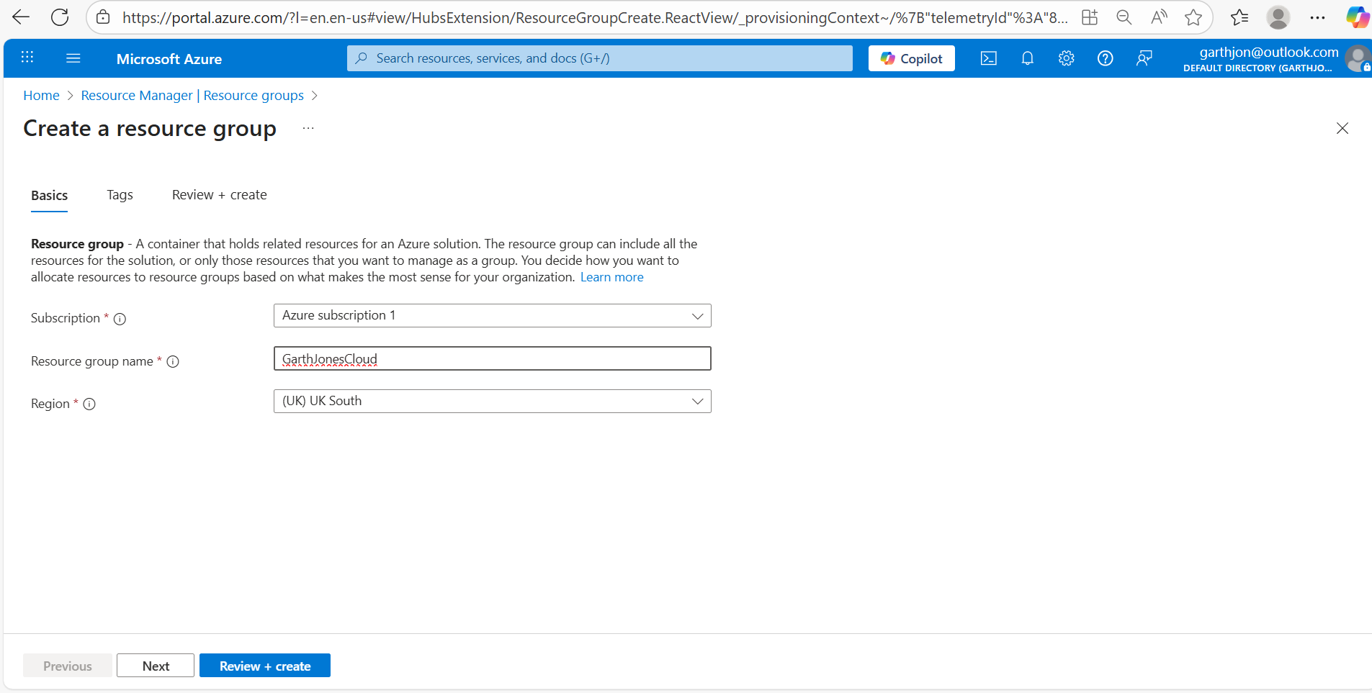

you should be able to see that the resultant group looks akin to this:

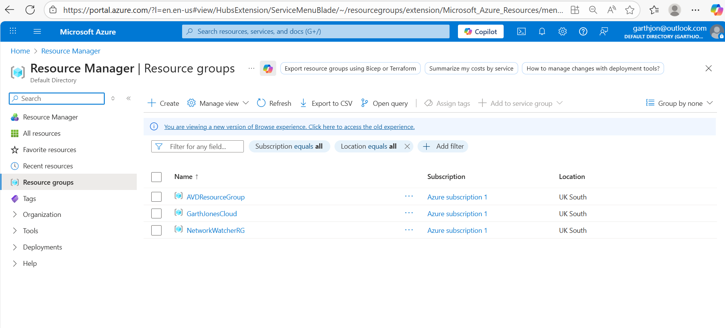

In your devops project select service connections:

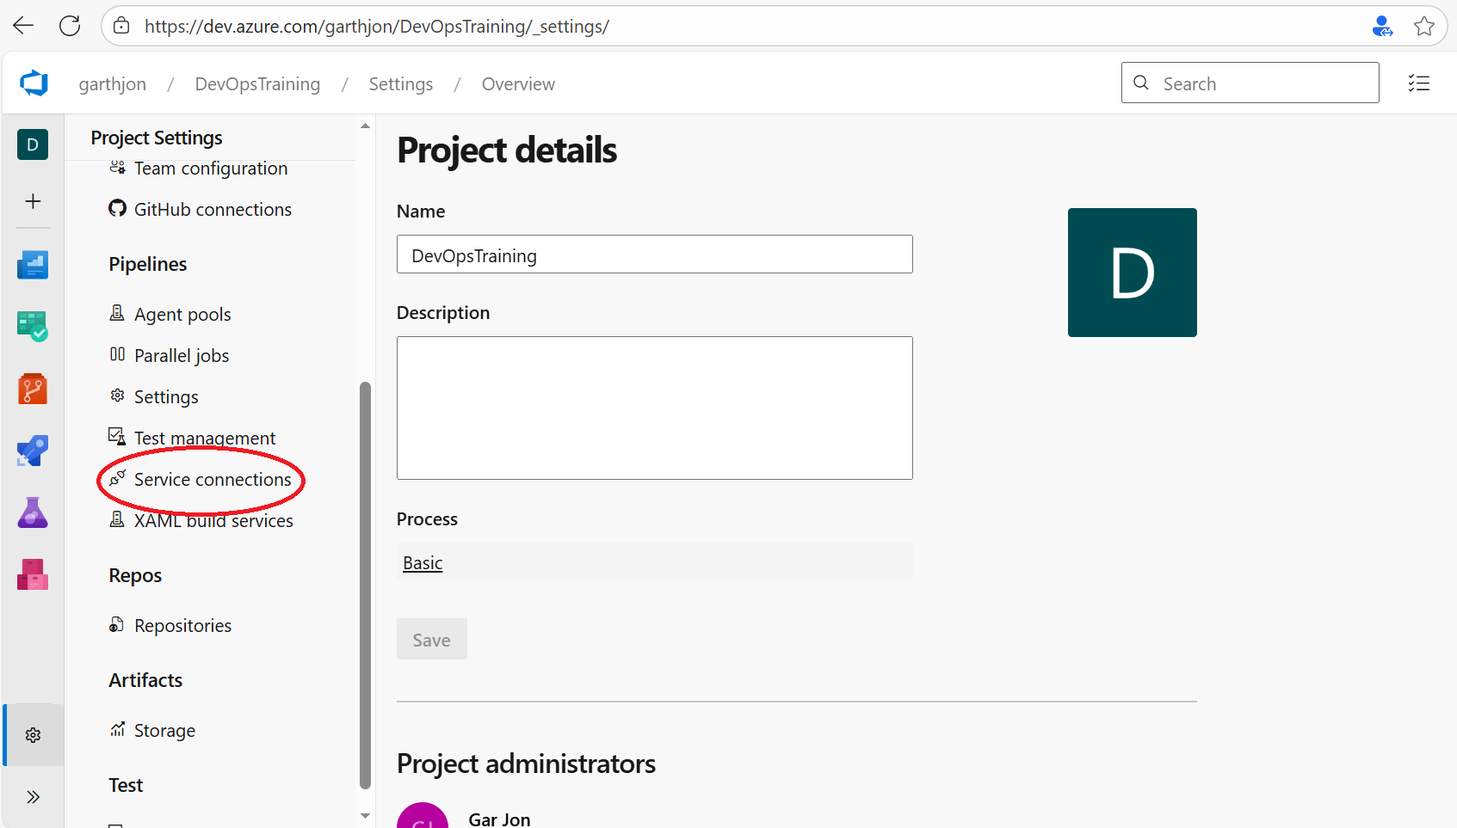

And create your first service connection as being a resource manager:

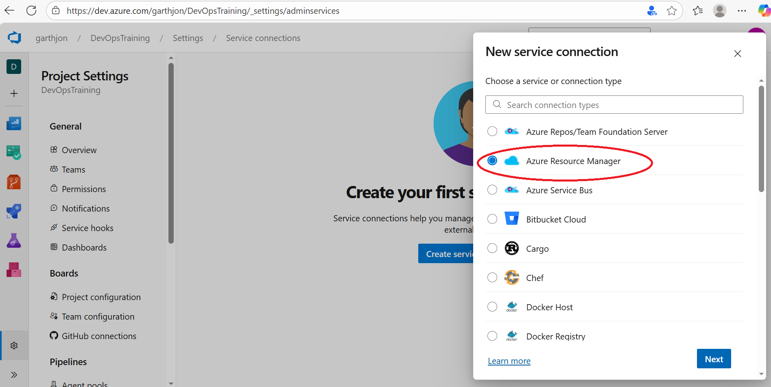

leave the default service connection type as ‘app registration automatic’:
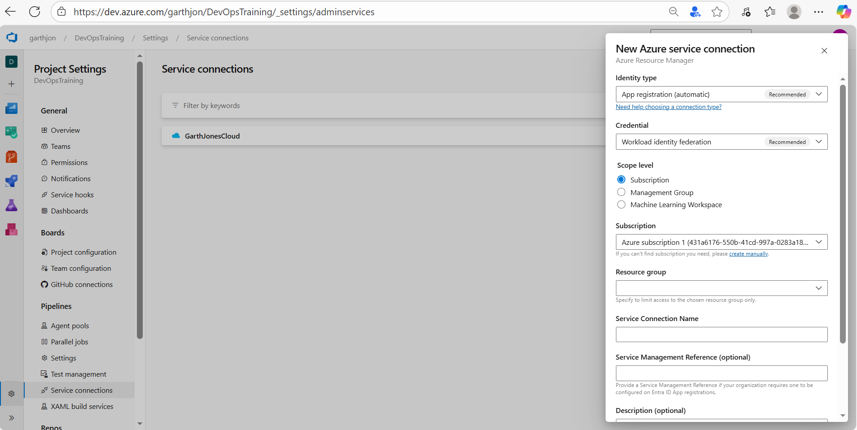

using the resource group I previously created I set up a new service connection, note how I grant access permissions to all pipelines:

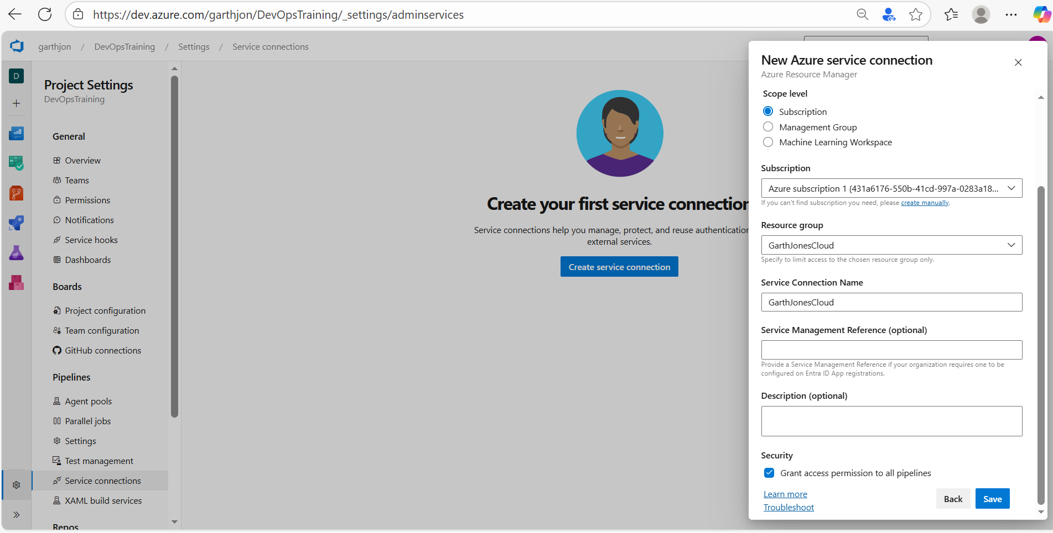

Once created the service connection it should look like this:

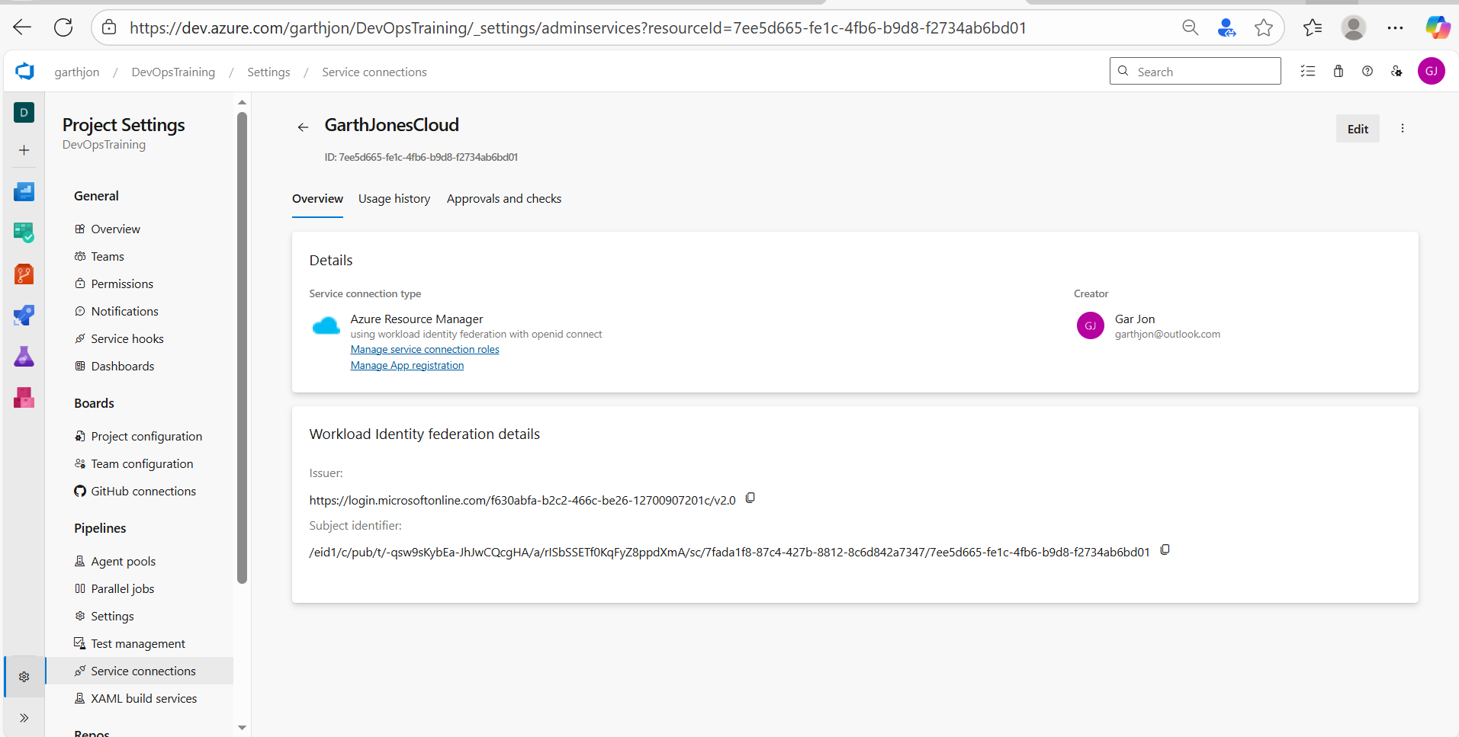

Clicking on ‘manage app registration’ we get a view of the app registration in the azure subscription itself, make a note of the name, as far as your azure subscription is concerned, this is an application (we know it to be devops) which is accessing your azure subscription and is going to try and do things, namely – use terraform to build resources in the named resource group:
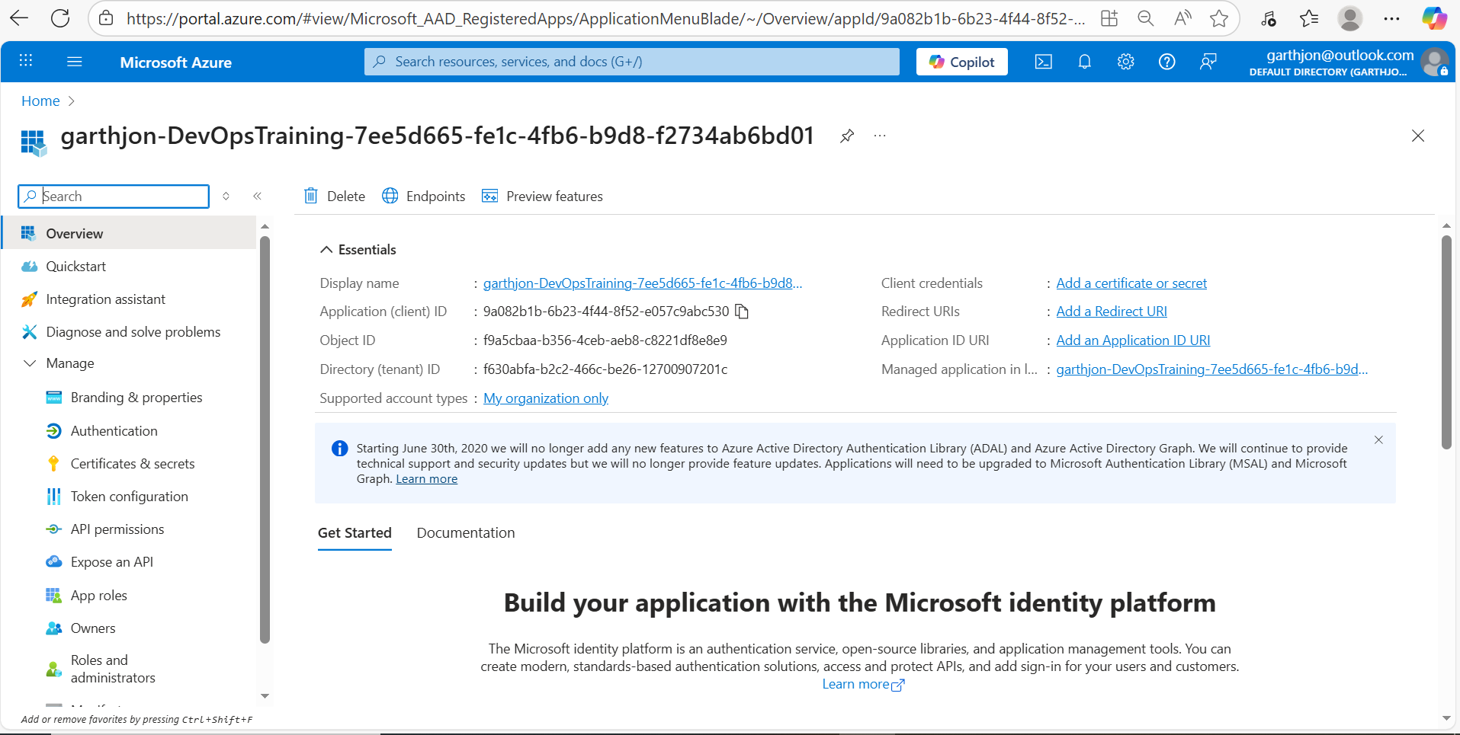

but at the moment, it can’t do anything because this application, doesn’t have a role, so we’re going to give it one and a powerful role which is traditionally known as ‘contributor’, so in your Azure subscription, go to the relevant subscription:

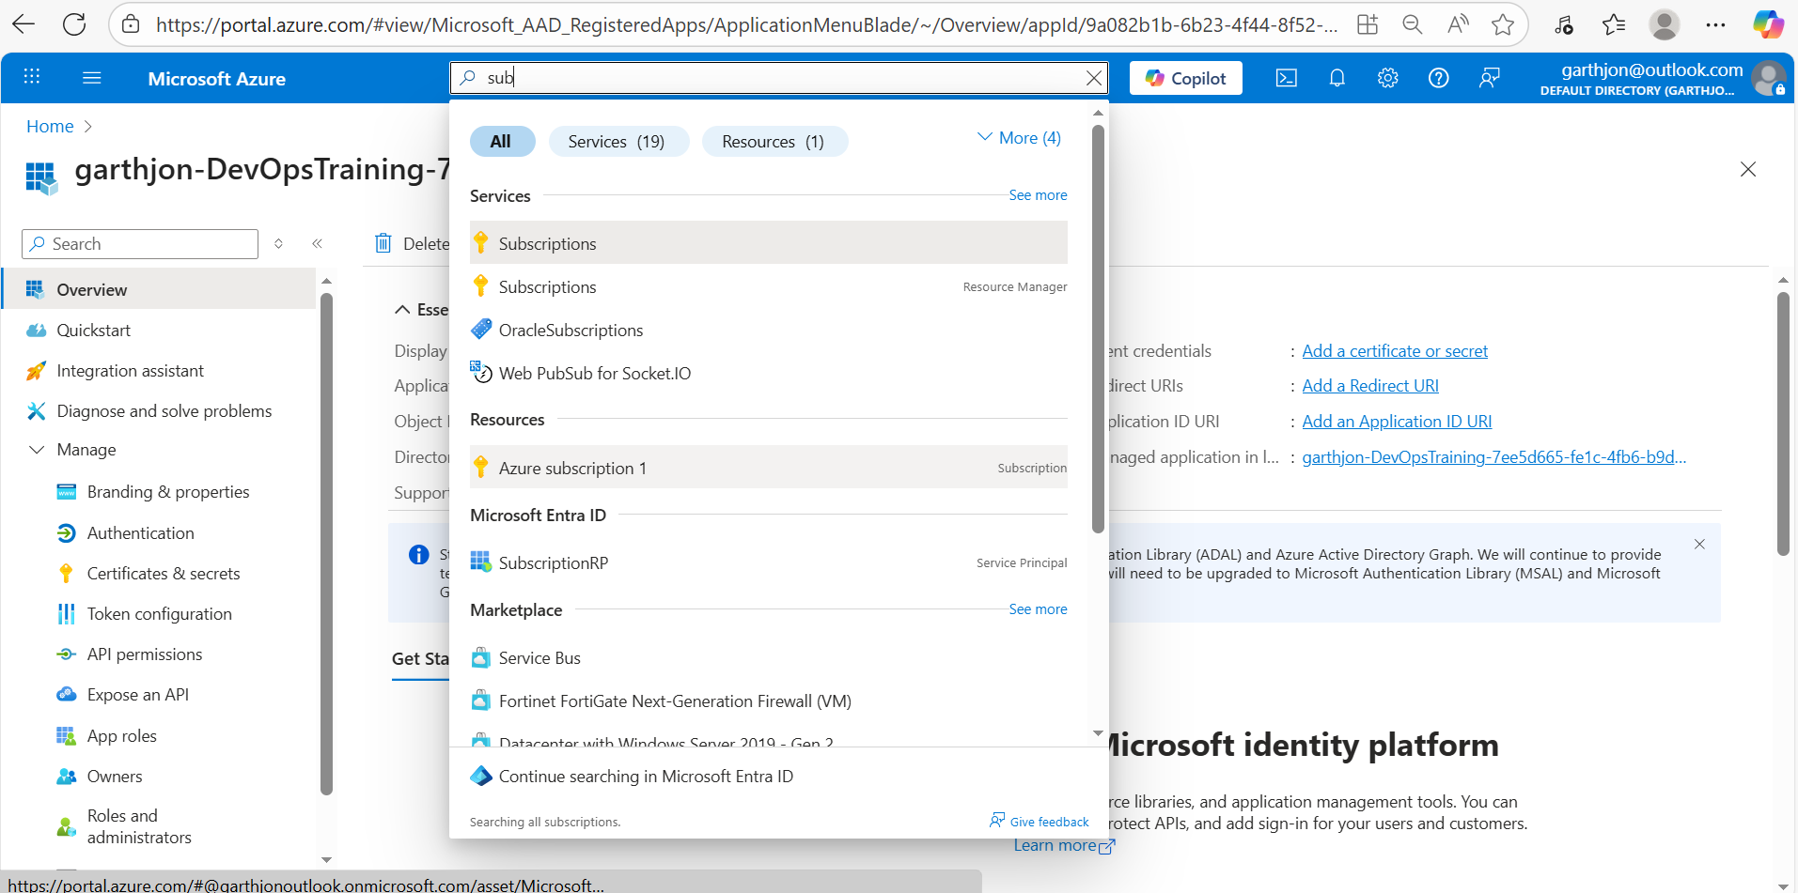

Under your subscription, select access control and go to ‘role assignment’:

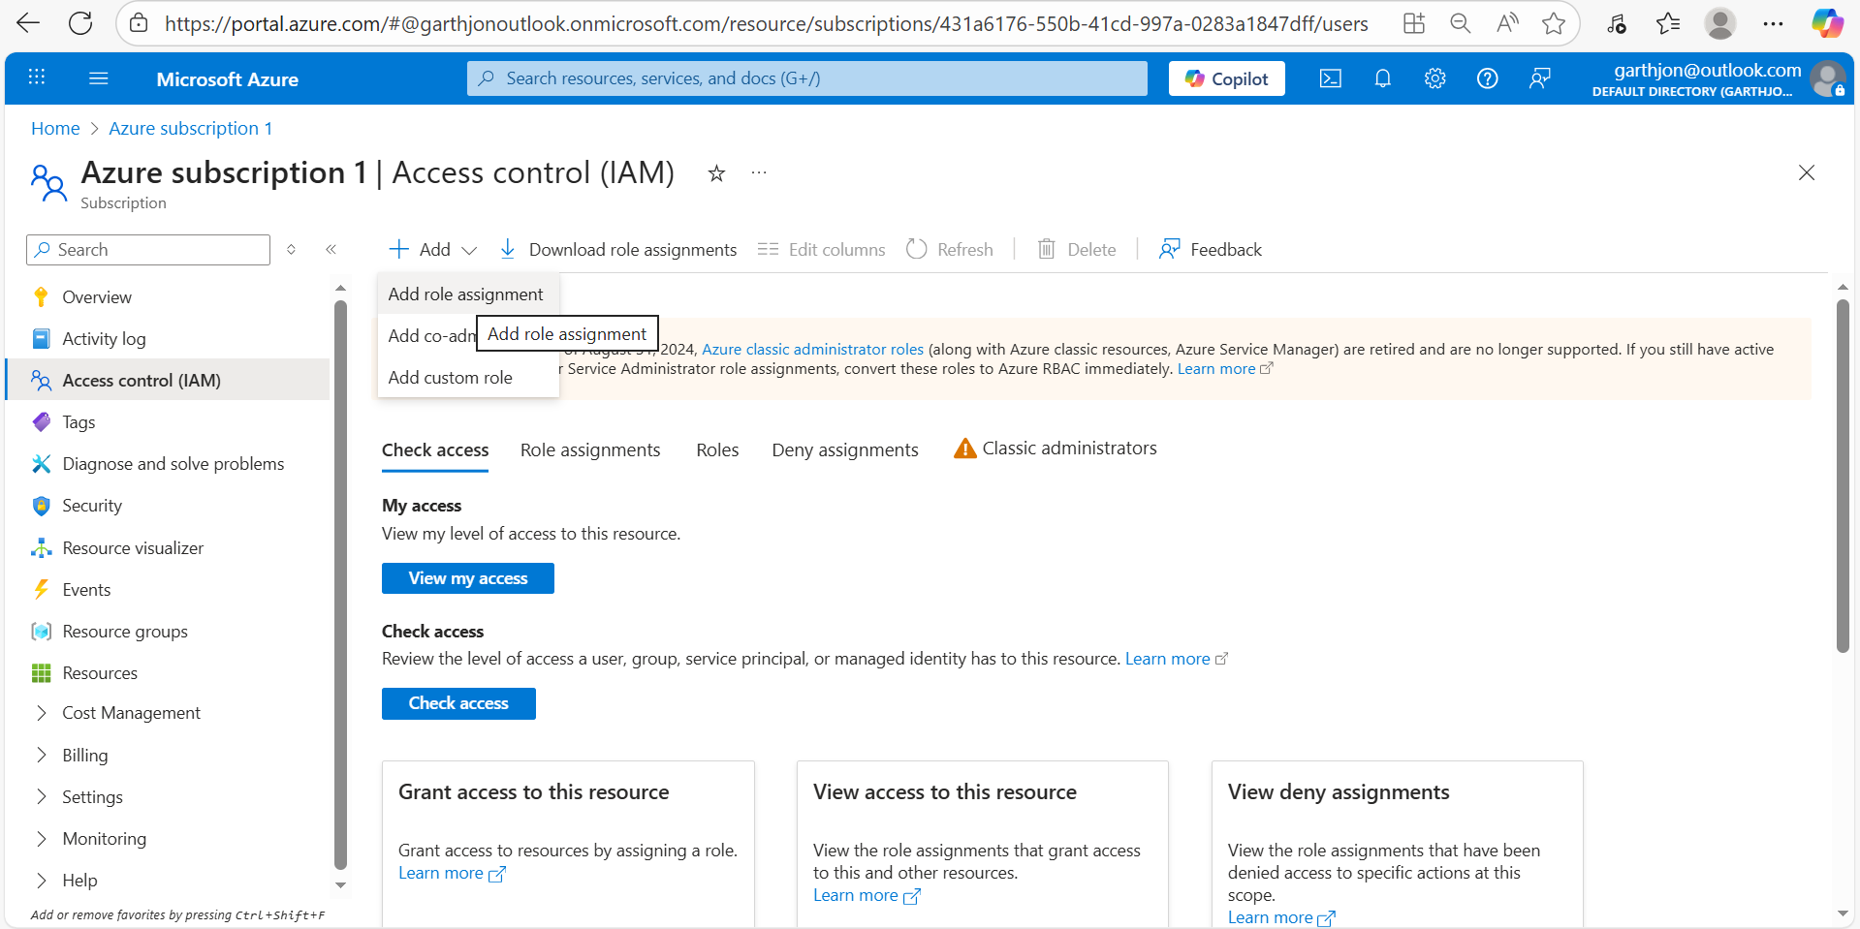

select ‘priviledged administrator roles’ and choose ‘contributor’:

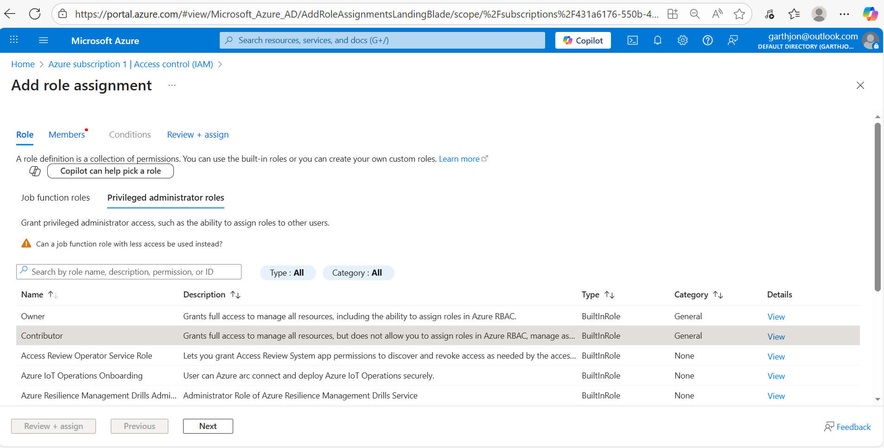

click on ‘select members’ find your app and assign the contributor role to the application.
Now the ‘azure devops’ application service connection has been assigned a contributor role and therefore should have the power to create resources/objects within the resource group in question:

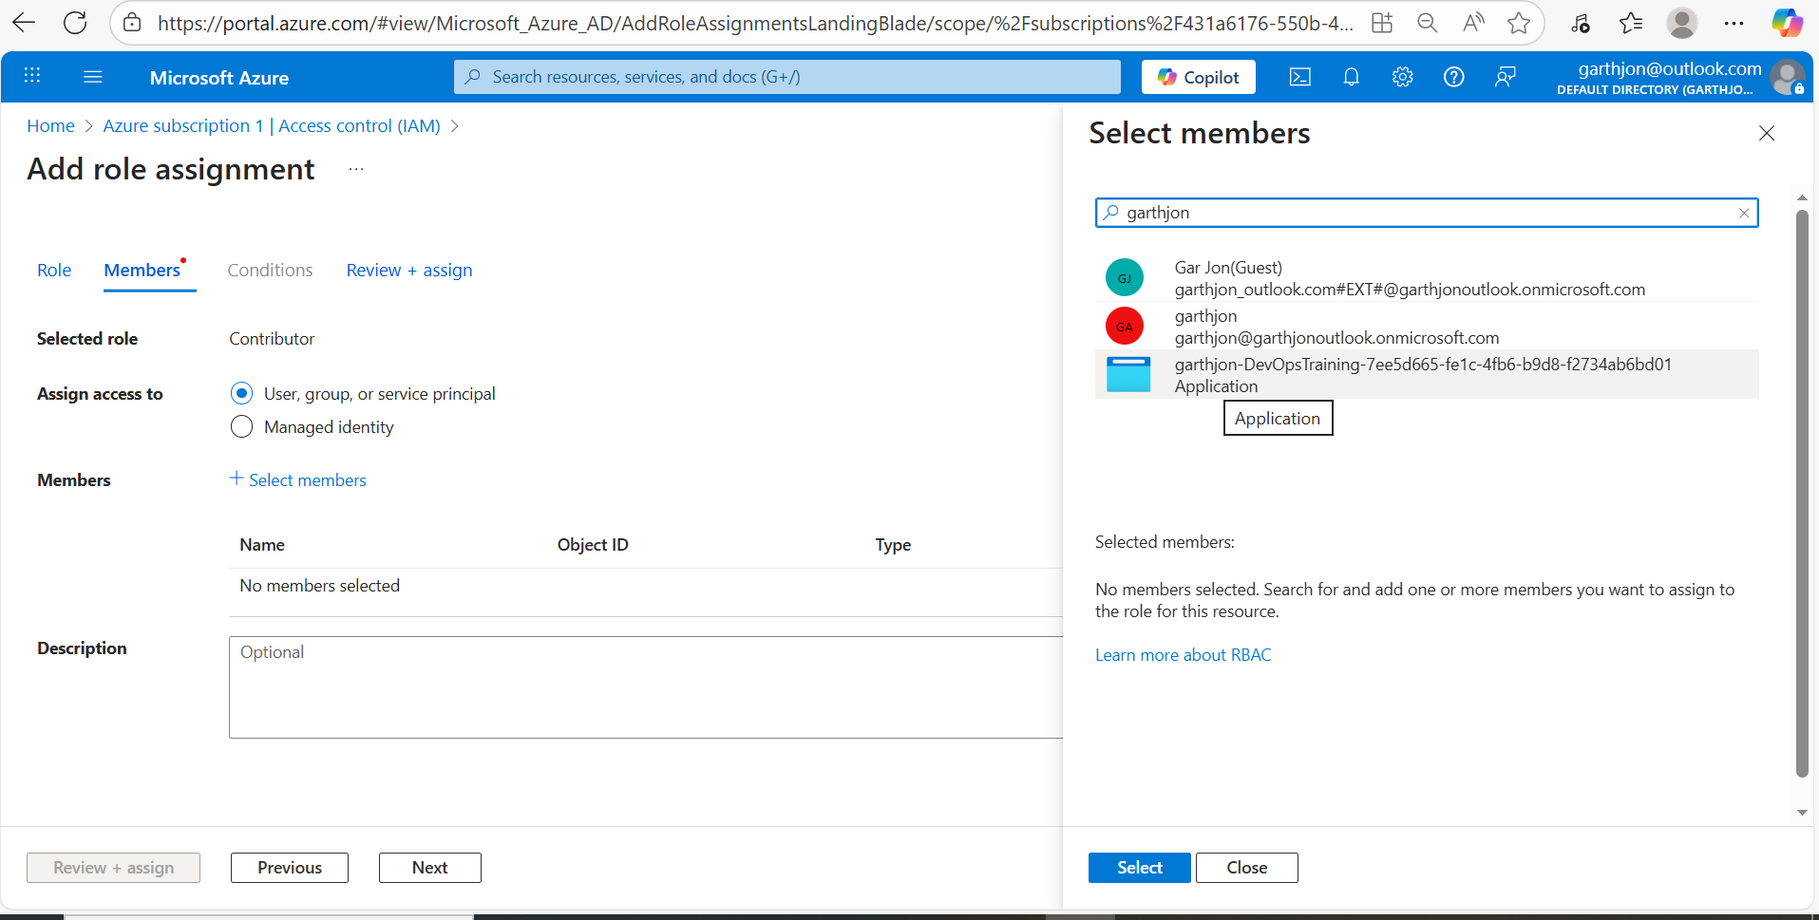

For reference the following youtube video is very useful for explaining the creation of a so called service principle in ‘azure’ which really (here) we are calling an application service connection with a contributor role. https://www.youtube.com/watch?v=qxdl4POrN3c as this video explores there is a further question on security certification with respect to this connection which we may need to configure/expand upon further but for now I’m focusing on the core idea of azure dev ops being an application which is ‘talking’ to the azure subscription as a an application service connection and has now been granted ‘contributor’ role meaning that it can create resources/objects within the azure subscription but only within a specific resource group.

Now we need to start coding terraform, and to do this first we need to create a Git Repo in our azure dev, to contain the terraform files that were going to use which (terraform file) can be run in a pipeline within azure devops (using the service principle account which we created earlier) in order to build out resources in the azure subscription/tenancy that the azure dev ops project is linked to.
Firstly then, within your azure dev ops project create a new git repo to contain your terraform scripts:

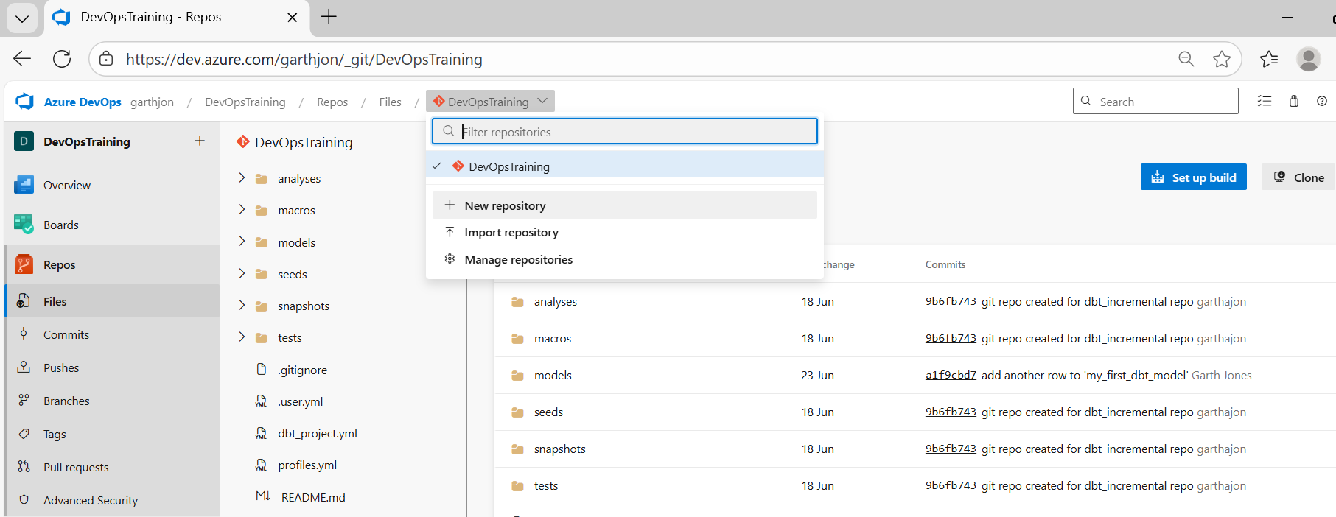

click on +New repository and give the repo an appropriate name, in this case TerraformPipelines:

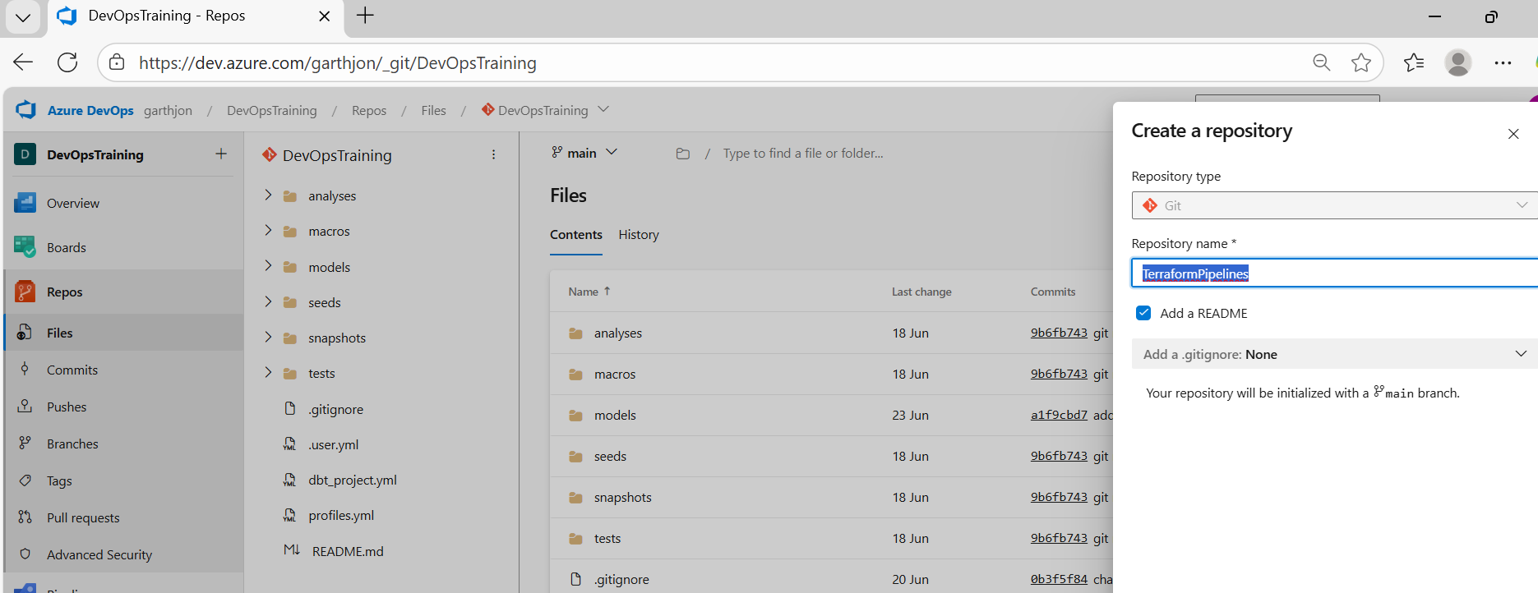

now what we need to do is link the repo in devops to visual studio code on our local machine so that we can start coding within the repo using VS Code, so in azure dev ops click on ‘clone in VS code’:

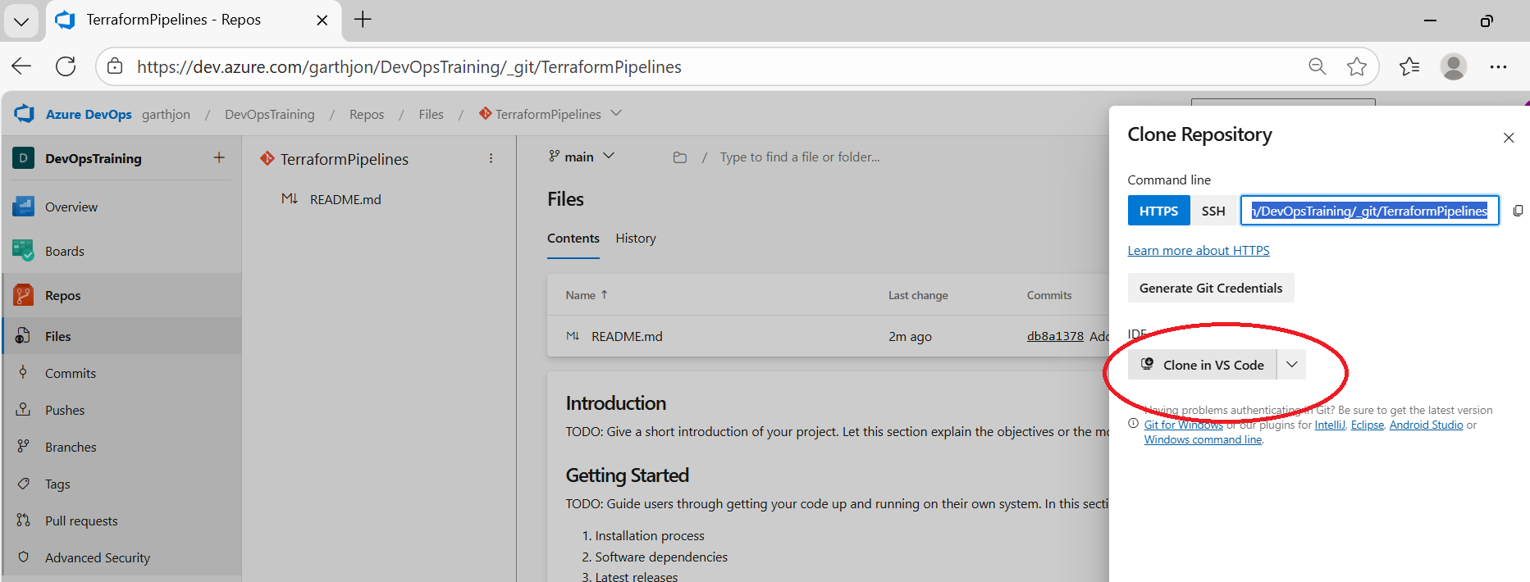

This will prompt VS code to open in your local machine and then for the Repo called TerraformPipelines to be ‘cloned’ on to your local machine which will look like a folder called TerraformPipelines’ but in fact it is git repo that replicated the remote azure devops repo within your dev ops project.

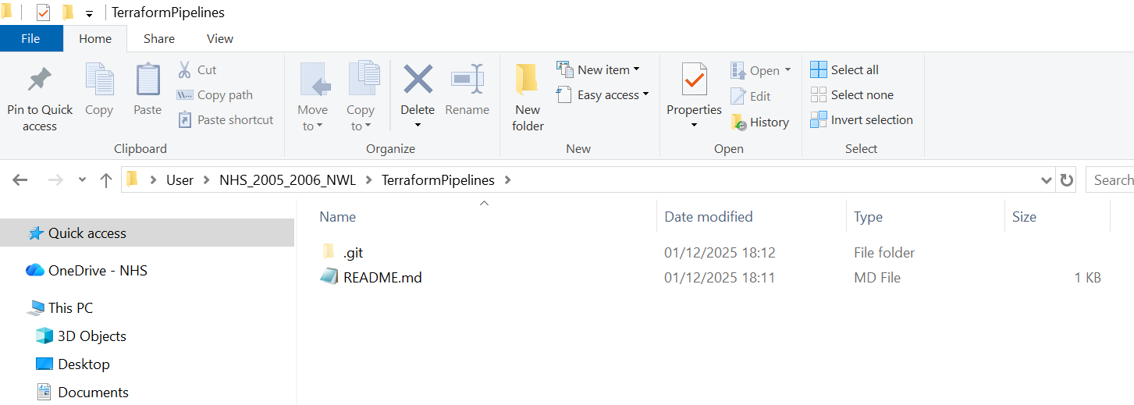

Now, I can work within this repo on my local machine and write scripts/create folders using VS code and then sync whatever changes I make on the local machine with the remote repo, to begin with we need to create a sub directory and a main.tf (terrform file) within that subdirectory:

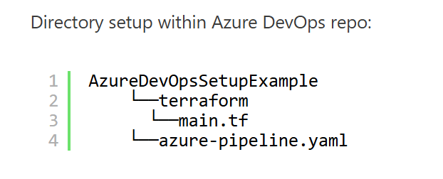
so create a terraform folder:

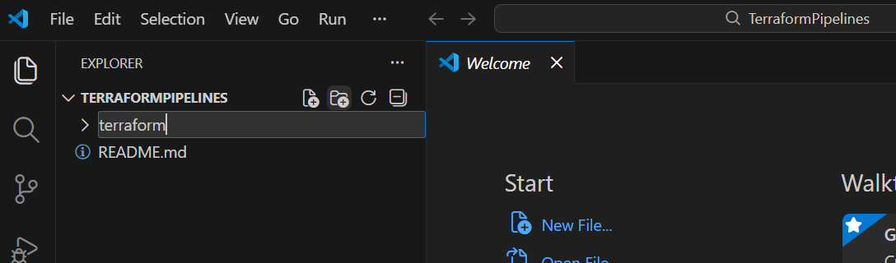

next create a main.tf file within the terraform sub directory:

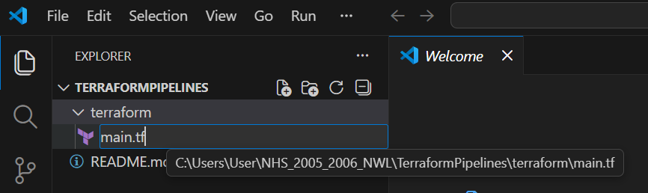

initially copy the content of the main.tf terraform example script verbatim (we will modify the specific names later) and sync the changes with the remote devops repo (do this directly into the main branch for now):

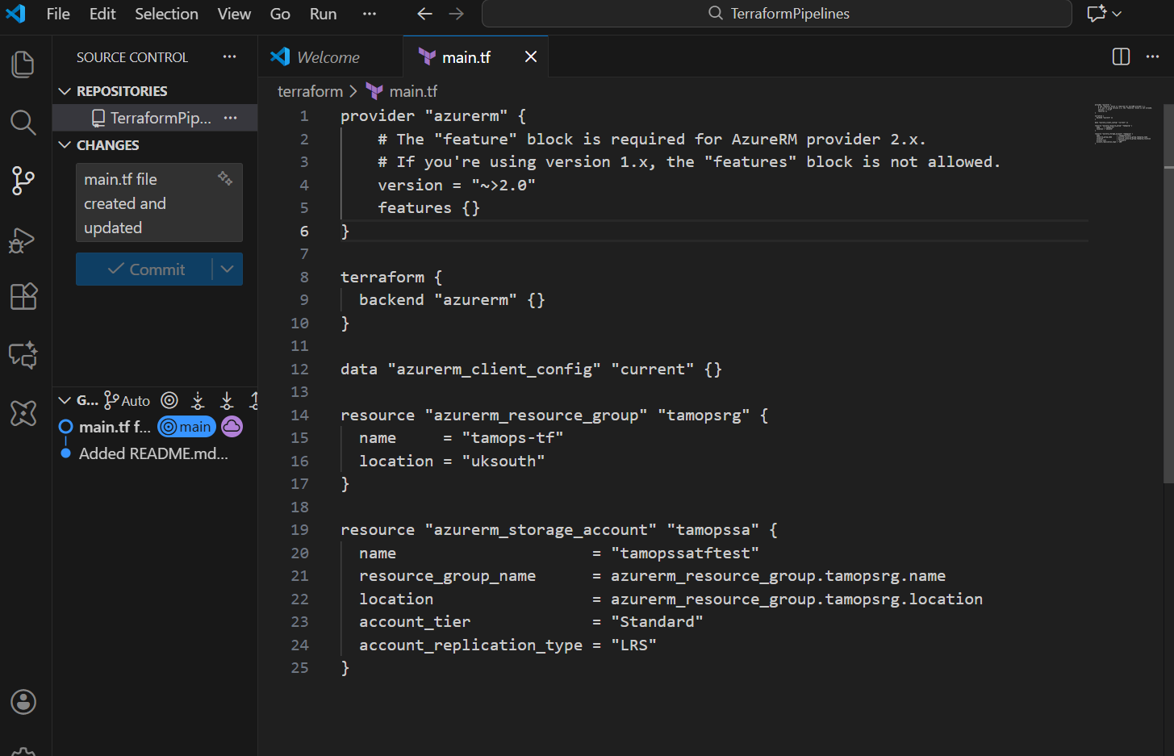

you should now see that the content of the azure devops repo reflects the changes in the main branch within devops:

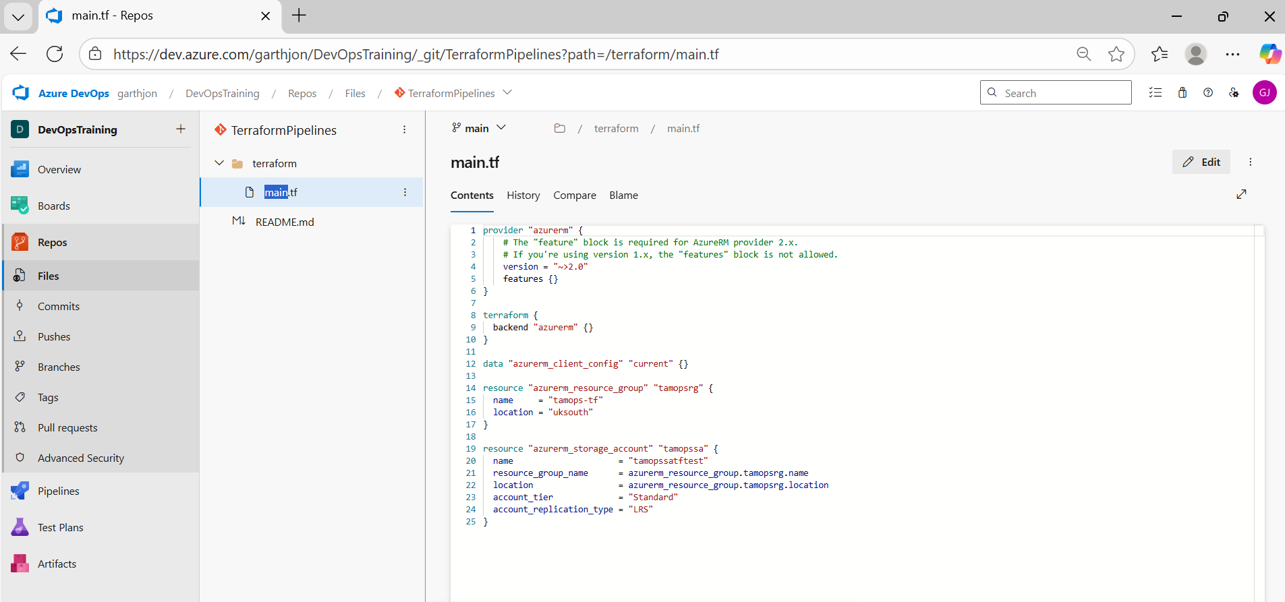

To consider an example part of the terraform code which is used to create a resource group:

resource "azurerm_resource_group" "example" {
name = "my-resource-group"
location = "East US"
}

"example"
- This is the Terraform reference name (local name).
- Used only inside the Terraform script to refer to this resource (as a variable).
- Not sent to Azure, not visible in the portal.
"my-resource-group"
- This is the actual Azure Resource Group name.
- This is what shows up in the Azure Portal.
- Terraform sends this value to Azure when creating the resource.

