Datashield – enhancing the existing azure dev ops pipeline build 17/03/2026
This is the current datashield ‘working’ infrastructure coded in the existing azure devop pipeline (note that the existing devops pipeline to build out all of the resources/implement the container apps to provision the datashield solution/build) is split into 4 code stages. One of the advantages of splitting the pipeline into stages is that we can then choose which specific stages of code we want to run each time we run the pipeline.
The current azure pipeline deploying these resources uses a mixture of azure command line interface (cli) code and terraform.

The current pipeline infrastructure/set up -

Stage 1 – Terraform – this stage as the name suggests uses terraform purely to build out in an azure cloud subscription
Creates:
- Resource Group – holds all the resources for the whole builds
- ACR – holds the docker images used in the build in an azure container registry
- Storage Account + File Share – file share used as persistent storage for the opal container within azure, this is the mounted to the container

Notes on improvements to stage 1 – unpack variables into a separate Terraform var fil, also note that terraform needs a terraform ‘state file’ in order to track the build/destruction of resources in azure
Stage 2 – Images - this stage is currently and necessarily deployed using azure cli script, you cannot readily import docker images and build bespoke docker images using terraform script
- this actually imports/builds docker images from which to create azure containers applications the image is stored/created in the azure container registry created at stage 1
- Import Docker Hub images (mongo, opal, rock)
- Build custom opal-datashield image (inline Dockerfile) – note that the custom opal datashield image build uses two custom shell scripts which are invoked when the container starts – a ‘wrapper’ and a ‘config’ script and these two shell scripts which exist ‘inside’ the container are run by the opal container at start up so the opal container can configure itself. You will see the import/invocation of these two shell scripts in the bespoke opal image definition in this stage

improvements for stage 2 – not really much to do here because this stage necessarily is in azure cli

Stage 3 – Deploy Container Apps (Mongo + Rock) – all of this next step in the current pipeline is built using azure cli code, but it needn’t be, it can actually be deployed using terraform BUT we cannot deploy the container apps until we have built the images so we probably need an additional ‘post image build’ terraform stage, rather than a stage 3 using azure cli, just because terraform is much simpler/eloquent as code
- Create Container Apps Environment (if missing)
- Attach Azure Files
- Deploy Mongo
- Assign AcrPull role
- Restart revision
- Deploy Rock
- Assign AcrPull role
- Restart revision

Improvements to stage 3 – change the deployment code to terraform, with separate terraform ‘tf’ files defining each container build
Stage 4 – Deploy OPAL – this is currently also scripted using azure cli, it needn’t be, we would be better deploying the bespoke opal image using terraform.
- Deploy opal-datashield
- Mount file share
- Assign AcrPull role
- Restart revision

Improvements to stage 4 – change the deployment code to terraform, with separate terraform ‘tf’ files defining each container build, also look to merging this with stage 3 potentially, note the reason that I separated the deployment of the opal container in stage 4 from stage 3 because all deployments taken together took too long and the pipeline timed out. The other reason I split this build out is because opal needed to be rebuilt and debugged many times, whereas rock and mongo.

this is the current git repo folder structure holding the code which the azure pipeline is working from –

repo/
├── azure-pipelines.yml ❗ (very large, ~1400+ lines)
├── terraform/
│ ├── main.tf (basic infra only)
│ ├── variables.tf
│ └── outputs.tf

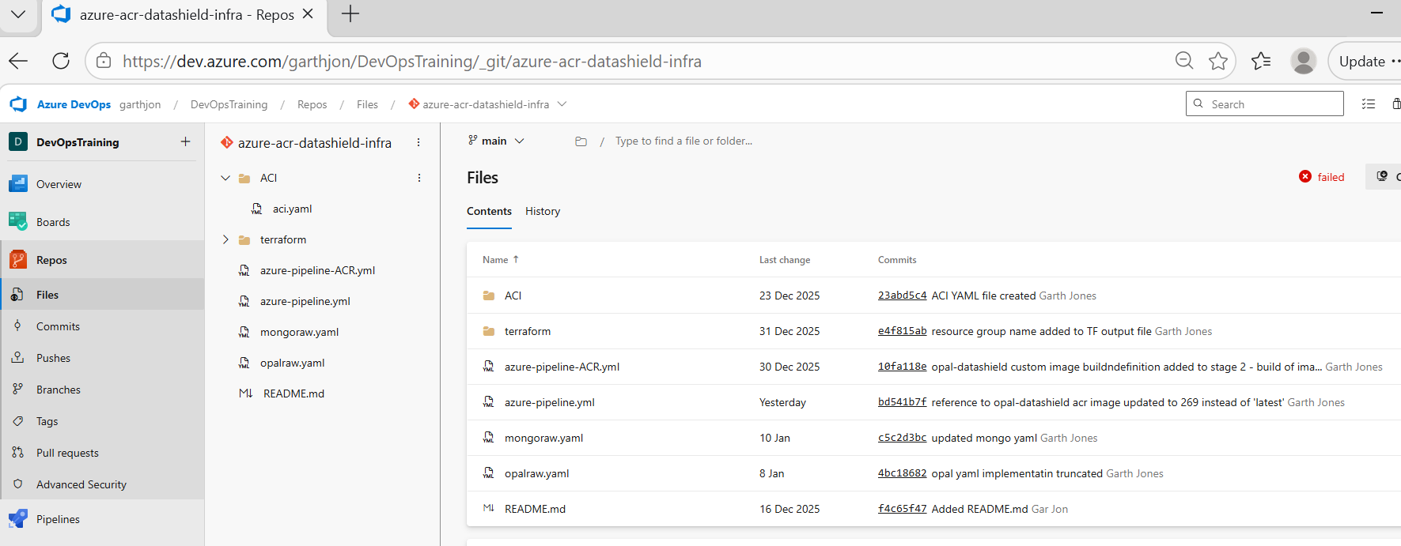

the file content of the terraform folder/subdirectory –

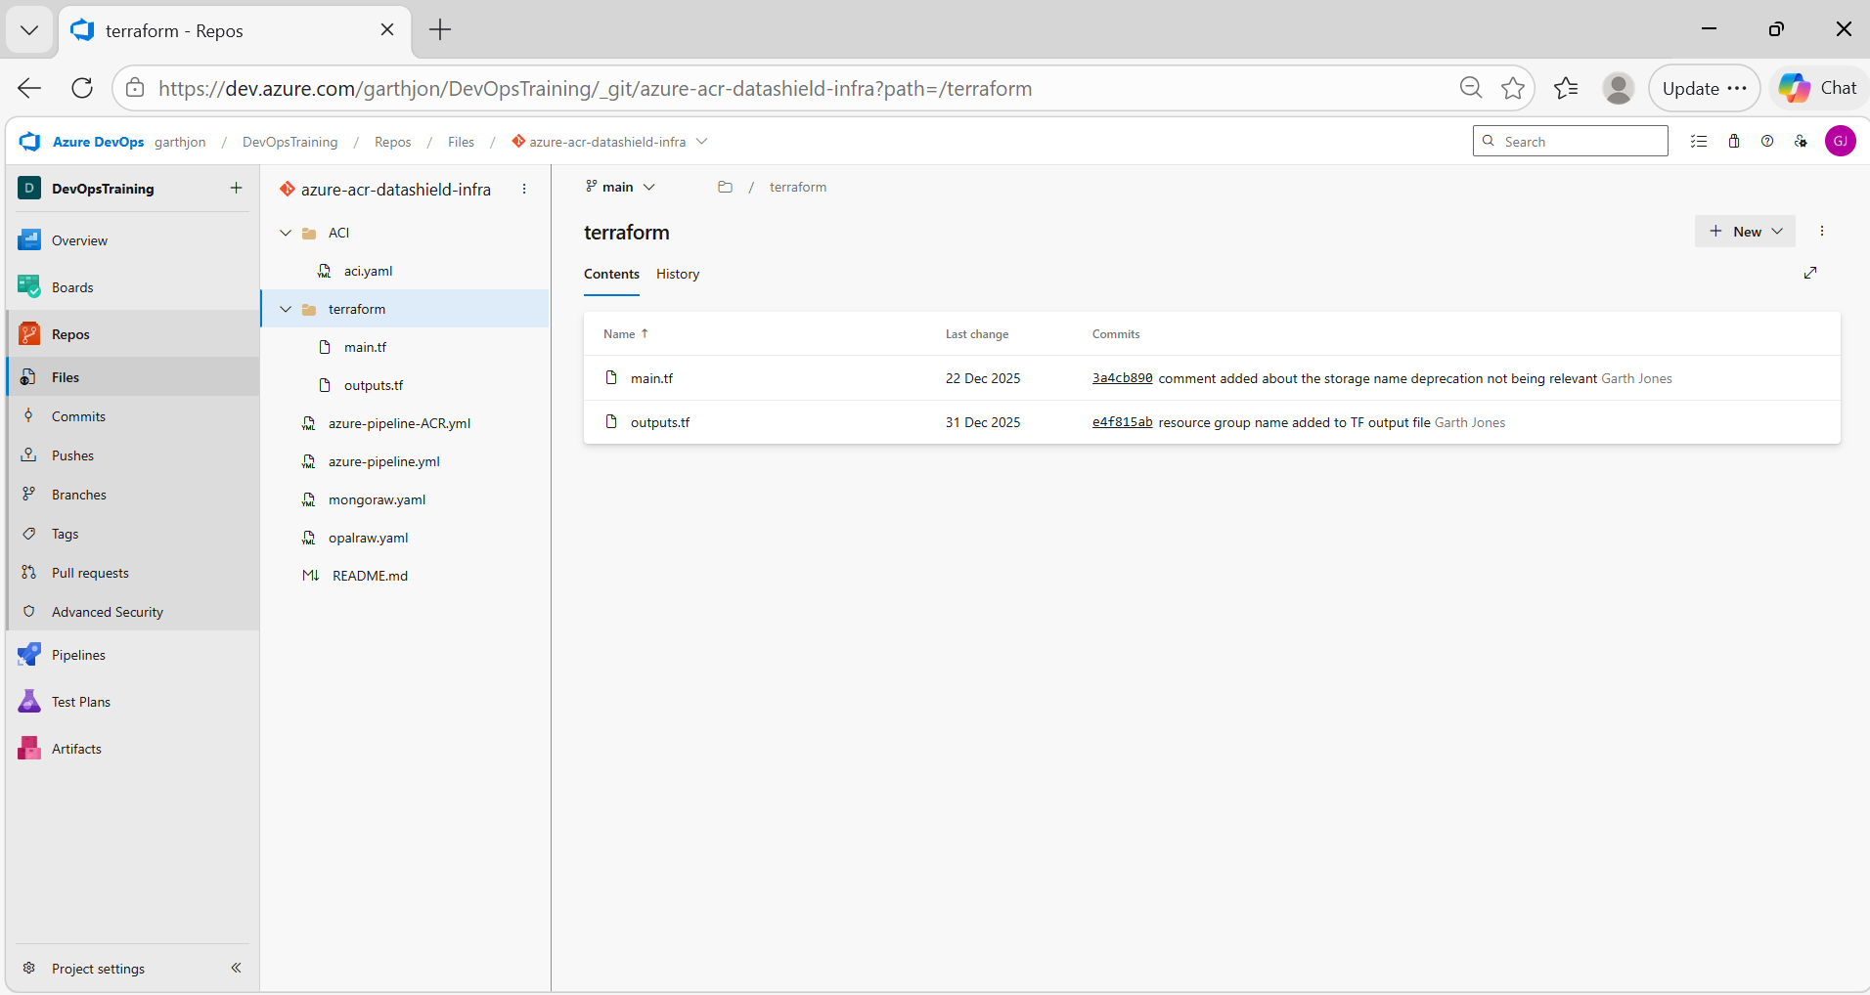

So that is the existing build.

The ideal (future) pipeline infrastructure/set up -

Stage 1 – Terraform (Infrastructure)
Stage 2 – Build / Import Images – n.b. necessarily azure cli code
Stage 3 – Terraform (Applications – deploy mongo and rock container apps)
Stage 4 – Terraform (Applications – deploy bespoke opal container app) – split from stage 3 because of time out and debugging issues

Stage Breakdown (Clean/improved Version)

Stage 1 – Infrastructure
Terraform creates ONLY:
- Resource Group
- ACR
- Storage Account
- File Share
- Container Apps Environment – existing stage 1 does not deploy this

Stage 2 – Images (unchanged)
- Import mongo
- Import rock-base
- Import opal – this image import is probably redundant because of the bespoke opal build below
- Build opal-datashield
👉 This stays CLI

Stage 3 – Applications (Terraform)
Terraform creates:
- Mongo container app
- ACR role assignments
- Rock container app
- ACR role assignments

Stage 4 – Applications (Terraform)
Terraform creates:
- Opal container app
- ACR role assignment
- Volume mounts

Improved pipeline repo folder structure -
repo/
├── azure-pipelines.yml
├── terraform/
│ ├── infrastructure/ ✅ Stage 1 – core infrastructure
│ │ ├── main.tf
│ │ ├── acr.tf
│ │ ├── storage.tf
│ │ ├── container_env.tf
│ │ ├── variables.tf
│ │ └── outputs.tf
│
│ ├── applications/ ✅ Stage 3
│ │ ├── mongodb.tf
│ │ ├── rock.tf
│ │ ├── opal.tf
│ │ ├── role_assignments.tf
│ │ ├── variables.tf
│ │ └── main.tf
Implementing the solution
Initially we create a repo in azure devops within which to hold the code which will be used to create the infrastructure,
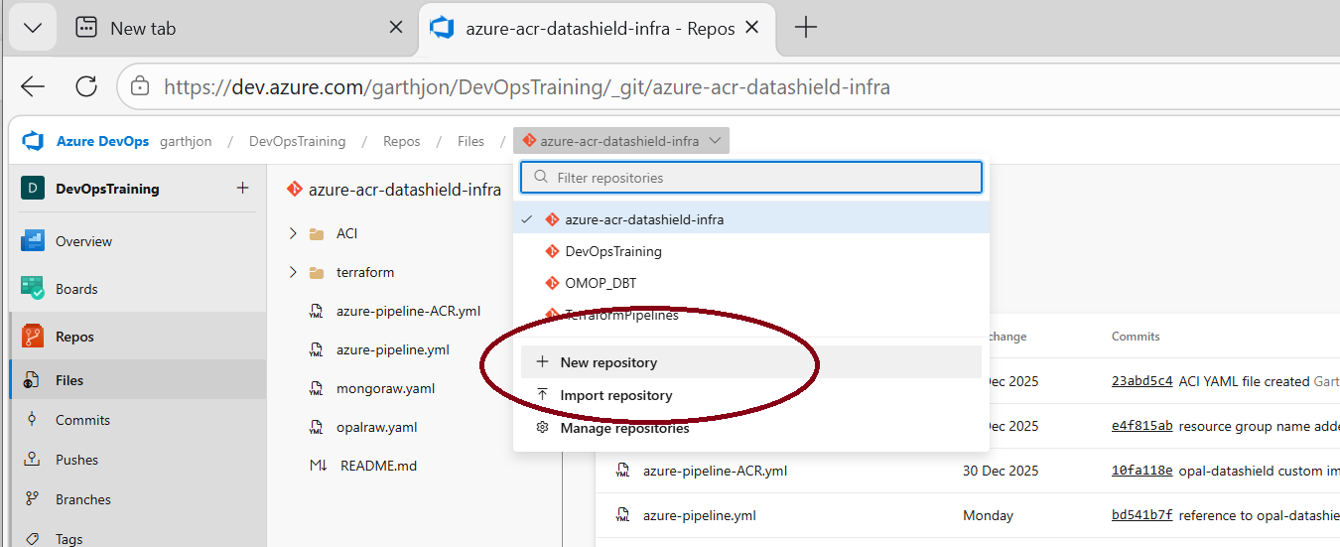
having created the repo with a basic folder/file structure we will clone the repo to the desktop, choosing to clone with vs code
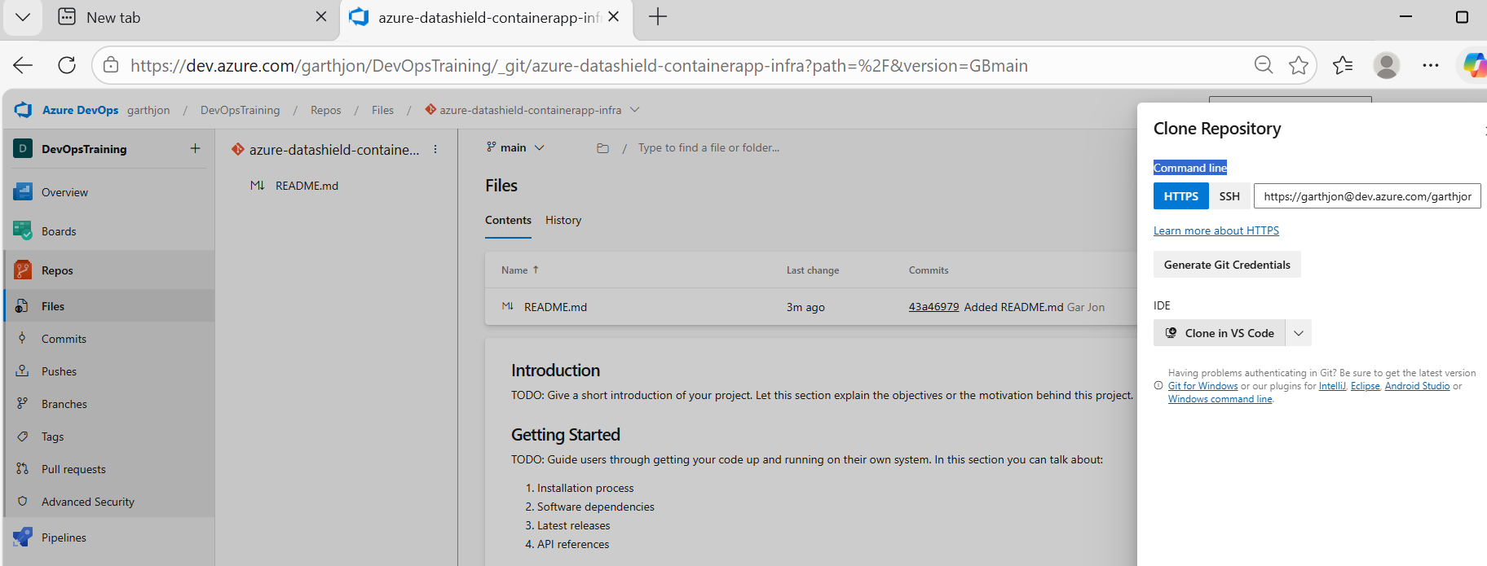
now that the repo is cloned to the desktop using visual studio, we will open a command prompt and just check that the git repo which has been created on the local desktop is properly synched to the remote devops repo
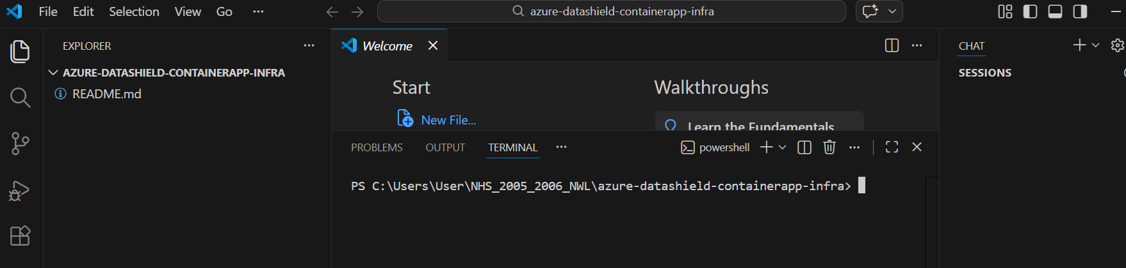

we issue a ‘git remote –v’ command to check that the local desktop repo is correctly synced with the remote azure repo both for pull/fetch and push changes and on running the command we can see that this is the case and so we’re ready to start coding each of the stages

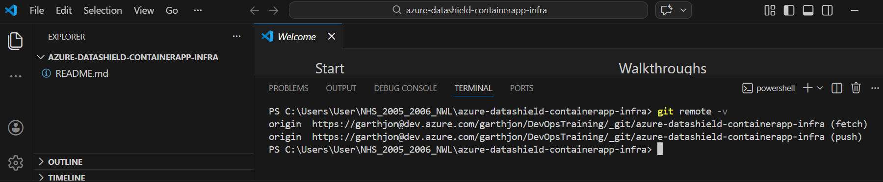

n.b. we are going to be running azure pipelines within dev ops which will use terraform code to build out infrastructure within an azure cloud, BUT in order for us to be able to run pipelines which run terraform code in order to deploy cloud infrastructure within an azure cloud platform, we have to have a set up in place for an agent pool and terraform state files within azure - we need both and stage 1, running terraform will use this existing agentpool/terraform state file infrastructure in order to do that, the infrastructure necessary for running azure devops pipelines which use terraform code in this case is set up in a specific cloud-resource group –
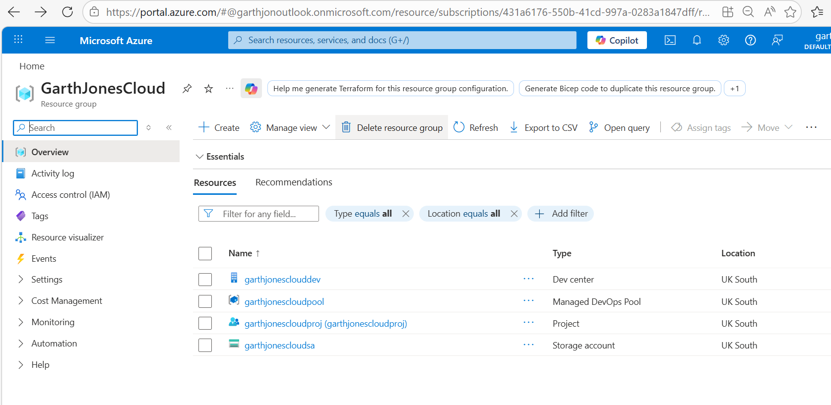
note that terraform state files are always necessary when undertaking a terraform-based cloud infrastructure deployment and it is recommended that a separate terraform state file is used for separate terraform deployments and as we are undertaking a new improve datashield deployment, I am suggesting that whereas, we use the existing cloud resource group to store the terraform state file and invoke the agent pool,we should create a new terraform state file for this deployment. If we look in the storage container we will see the existing terraform state files for separate existing projects/resource groups. So really this resource group/project is being used to track and deploy other projects – like a deployment resource group/project –

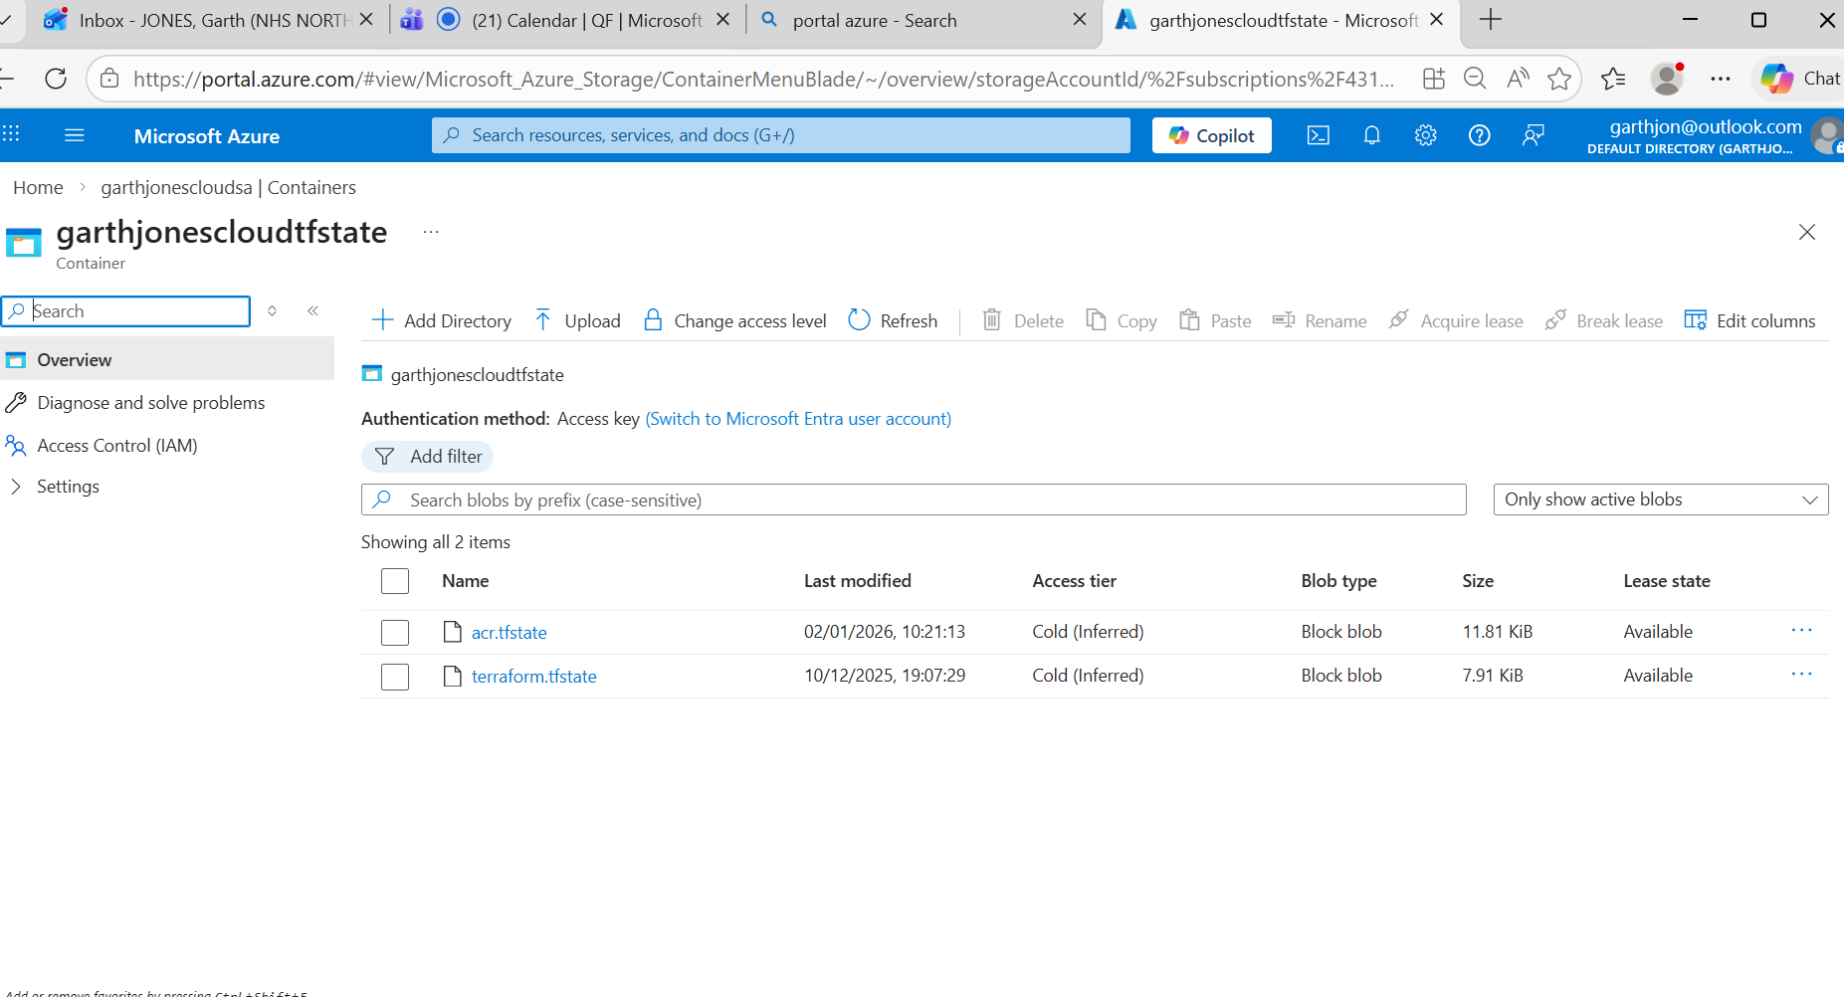
so in terraform stage1 when I am stating where the terraform file exists, I will state the same resource group as being the deployment project/infrastructure, but I will change the name of the terraform state file to datashield.tfstate
