Azure Devops Terraform Datashield Pipeline 18/12/2025

There are a few important considerations prior to going ahead and building a datashield solution within the Azure environment using terraform, git and azure pipelines.
I set out some of these considerations below –

- 3 docker images are required to build a datashield environment: OPAL (which we can think of as being the orchestration application which the ‘R’ client talks to or queries and which then orchestrates requests to the ROCK ‘R’ server and the data on behalf of the client, so OPAL is a kind of go between really) ROCK (which is an R server which OPAL works with for aggregate R queries) and MONGODB (which deals with the metadata).
- But rather than using a conventional Docker compose approach to build out a datashield environment we are going to build a set of Azure cloud resources: an azure constainer registry and an azure container instance group and these azure resources are going to be used to build the datashield environment, and the build and configuration is set up using a combination of azure ci/cd pipelines and terraform
- This will be considered as a contained project, so it will have it’s own terraform state file with a unique name or key name in an azure storage container dedicated to storing terraform state files for each relevant project and its own git repo within azure dev ops and its own resource group and resources therein within Azure

The above considerations inform the following necessary steps to set up the datashield environment within an azure cloud:

- create a git repo within an azure devops project and clone this repo into a coding environment such as vs code, this repo will contain an azure yml pipeline file and the terraform code file
- ensure that you have a separate resource group, storage account and container set up within an Azure subscription to store your terraform state file
- create a terraform file and an azure pipeline within your repo to create a resource group and an azure container registry within that group which will serve to import the docker image into azure ready to construct the environment
- create another step in your azure pipeline with which to import the docker images into the azure container registry
- create another step in the pipeline with which to deploy the docker images as an container instance [ACI] group

Note that having created the container instance group and having deployed the docker images, and therefore datashield solution, as a container instance group we note that it is actually better to deploy a containerized solution, which is what datashield is, within Azure as an Azure container app solution, we will still use terraform and an azure pipeline to do so, but we’re choosing to implement datashield again in a better build solution namely containerized apps because this is more robust, and the reasons for this are as follows –
Feature | ACI (Container Group) | Azure Container Apps
Public endpoint | Optional | Optional
Internal-only | Awkward | First-class
Scaling | Manual | Built-in (KEDA)
Ingress | Basic | Envoy-based
Service discovery | Manual | Automatic
Identity | Basic | Strong
Best for | Demos / batch | Long-running apps

Having created an azure container registry in a pipeline with mongo db, rock and opal images imported in to that registry and having looked to instantiate those images as containers to implement the datashield set up in an azure container instance environment with settings configured according to similar settings set out in the prostate cancer research (see Olly Butters Liverpool university - https://github.com/OllyButters/datashield_pcr/tree/main/docker ) datashield dockercompose yml file; we are now deciding to shift away from implementing datashield in an azure container instance environment to implementing datashield in an azure container application environment.

The reason for this shift in implementation approach is partly for the reasons set out in the table above and partly because this is how the Accenture developer team have already implemented the datashield docker containerised solution within the One London Secure Data azure Environment. This seems to be a ‘best practice’implementation of a docker containerized environment such as the datashield solution where multiple docker images are used within a containerised set up.
But it will be well to spell out the exact reasoning behind this environment set up choice for datashield –

Why an Azure Container Application Environment is better than an Azure Container Instance Environment for DataSHIELD
- ✅ No public exposure of sensitive services
- ✅ Clean network isolation
- ✅ Better compliance posture
- ✅ Easier TLS and CSRF configuration
- ✅ Easier future scaling
• ✔ Yes, Container Apps allows internal-only OPAL
• ✔ Access via internal DNS, not public IP
• ✔ Much better security model
• ✔ Better long-term choice than ACI
The ‘internal only’ OPAL access feature is important, because I want to (initially) perform restrictive testing within the environment and OPAL is the central control point application that I will initially use to review the set up using a front end application, as an environment administrator, and also review the exposed datasets ready to serve to clients – these should be visible via the OPAL front end see - https://opaldoc.obiba.org/en/latest/r-user-guide/datashield.html
It is also relevant/important to spell out known issues with setting the datashield ‘server’ side environment up within the Azure environment using the Container Apps approach and the biggest known issue seems to be making file shares work, which is likely to be the biggest problem when we attempt to mount the synthetic data into OPAL provided by Olly Butters for testing.

Important limitation (be aware)
Azure Container Apps does not support Azure Files mounting for stateful databases the same way Azure Container Instances does.
For MongoDB persistence you typically need:
- Azure Cosmos DB (Mongo API) or
- Azure Managed Disk via AKS or
- External database service
So for production DataSHIELD, people usually choose:
- AKS (full control) or
- Hybrid (Container Apps + external DB)

There is another problem which is that containers running in the azure container app service environments are liable to restart and this would retrigger the shell script on each restarts causing the shell script to attempt to reconfigure the container on each restart, but since the container has already been created, initialized and configured, there is actually no need to re-configure it, so ChatGPT recommends that with shell scripts are being used to configure a container when it starts, that that shell script should have a check at the beginning to verify whether or not the container has been initialized already –
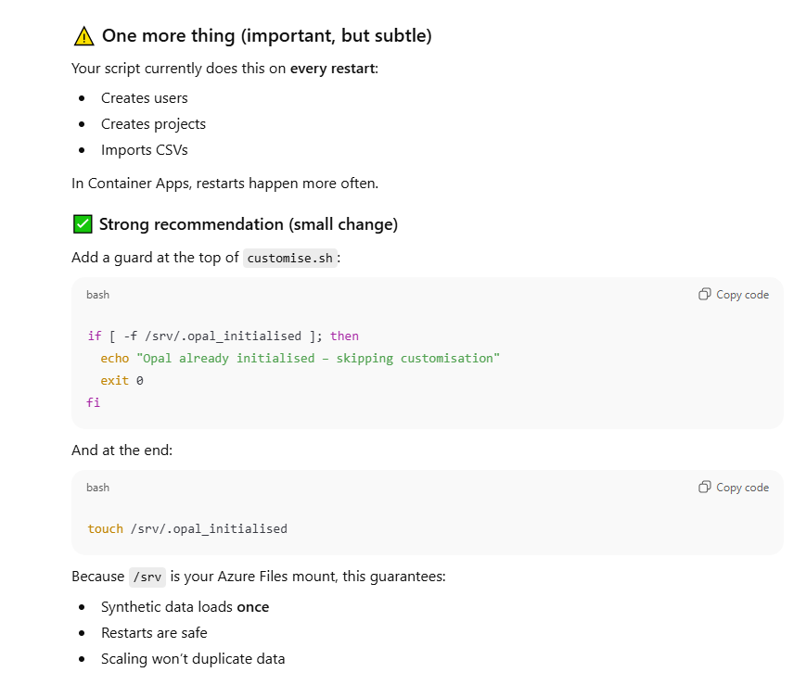
And this leads us to focus on that complexity because the Olly Butters prostate cancer research containerized datashield environment solution does use a shell file which runs after the container is started in order to initialize and configure the environment. Which leaves us with two questions – how does is that start up shell file incorporated into the datashield environment build within the azure container apps environment, this is a complexity because the azure container apps environment does not run in the same way as docker, the problem is the shell script, because references cannot be made to the shell script location after the container is initiated from the image so we must create a specialized docker image of opal which has a reference to the shell script in it. In other words the reference to the bash or shell script has to be in the docker image definition, so that when the container is built from the specialized docker image definition the reference to the custom.sh file which instantiates the opal settings [such as default synthetic data loaded and user name/password details] is ‘baked’ into or known/by the container at start up – because the reference to that file [which lives in the Olly Butters github repo] is defined in the specialist docker image. So, in other words, we have to create an augmented/specialist version of the OPAL image with references to the custom.sh file and also the environment variables that it needs to use, so that when azure container apps spins up a container from this image, the container already knows within itself where the custom.sh file that it needs lives and the image definition in itself states that this file is run when the container starts – i.e. the container itself is telling itself to run the customize.sh file and has all the references it needs at start up rather than a docker compose process doing it – we’re not using docker compose so we have to do this, in this other way. In other words we have to create a bespoke OPAL ‘azure container app’ friendly docker image that is capable of ‘configuring itself at start up’ using its own reference to the customize.sh file rather than the docker compose wrap around doing that for it – because the wrap around just isn’t there, in azure container app environments the containers have to be able to configure themselves at start up. So we need to create a bespoke specialized opal image for this project which is capabile of initializing itself at start up using its own self-referenced customize.sh file. Another point which I may have mentioned already, but which is worth mentioning again is that the customize.sh file references environment variables, there is a question as to whether these environment variables are defined within the OPAL image and/or within the azure app container environment, but the OPAL container when it is instantiated from the specialized Docker opal image stored in the Azure container registry has to be able to reference the environment variables because these environment variables are used in the customize.sh file at container start up time, so this is a significant configuration dependency.

I’m using chatgpt to help me implement this recommended container application environment and below is an interesting sketch of the set up architecture necessary to implement this environment generated by chatgpt, noting that originally for the azure container instance environment set up I used an aci yaml file to define the container configuration:

1 -Why your current Container Apps stage is incomplete
Your original ACI YAML defined three tightly-coupled containers:
- mongodb
- rock
- opal
with:
- fixed CPU/memory per container
- explicit ports
- environment variables wiring them together
- Azure Files mounted at /srv
- internal service-to-service networking
Your current Container Apps stage:
✔ creates a Container Apps environment
✔ attaches Azure Files
✔ assigns AcrPull
❌ deploys only one container app
❌ loses MongoDB + Rock entirely
❌ loses environment variables
❌ loses internal-only networking relationships
❌ loses CPU/memory parity
❌ loses multi-container topology
so you can see that chatgpt is noting that in an attempted environment conversion much of the requisite configuration to make the datashield set up has been lost, but what I find particularly interesting about these notes is that ChatGPT is spelling out what IS required, for example environment variables used so the containers work together in a group, i.e. the environment variables are ‘the wiring’.

Chat gpt then proceeds to note that in this conversion of environment set up a container application environment is needed along with 3 container applications running withing that environment, this will be the basis of the new environment set up –

2 - Key rule you must internalise (this explains everything)
Container Apps does NOT replace an ACI container group 1:1
Instead:
ACI | Container Apps
1 container group | 1 Container Apps environment
3 containers | 3 container apps
shared localhost | internal DNS
links | automatic service discovery
single YAML | multiple app definitions
Your ACI YAML must be decomposed into three container apps.
So chat gpt is starting to sketch clearly for us the kind of set up we need in order to implement the datashield environment within Azure as a container application environment, but it goes further and actually spells that architecture out in a clear diagram –

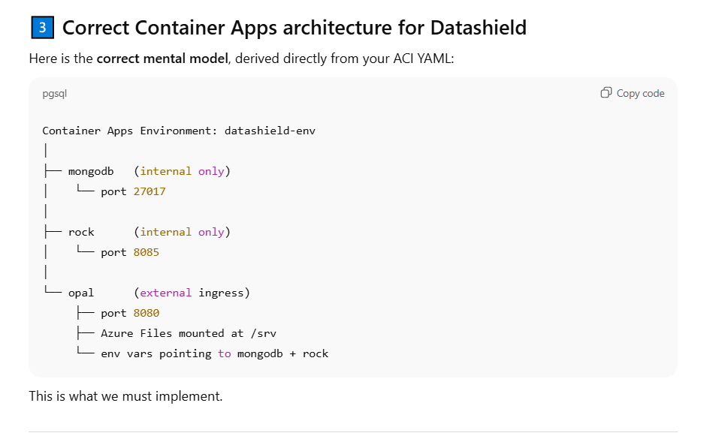

I will note in passing that having an Ai tool spell out clearly upon questioning the exact set up required and this set up seeming entirely sensible is nothing short of a game changer, very probably in the absence of such an aid I could have eventually arrived at this sort of coherent system set up logic, but having it spelt out so clearly at the outset before then proceeding to build the requisite pipeline based upon this architecture is, to reiterate, a game changer. Moreover ChatGpt then proceeds to draft the necessary azure pipeline script to be implemented as a pipeline within azuredevops, which I will not paste here but which accords with the requisite environment set up and is a more robust azure container application environment set up than the previously proposed azure container instance environment set up.

We noted previously that the OPAL docker image, which is the main application in the Datashield environment set up, needs to be updated to incorporate the customize shell script so that once the OPAL image is instantiated as a container, it will be able to customize itself using the customize shell script on start up and we explained that in a docker compose set up, docker compose would customize the container using the customize.sh file but that in an azure container app environment the container has to be able to use the customize.sh file on start up to customize itself. So we have created a specialized OPAL image with this modification and placed it in the azure container registry and also downloaded the correct mongodb and rock images from docker hub. With the correct images which will be spun up into configured containers within an azure container app environment i.e. deployed; we are now in a position to deploy the datashield container app environment, but there are some good practices and considerations to keep in mind as we complete what I am calling ‘stage 3 deployment’ -

✅ Use the correct custom image (opal-datashield)
✅ Correctly mount Azure Files – the azure file share in the azure cloud to the /srv folder location in the OPAL container, the reason for this is that at start up, the container using the customize.sh script will pull the synthetic files from github into the the azure file share and then access the azure file share as though the files are stored in the local container /srv folder location and from here can then import those csv files into the OPAL data management console/server and make those files available to anyone querying that OPAL server.
✅ Pass all required Opal + synthetic data environment variables
✅ Enables managed identity on the Container Apps environment
✅ Correctly assigns the AcrPull role to the managed identity permission thereby giving the azure container app environment permissions to pull the required docker images from the azure container registry
✅ Enforces single-replica stateful Opal – i.e. do not permit OPAL to scale beyond one container for now when it runs
✅ Is safe and repeatable (create-or-update logic)

a few more considerations on the environment variables. We have already noted that the datashield needs a set of environment to quote ‘wire the mongodb, rock and opal’ containers together such that they work together, these environment variables vary from port addresses through to valid username/password credentials through to file locations, these variables are referenced primarily within the OPAL container configuration. BUT i have previously asked the question – ‘where is the correct place to define the environmenbt variables which will be references within the datashield environment set up?’ is it in the container, at container level or is a level up at the container environment level which holds/wraps around the containers? When we do the deployment what we’re actually doing is deploying a specific azure container app environment which will hold a set of containers that talk to each other and work together (using environment variables) in order to run a solution – in this case Datashield.
It seems that when we deploy we need to define environment variables in the container app deployment script and these will take precedence over the environment variables already defined in the docker image. Thus the definition of environment variables in the container app deployment script supercedes the same variables defined in the docker image, which suggests that we can probably remove the stated environment variable definitions in the docker image file for OPAL.

Back to deployment stage 3 here is the correct architecture for deploying the 3 azure container registry images as the Datashield solution in an azure container app environment, note that that each image has to be defined as a separate container app –

3️- What the corrected architecture looks like
Container Apps Environment
│
├── mongodb (internal, port 27017)
├── rock (internal, port 8085)
└── opal (internal or external, port 8080)
All three:
- Same environment
- Same ACR
- Same managed identity

🔧 Split deployment into three container apps
- MongoDB
  - Internal ingress
  - Single replica
  - No Azure Files
- Rock
  - Internal ingress
  - Single replica
- Opal
  - Internal or external ingress
  - Azure Files mounted to /srv
  - Custom image opal-datashield
  - Env vars passed here
Also further deployment best practice will entail –
- Deploys three separate Container Apps
  - mongodb
  - rock
  - opal (your custom opal-datashield image)
- Uses explicit ordering (MongoDB → Rock → Opal)
- Uses startup/readiness probes so Opal won’t start serving until dependencies are reachable
- Mounts Azure Files to /srv for Opal (as required)
- Keeps everything idempotent (safe to re-run)
⚠️ Important note up front
Azure Container Apps cannot truly block creation of one app until another is “ready”.
What we can do (and do correctly below) is:
- Create in order
- Add startup probes so containers wait before becoming ready
- Ensure Opal won’t function until MongoDB + Rock are reachable
This is the correct ACA-native approach.

A nice neat list of the architecture for stage 3 deployment with all dependencies is set out below –

Below is a clean, complete, corrected rewrite of Stage 3 that includes:
✅ Idempotent creation of the Container Apps Environment (datashield-env)
✅ Azure Files attachment to the environment
✅ Three separate Container Apps (Mongo → Rock → Opal)
✅ Logical sequencing (Mongo first, then Rock, then Opal)
✅ Startup probes to enforce readiness
✅ All required OPAL environment variables
✅ Correct image references (ACR)
✅ Correct /srv Azure Files mount for Opal
✅ No missing dependencies
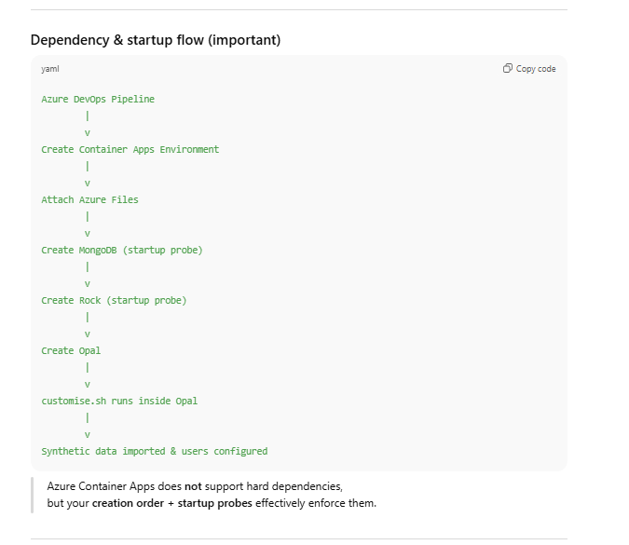

docker-compose concept | Azure Container Apps equivalent
Docker network | Container Apps Environment
Service name DNS | App name DNS
Volume mount | Azure Files
depends_on | Creation order + probes
post_start | Entrypoint in image
Custom init script | customise.sh baked into image

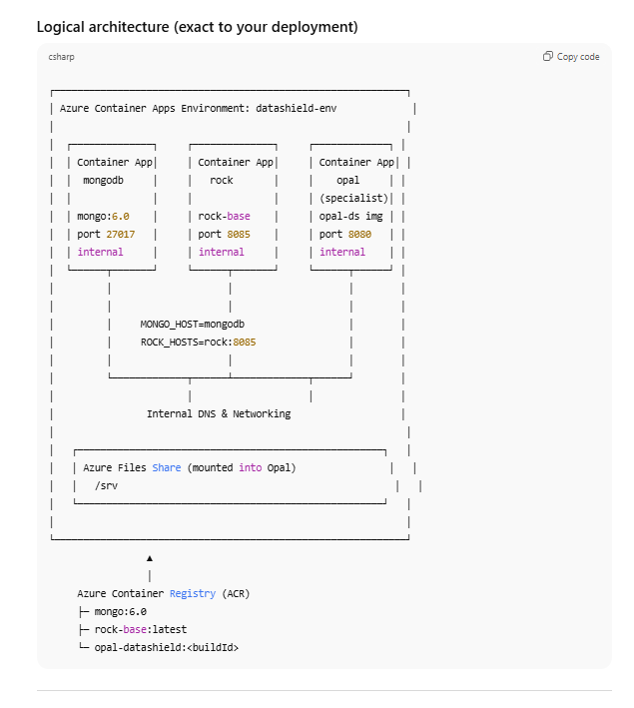

Component-by-component explanation

1. Azure Container Apps Environment (datashield-env)
This is the shared execution boundary for all three services.
- Created idempotently by the pipeline
- Provides:
  - Internal DNS (service-name-based discovery)
  - Shared networking
  - Managed identity
- Acts like the “Docker network” from your original docker-compose
datashield-env

2. Azure Files (mounted once, reused)
Attached at environment level, then mounted into Opal.
- Backed by:
  - Azure Storage Account
  - Azure File Share
- Mounted into Opal at:
- /srv
- Used for:
  - Persistent Opal data
  - Equivalent to:
  - /datashield/1/opal:/srv
Azure Files
└── mounted as datashieldfiles:/srv

3. MongoDB Container App
mongodb
- Image: mongo:6.0 (from ACR)
- Ingress: internal only
- Port: 27017
- Startup probe:
  - TCP socket on 27017
- Role:
  - Metadata + project storage for Opal
- DNS name inside environment:
- mongodb
This replaces the mongodb service in docker-compose.

4. Rock Container App
rock
- Image: rock-base:latest (from ACR)
- Ingress: internal only
- Port: 8085
- Startup probe:
  - HTTP readiness on port 8085
- Role:
  - DataSHIELD computation engine
- DNS name inside environment:
- rock
This replaces the rock service in docker-compose.

5. Opal Container App (Specialist Image)
opal
- Image: opal-datashield:<buildId>
- Built earlier in the pipeline
- Ingress: internal (can be made external later)
- Port: 8080
- Azure Files mounted:
- /srv

🔑 Specialist image behaviour
This is the key difference from a vanilla Opal deployment:
- The Dockerfile:
  - Copies customise.sh into the image
  - Marks it executable
  - Configures it to run on container startup
- When the Opal container starts:
  - Opal service boots
  - customise.sh waits for Opal API readiness
  - Script uses environment variables to:
    - Create users
    - Create projects
    - Import synthetic CSV data from GitHub
    - Assign DataSHIELD permissions
✔ No pipeline reference to customise.sh is required
✔ No sidecar container is needed
✔ Behaviour is deterministic and repeatable

6. Environment variables (runtime, not build-time)
Defined on the Opal Container App, not globally:
- OPAL_ADMINISTRATOR_PASSWORD
- OPAL_DEMO_*
- OPAL_COHORT_*
- MONGO_HOST=mongodb
- ROCK_HOSTS=rock:8085
- CSRF_ALLOWED=...
These are:
- Injected at container startup
- Read by customise.sh
- Override Dockerfile defaults (if any)
This mirrors how docker-compose injected environment variables.

Image sourcing (ACR)
All three Container Apps pull images from ACR using the Container Apps Environment managed identity:
Container App | Image Source
mongodb | acr.azurecr.io/mongo:6.0
rock | acr.azurecr.io/rock-base:latest
opal | acr.azurecr.io/opal-datashield:<buildId>
No registry credentials are embedded — access is via AcrPull RBAC.

Specialist Opal image – what actually happens at startup
This is the most important part of the diagram.

At container startup (Opal only):
- Azure injects environment variables
(defined in the Container App)
- OPAL_ADMINISTRATOR_PASSWORD
- OPAL_DEMO_PROJECT
- OPAL_DEMO_SOURCE_DATA_URL
- MONGO_HOST=mongodb
- ROCK_HOSTS=rock:8085
- ...
- Opal service starts normally
- customise.sh is executed automatically
  - Script is baked into the image
  - No pipeline reference required
  - Equivalent to docker-compose post_start
- customise.sh:
  - Waits for Opal API readiness
  - Connects to MongoDB via:
  - mongodb:27017
  - Registers Rock server:
  - rock:8085
  - Downloads synthetic CSVs from GitHub
  - Imports data into Opal projects
  - Creates users and permissions
✔ Fully declarative
✔ Repeatable
✔ Environment-variable driven

Why this design is correct (and better than alternatives)

❌ Not correct
- Running customise.sh from the pipeline
- Sidecar “init containers” (not supported in ACA)
- Baking credentials or URLs into the image

✅ Correct
- Image encapsulates behavior
- Runtime config supplied via Container App env vars
- Data persistence via Azure Files
- Clear service separation

One-sentence summary
Stage 3 deploys three container apps from ACR into a single Container Apps Environment, mounts Azure Files into a specialist Opal image, injects runtime environment variables, and relies on a baked-in customise.sh script to configure users and ingest synthetic data once Opal starts and can reach MongoDB and Rock internally.

