Azure Dev Ops – and the Azure Portal/Free Account 23/05/2025

This guide is working from ‘azure-devops-succinctly.pdf’ (which is a free ebook)
You need to create an account in Microsoft Outlook as a first step

https://account.microsoft.com/account

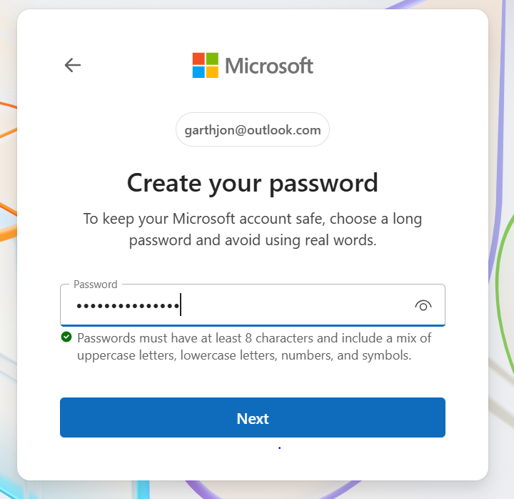

****1*ol***ph*

https://azure.microsoft.com/en-us/free/

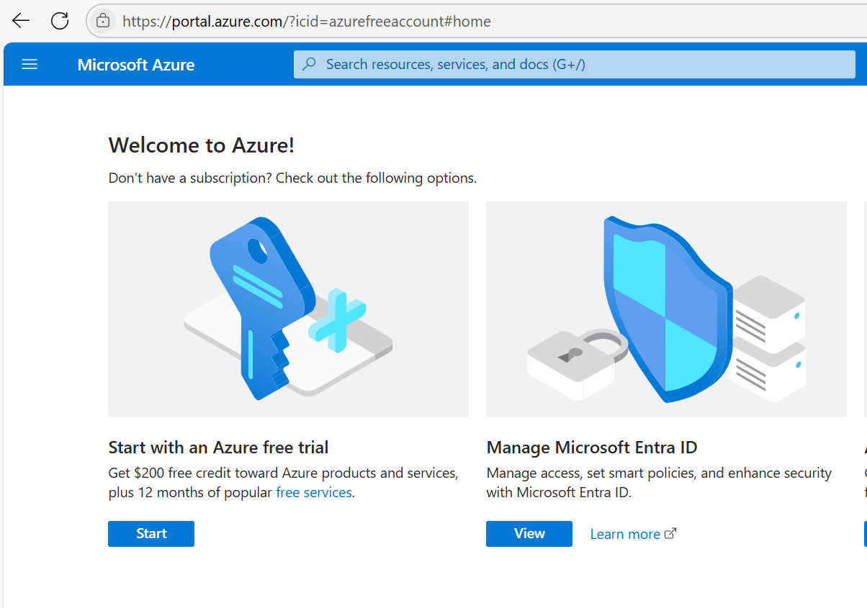

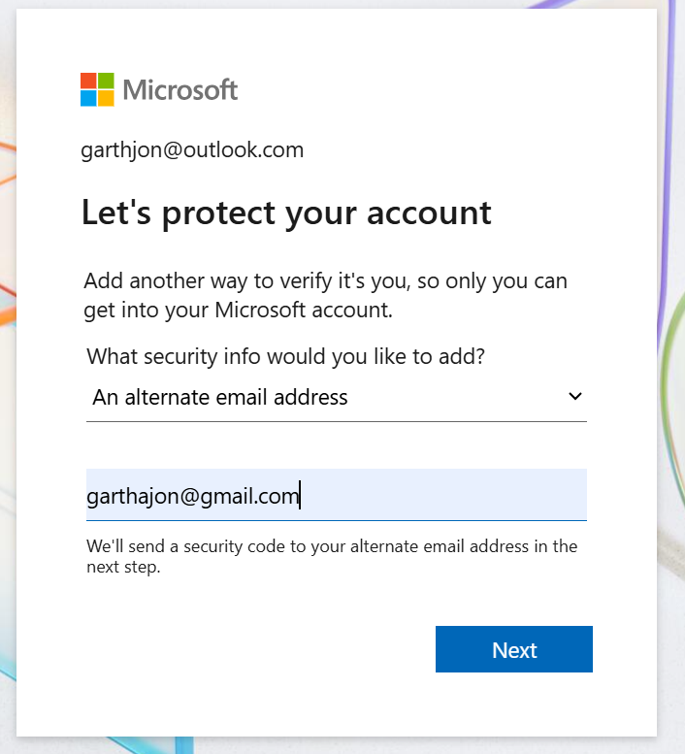

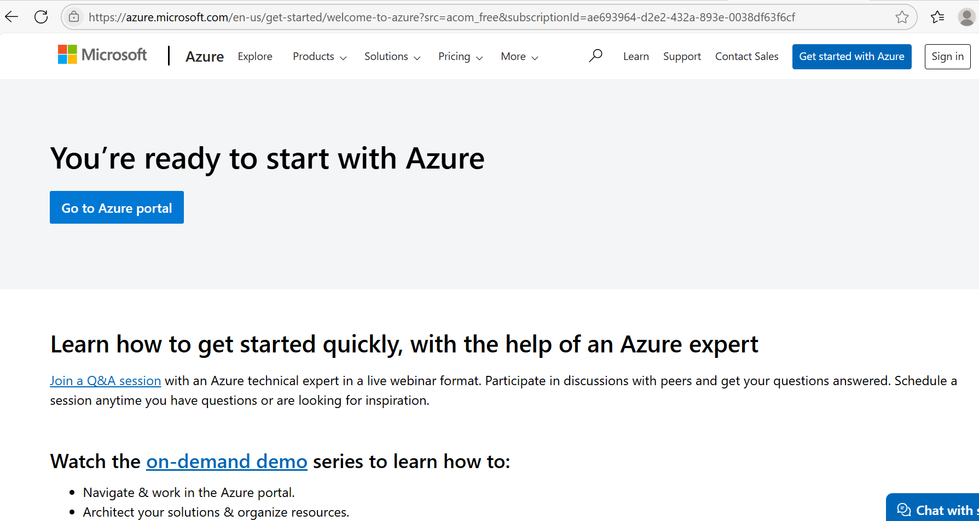
https://azure.microsoft.com/en-us/get-started/on-demand/?OCID=AZ_ODD_RM

Quick start centre:

https://portal.azure.com/?quickstart=true#view/Microsoft_Azure_Resources/QuickstartCenterMenuBlade/~/overviewTab

But as you’re logged in to your outlook account, you can navigate to the main portal page:

https://portal.azure.com/#home

so now we’re using a ‘free’ version of Azure which doesn’t seem to have a time limit on that free version and comes with $200 free credit in order to begin experimenting with azure cloud:
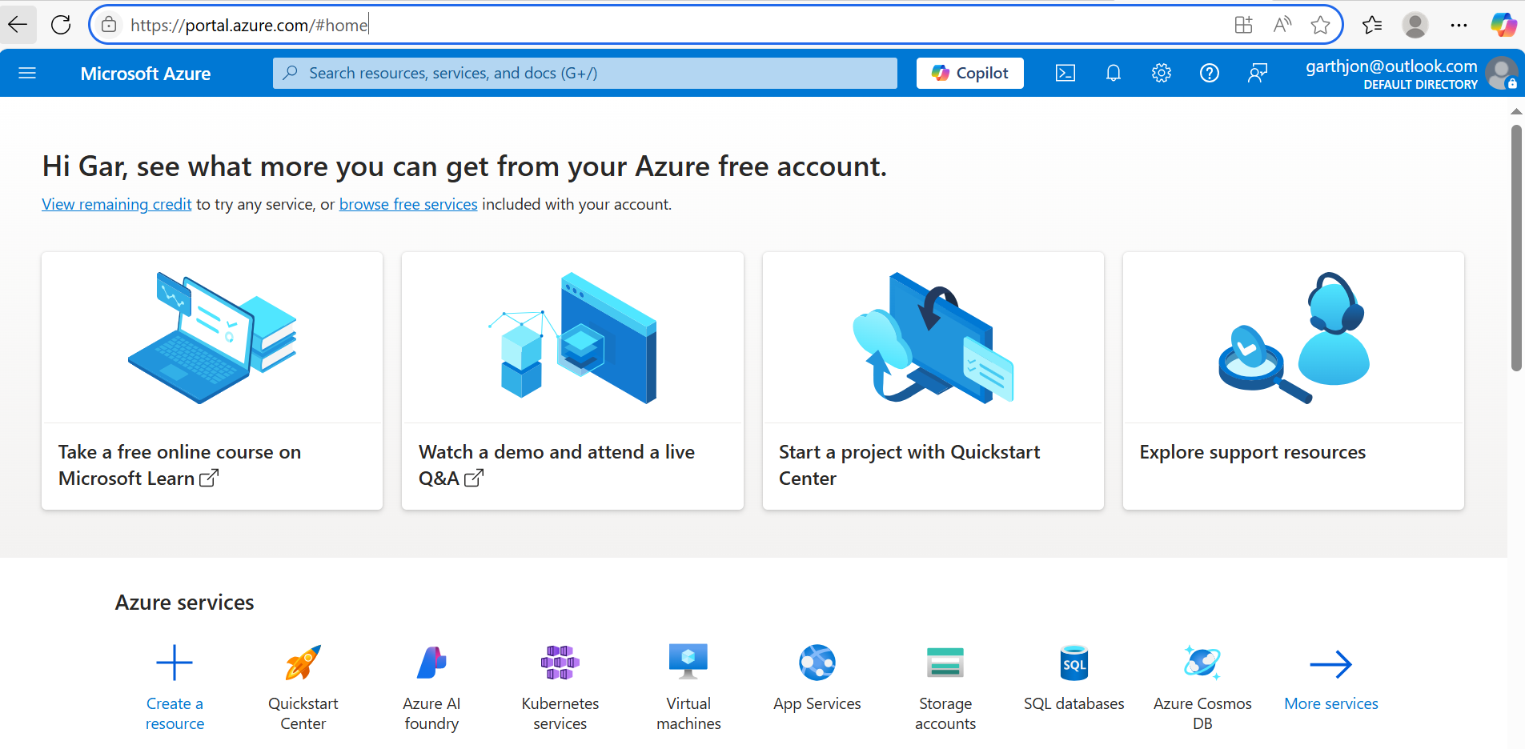

we have now (just) created an Azure Tenant which in a sense is the first necessary object which needs to be created in order to have a functioning azure cloud platform:

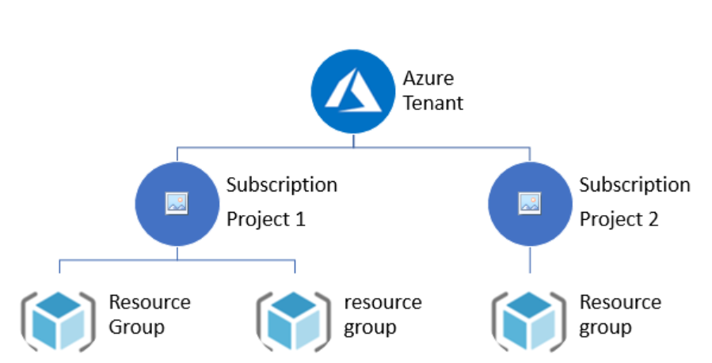

The Azure tenant is also sometimes referred to as ‘the account’, but it is the same thing and the highest/most fundamental in the order of objects to create in order to get going with Microsoft azure cloud:

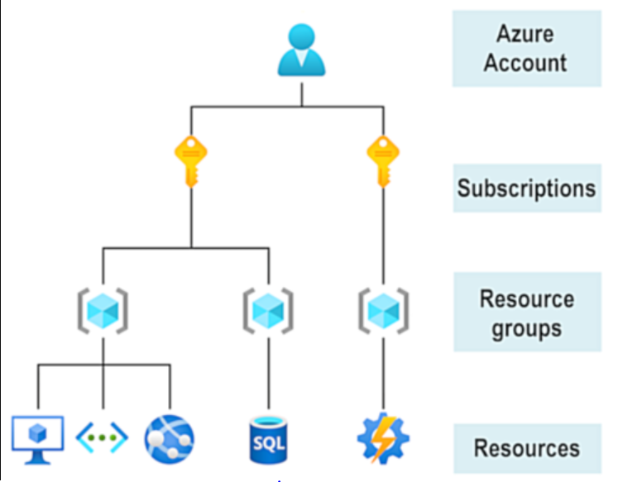

moreover, because you created it – it is you who is the administrator with the highest level of permissions, you will be able to create subscriptions (more on this shortly) add users and create resources (like virtual machines, storage containers or azure data factories) within this tenancy. But you’ll need to exercise caution because the resources (such as VMs) all cost money and you only have $200 free credit – so keep this in mind.

Subscriptions

Now let’s take a look at subscriptions.
Firstly, navigate to ‘all services’ on the menu on the top left:

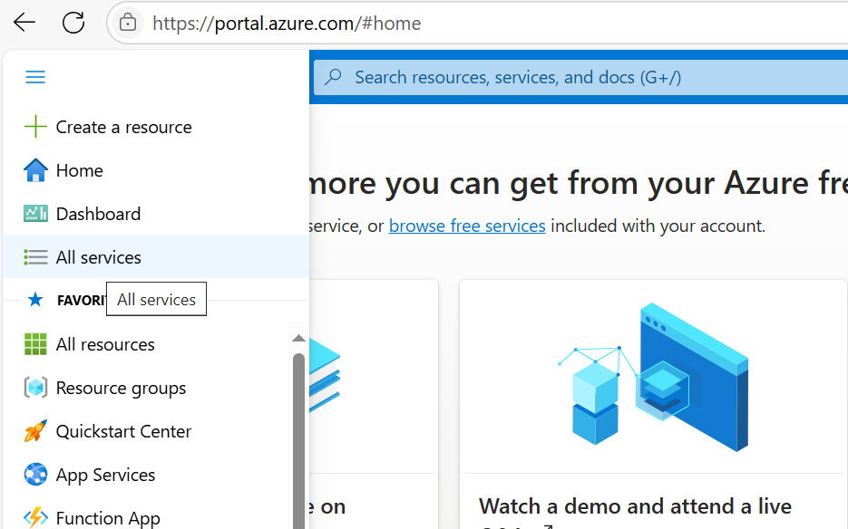

search for subscriptions:

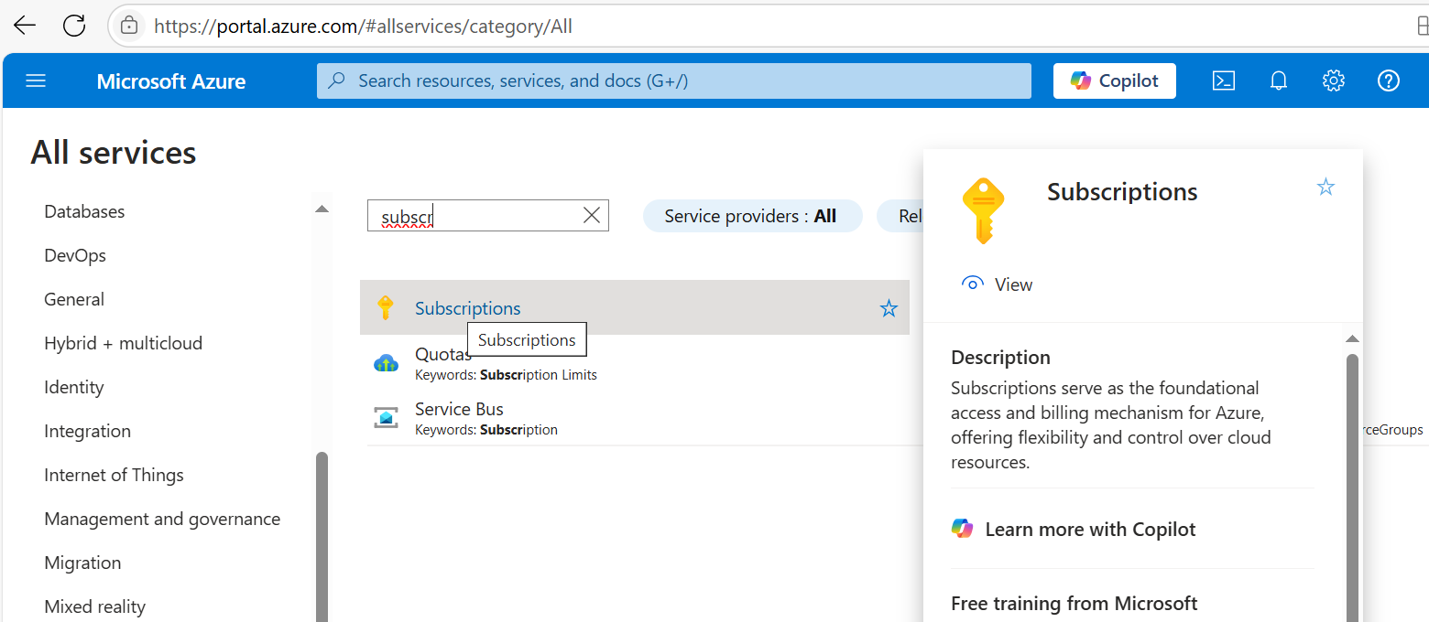

we see that the current subscription is a free $200 credit subscription, we also see (unfortunately) that this free subscription expires within 30 days, which unfortunately means that we do have a time constraint on the usage of the free version:

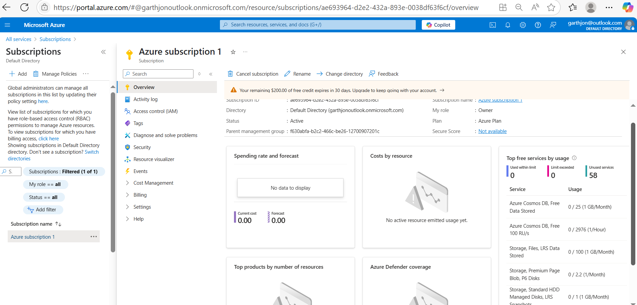

The subscription, is the next level down in the object hierarchy below the tenancy. And a subscription is necessary in order for Microsoft to bill you for the services you use. In the free version you get 5GB free storage and $200 of free paid services credit, but it only lasts for 30 days unfortunately. Here, you can see an overview of costs, spending and usage.

Your Azure tenant has a name and an ID, you can find this in the Azure Active Directory or AAD and the AAD is another fundamental component in Azure Cloud land. This is under Microsoft Entra which should be listed under your favourites in the top left hand menu:

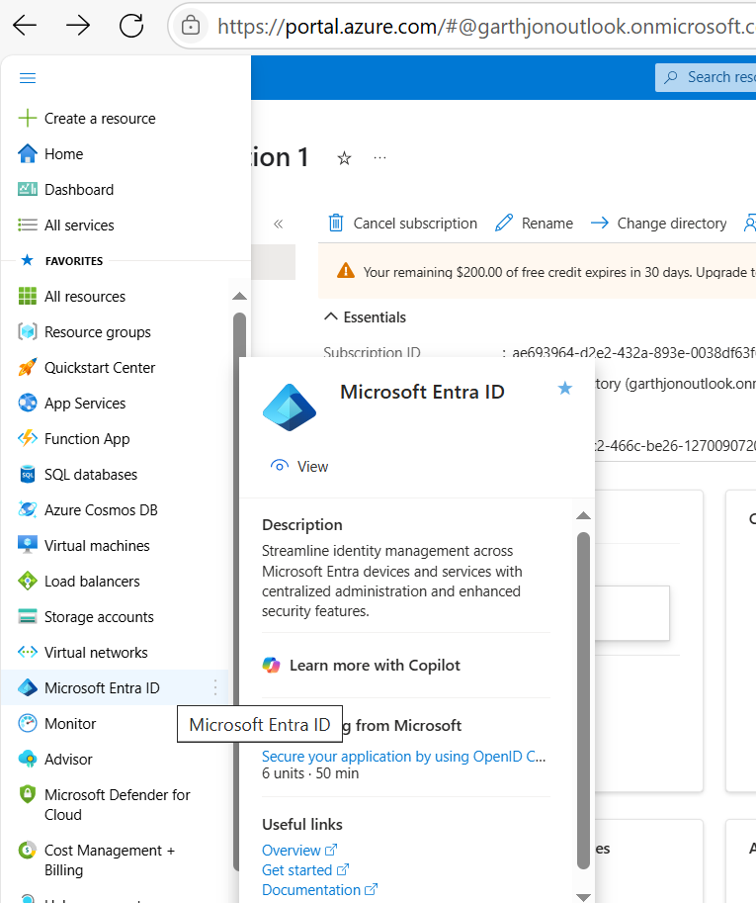

You can see the details of your tenant and active directory on the Entra page:

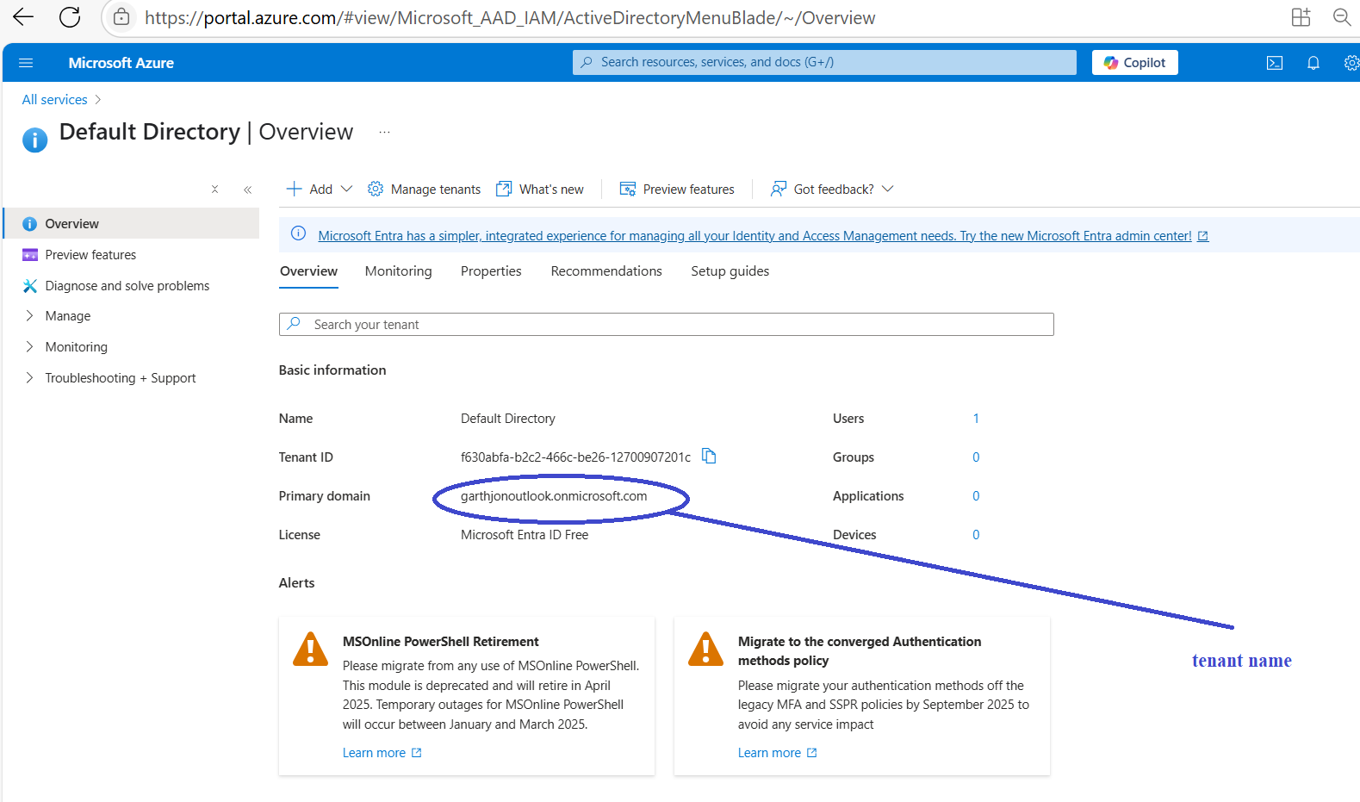

we can also take a look at the Users within the tenancy. You are the tenancy owner and administrator and can therefore add users to the tenancy, which we will need to do later on.

Installing Azure Dev Ops:

Azure DevOps is not installed in the same way as a traditional resource like a VM or App Service. Instead, you create an organization in Azure DevOps and link it to your Azure AD tenant.

✅ To create a new Azure DevOps organization:
- Visit https://dev.azure.com
- Sign in with an account in your Azure AD tenant
- Click "New organization"
- Choose your organization name and Azure region
- Link it to your Azure directory (if not already)
- Create a new project inside the org
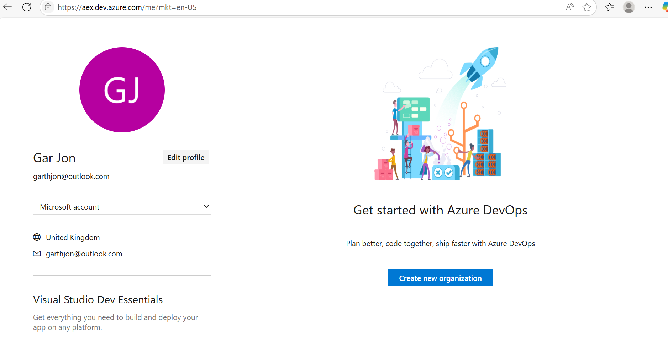

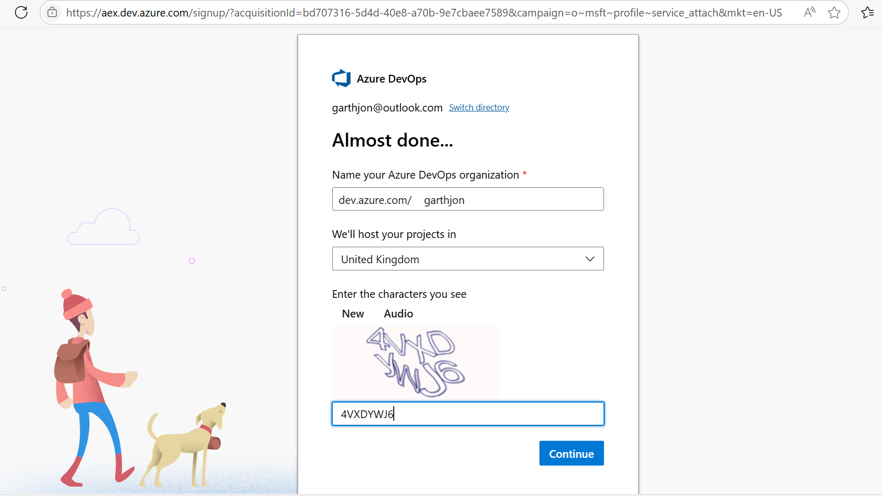

thus https://dev.azure.com/garthjon/ becomes the Azure devops organization (where I can run devops projects), as distinct from the azure tenancy https://portal.azure.com/#home
where I run services such as ‘azure data factory’. I had wrongly supposed that devops runs as a service; it doesn’t it runs as something called a devops organization and that has to be created separately – still with the azure account which you use for the main azure tenant, but separately and you set this up by going to: https://dev.azure.com whilst logged in with whichever outlook account which you are using for your azure tenant.

Once we have set up an Azure DevOps Organisation, we can then set up an Azure Dev Ops project:

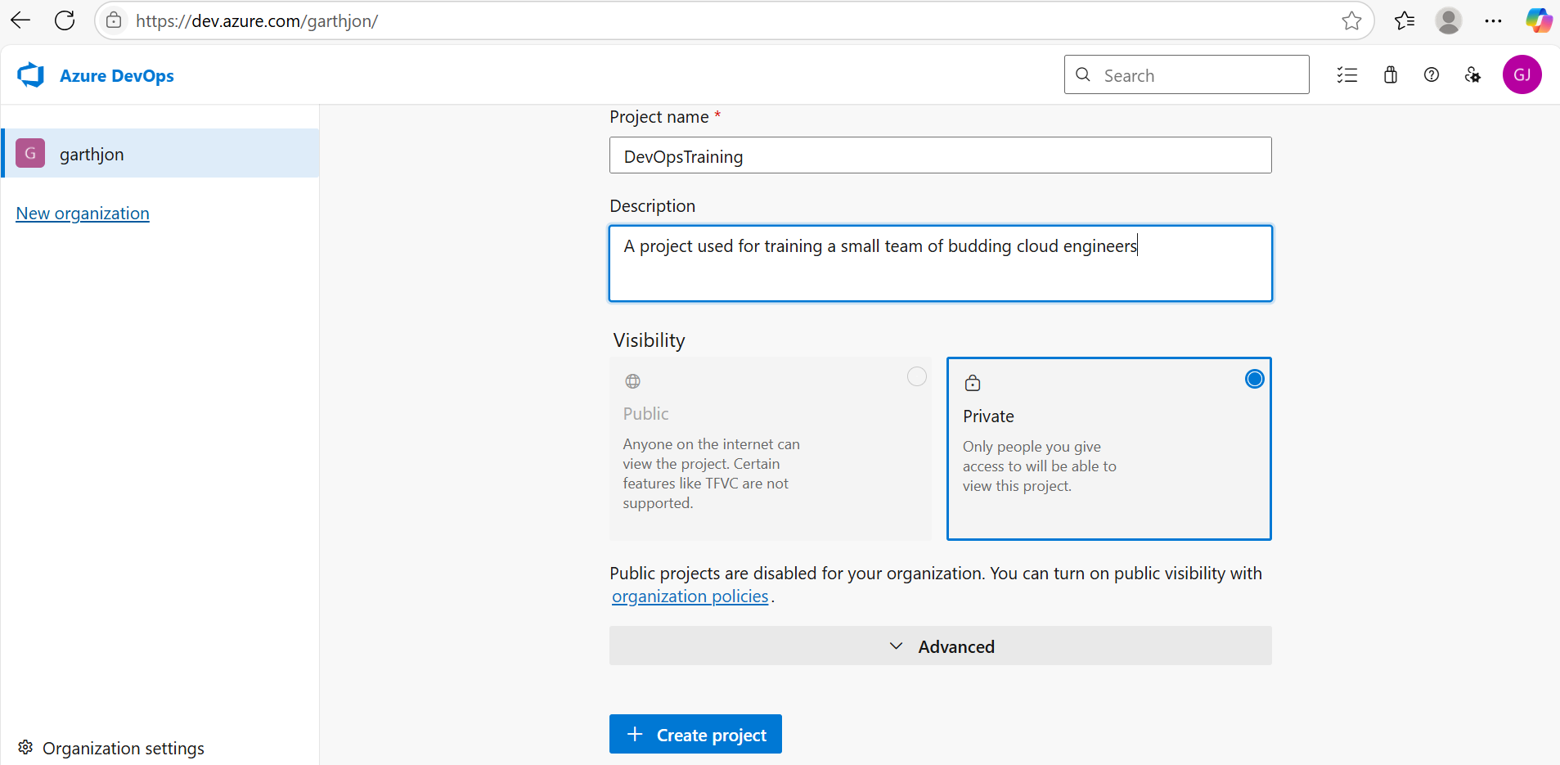

Having created a project, we are now all good to start using devops: https://dev.azure.com/garthjon/DevOpsTraining

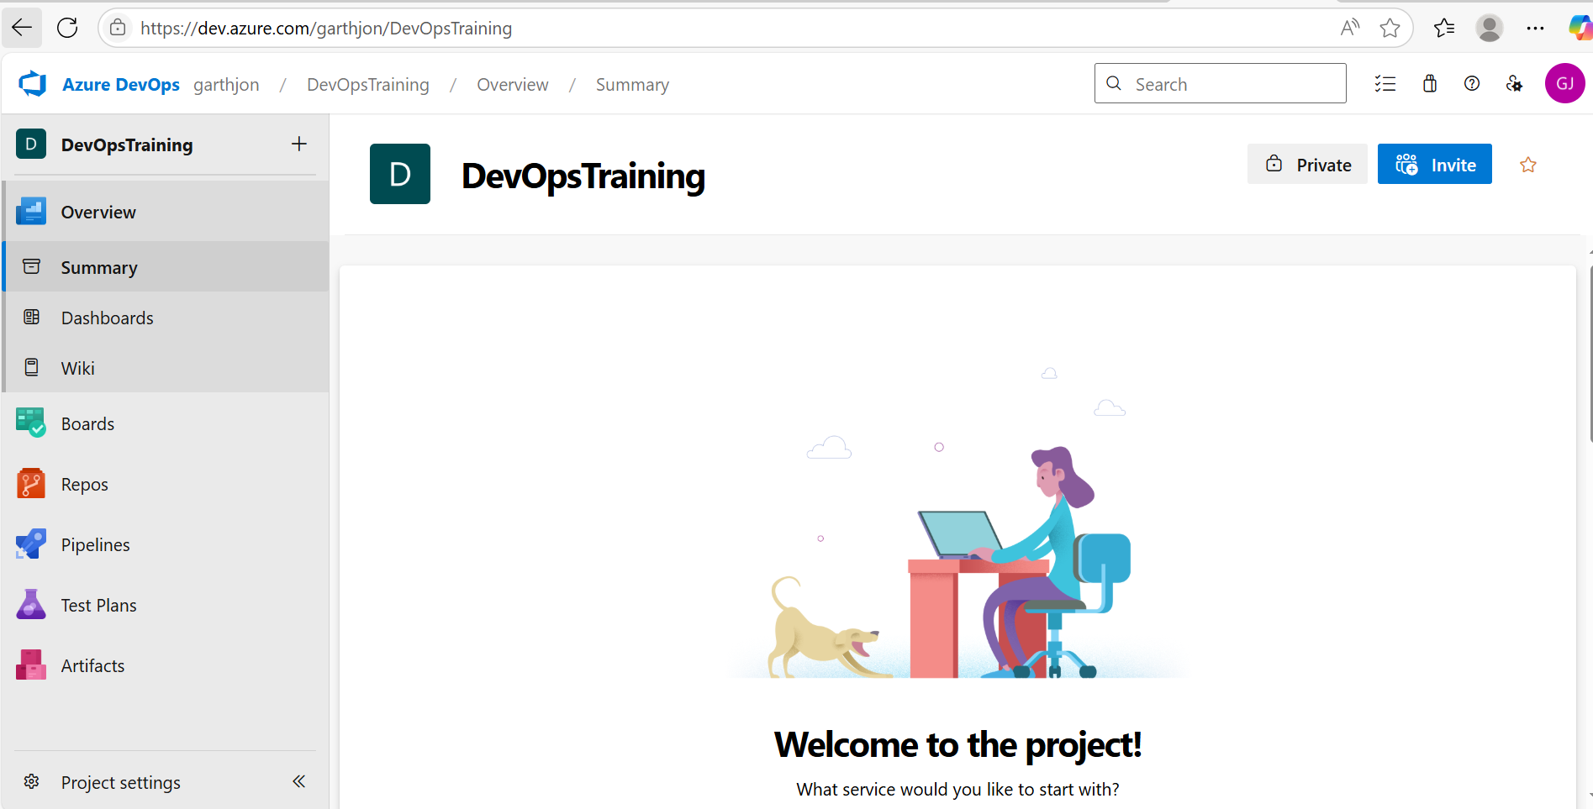

Under 'organisation' settings when under the Microsoft Entra settings on the left, I connected directory (in order to connect to the Azure Active Directory that I have set up in the tenant).

Under Organisation – you can also add users which (once you have connected to your active directory) will add users not only to your devops but also to your ad in your azure portal/tenant, you will then need to go to your azure subscription and under your subscription, assign the users you just added in devops

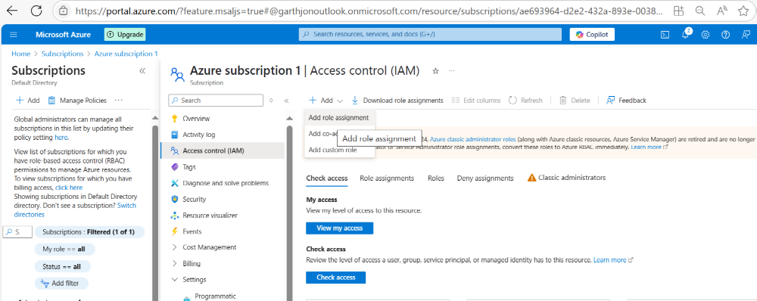
you can then assign the role of 'reader' against the subscription

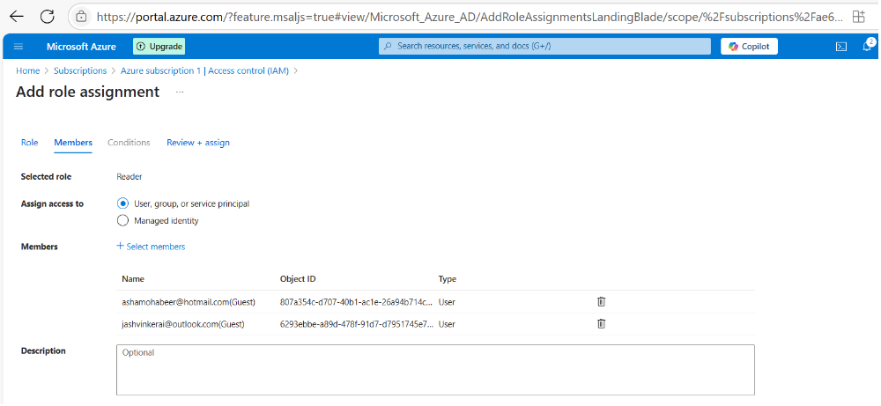

Creating different project types with Boards (Basic, Agile, Scrum) with different task types

When you create a project you can go into advanced settings and choose between different types of work item settings namely: basic, agile, scrum or CCIM. Depending on which work item setting you choose different kinds of tasks will be available to you on your Board:

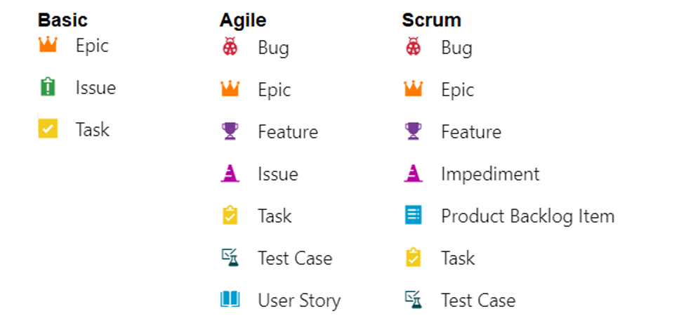

Epics, stories or issues can be created and placed on a backlog, they are then estimated in terms of time to complete and placed in prioritized order within a sprint.
In dev ops within your project (for example) you can create an epic (as a new work item) called ‘read azure dev ops’ for example, and then you can add an issue (as a work item) and then link the epic as being the parent of the work item.

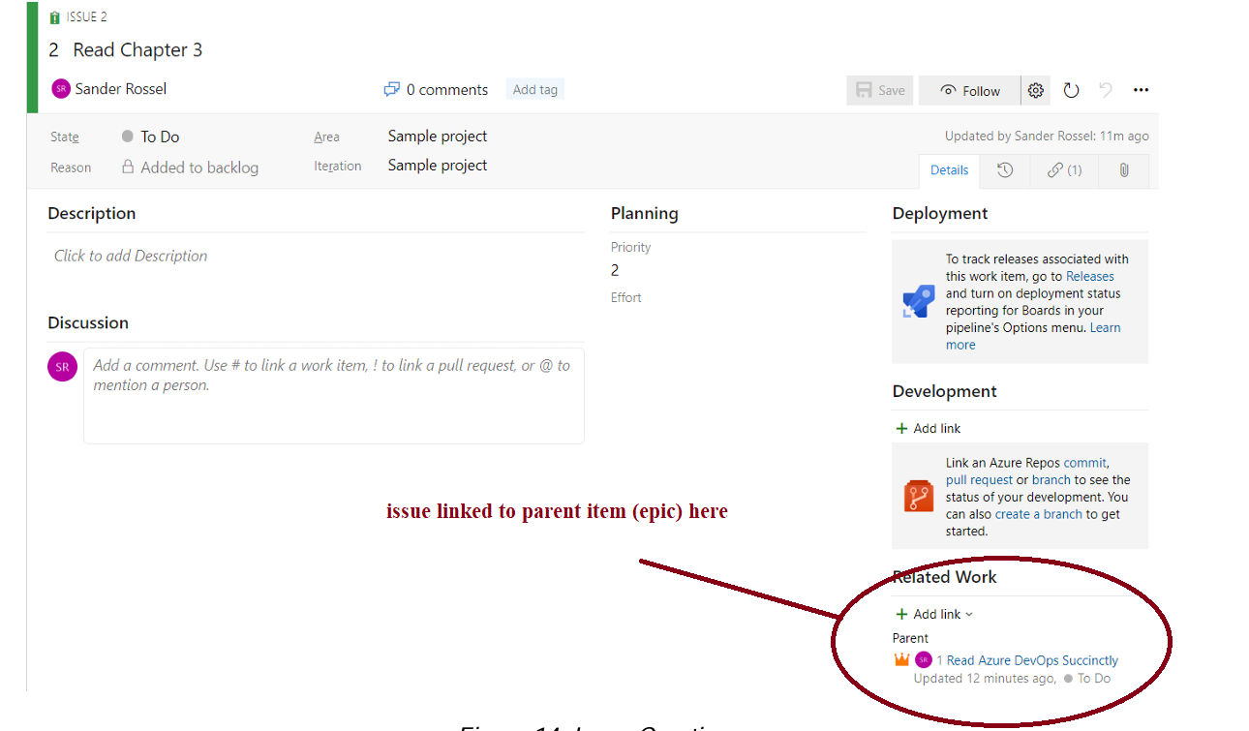
within the issue we can also choose ‘add another link’ and the choose ‘new item’ and Task of type child and enter (for example) ‘read terminology’. If you go to the backlog you can now switch between Epics and Issues and view the 3 work items you have just created:

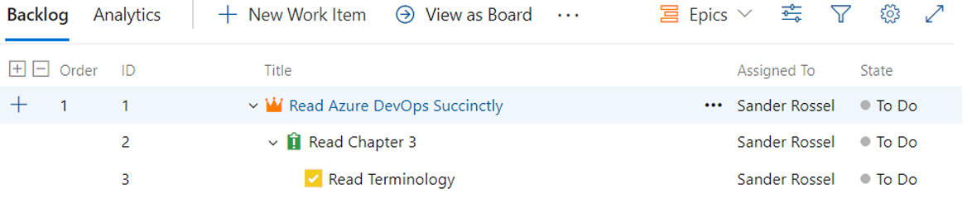

If you switch to Boards you’ll see 3 columns: to do, doing and done, you can switch between epic and issue view (issue tends to be the best view as this is what we actually need to do or are doing):

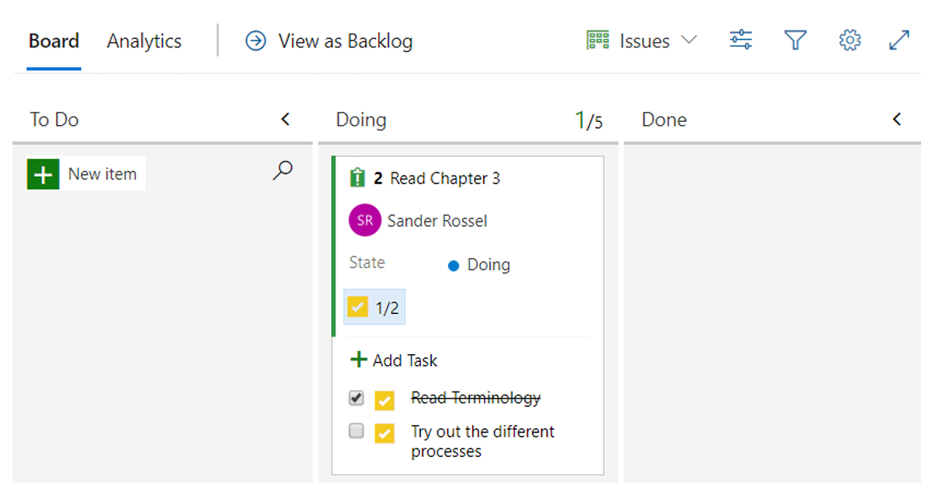

If you want to signal to your team that you are working on an issue, you can click on it and drag it to the next column/lane and tick off the tasks as you complete them. When an item (issue) is assigned to you, you can go to the ‘my work items’ tab and it will show you the issue(s) that you’re working on.

Agile Boards

Within Agile Boards user stories tend to replace issues, and tasks can be set within user stories and user stories can be set within epics or features or, indeed, you can solely use user stories if you wish without wrapping them up in the hierarchy of epics/features, but user stories in the Agile board can also have bugs and tests. Tasks bugs and tests are part of the user story and – when you look at the user story card in the board, you can see the tasks. bugs and issues on the card relevant to the user story in question:

