OMOP with DBT and snowflake using GIT repos 20/02/2026

The London data service has an OMOP GIT repo which contains a DBT project with DBT scripts/models used to generate OMOP datasets using a connection to a snowflake warehouse and raw datasets within that snowflake warehouse – note that the DBT models are basically making OMOP transform/fact datasets from the raw datasets within the snowflake warehouse.

We want to access the DBT project within that GIT repo and work with that project to generate the OMOP transforms in a test snowflake account. In order to access this DBT model we will initially clone the London Data Service OMOP Git repo to a local machine.

Having installed GIT on to a local machine I open the command prompt in administrator mode and change directory to the folder within which I want to create the GIT REPO. The folder in this case is called GIT.

>cd C:\Users\garth_cq08ui7\Documents\GIT

I then issue a git clone command to clone the london data service OMOP REPO to my local machine, with option no-checkout and I use sparse checkout options/commands to instruct the clone operation to only retain the OMOP_SNOWFLAKE directory from the REPO which is the DBT model

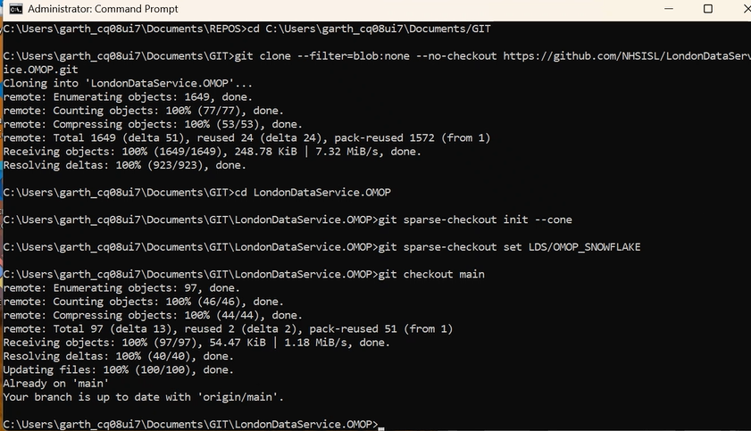

we have now cloned the GIT repo which contains the DBT model to our local machine, now lets link this local GIT repo to an azure dev ops remote repo so that this local repo is mirrored in the remote dev-ops repo.

So we need to log in to our devops account and create a new git repo within an existing project called ‘DevOpsTraining’

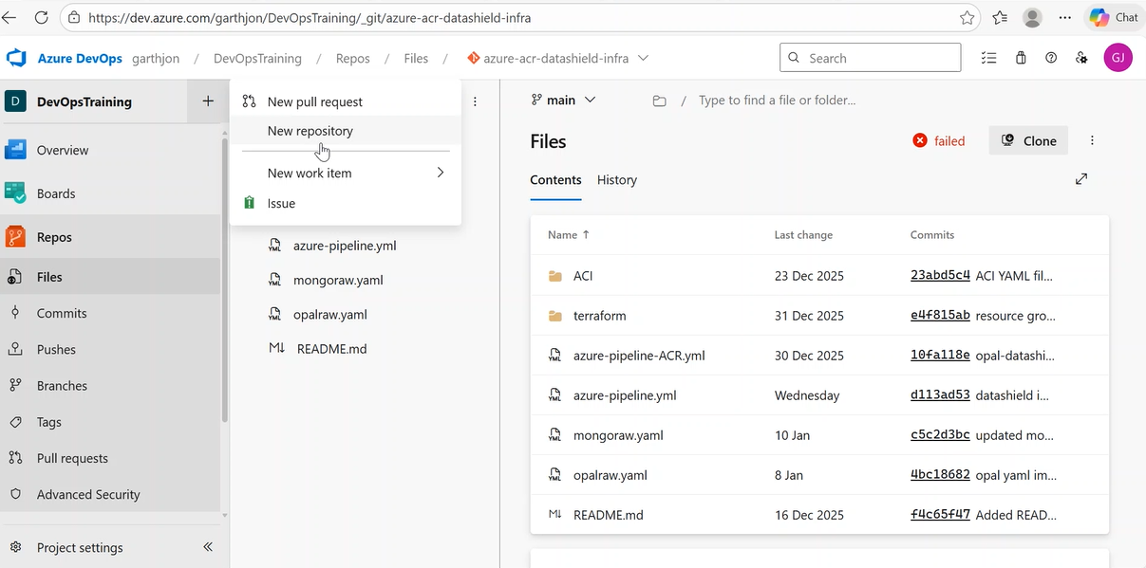

we then need the details of this remote repo URL to link the local git repo to this remote azure dev ops repo, so we go into the clone repository settings to get that URL

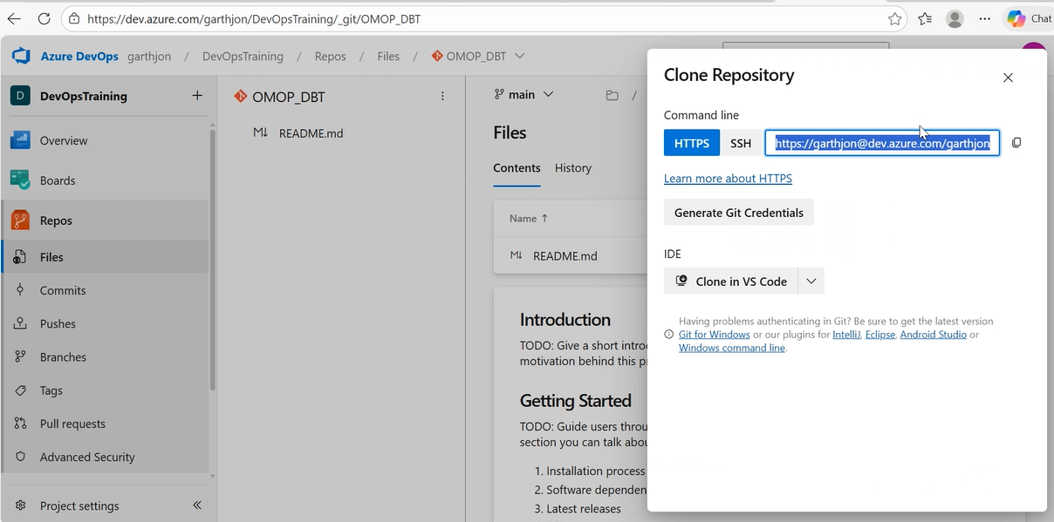

We then need to run some git remote add or set commands depending on whether or not a remote origin already exists and then push the contents of the current local git repo to the remote repo and commit changes with a commit message, note that the default branch being pushed is the ‘main’ branch.

Note you may need to delete the default existing branch of your new remote dev ops repo in order for the push to work

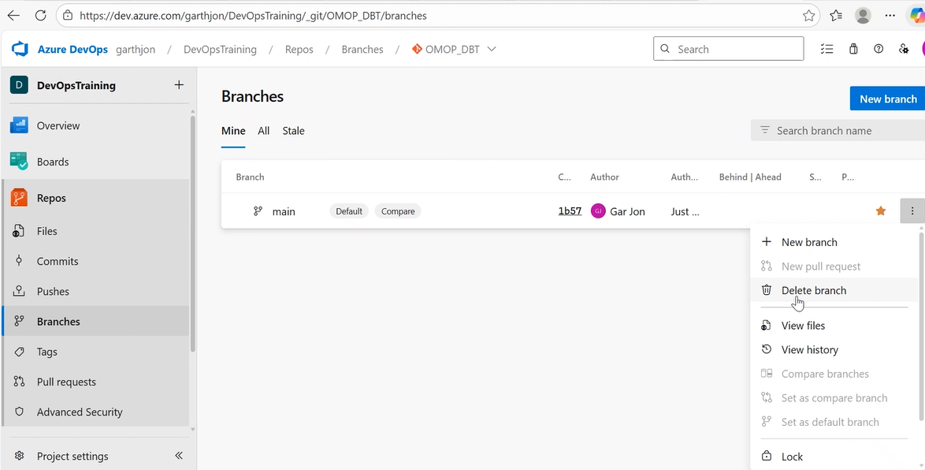

ensure that you have committed changes in your local branch, when you run commit for the first time you will be prompted for your email and name

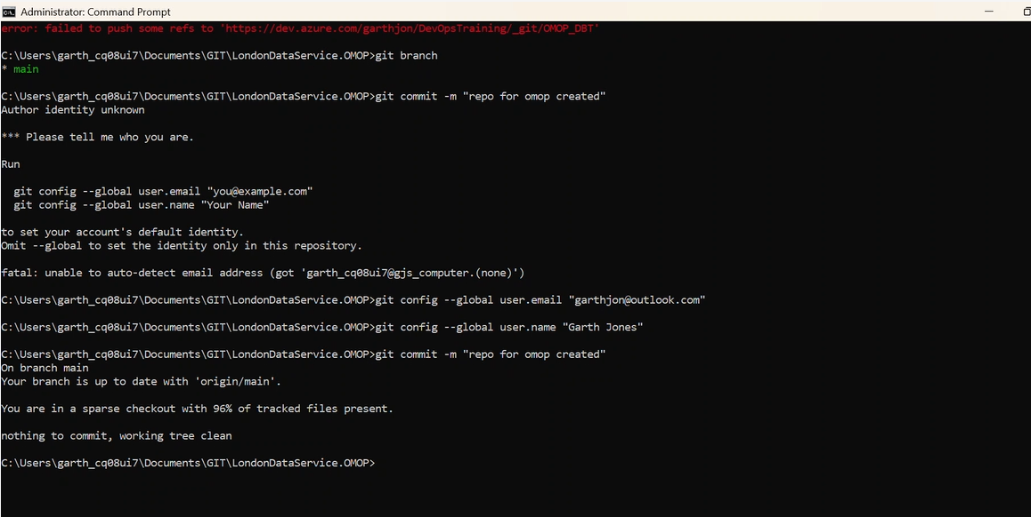

if all goes pear shaped following the git clone and you are not able to commit or push to remote and get a whole host of errors, that probably means that in the process of cloning using sparse-checkout a corruption has happened, but as long as you have all the files you need, you can just delete the current git. Repo history as follows –

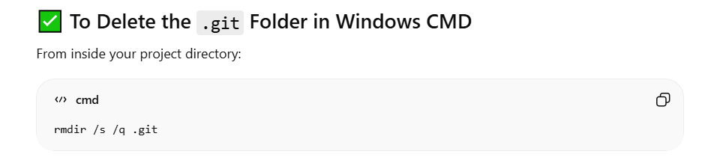

and then you can re-establish both the local git repo and connect that local git repo correctly to the remote repo, commit changes and push changes to the main branch in the remote repo

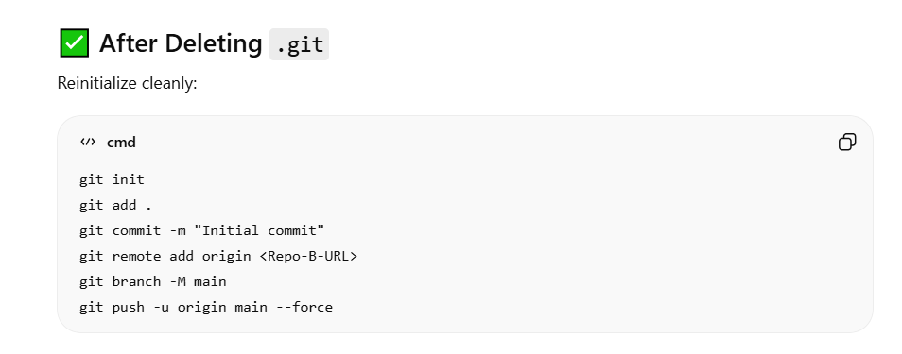

then you will have your local repo successfully synced with the remote azure dev ops repo and you will have removed the previous ‘head’ reference to the london data service repo

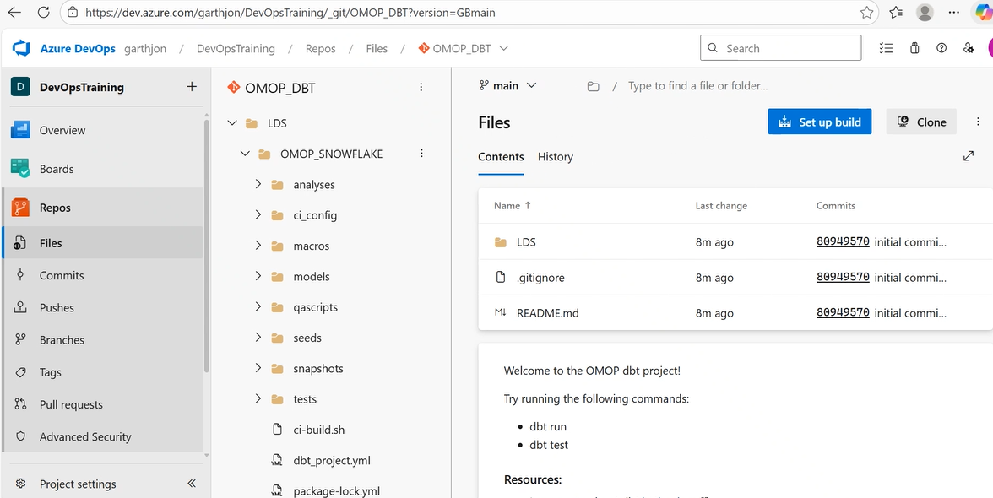

having established the git repo, which contains the dbt project on our local machine cloned from the london data service we now need to initialize the cloned dbt project within our local machine as being a recognizable dbt project on the local machine but first lets just check that DBT is up and running on the local machine by running a version check –

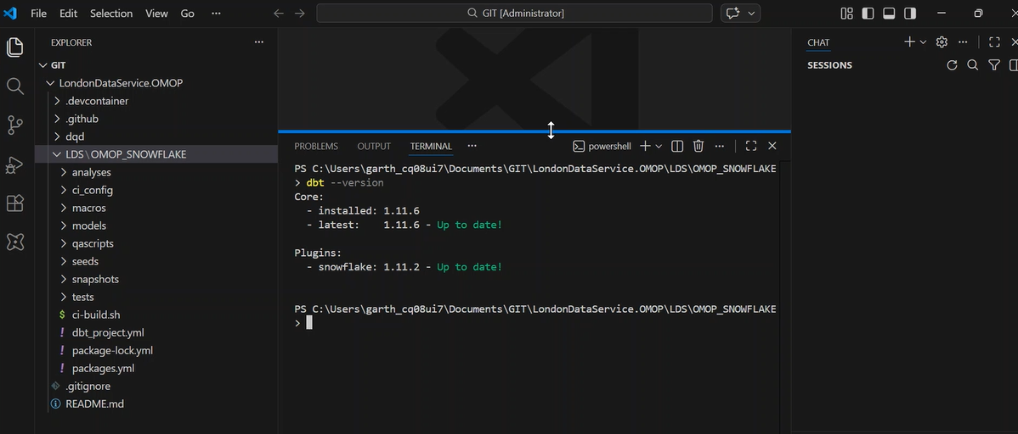

we know that we have cloned a dbt project, usually when dbt project is initialized/created at the command line we would normally use the command ‘run dbt init’ and this would create the dbt project directory in the current folder directory with the requisite dbt project folder/configuration. But here we do not want to do that because we already have an existent dbt project which we have cloned, moreover the fact of a file called ‘dbt_project.yml’ being present in the directory tells dbt that this directory is essentially a dbt project.
One thing to note at this stage is that we do have a missing ‘profiles.yml’ file which specifies the configuration/connection settings to the snowflake account, so we will need to create that file or the project won’t be able to connect to snowflake.

Installing DBT dependencies using ‘dbt deps’ is necessary in the case of cloning a DBT project, because just because you have cloned the project does not mean that the associated package dependencies specified within the packages.yml file will have been installed locally on your machine with respect to the dbt project that you just cloned.
We wouldn’t need to worry about running ‘debt deps’ in the case where the packages.yml is empty and does not specify any packages to install but in our case this is not so, there two packages specified within the packages.yml file

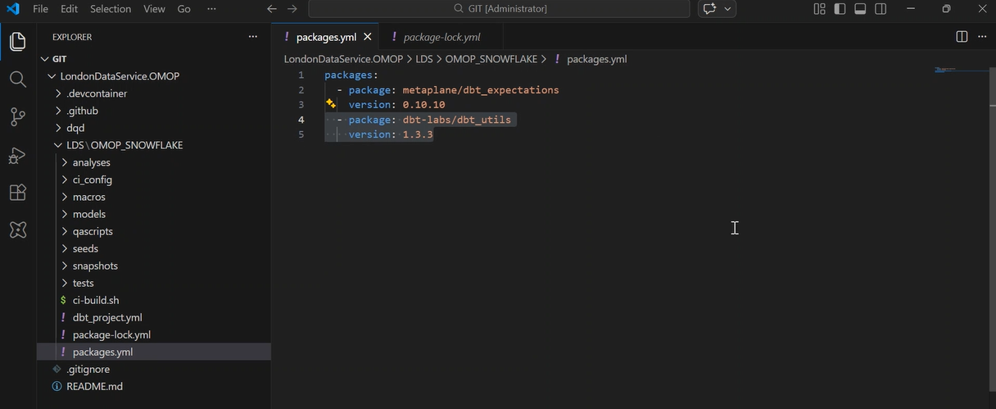

so within the project directory we must run dbt deps which will install of the packages and the package version mentioned in file packages.yml but note that there is an additional files with package details called ‘package-lock.yml’ and packages are also installed in accordance with the package references stipulated in this file

