Permitting access from Snowflake to an S3 Bucket in AWS Account – using the Identity Access Management Service in AWS.

https://xodegcg-rl95447.snowflakecomputing.com/console/login

https://app.snowflake.com/xodegcg/rl95447/#/homepage

username: garthjon

🔹 Step-by-Step: Creating the AWS IAM Role

1️⃣ Create an IAM Role in AWS
- Go to the AWS IAM Console → Roles → Create Role.
- Select "Custom trust policy" and paste this JSON:
{
"Version": "2012-10-17",
"Statement": [
{
"Effect": "Allow",
"Principal": {
"AWS": "arn:aws:iam::692859908729:root"
},
"Action": "sts:AssumeRole",
"Condition": {
"StringEquals": {
"sts:ExternalId": "UQ75769_SFCRole=2_tm39RU4pXse8DJxavXd9M8ngsco="
}
}
}
]
}}

🔹 How IAM Policies Work in AWS
- Trust Policy → Defines who (which entity) can assume the role.
- Permissions Policy → Defines what actions the role is allowed to perform.
Since these policies are applied at different levels (trust policy is attached to the role itself, while the permissions policy is an IAM policy attached to the role), they cannot be fully merged into one JSON file.

✅ The Best Way to Structure the IAM Role
Even though they cannot be combined into one single policy, you can set them up properly in a single AWS IAM role.

1️⃣ Trust Policy (Define Who Can Assume the Role)
When creating the IAM role, use the following Trust Policy under the Trust relationships tab:
json
CopyEdit
{
"Version": "2012-10-17",
"Statement": [
{
"Effect": "Allow",
"Principal": {
"AWS": "YOUR_SNOWFLAKE_AWS_IAM_USER_ARN"
},
"Action": "sts:AssumeRole",
"Condition": {
"StringEquals": {
"sts:ExternalId": "YOUR_SNOWFLAKE_EXTERNAL_ID"
}
}
}
]
}
✅ What This Does:
- Allows Snowflake (using the IAM User ARN) to assume this IAM role.
- Requires the External ID from Snowflake for additional security.

2️⃣ Permissions Policy (Define What the Role Can Do)
Now, attach the following Permissions Policy to the role under Permissions → Attach Policy → Create Policy:
json
CopyEdit
{
"Version": "2012-10-17",
"Statement": [
{
"Effect": "Allow",
"Action": [
"s3:GetObject",
"s3:ListBucket"
],
"Resource": [
"arn:aws:s3:::your-bucket-name",
"arn:aws:s3:::your-bucket-name/*"
]
}
]
}
✅ What This Does:
- Grants permissions to read files from the S3 bucket.
- The ListBucket permission allows Snowflake to see the files in the bucket.
- The GetObject permission allows Snowflake to retrieve files.

🚀 Summary: Why Can't You Fully Merge Them?
✔ Trust Policies go in the Trust Relationships of the IAM role (define who can assume the role).
✔ Permissions Policies are attached as IAM Policies to the role (define what the role can do).
👉 You must create both separately but attach them to the same IAM role.
Would you like help setting it up in AWS? 😊

Summary (IAM – identity and access management in snowflake from AWS) – integration of snowflake with AWS:

The Snowflake_access (IAM) role is located here (for my AWS account) with trust and permissions policy set up – I called the IAM role to permit connection between AWS and Snowflake ‘snowflake access’ :

https://us-east-1.console.aws.amazon.com/iam/home?region=eu-north-1#/roles/details/snowflake_access?section=trust_relationships

Note that once I had set up the IAM role I had to run this code to set up the integration in snowflake:

-- i had to create an AWS free tier account which gave me 12 months AWS access (free)
-- I need this because I need an S3 bucket for cloud of the parquet files
-- so that I can ingest the parquet files from the cloud S3 bucket into snowflake
-- using an integration and a stage (with the relevant permissions and accounts)
-- https://eu-north-1.console.aws.amazon.com/console/home?region=eu-north-1#

-- firstly create the integration for an S3 bucket which I have created in AWS
begin
CREATE OR REPLACE STORAGE INTEGRATION my_s3_integration
TYPE = EXTERNAL_STAGE
STORAGE_PROVIDER = 'S3'
ENABLED = TRUE
STORAGE_AWS_ROLE_ARN = ' arn:aws:s3:::garthsfirstbucket
STORAGE_ALLOWED_LOCATIONS = ('s3://garthsfirstbucket/');
--SHOW INTEGRATIONS;
end
begin
end

I then ran the following command in a separate query window to get the description of the integration:

DESC STORAGE INTEGRATION my_s3_integration;

And this gave me the ‘STORAGE_AWS_EXTERNAL_ID’ which I could then update in the AWS IAM trusted policy so as to create the vetted link between snowflake and AWS.

Note that I also had to then update the AWS_ARN against the AWS IAM trust policy to match the output returned. From this command thus this:

{
"Version": "2012-10-17",
"Statement": [
{
"Effect": "Allow",
"Principal": {
"AWS": "arn:aws:iam::084828560849:user/156w0000-s"
},
"Action": "sts:AssumeRole",
"Condition": {
"StringEquals": {
"sts:ExternalId": "UQ75769_SFCRole=2_1D/KolNH+P/wIWgPI36dxlpz+mQ="
}
}
}
]
}

had to match this:

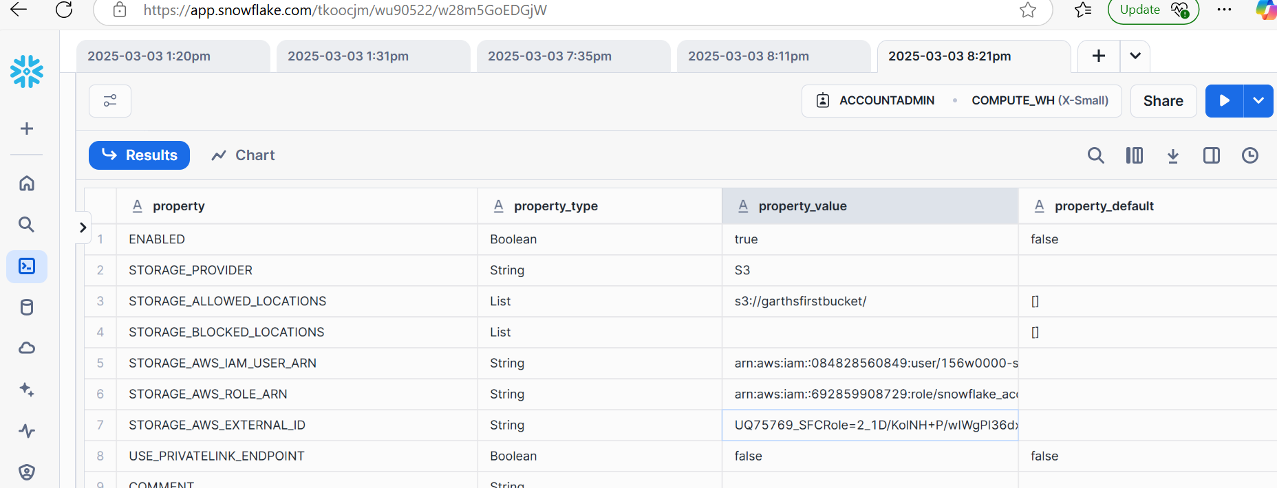
so the part of the AWS IAM (Identity Access Management) policy which needs to be updated with the account/id details from SNOWFLAKE is the Trust Relationship/trusted entities tab:

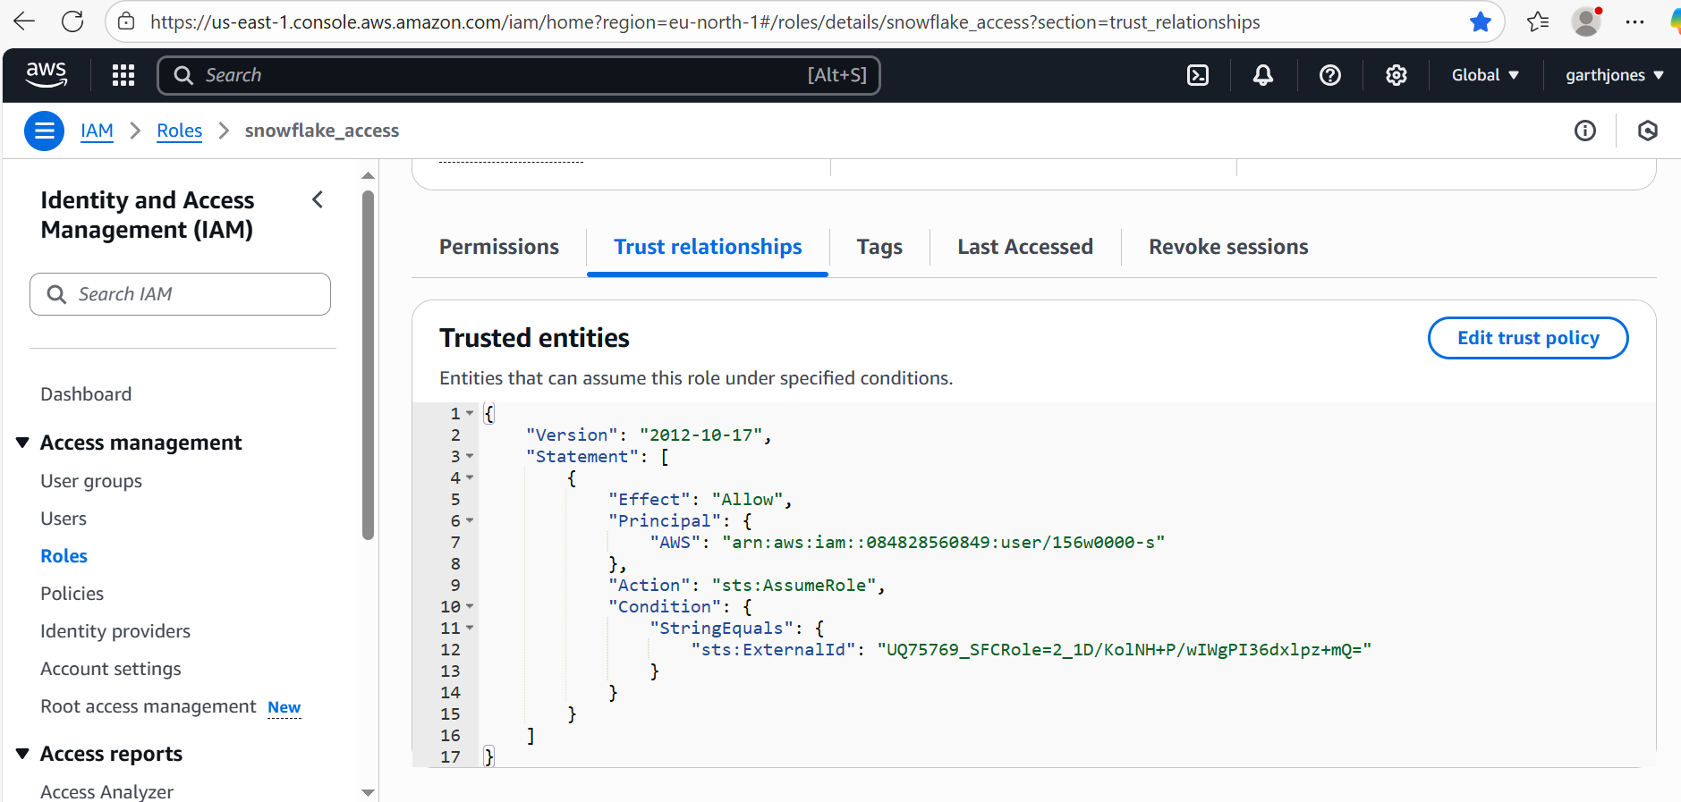

Therefore this:

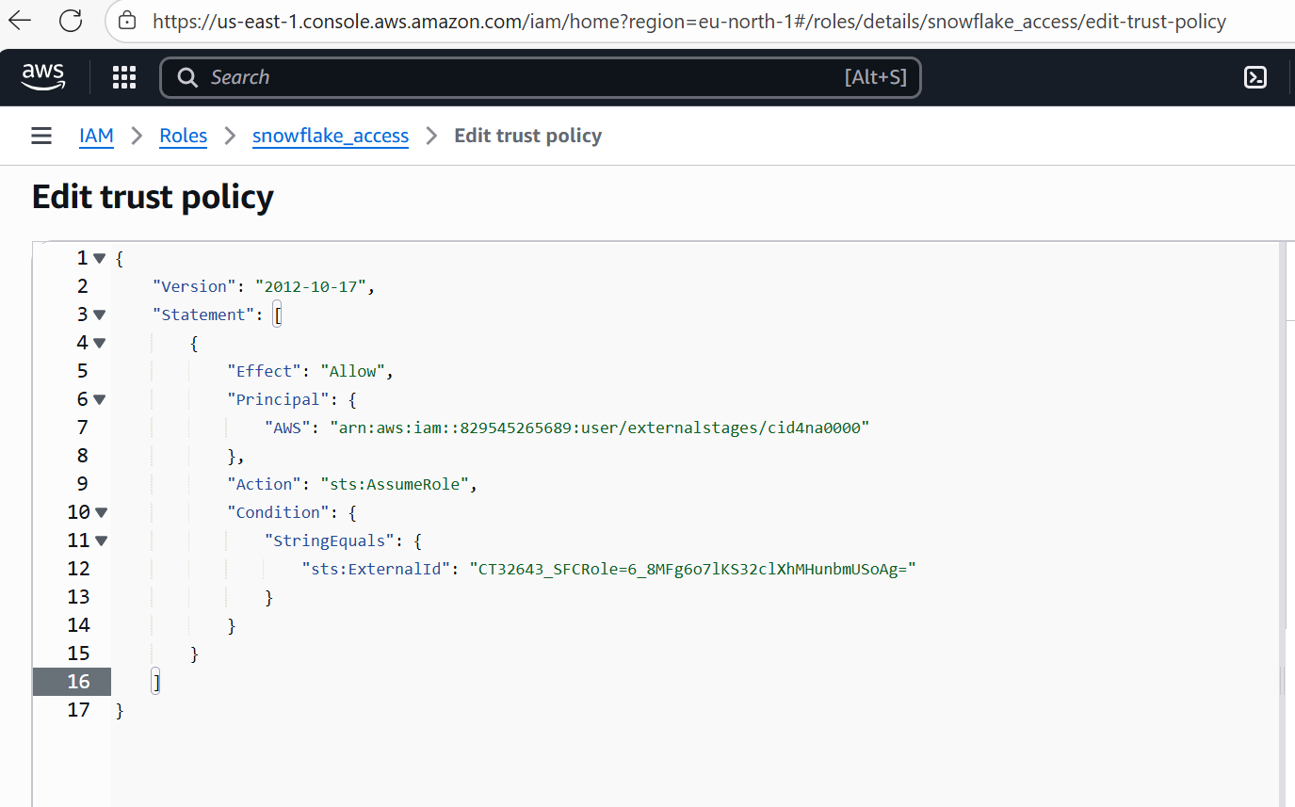

is updated to match, this:

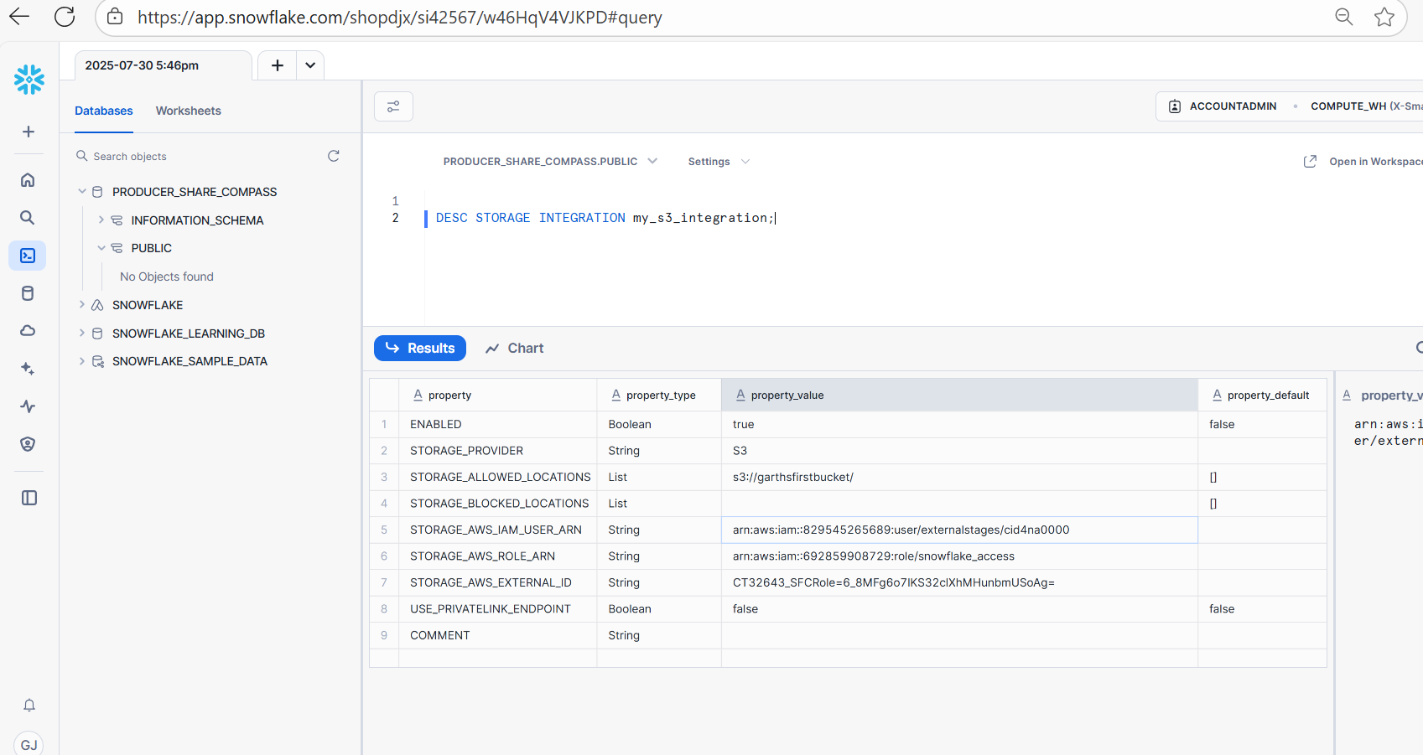

I then created a STAGE from the integration using the following script:

CREATE OR REPLACE STAGE my_s3_stage
STORAGE_INTEGRATION = my_s3_integration
URL = 's3://garthsfirstbucket/'
FILE_FORMAT = (TYPE = PARQUET);

The following query lists the contents of the BLOB container in AWS:

LIST @my_s3_stage;

Net having checked the contents of the BLOB container in AWS I create a parquet file format in preparation to import the file into snowflake:

CREATE OR REPLACE FILE FORMAT my_parquet_format
TYPE = 'PARQUET'
COMPRESSION = 'AUTO'
BINARY_AS_TEXT = FALSE; -- Keeps binary data in its original form

Now we can run a query in snowflake to check the schema of the file in staging:

SELECT * FROM TABLE(
INFER_SCHEMA(
LOCATION=>'@my_s3_stage',
FILE_FORMAT=>'my_parquet_format'
)
);

And as you can see, now we’re really getting somewhere by way of ingesting actual data:

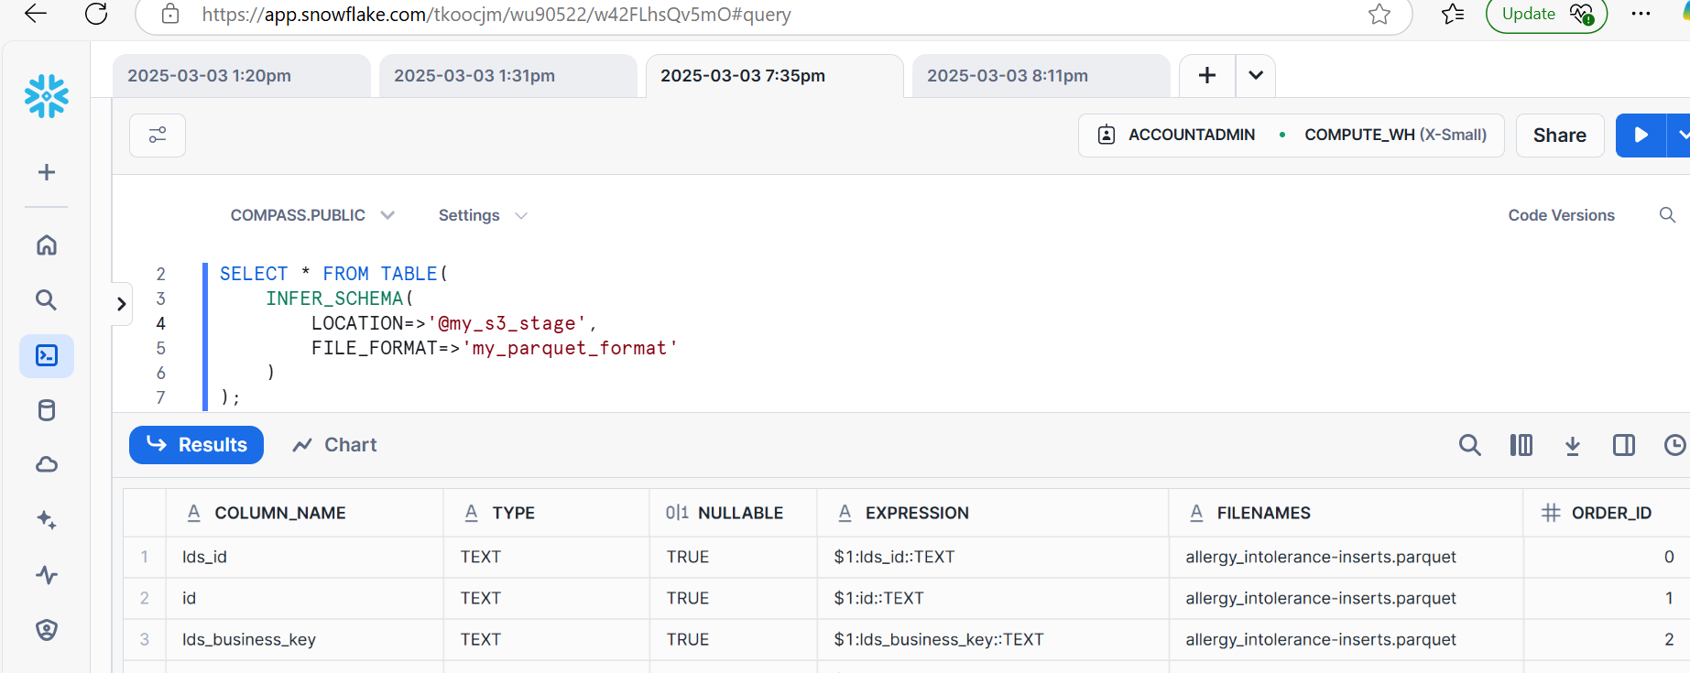

And finally we insert the data into a table in snowflake and voila….

CREATE OR REPLACE TABLE allergy_intolerance
AS
SELECT * FROM '@my_s3_stage/allergy_intolerance.parquet'
(FILE_FORMAT => my_parquet_format);

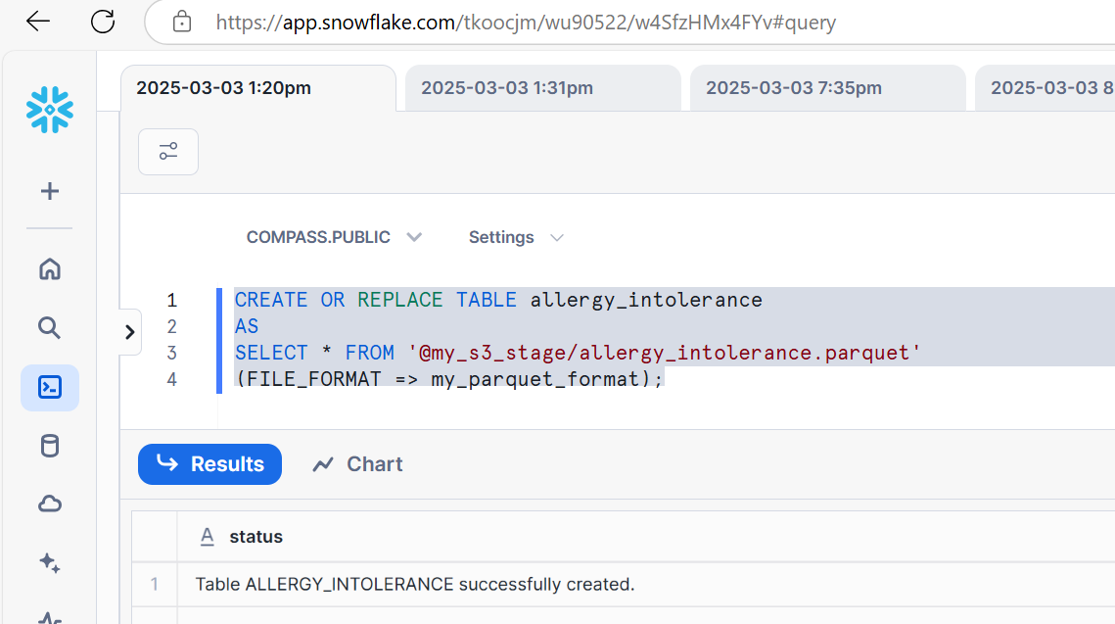

Finally, unfortunately the query above pulls through all of the data from the parquet file into a single 'variant' column. But that won't work so we need to employ some dynamic SQL to create a table and insert the data (on the fly) – this works:

CREATE OR REPLACE FILE FORMAT my_parquet_format TYPE = parquet, REPLACE_INVALID_CHARACTERS = TRUE, BINARY_AS_TEXT = FALSE;
BEGIN
-- Infer the schema
CREATE OR REPLACE TEMP TABLE inferred_schema AS
SELECT * FROM TABLE(
INFER_SCHEMA(
LOCATION => '@my_s3_stage/allergy_intolerance-inserts.parquet',
FILE_FORMAT => 'my_parquet_format'
)
);
-- Generate the CREATE TABLE statement dynamically
LET create_stmt STRING;
SELECT 'CREATE OR REPLACE TABLE ALLERGY_INTOLERANCE (' ||
LISTAGG(column_name || ' ' || upper(type), ', ')
|| ');'
INTO create_stmt
FROM inferred_schema;
-- Execute the CREATE TABLE statement
EXECUTE IMMEDIATE create_stmt;
END;
DECLARE copy_query STRING;
-- VARIABLE DECLARATION BETWEEN BEGIN AND END USES LET
-- VARIABLE ASSIGNMENT WITHIN BEGIN AND END USES :=
BEGIN
LET col_list STRING;
SELECT LISTAGG('"' || UPPER(column_name) || '"', ', ') INTO :col_list
FROM TABLE(INFER_SCHEMA(
LOCATION => '@my_s3_stage/allergy_intolerance-inserts.parquet',
FILE_FORMAT => 'my_parquet_format'
));
copy_query := 'COPY INTO allergy_intolerance (' || col_list || ') FROM (SELECT ';
LET select_list STRING;
SELECT LISTAGG('$1:' || column_name || '::' || type, ', ') INTO :select_list
FROM TABLE(INFER_SCHEMA(
LOCATION => '@my_s3_stage/allergy_intolerance-inserts.parquet',
FILE_FORMAT => 'my_parquet_format'
));
copy_query := copy_query || select_list || ' FROM @my_s3_stage/allergy_intolerance-inserts.parquet) FILE_FORMAT = (FORMAT_NAME = ''my_parquet_format'');';
EXECUTE IMMEDIATE :copy_query;
END;
-- RETURN :copy_query;
-- EXECUTE IMMEDIATE :copy_query;

handing invalid characters and binary conversion to text on importing a parquet file, using file format parameters

The discussion in this thread highlights an issue of binary and non-ascii (invalid characters) being pulled into snowflake from a parquet file:

https://stackoverflow.com/questions/60403487/how-to-remove-unicode-replacement-character-from-snowflake

It seems one way to handle these invalid character issues on the import is to use modifiers in the file format specification, this is specifically discussed here:

https://docs.snowflake.com/en/sql-reference/sql/copy-into-table#type-csv

with the possible format modifiers for a parquet file being:

-- If FILE_FORMAT = ( TYPE = PARQUET ... )
COMPRESSION = AUTO | SNAPPY | NONE
BINARY_AS_TEXT = TRUE | FALSE
USE_LOGICAL_TYPE = TRUE | FALSE
TRIM_SPACE = TRUE | FALSE
USE_VECTORIZED_SCANNER = TRUE | FALSE
REPLACE_INVALID_CHARACTERS = TRUE | FALSE
NULL_IF = ( [ '<string>' [ , '<string>' ... ] ] )

I therefore had to modify the file format statement to be:

CREATE OR REPLACE FILE FORMAT my_parquet_format TYPE = parquet, REPLACE_INVALID_CHARACTERS = TRUE, BINARY_AS_TEXT = FALSE;

in order to handle invalid characters and binary formats and get the parquet import to work.

This is the complete (working) code to dynamically construct a table and import from a specific parquet file:

CREATE OR REPLACE FILE FORMAT my_parquet_format TYPE = parquet, REPLACE_INVALID_CHARACTERS = TRUE, BINARY_AS_TEXT = FALSE;
BEGIN
-- Infer the schema
CREATE OR REPLACE TEMP TABLE inferred_schema AS
SELECT * FROM TABLE(
INFER_SCHEMA(
LOCATION => '@my_s3_stage/allergy_intolerance-inserts.parquet',
FILE_FORMAT => 'my_parquet_format'
)
);
-- Generate the CREATE TABLE statement dynamically
LET create_stmt STRING;
SELECT 'CREATE OR REPLACE TABLE ALLERGY_INTOLERANCE (' ||
LISTAGG(column_name || ' ' || upper(type), ', ')
|| ');'
INTO create_stmt
FROM inferred_schema;
-- Execute the CREATE TABLE statement
EXECUTE IMMEDIATE create_stmt;
END;
DECLARE copy_query STRING;
-- VARIABLE DECLARATION BETWEEN BEGIN AND END USES LET
-- VARIABLE ASSIGNMENT WITHIN BEGIN AND END USES :=
BEGIN
LET col_list STRING;
SELECT LISTAGG('"' || UPPER(column_name) || '"', ', ') INTO :col_list
FROM TABLE(INFER_SCHEMA(
LOCATION => '@my_s3_stage/allergy_intolerance-inserts.parquet',
FILE_FORMAT => 'my_parquet_format'
));
copy_query := 'COPY INTO allergy_intolerance (' || col_list || ') FROM (SELECT ';
LET select_list STRING;
SELECT LISTAGG('$1:' || column_name || '::' || type, ', ') INTO :select_list
FROM TABLE(INFER_SCHEMA(
LOCATION => '@my_s3_stage/allergy_intolerance-inserts.parquet',
FILE_FORMAT => 'my_parquet_format'
));
copy_query := copy_query || select_list || ' FROM @my_s3_stage/allergy_intolerance-inserts.parquet) FILE_FORMAT = (FORMAT_NAME = ''my_parquet_format'');';
EXECUTE IMMEDIATE :copy_query;
END;
-- RETURN :copy_query;
-- EXECUTE IMMEDIATE :copy_query;

Online parquet file viewer:

note for parquet files (being able to view these online), and therefore troubleshoot, the following tool is very useful:

https://www.tablab.app/parquet/view

