# Release Information

|  |  |
| --- | --- |
| Release | 1 |
| Leader | Nicholas Baerwald |
| SVN Revision Number | 123 |

In this iteration the functionality of a customer being able to make an order was added. Customers also have the ability to view the progress of their orders.

# Progress

|  |  |  |  |
| --- | --- | --- | --- |
| **Stories and spike solutions worked on during this release** | | | |
| **Story, Spike** | **Description** | **% Impl.** | **Notes, plan for completion** |
| FND-24 | Create Chef orders Screen | 0 | Will do in iteration two |
| FND-25 | Create Customer Payment Screen | 0 | Will do in iteration two |
| FND-23 | Create Menu Ordering Screen | 80 | Will improve and clean up in iteration 2 |
| FND-28 | Create Customer Class | 100 |  |
| FND-29 | Create Order Class | 100 |  |
| FND-30 | Link Orders and Customers to UI | 50 | Iteration 2 |
| FND-31 | Create button for chef to mars as “in progress” | 90 | Will finish in iteration 2 |
| FND-32 | Create screen for users to track order | 75 | Will finish in iteration 2 |
| FND-26 | Create button to mark an order complete | 70 | Logic is done just needs implementation |
| FND-21 | Create Admin backend for adding admin | 0 |  |
| FND-22 | Create Admin backend for removing people | 0 |  |

|  |  |  |
| --- | --- | --- |
| **Accomplishments by engineer** | | |
| **Team Member** | **Total Time (hrs)** | **Stories, Spikes implemented** |
| Nicholas Baerwald | 12 | FND-28  FND-29  FND-30(w/Noah) |
| Nic Skoronski | 15 | FND-32(w/Noah)  FND-31 |
| Garth Macey | 5.8 | FND-21  FND-22  FND-26 |
| Noah Schroeder | 25 | FND-23  FND-24  FND-25 |
| TEAM TOTAL | **57.8** |  |

|  |  |
| --- | --- |
| **Document updates** | |
| **Document** | **Changes** |
| ClassDiagram.docx | Created t he design level class diagram |
|  |  |

# Issues

|  |  |  |  |  |
| --- | --- | --- | --- | --- |
| **Issue Number** | **Discovery**  **Date** | **Resolution**  **Date (Est.–Act.)** | **Responsible Person** | **Description (Prob / Resolution)** |
| 1 | 3/7/2019 |  | Nicholas | The tests are not building. Compiler states missing a NuGet file. |
| 2 | 3/8/2019 |  | Noah | The order progress view is not instantiated until it is clicked on. |
|  |  |  |  |  |
|  |  |  |  |  |

# Screen Shots

Spike 2: Was used to figure out how to create only one instance of a view and how to use the prism library.

Showing that there is a page view counter.

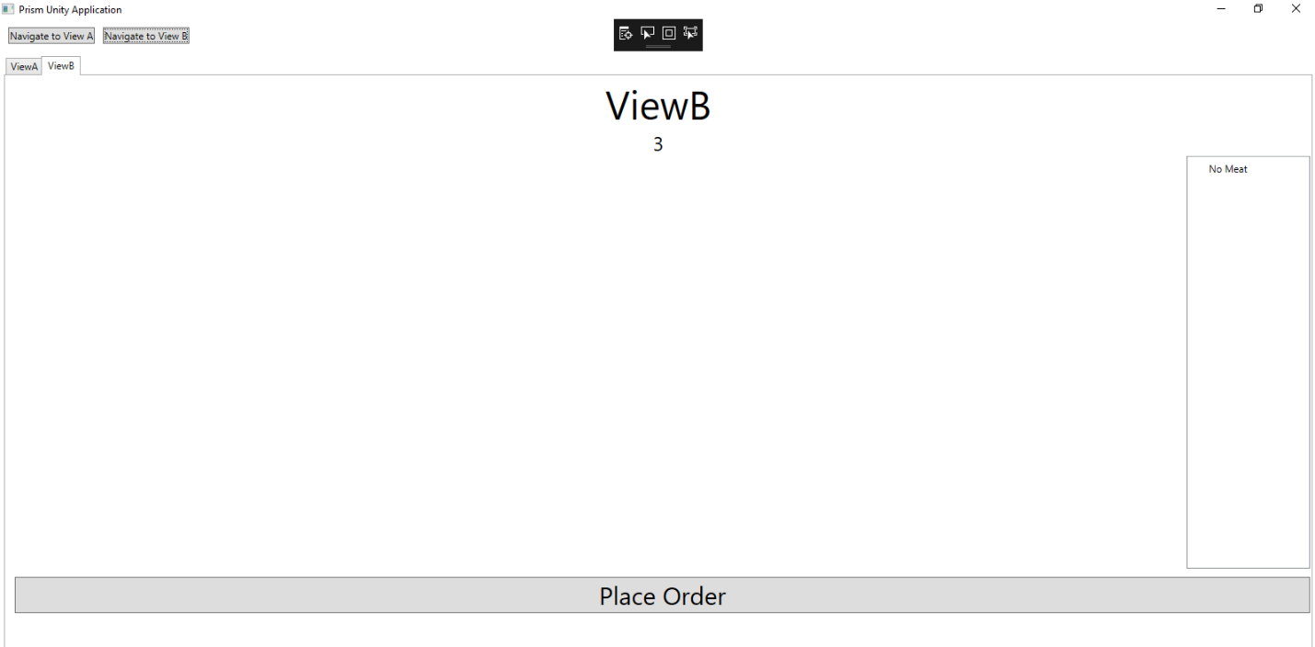

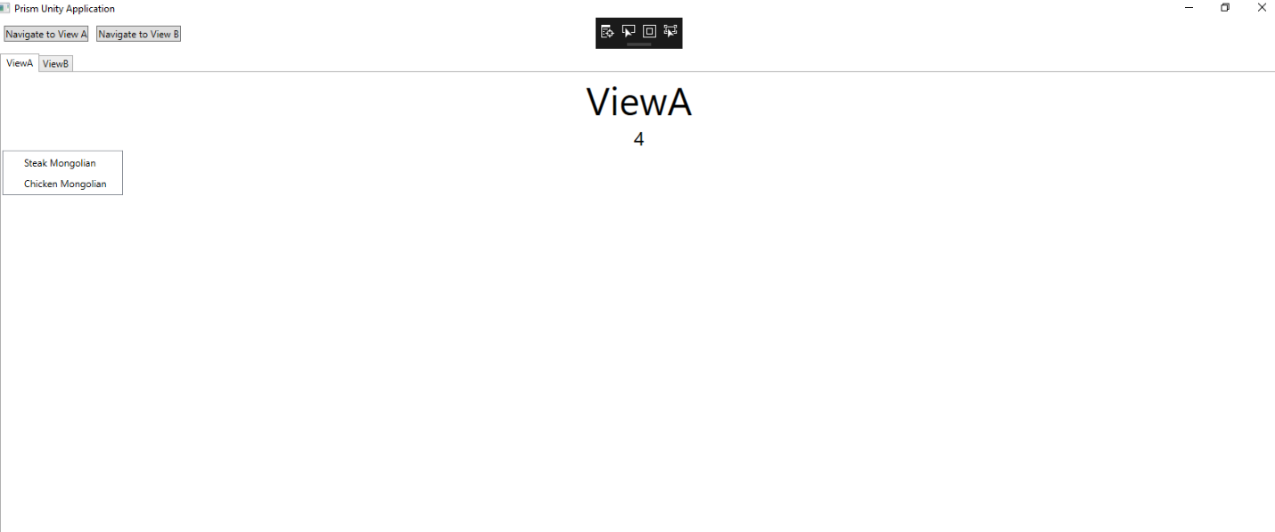

Spike 1: Was used to figure out the messenger, to be able to send info from class to class.

Code to be able to receive the information that was published

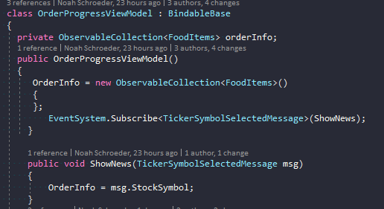

Publishes the information for view

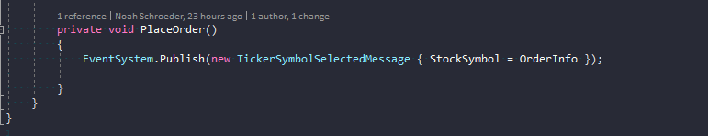

UI:

Current order menu, allows the customer to select what food they want in the order and then to place 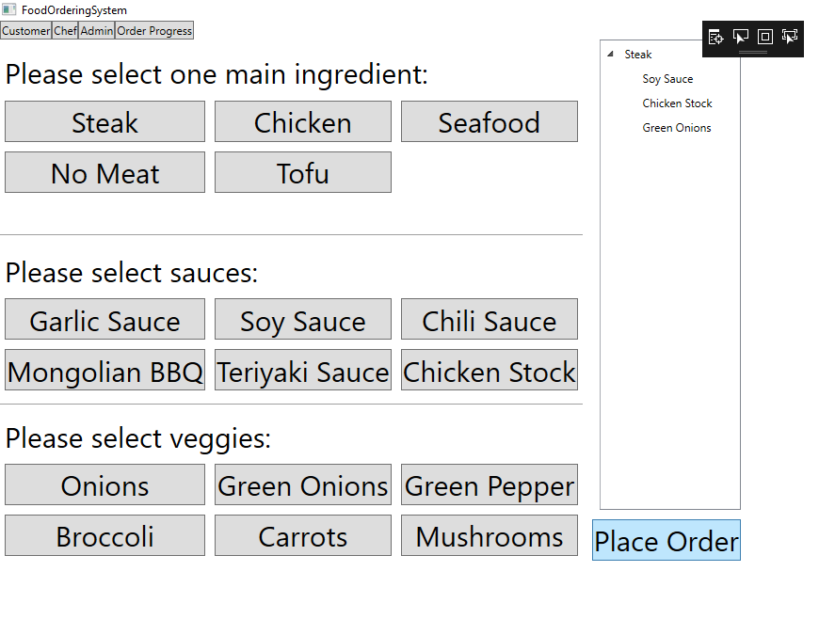the order

Order Progress menu updates with the order

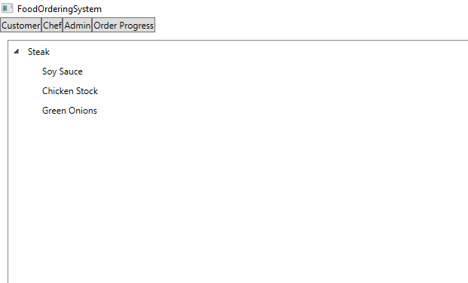

Chef View:

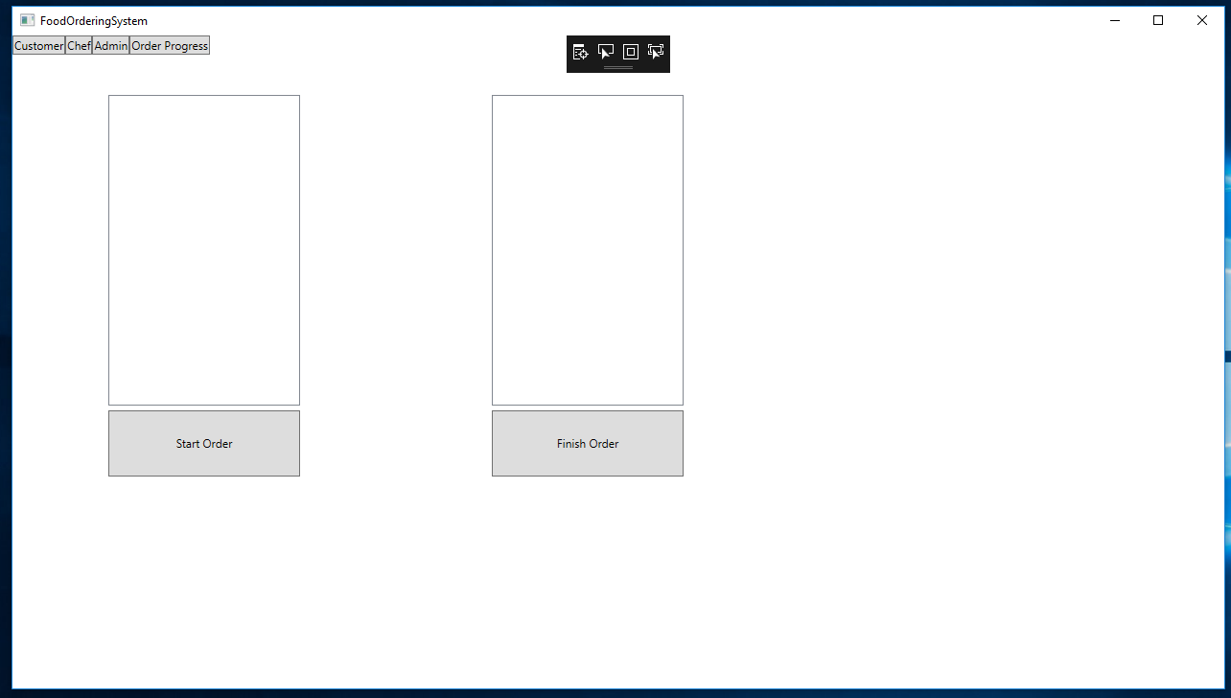

Class Diagram