Define
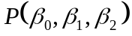 as the price function ; i.e., 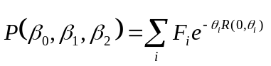
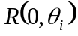 is the discount rate as given by Nelson Siegel ; i.e., 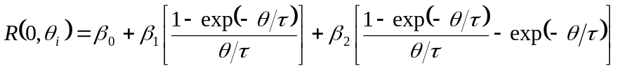

Derivative of P with respect to β₀ is:

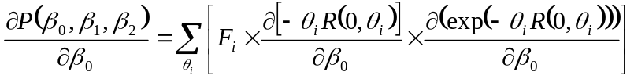

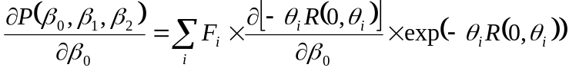

Since 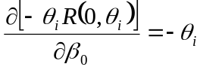, 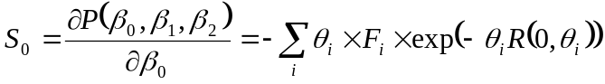

Since 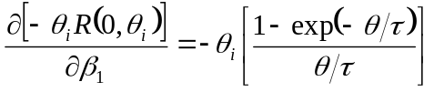, 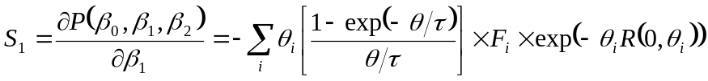

Since 

