Untitled

Garth Tarr and Sarah Romanes

01/04/2019

## My test

This is an example R Mardown document to improve the template.

Knit this file, change the style, then save the resulting file as template.docx.

> summary(cars)

speed dist   
 Min. : 4.0 Min. : 2.00   
 1st Qu.:12.0 1st Qu.: 26.00   
 Median :15.0 Median : 36.00   
 Mean :15.4 Mean : 42.98   
 3rd Qu.:19.0 3rd Qu.: 56.00   
 Max. :25.0 Max. :120.00

> # load some packages  
> library(dplyr)

Attaching package: 'dplyr'

The following objects are masked from 'package:stats':  
  
 filter, lag

The following objects are masked from 'package:base':  
  
 intersect, setdiff, setequal, union

> library(ggplot2)  
> cars %>% ggplot(aes(x = dist, y = speed)) +   
+ geom_line(colour = 2, fill = "red")

Warning: Ignoring unknown parameters: fill

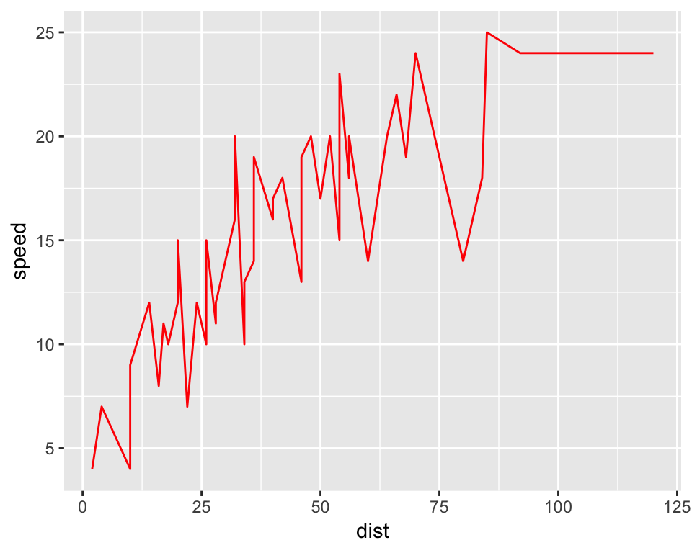

## Including Plots

You can also embed plots, for example:

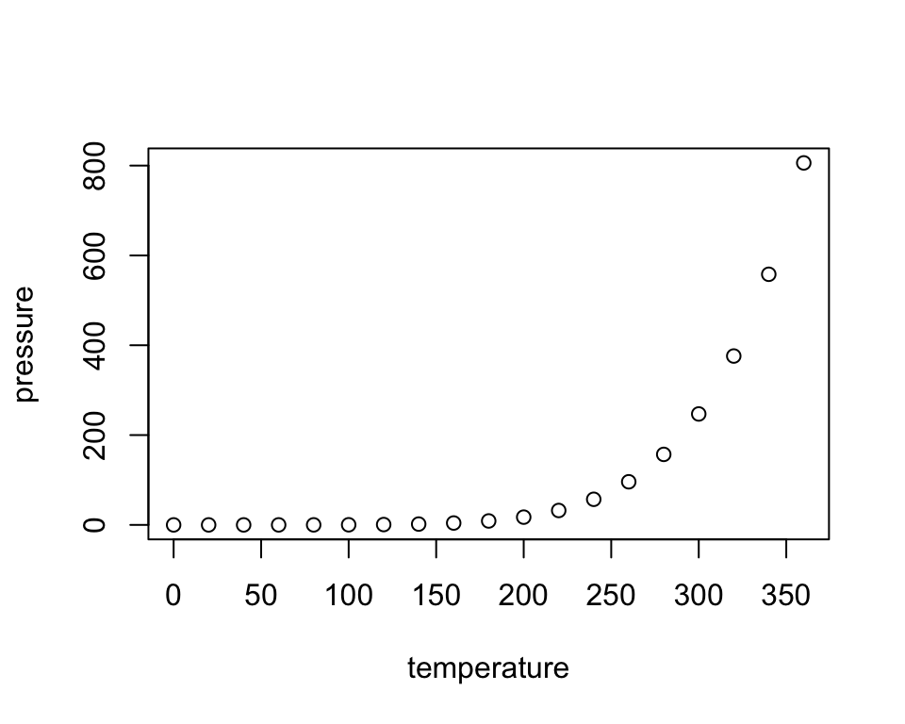

Note that the echo = FALSE parameter was added to the code chunk to prevent printing of the R code that generated the plot.