Word2Vec Explained from Scratch
A simple study note built from this chat, including examples and diagrams
Core idea: Word2Vec learns a numeric vector for each word by looking at nearby words. Similar words get similar vectors because they appear in similar contexts.

1. What Word2Vec is
Word2Vec converts each word into a vector of numbers called an embedding. Instead of storing a word only as a label, it stores the word as a learned numeric pattern.
- Example: king → [0.21, -0.44, 0.67, ...]
- If Google used 300 dimensions, that means each word is represented by 300 numbers.
- These numbers are learned automatically from text during training.

2. One-hot encoding vs Word2Vec
Approach | Example for 'king' | What it captures
One-hot encoding | [0, 1, 0, 0, ...] | Only identity of the word
Word2Vec embedding | [0.21, -0.44, 0.67, ...] | Context and similarity learned from text

3. How the vector values are decided
The vector values are not manually chosen. They usually start as small random numbers. During training, the model keeps adjusting those numbers so that the word becomes better at predicting nearby words, or better at being predicted by nearby words.
- At the beginning: the numbers mean nothing.
- After many training updates: the numbers become meaningful patterns.
- The embedding is usually taken from the input-to-hidden weight matrix.

4. How Word2Vec works internally
For a tiny sentence like: the king loves queen
- Build vocabulary: the, king, loves, queen
- Assign indices: the=0, king=1, loves=2, queen=3
- Convert input word to one-hot vector
- Use the one-hot vector to select the row for that word from the embedding matrix
- Multiply by the output matrix to get scores for all words
- Apply softmax to turn scores into probabilities
- Compare with the correct target word
- Update weights using the error

5. CBOW vs Skip-gram
Model | Input | Target
CBOW | Context words | Center word
Skip-gram | Center word | Context word(s)
Example with sentence: the king loves queen
- CBOW: [the, king, queen] → loves
- Skip-gram: king → the, king → loves

6. What is a feature here?
In embedding discussions, feature usually means one value or one dimension inside the vector. So if a word has a 300-dimensional vector, you can loosely think of it as 300 learned features.
- Input word = king
- Embedding = 300 numbers
- Each number = one dimension / one learned feature

7. Human view vs model view
In human language, we may describe the word 'king' using concepts like royalty, leadership, power, male, ruler, wealth, throne-related, and kingdom-related. This is useful for intuition.
But inside real Word2Vec, there are no explicit columns named 'royalty' or 'power'. The model only stores numbers. The meaning comes from the combination of all dimensions together.

8. Important correction
Human-made feature example | Real Word2Vec
Columns can be named: gender, wealth, power, weight, speak | Columns are not explicitly named
Useful for understanding | Used in actual training
Manually designed by a person | Learned automatically from text

9. Why king - man + woman ≈ queen
This famous example shows that embeddings can capture relationships. The intuition is: king contains a male royal meaning. Subtracting man removes the male/common-man part, and adding woman shifts the result toward queen.
- This is vector arithmetic on learned embeddings.
- It works because the model learned consistent relationships from many sentences.
- It is an approximate relationship, not magic.

10. Explanation based on the shared diagrams
Your diagrams show the right intuition. They use simple, manually named features to make the concept easy to understand.
- In your table, words are represented using explicit feature columns such as gender, wealth, power, weight, and speak.
- That means your example is a human-designed feature vector, not a real trained Word2Vec embedding.
- This is still very useful because it helps explain why similar words are close in vector space.
- The 3D sketch also shows how words can be plotted as points or arrows in space and compared visually.
- The equation king - man + woman = queen shows how vector operations can capture relationships.
- In real Word2Vec, the same idea holds, but the 300 dimensions are learned automatically rather than manually labeled.

Figure 1. Diagram from the conversation
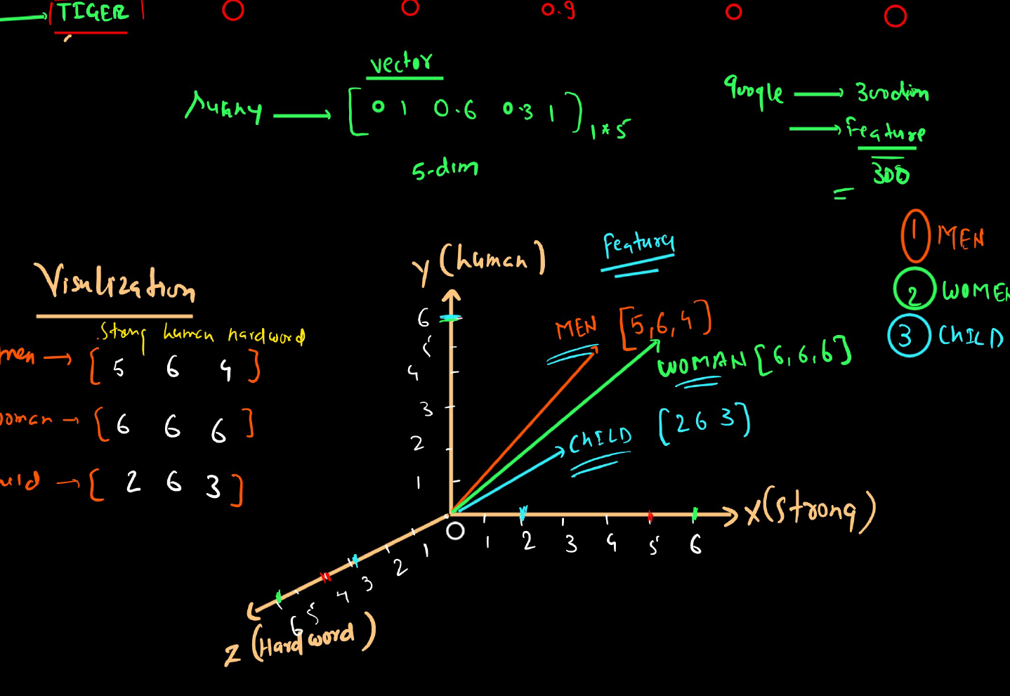
Manual feature vectors visualized in 3D space.

Figure 2. Diagram from the conversation
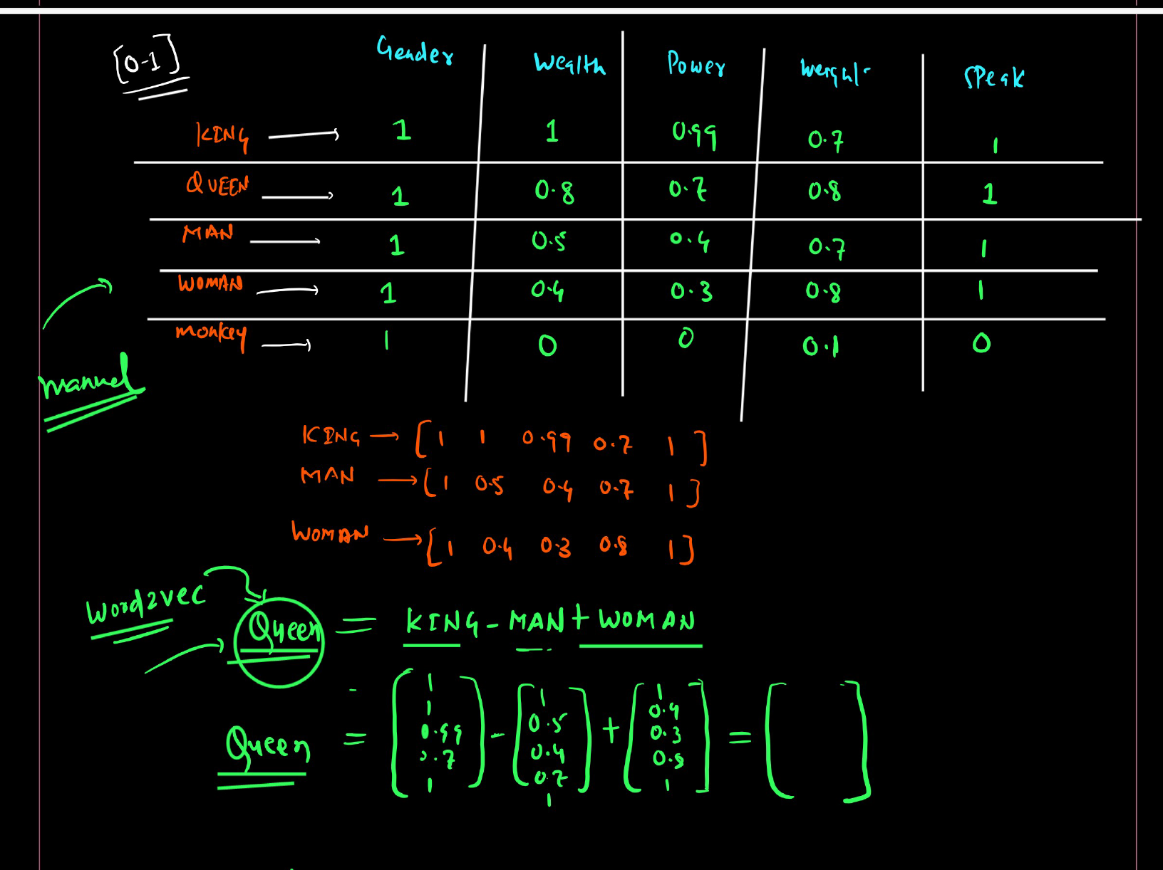
Human-made feature table and vector arithmetic intuition.

Figure 3. Diagram from the conversation
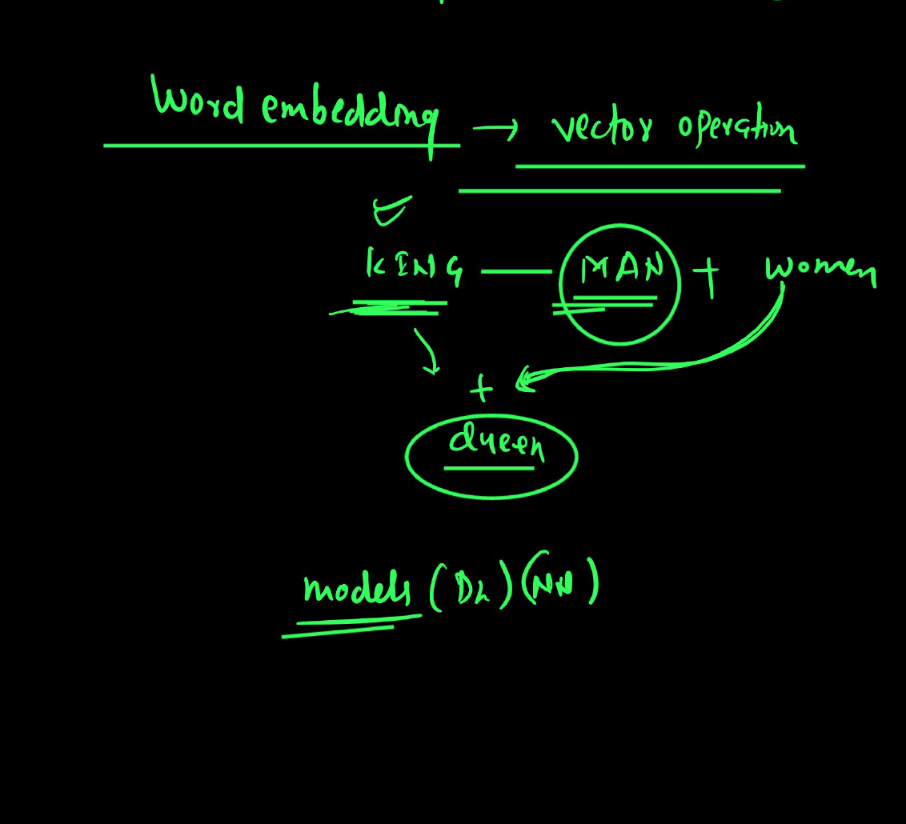
Embedding relationship: king - man + woman ≈ queen.

11. Final short answers from the chat
Q: Is a feature part of the 300 dimensions or part of the input?
A: A feature is part of the 300 dimensions, not the input word itself.
Q: Does king have explicit features like royalty, wealth, and power?
A: In human explanation, yes. In real Word2Vec, no explicit labels exist; the concepts are encoded implicitly across many dimensions.
Q: How is the vector assigned to an input word?
A: Each word has an index. That index points to one row in the embedding matrix.
Q: How is the target word decided?
A: From nearby words using a context window. In Skip-gram the target is a nearby context word; in CBOW the target is the center word.

12. One-line takeaway
Word2Vec does not assign meaning by rules. It learns word vectors by repeatedly adjusting numbers so words become good at predicting their context.

